




Y9 Summer
Competition
English | Write a poem about your identity.
Maths | Create a PowerPoint presentation over the summer to help you revise all the maths formulae you’ve learned so far. On each slide, write down a different formula, then look up an example online showing how that formula is used. After that, make up your own question where you can apply the same formula, and solve it. This will help you remember the formulae and understand how to use them properly.
Science | Create a poster or a model to show and explain how our atmosphere has changed from the early atmosphere to the present day. You should include illustrated comparisons of the atmospheres and the surface of the Earth, as well as explaining what caused these changes to occur.
Geography | Cook one of the recipes from the stop food waste day website: Recipes & Tips  Take a photo and send us a review!
History | Use the link and tab ‘Migration patterns over the last millennium’ to read about the story of migration to Britain. Then select 1 group from each period (medieval, early modern, industrial, modern) and make a poster for them making note of the reasons that they migrated to Britain, their experiences and their impact (what they changed). https://www.bbc.co.uk/bitesize/guides/zt8qrdm/revision/2
RS | Watch the film “The Covenant” on Youtube and write the story in your own words.  The Covenant | English | Official Full HD Movie
Art | Take a collection of your own photographs on the theme of Organic/Natural Forms (at least 10) Complete a sustained, tonal drawing from one of your photographs.  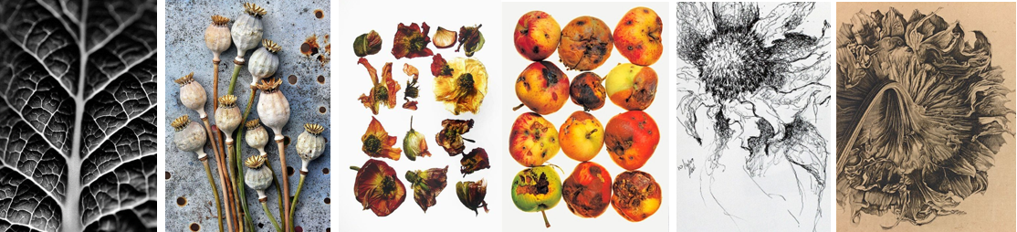
Drama | Create your own script based on the ‘A,B,C’ Structure, where each line of dialogue begins with the next letter in the alphabet. Your script could be about anything, a trip to the beach, or a camping trip gone wrong!  Example of dialogue could be:  Ella: ‘Alright Ed, calm down I’ve definitely packed the tent, you need to chill out!  Ed: ‘But, Ella I’m worried the tent has a hole in it!’  Have fun being creative and writing a script!
Music | Write a blog post about a song of your choice trying to promote it to others. You should include reasons why you think others should listen to the song. You might be able to comment on the song’s... instruments, rhythm, melody (main tune), structure, dynamics (how loud it is) and tempo (how fast/slow it is).
Engineering and Product Design | Produce a detailed product study about a product of your choice but which you think could be improved. (Before you start taking things apart please check with an adult that it is safe and you are allowed!) Your product study could include…  A photograph of the product you have chosen; A list of parts, including the materials that have been used; Use ACCESSFM to analyse the current product and make judgements about the good and bad points; Make suggestions about how the product could be improved, include annotated drawings to show these improvements; An exploded diagram of the product; An orthographic drawing of the product, including dimensions.
Hospitality and Catering | Around the World in 80 bites!  Research dishes from around the World. Can you discover a different dish to take you on a journey around the whole World? Try to cater for a range of dietary requirements, different meal times, as well as pushing yourself out of your comfort zone to consider new flavours, a range of cooking styles and new skills. Why not try to cook some dishes too or, if you’re abroad on holiday, try the local delicacy and write a review of the organoleptic qualities.
ICT | You have been asked to give your expert opinion on the use of facial recognition by the police in Downham Market. You need to explain 3 reasons why this would be good for the public and 3 reasons why it might be bad for the local community. Carry out some internet research to help with your arguments for or against.
MFL | Write a paragraph on each of the following GCSE 3 themes, showing what you have learnt in French / Spanish so far. Aim to include past, present + future tenses, opinions + reasons, plus any other flashy grammar you know.  - Family, friends, relationships, diet + healthy living, school, work  - Free time activities, celebrations, festivals + your favourite celebrity  - Holidays, media ( TV, social media, film), technology, where you live, what you do to protect the environment
PE | PARTICIPATION TASK – Steps in a day challenge  Record the maximum amount of steps you can take in a day, this can be tracked on the health app/fitness apps on your phone.  EXCELLENCE TASK – 5K time challenge  Record the quickest time you complete a 5K run. A leaderboard will be gathered and shared upon your return. Email a picture of your time to TWalker@dma.tela.org.uk
Health & Social | As we move through life, we experience different life stages. For middle adulthood (46-65 yrs), research 3 physical milestones, 3 intellectual milestones, 3 emotional milestones and 3 social milestones. You can make a table, a poster, notes showing the information.  We also experience life events such as puberty, starting and ending relationships, bereavement, retirement, having a baby, starting school/college and so on. Some are expected; some are unexpected. Pick one life event. Create a leaflet describing the life event – what it is?

