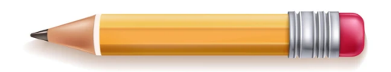
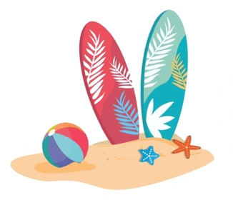
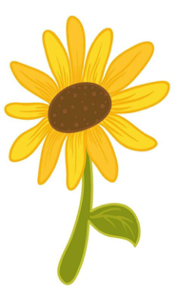
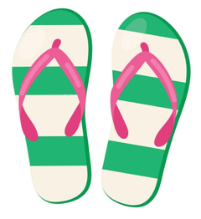

Summer
Homework
English | Read a gothic text and then write your own gothic horror story.
Maths | Think back to your mathematical career this year, think of a topic you enjoyed/ are proud of your progress. Create a revision tool for future year 8’s to use. This could be a poster or a PowerPoint or even a video, maybe even a dance to describe linear lines! If you’re struggling to remember topics look here: https://dma.tela.org.uk/wp-content/uploads/2023/07/KS3-Maths-Curriculum-overview.pdf
Science | Use your knowledge of the space topic to produce a model of the solar system, or a model of a rocket. This could include key information about the planets, or the different features of the rocket. There will be prizes available for the best models produced. If you do not have any materials, then you could produce a poster showing the solar system or a rocket.
Geography | Design and build your own volcano using any materials you like, get creative with shape, texture, and colour. Experiment with safe household ingredients to create an exciting eruption.
History | Using your knowledge of the Industrial Revolution and the available materials in Britain and its empire, design (or make) an invention that would have benefited Britain in the 18th and 19th Centuries.
RS | Write a letter to Sir Kier Starmer about one law that you would change in society and why? The best will win an award
Art | Your challenge is to take a series of photographs inspired by the artist Andy Goldsworthy. He is an English sculptor, photographer, and environmentalist who produces site-specific sculptures and land art situated in natural or urban settings. How can you take inspiration from him in your own photographs?  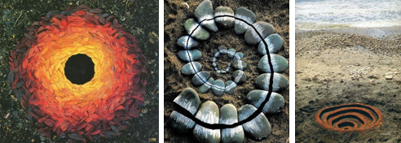
Drama | Create your own Set using an old shoe box (or small used cardboard box). Your Set could be from a scene from your favourite show, or even a scene from a chapter in a book/magazine/film. Shoe Box Sets could be: Mrs McIntyre’s classroom in the 1930s, The trench in World War, any scene looked at during your study of ‘Blood Brothers’. Use this link to get some inspiration of what you could make and have fun!  shoe box set design - Google Search
Music | Design a brand new type of musical instrument. What does it look like? How does it create sound? What style of music would it play? You might want to include diagrams, labels, annotations, etc..
Technology | Design and make a product which will encourage wildlife to visit your garden using something recycled from your home. This could be anything from a tin can or milk carton to a wooden pallet! You can make more than one, you may even wish to make a range of products. The most important thing is that you have fun and get creative!
ICT | Design a new APP for an Ipad or Smart Phone. You need to design the layout, buttons, logo. You need to describe what it does and how it would work.
MFL | Create/design a postcard in Spanish/French describing where you went on holiday, what you did, who you went with +what it was like. It doesn’t have to be true – feel free to be creative! You can add drawings, pictures or images if you like. You can either post it to the school from your holiday destination or hand it in to your teacher on the first lesson back.
PE | PARTICIPATION TASK – Steps in a day challenge  Record the maximum amount of steps you can take in a day, this can be tracked on the health app/fitness apps on your phone.  EXCELLENCE TASK – 5K time challenge  Record the quickest time you complete a 5K run. A leaderboard will be gathered and shared upon your return. Email a picture of your time to TWalker@dma.tela.org.uk

