Year 12 Pure Maths Homework Booklet
Name:____________________________________
Maths Teachers:____________________________

Contents
Page 2: Algebraic Expressions
Page 5: Quadratics
Page 10: Equations and Inequalities
Page 15: Graphs and Transformations
Page 20: Straight Line Graphs
Page 26: Circles
Page 30: Algebraic Methods
Page 34: The Binomial Expansion
Page 37: Trigonometric Ratios
Page 41: Trigonometric Identities and Equations
Page 45: Vectors
Page 48: Differentiation
Page 54: Integration
Page 58: Exponentials and Logarithms

Algebraic Expressions
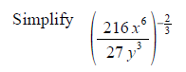
Practicing the Technique
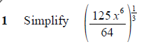
2

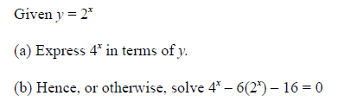
3

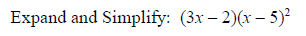
4

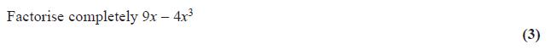
Exam Questions
1)

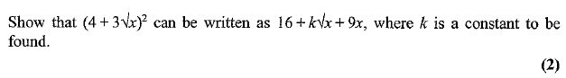
2)

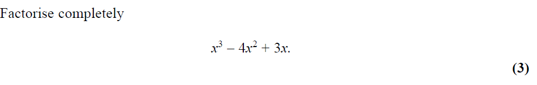
3)

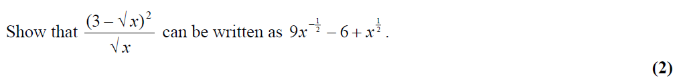
4)

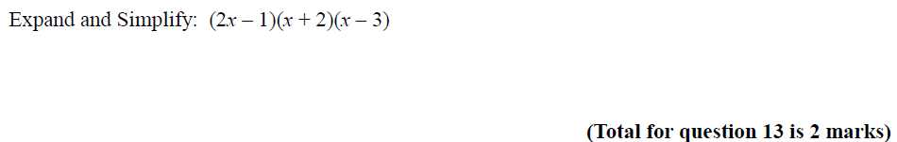
5)

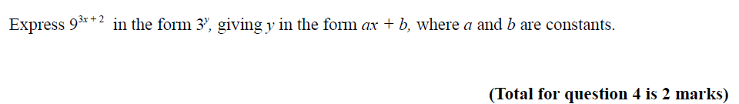
6)

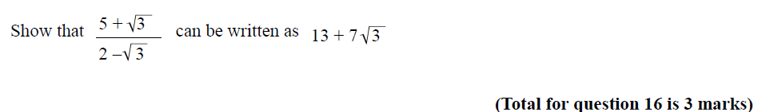
7)

Quadratics
Practicing the Technique
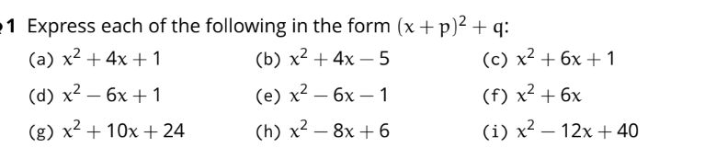
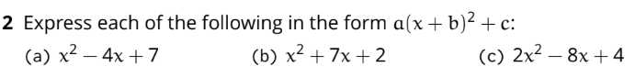

Exam Questions
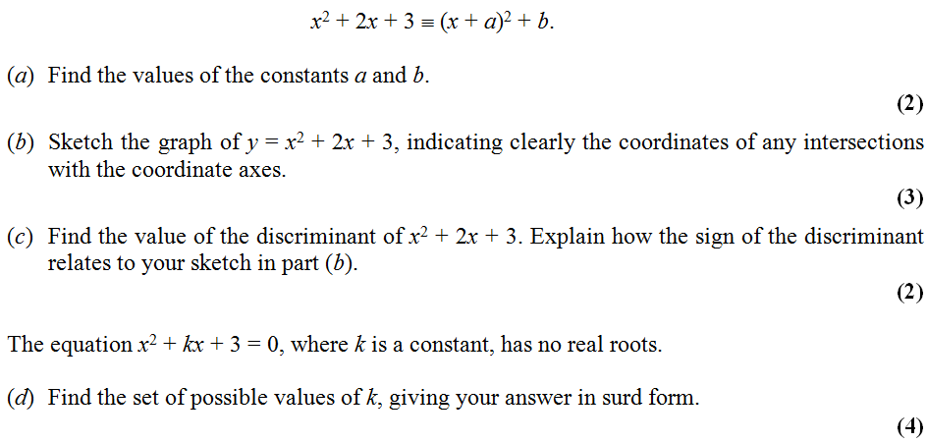
1)

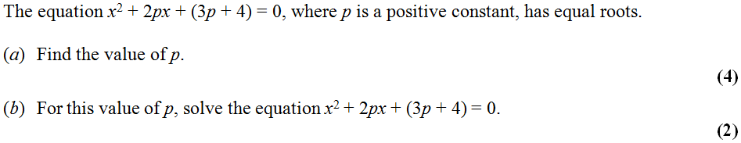
2)

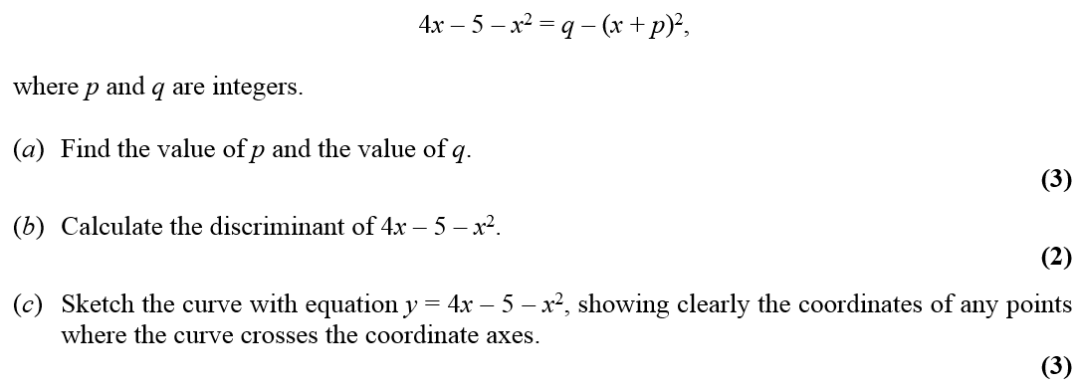
3)

4) 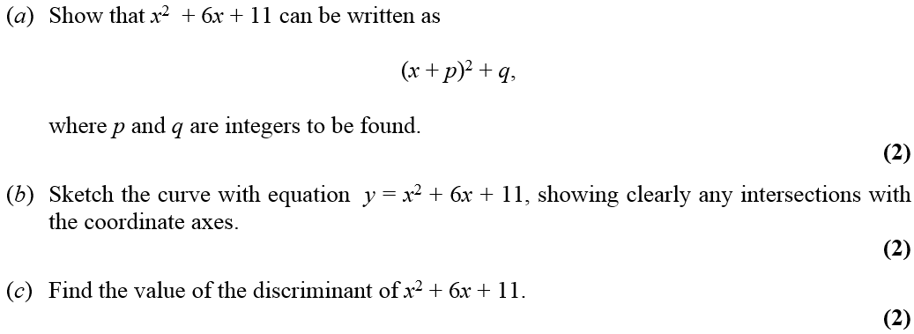

Equations and Inequalities
Practicing the technique
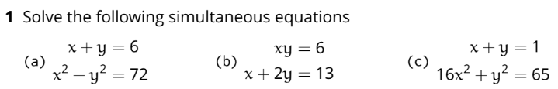

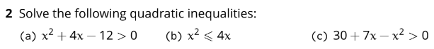

Exam Questions
1) Find the solutions to the simultaneous equations. You must show all working
y – 2x = 3
x2 + y2 = 18

x =……………………. y =…………………….
or x =……………………. y =…………………….
(Total 7 marks)

2)
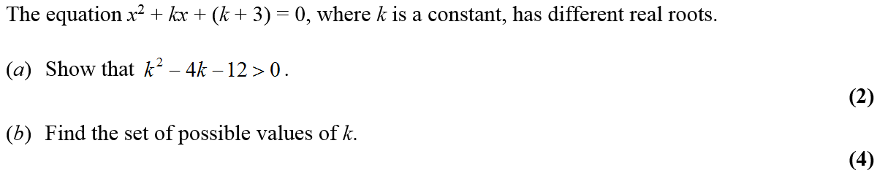

3)
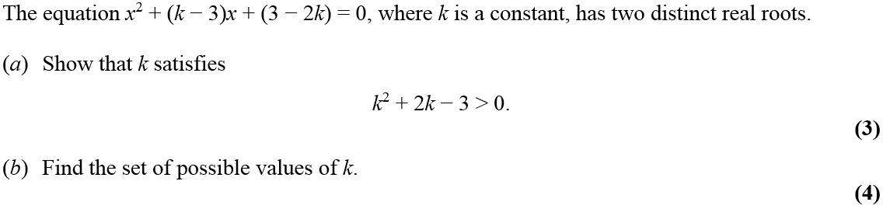

Graphs and Transformations
Practicing the technique
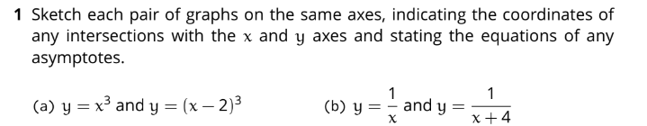

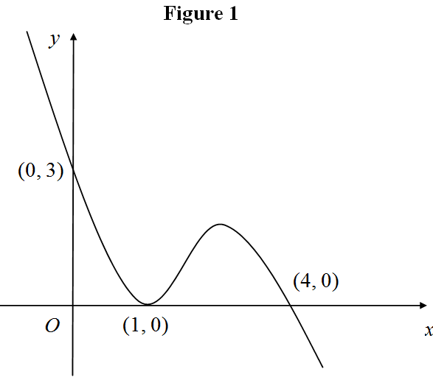
Exam Questions
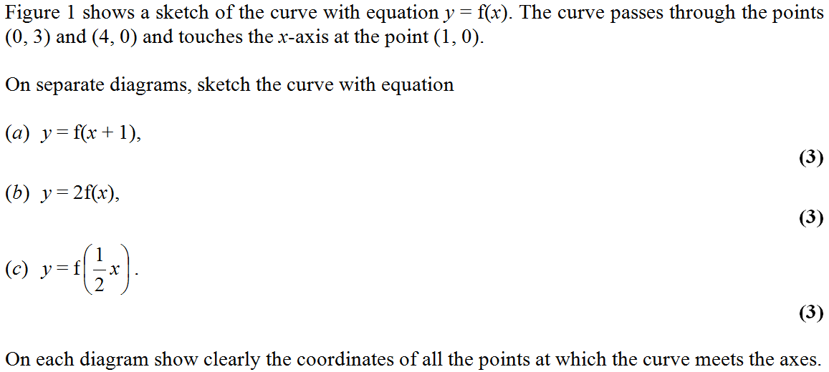
1)

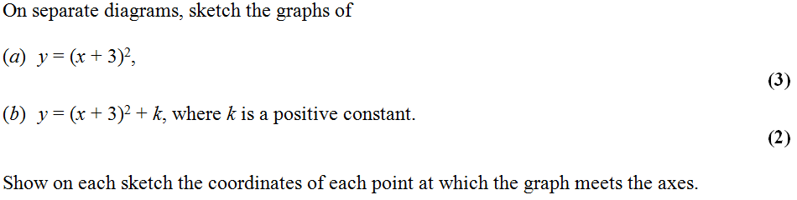
2)

3) 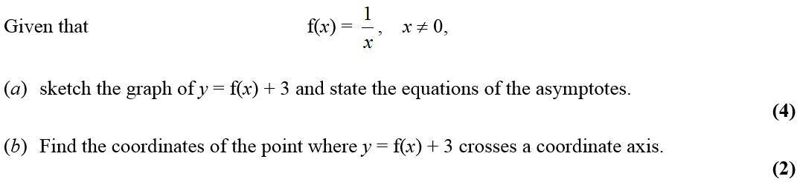

4) 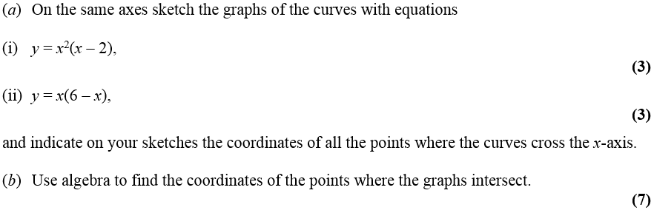

Straight Line Graphs
Practicing the Technique
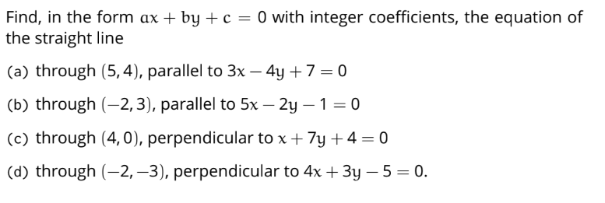

Exam Questions
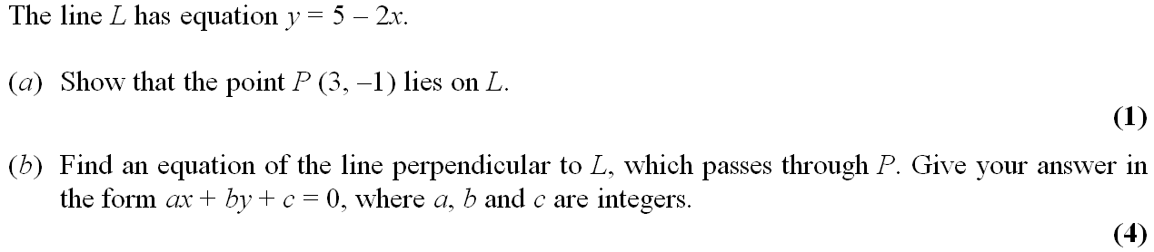
1)

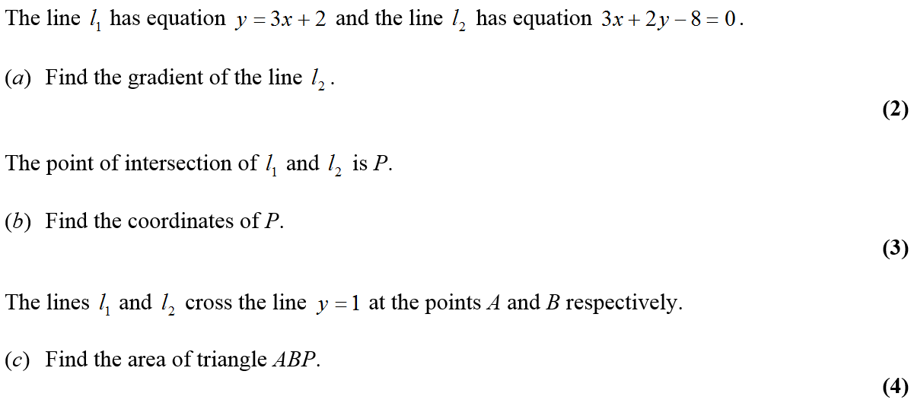
2)

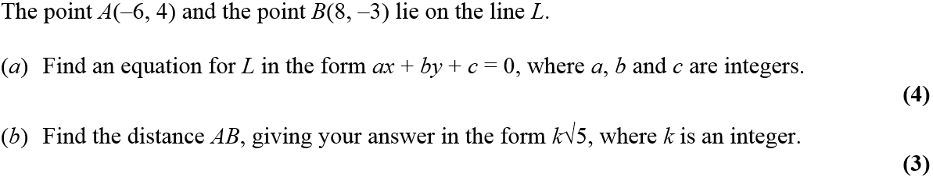
3)

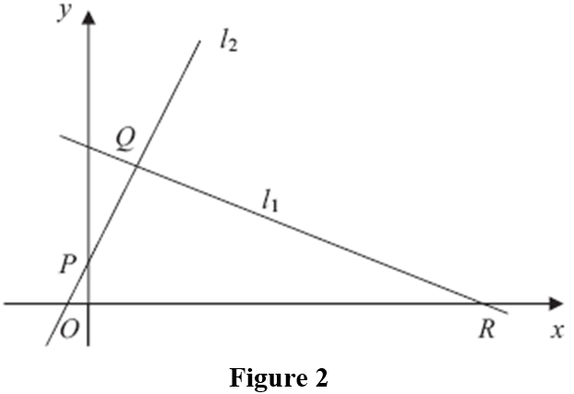
4)

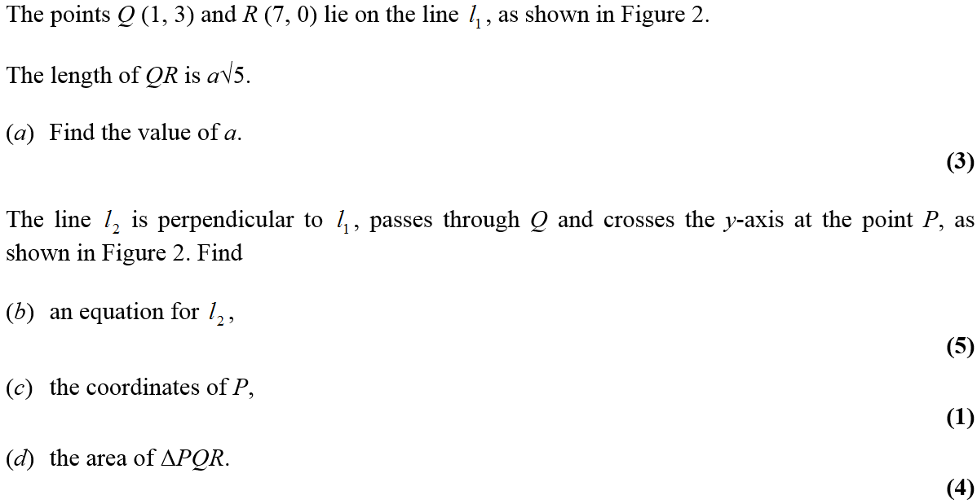

Circles
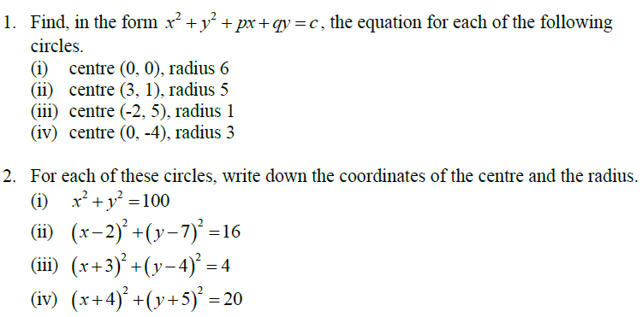
Practicing the Technique

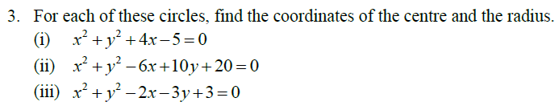

Exam Questions
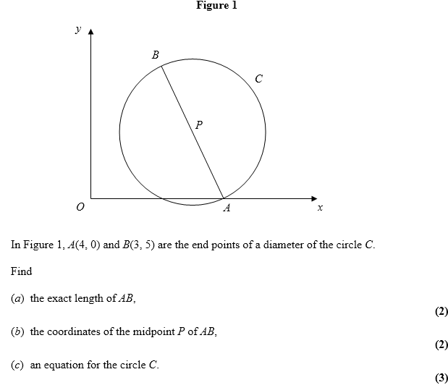
1)

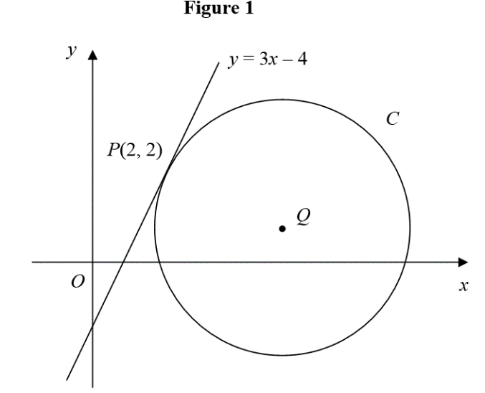
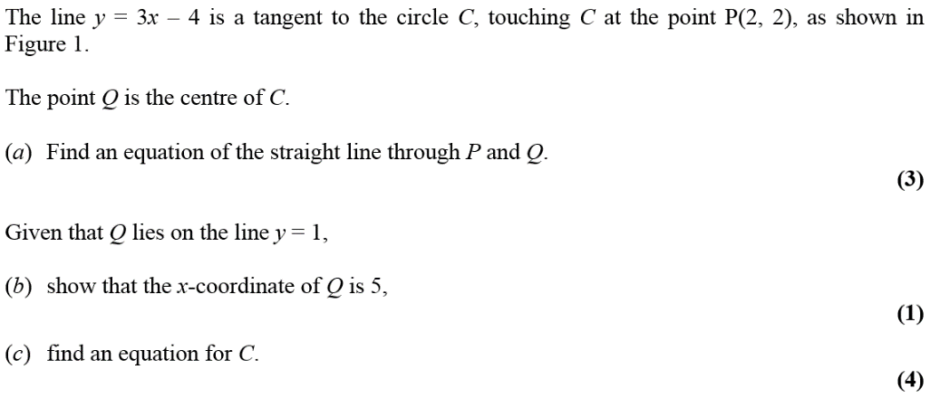
2)

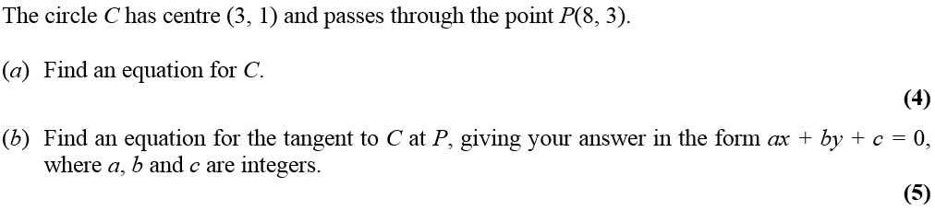
3)

Algebraic Methods
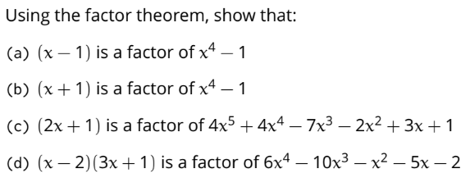
Practicing the Technique
1)

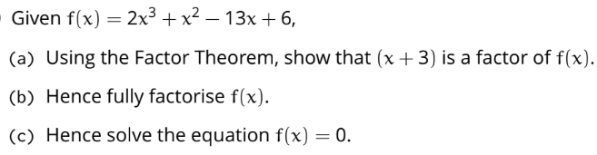
2)

Exam Questions
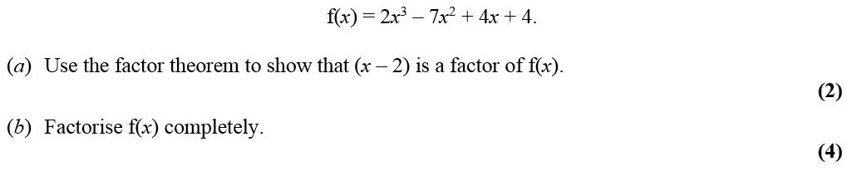
1)

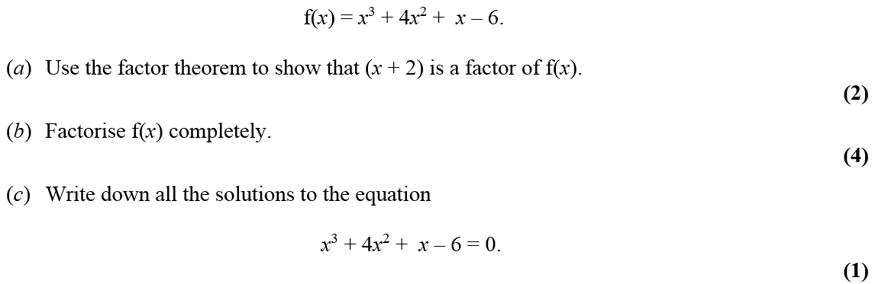
2)

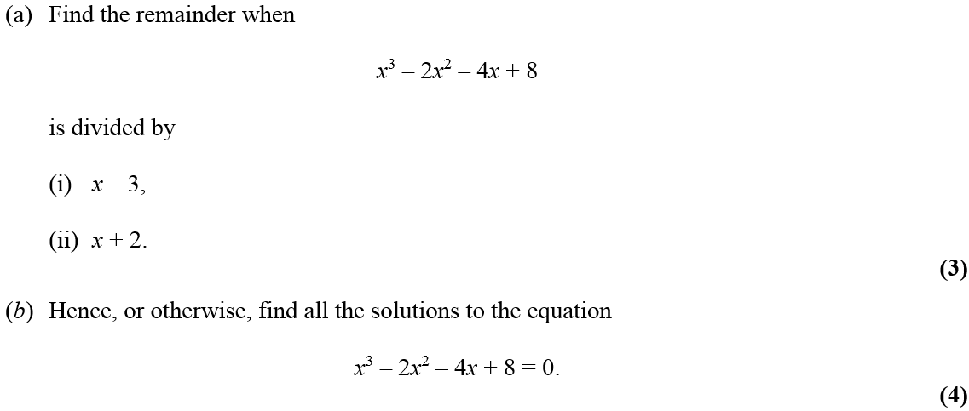
3)

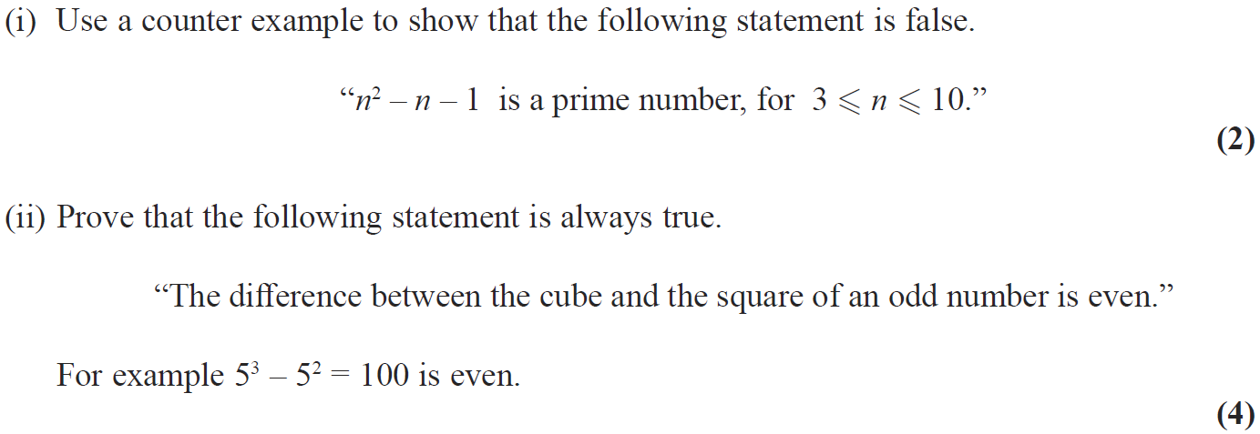
4)

The Binomial Expansion
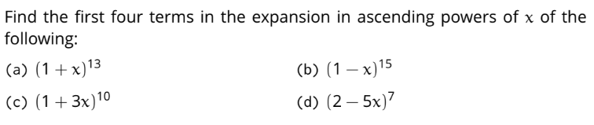
Practicing the Technique

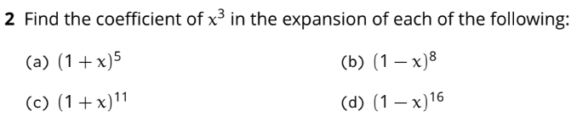

Exam Questions
1)

2)

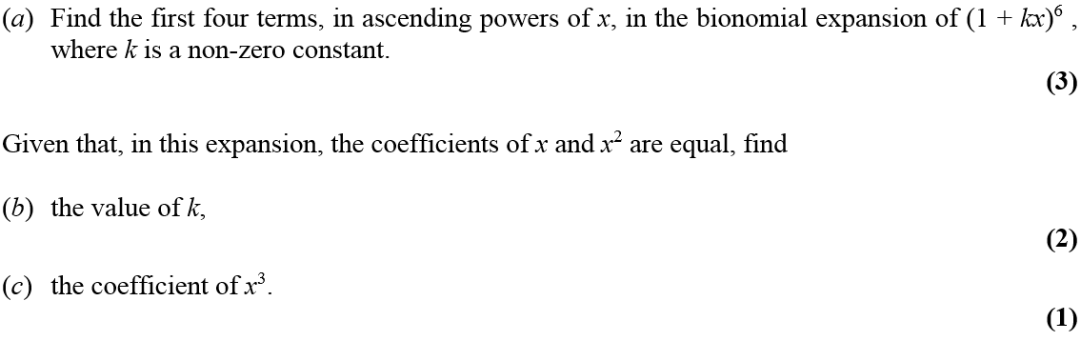
3)

Trigonometric Ratios
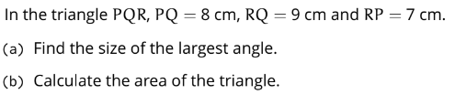
Practicing the Technique
1)

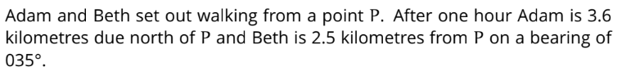
2)

Find the distance between Adam and Beth after one hour

Exam Questions
1)
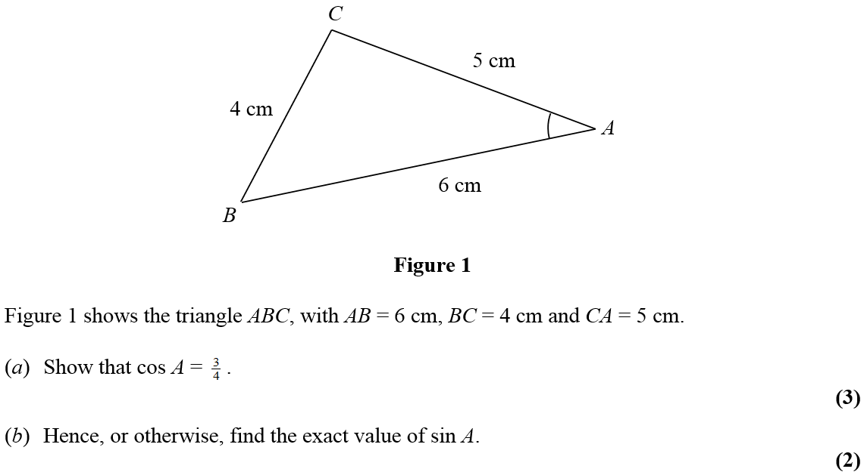

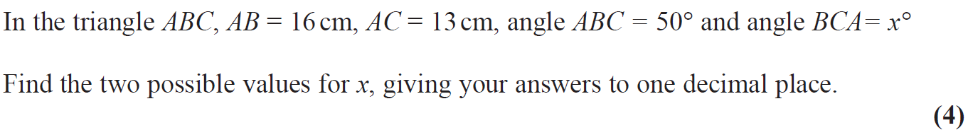
2)

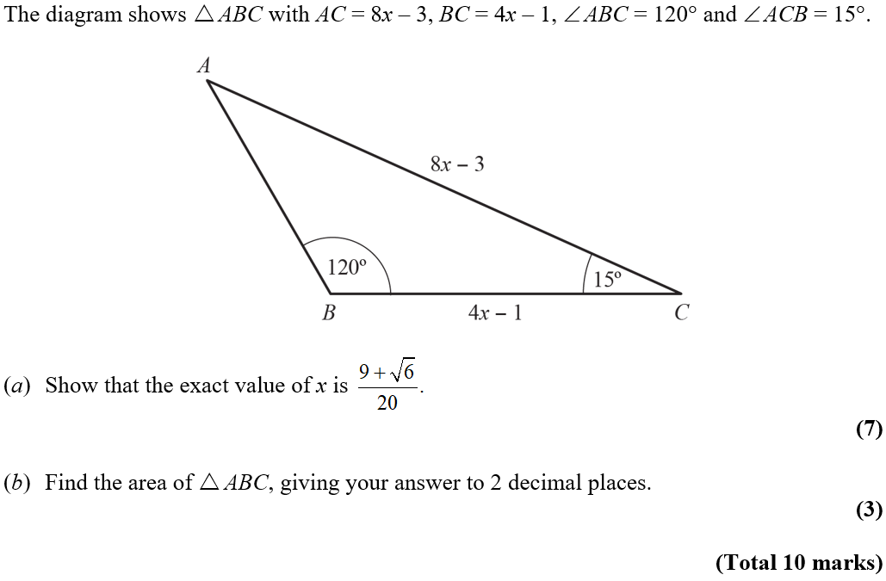
3)

Trigonometric Identities and Equations
Practicing the Technique
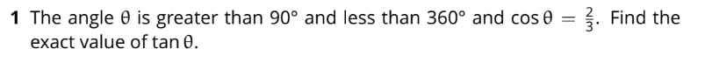

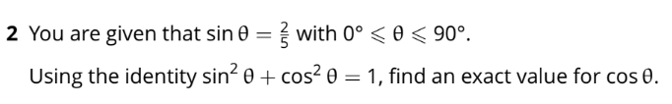

Exam Questions
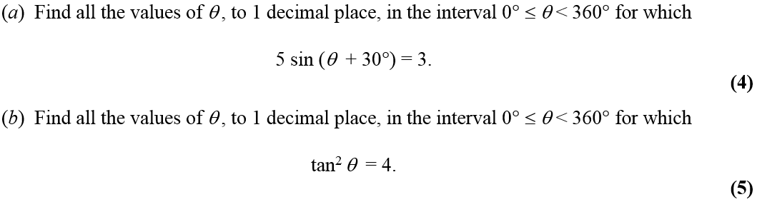
1)

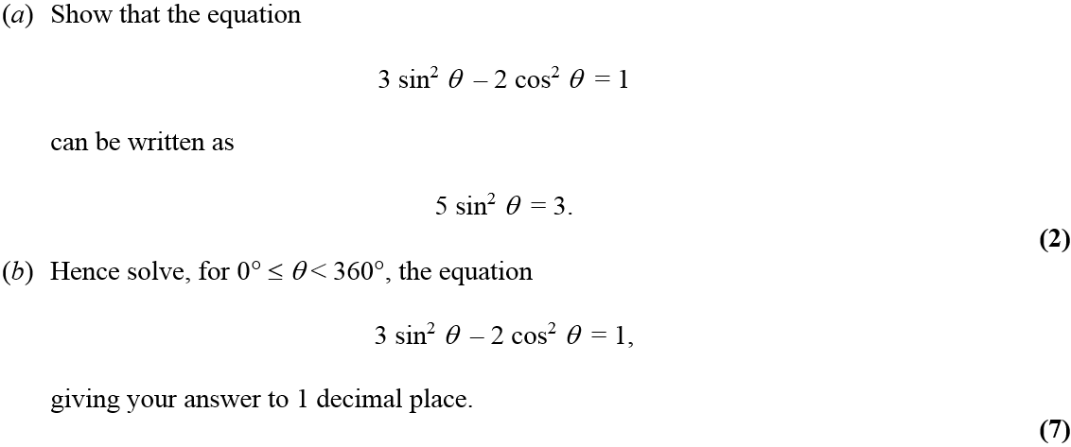
2)

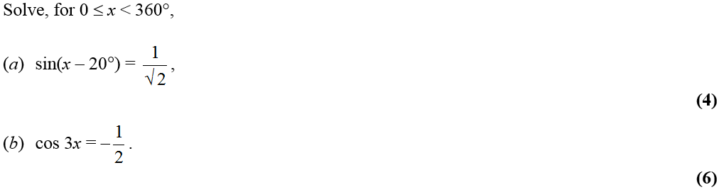
3)

Vectors
Practicing the Technique
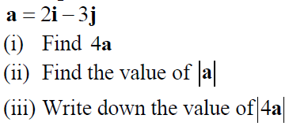
1)

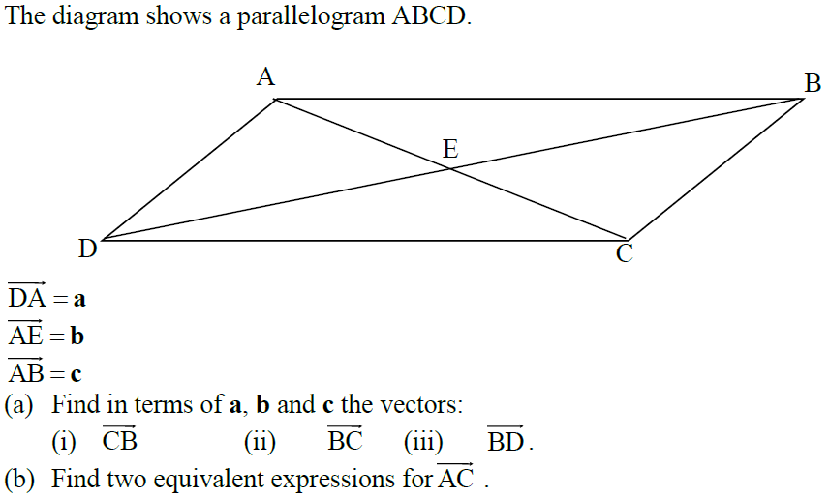
2)

Exam Questions
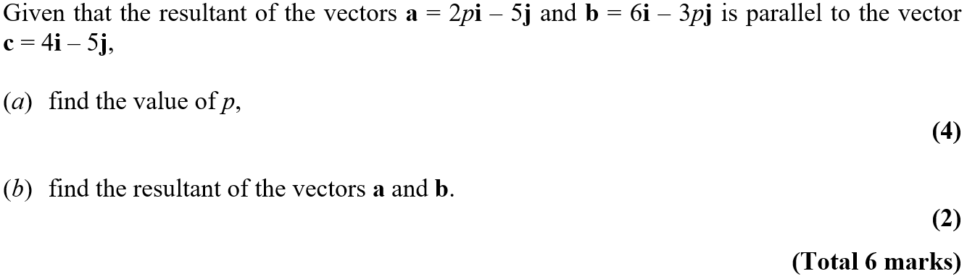
1)

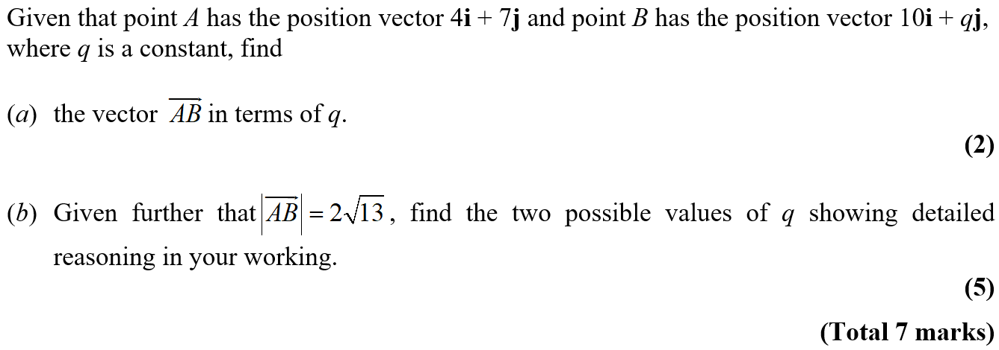
2)

Differentiation
Practicing the Technique
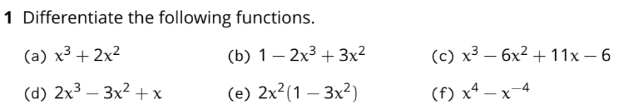

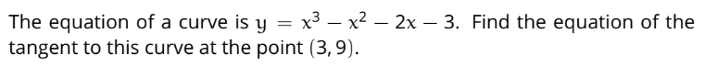
2)

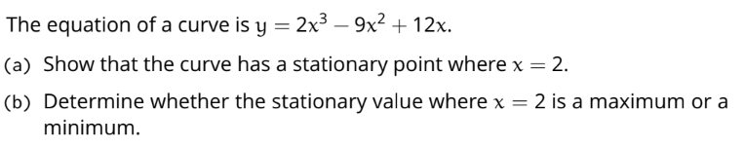
3)

Exam Questions
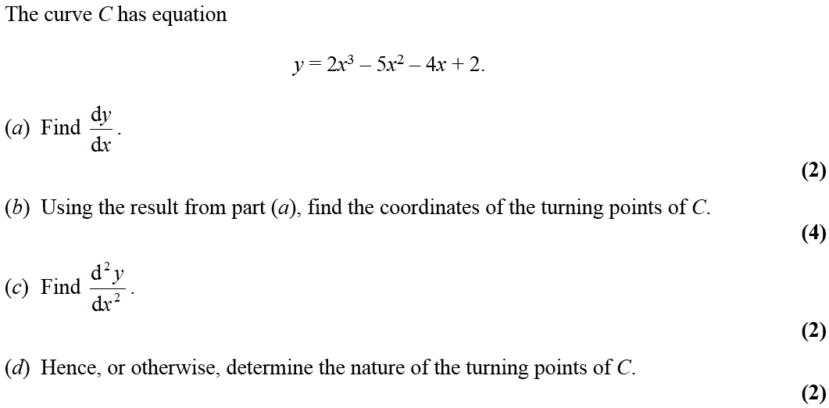
1)

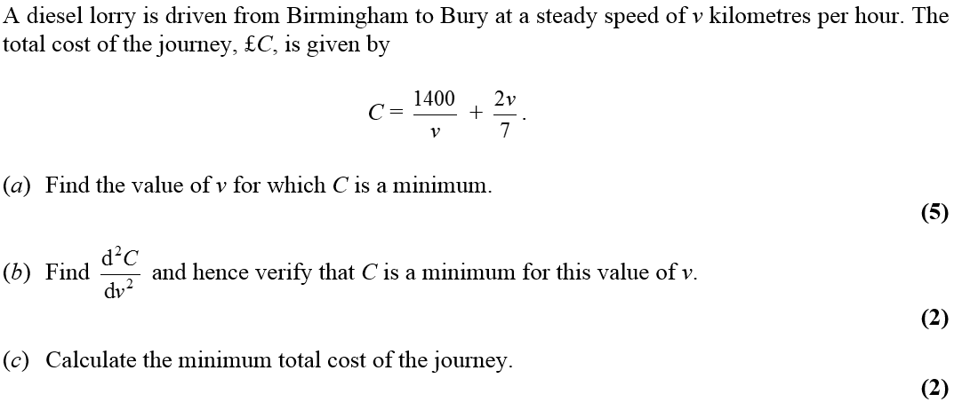
2)

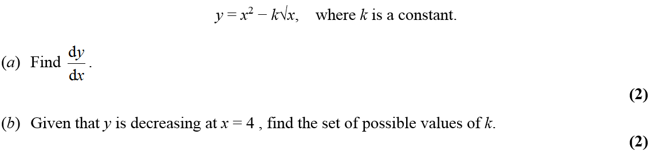
3)

4)

Integration
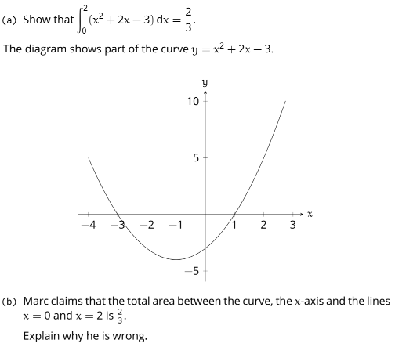
Practicing the Technique

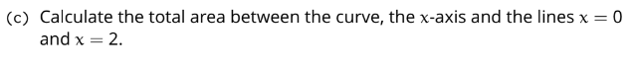

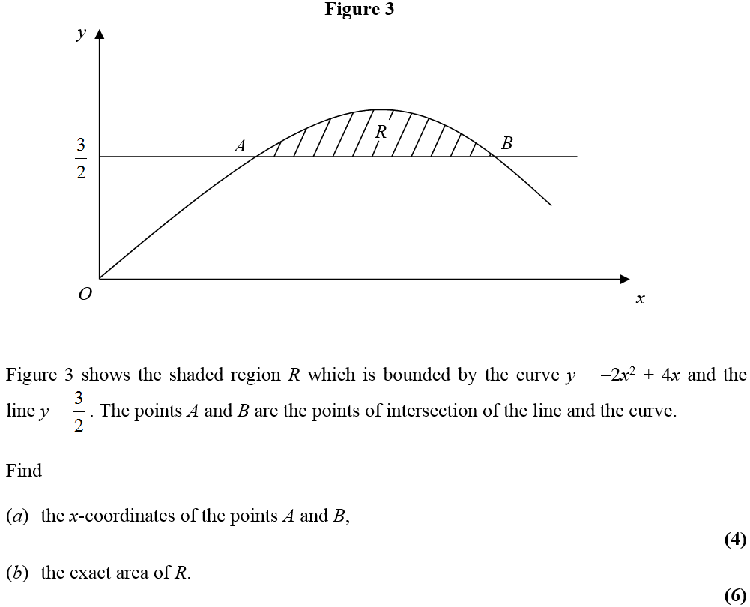
Exam Questions
1)

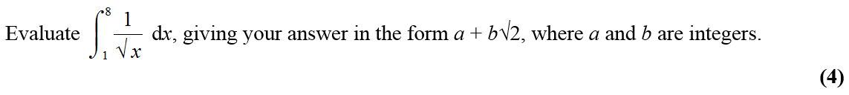
2)

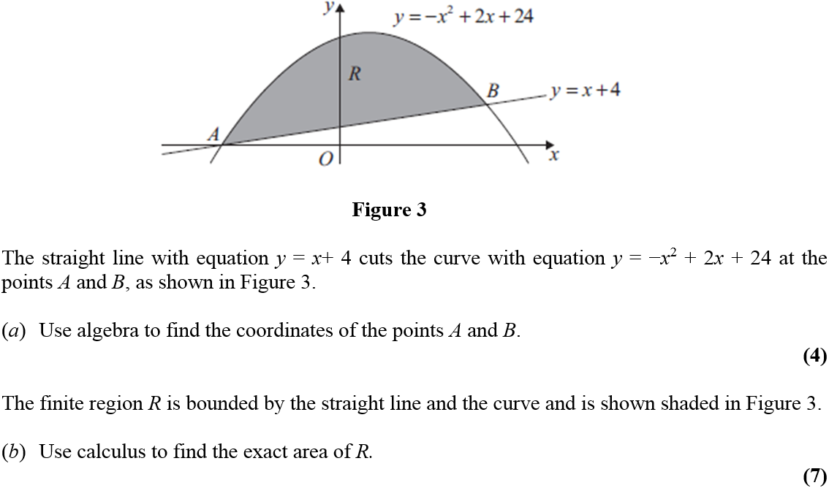
3)

Exponentials and Logarithms
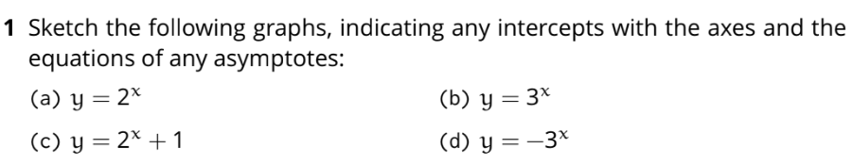
Practicing the Technique

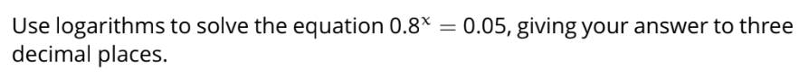
2)

Exam Questions
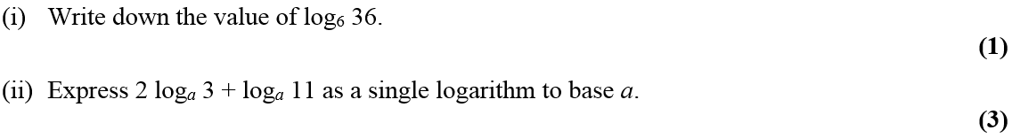
1)

2)

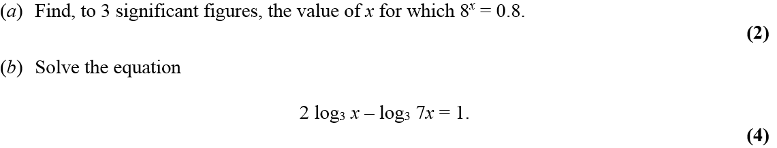
3)

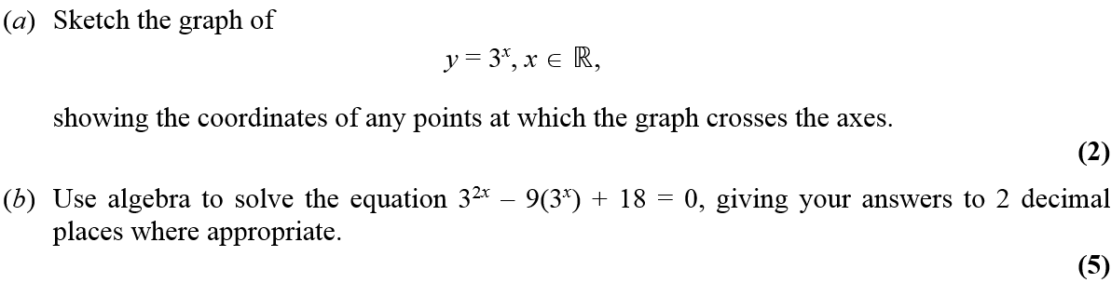
4)

