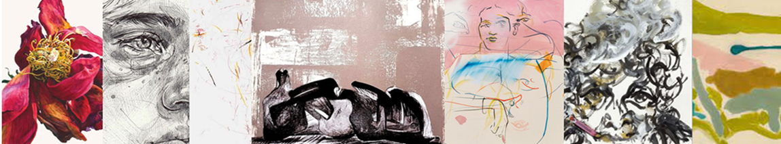

A Level Fine Art Year 11 into 12 Prep Task

Activities to be completed | Additional resources/support
Task 1: Take a series of ‘exceptional’ photographs (at least 10) based on your interpretation of the theme ‘Viewpoints’  You will discuss possible ideas, genres, concepts and starting points in your transition lesson to help inspire the focus of your photography.  Consider the impact of:  - Lighting: high contrast to enhance tonal variation? Enhanced shadows? Tone to create atmosphere/mood?  - Colour or greyscale.  - Composition: Cropped/zoomed, rule of thirds, rule of odds, leading lines etc.  - Repetition of an image with changes/no changes.  - What is in the background: does it distract or enhance the image?  Please e-mail these into kandrew@dma.tela.org.uk.  Task 2: Complete two sustained studies from your strongest photographs. One in pencil, the other can be a media/technique of your own choice.  Task 3: Complete a typed written statement of interest to support your photographs and drawings. Give us an understanding of why you are interested in the theme chosen. | Inspirational student work:  https://www.studentartguide.com/  Edexcel online A Level examples to inspire starting points:  Exemplar material

