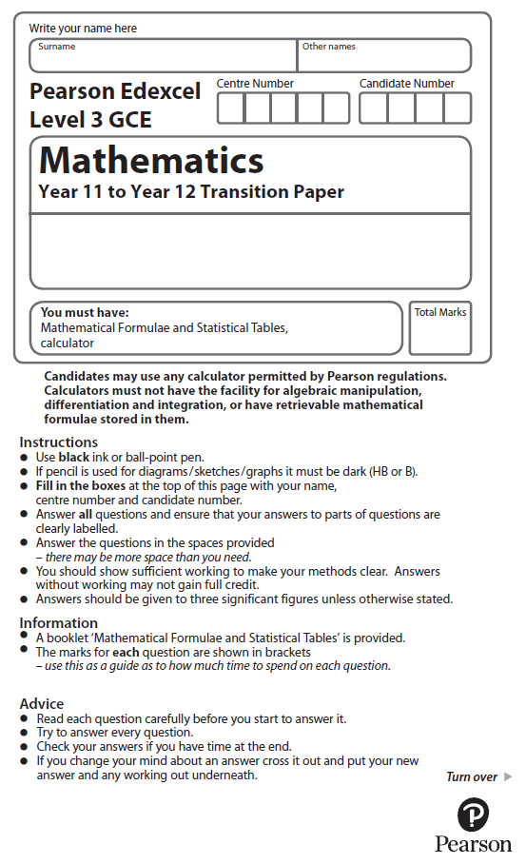
Circles


You may use a calculator to answer these questions.

1. The equation of circle C is x² + y² = 16
The circle C is translated by the vector to give circle B.
Draw a sketch of circle B.
Label with coordinates the centre of circle B and any points of intersection with the
x-axis.

(Total for Question 1 is 3 marks)

2.

Figure 1

The circle C has centre P(7, 8) and passes through the point Q(10, 13), as shown in Figure 1.
(a) Find the length PQ, giving your answer as an exact value.
(2)
(b) Hence write down an equation for C.
(2)
The line l is a tangent to C at the point Q, as shown in Figure 2.
(c) Find an equation for l, giving your answer in the form ax + by + c = 0, where a, b and are integers.
(4)
(Total for Question 2 is 8 marks)
3. The circle C has equation
x² + y² − 2x + 14y = 0

Find
(a) the coordinates of the centre of C,
(2)
(b) the exact value of the radius of C,
(2)
(c) the y coordinates of the points where the circle C crosses the y-axis.
(2)
(d) Find an equation of the tangent to C at the point (2, 0), giving your answer in the form ax + by + c = 0, where a, b and c are integers.
(4)
(Total for Question 3 is 10 marks)
4. The circle C has equation
x² + y² – 10x + 6y + 30 = 0
Find
(a) the coordinates of the centre of C,
(2)
(b) the radius of C,
(2)
(c) the y coordinates of the points where the circle C crosses the line with equation x = 4,
giving your answers as simplified surds.
(3)
(Total for Question 4 is 7 marks)

5. A circle C has centre (−1, 7) and passes through the point (0, 0).
Find an equation for C.

(Total for Question 5 is 4 marks)

6. A circle C with centre at the point (2, –1) passes through the point A at (4, –5).

(a) Find an equation for the circle C.
(3)

(b) Find an equation of the tangent to the circle C at the point A, giving your answer in the form ax + by + c = 0, where a, b and c are integers.
(4)
(Total for Question 6 is 7 marks)

7. The circle C has equation
x² + y² − 20x − 24y + 195 = 0.

The centre of C is at the point M.

(a) Find
(i) the coordinates of the point M,
(ii) the radius of the circle C.
(5)
N is the point with coordinates (25, 32).
(b) Find the length of the line MN.
(2)

The tangent to C at a point P on the circle passes through point N.

(c) Find the length of the line NP.
(2)
(Total for Question 7 is 9 marks)

8. The points A and B have coordinates (–2, 11) and (8, 1) respectively.

Given that AB is a diameter of the circle C,

(a) show that the centre of C has coordinates (3, 6),
(1)
(i) find an equation for C.
(4)
(c) Verify that the point (10, 7) lies on C.
(1)
(d) Find an equation of the tangent to C at the point (10, 7), giving your answer in the form y = mx + c, where m and c are constants.
(4)
(Total for Question 7 is 10 marks)
9.

Figure 2

The circle C with centre T and radius r has equation

x² + y² – 20x – 16y + 139 = 0.
(a) Find the coordinates of the centre of C.
(3)
(b) Show that r = 5
(2)
The line L has equation x = 13 and crosses C at the points P and Q as shown in Figure 1.
(c) Find the y coordinate of P and the y coordinate of Q.
(3)
(Total for Question 9 is 8 marks)

10. A circle C has equation
x² + y² – 4x + 8y – 8 = 0
(a) Find
(i) the coordinates of the centre of C,
(ii) the exact radius of C.
(3)
The straight line with equation x = k, where k is a constant, is a tangent to C.
(b) Find the possible values for k.
(2)
(Total for Question 10 is 5 marks)

11. The circle C has equation
x² + y² + 4x − 2y −11 = 0.
Find
(a) the coordinates of the centre of C,
(2)
(b) the radius of C,
(2)
(c) the coordinates of the points where C crosses the y-axis, giving your answers as simplified surds.
(4)

(Total for Question 11 is 8 marks)

12.
Figure 3

Figure 3 shows a circle C with centre Q and radius 4 and the point T which lies on C. The tangent to C at the point T passes through the origin O and OT = 6√5.
Given that the coordinates of Q are (11, k), where k is a positive constant,
(a) find the exact value of k,
(3)
(b) find an equation for C.
(2)

(Total for Question 12 is 5 marks)

13.
Figure 4

The circle C has radius 5 and touches the y-axis at the point (0, 9), as shown in Figure 4.
(a) Write down an equation for the circle C, that is shown in Figure 4.
(3)
A line through the point P(8, –7) is a tangent to the circle C at the point T.
(b) Find the length of PT.
(3)
(Total for Question 13 is 6 marks)

14. A circle C with centre at (−2, 6) passes through the point (10, 11).
(a) Show that the circle C also passes through the point (10, 1).
(3)
The tangent to the circle C at the point (10, 11) meets the y-axis at the point P
and the tangent to the circle C at the point (10, 1) meets the y-axis at the point Q.
(b) Show that the distance PQ is 58, explaining your method clearly.
(7)
(Total for Question 14 is 10 marks)

15. A circle C has centre (2, 5). Given that the point P(–2, 3) lies on C.
(a) find an equation for C.
(3)
The line l is the tangent to C at the point P. The point Q(2, k) lies on l.
(b) Find the value of k.
(5)
(Total for Question 15 is 8 marks)

16. The circle C has equation
x² + y² − 6x + 10y + 9 = 0.
(a) Find
(i) the coordinates of the centre of C,
(ii) the radius of C.
(3)
The line with equation y = kx, where k is a constant, cuts C at two distinct points.
(b) Find the range of values for k.
(6)
(Total for Question 16 is 9 marks)

