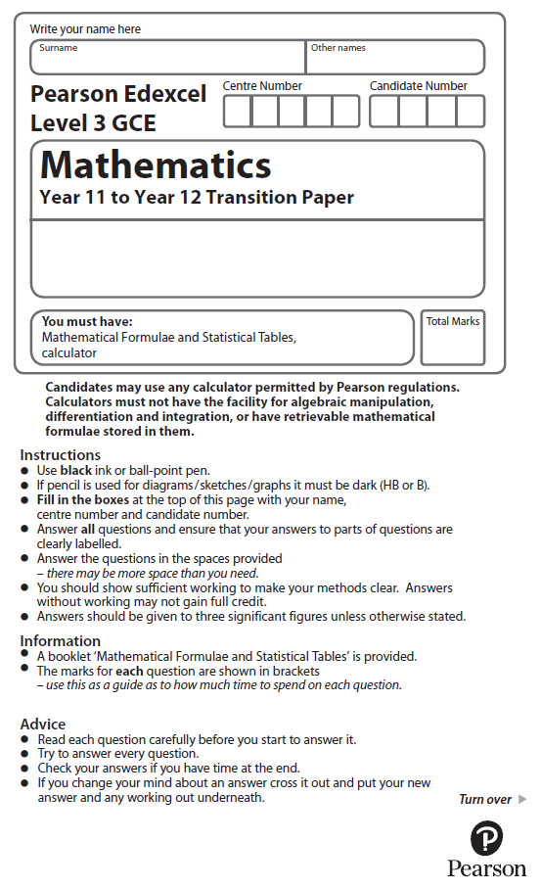
Straight Line Graphs

Calculators may NOT be used to answer these questions unless a symbol is shown next to the question.

1. The line L is given by the equation 3y – 2x = 24.

(a) Write the equation for L in the form y = mx + c.

(2)

(b) Find an equation of the line parallel to line L and which passes through the point (3, 3).
(2)

(Total for Question 1 is 4 marks)
___________________________________________________________________________

2. The line l₁ has equation 4y – 3x = 10
The line l₂ passes through the points (5, –1) and (–1, 8).

Determine, giving full reasons for your answer, whether lines l₁ and l₂ are parallel, perpendicular or neither.
(4)

(Total for Question 2 is 4 marks)
___________________________________________________________________________

3. The line l passes through the points A (3, 1) and B (4, – 2).
Find an equation for l.

(Total for Question 3 is 3 marks)
___________________________________________________________________________
4. The line l₁ has equation 2x + 4y – 3 = 0
The line l₂ has equation y = mx + 7, where m is a constant.

Given that l₁ and l₂ are perpendicular,

(a) find the value of m.
(2)
The lines l₁ and l₂ meet at the point P.

(b) Find the x coordinate of P.
(2)
(Total for Question 4 is 4 marks)
___________________________________________________________________________
5. The diagram shows a straight line L₁.

The line L₂ is parallel to L₁ and passes through the point (2, 1).

(a) Find an equation of the line L₂.
Give your answer in the form of y + mx + c.
(3)
The line L₃ is perpendicular to L₁ and passes through the point (0, –5).

(b) Find an equation of the line L₃.
Give your answer in the form ax + by + = c = 0 where a, b and c are integers.

(3)
(Total for Question 5 is 6 marks)
___________________________________________________________________________
6.
Figure 2 shows the straight line l₁ with equation 4y = 5x + 12

(a) State the gradient of l₁
(1)

The line l₂ is parallel to l₁ and passes through the point E (12, 5), as shown in Figure 2.

(b) Find the equation of l₂. Write your answer in the form y = m x + c, where m and c are constants to be determined.
(3)

The line l₂ cuts the x-axis at the point C and the y-axis at the point B.
(c) Find the coordinates of
(i) the point B,
(ii) the point C.
(2)
The line l₁ cuts the y-axis at the point A.
The point D lies on l₁ such that ABCD is a parallelogram, as shown in Figure 2.

(d) Find the area of ABCD.
(2)
(Total for Question 6 is 8 marks)
___________________________________________________________________________
7. The line l passes through the points A(5,8) and B(3, 11).

(a) Find an equation for l in the form ax + by + c = 0, where a, b and c are integers.
(4)

(b) Find the length AB leaving your answer in surd form.
(2)

The point C has coordinates (t, 8) and AC = CB.

(c) Find the value of t.
(3)

(d) Find the area of triangle ABC.
(2)
(Total for question 7 is 11 marks)
___________________________________________________________________________

8. The straight line L₁ passes through the points P and Q with coordinates (2, 5) and (6, −2)
respectively.

(a) Find an equation for L₁ in the form ax + by = c where a, b and c are integers.

(3)

The straight line L₂ is perpendicular to L₁ and passes through the point (7, 5).

(b) Find an equation for L₂ in the form y = mx + c
(3)

The straight lines L₃ and L₄ have equations y = 3x and x = 3y respectively.

(c) Are the lines L₃ and L₄ perpendicular to each other?
Give a reason for your answer.
(1)
(Total for Question 8 is 7 marks)
___________________________________________________________________________

9. The straight line L₁ has gradient and passes through the point with coordinates (2, −1)

(a) Find an equation for L₁ in the form px + qy + r = 0 where p, q and r are integers.
(3)

The straight line L₂ is parallel to L₁ and passes through the point with coordinates (3, 4)

(b) Find an equation for L₂ in the form y = mx + c
(3)

(c) Show, by considering gradients, that the line with equation 3x + 2y = 4 is perpendicular to the line with equation 2x − 3y = 6
(2)

(Total for question 9 is 8 marks)
___________________________________________________________________________

10. The straight line L is drawn on the grid.

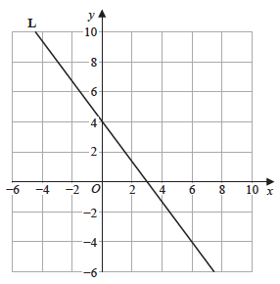

(a) Find an equation for L
Give your answer in the form ax + by + c = 0 where a, b and c are integers.

(3)

The straight line L₁ is parallel to L

(b) Find the gradient of L₁
(1)
(Total for Question 10 is 4 marks)
___________________________________________________________________________
11. The straight line L₁ has equation y = x – 1
(a) Write the equation of L₁ in the form ax + by = c where a, b and c are integers.
(1)

The straight line L₂ is parallel to L₁ and passes through the point with coordinates (–2, –6)

(b) Find an equation for L₂ in the form y = mx + c
(3)
(Total for Question 11 is 4 marks)
___________________________________________________________________________

12. The straight line L₁ passes through the points P and Q with coordinates (1, 5) and (3, 2) respectively.

The line L₂ is perpendicular to the line L₁ and passes through the point P.

Find the equation of the line L₂
Give your answer in the form y = mx + c
(Total for Question 12 is 4 marks)
___________________________________________________________________________

13. The straight line M has equation y = −x + 3
The point A has coordinates (3, 4)

(a) Find an equation of the straight line which passes through A and is parallel to M.
Give your answer in the form y = mx + c
(3)

(b) Find an equation of the straight line which passes through A and is perpendicular to M.
(2)
(Total for Question 13 is 5 marks)
___________________________________________________________________________

