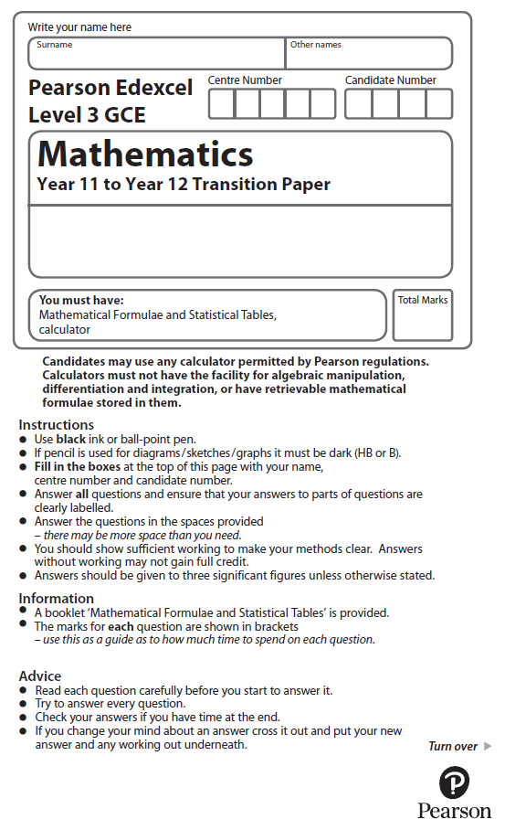
Equations and Inequalities


Calculators may NOT be used to answer these questions unless a symbol is shown next to the question.

1. On the grid, shade the region that satisfies all these inequalities.

x > 0 | y > 0 | y > 3x – 6 | 2x + y < 12
Label the region R.

(Total for Question 1 is 4 marks)

2. Solve 6(2 – 3x) < 5(x + 1)
(Total for Question 2 is 3 marks)

3. (a) Solve x² ≥ 4x + 5

(3)
(b) For what range of values of b has the equation 25x² + bx + 16 = 0 no real roots?

(2)
(Total for Question 3 is 5 marks)

4. (a) On the grid, shade the region that satisfies all these inequalities.
x < 3 y – x < 5 7x + 5y > 35
Label the region R

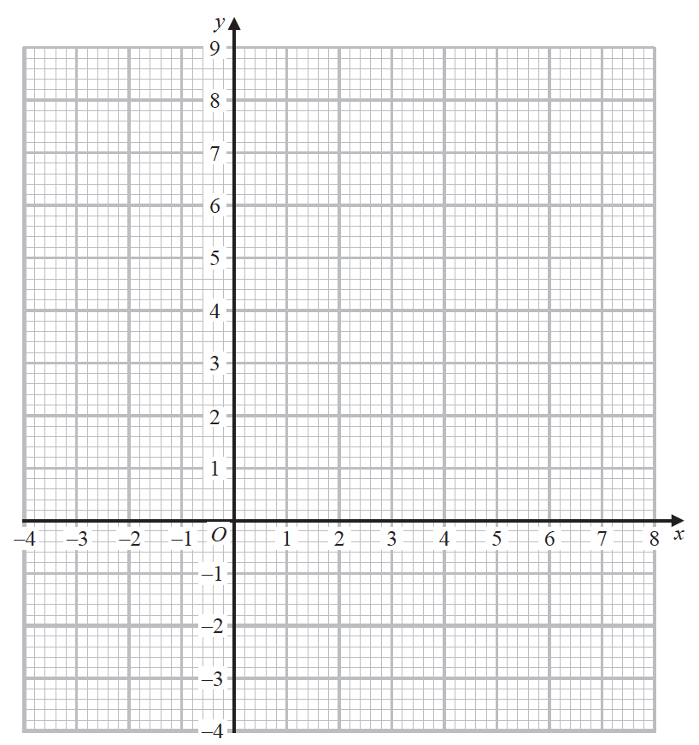
(5)
(b) Write down the coordinates of each of the points, with integer coordinates, that satisfy
x < 3 y – x < 5 7x + 5y > 35
(1)
(Total for Question 4 is 6 marks)

5. On the grid, shade the region that satisfies all these inequalities.
4x + 3y < 24 x > −2 3y > 9 − x
Label the region R.

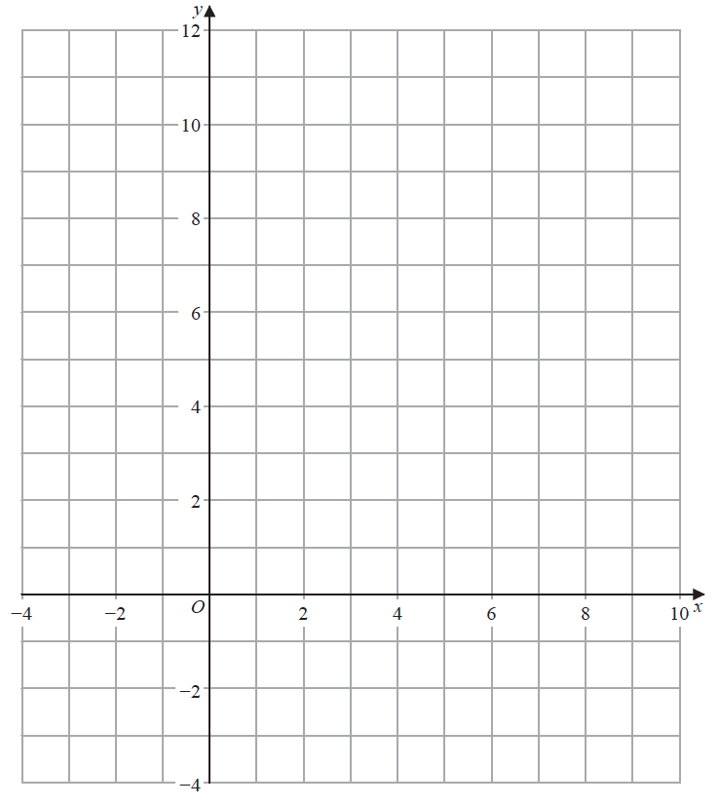

(Total for Question 5 is 5 marks)

6. Solve, algebraically, the simultaneous equations
2x² + 2y = 7
2y + 2x = 3

(Total for Question 6 is 5 marks)

7. On the grid, shade the region that satisfies all these inequalities.

x > −1 | 2x + y < 6 | y < 4 − x
Label the region R.

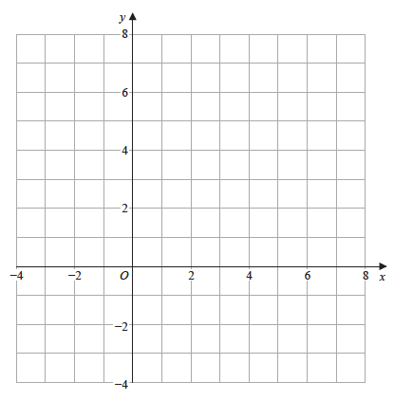

(Total for Question 7 is 5 marks)

8. Solve, algebraically, the simultaneous equations
2x + y = 7
4x² + 3y² = 43

(Total for Question 8 is 5 marks)

9. Solve the simultaneous equations

y – 2x – 4 = 0
4x² + y² + 20x = 0
(Total for Question 9 is 7 marks)

10. Solve the simultaneous equations

y + 4x + 1 = 0
y² + 5x² + 2x = 0
(Total for Question 10 is 6 marks)

11. Find the set of values of x for which

(a) 2(3x + 4) > 1 – x,
(2)
(b) 3x² + 8x – 3 < 0.
(4)
(Total for Question 11 is 6 marks)

12. Find the set of values of x for which
(a) 4x − 5 > 15 − x,
(2)
(b) x(x − 4) > 12.
(4)
(Total for Question 12 is 6 marks)
13. Solve the simultaneous equations
x + y = 2
4y² – x² = 11
(Total for Question 13 is 7 marks)

14. The curve C has equation y = x(5 − x) and the line L has equation 2y = 5x + 4.
(a) Use algebra to show that C and L do not intersect.
(4)
(b) Sketch C and L on the same diagram, showing the coordinates of the points at which C and L meet the axes.
(4)
(Total for Question 14 is 8 marks)

15. (i) Show that x² − 8x + 17 > 0 for all real values of x.
(3)

(ii) “If I add 3 to a number and square the sum, the result is greater than the square of the original number.”

State, giving a reason, if the above statement is always true, sometimes true or never true.
(2)
(Total for Question 15 is 5 marks)

