
Subject Sociology

Homework for year 11 going into year 12

Key Info
This work is designed to introduce you to A Level Sociology. You will research some key sociological terminology and concepts. There is also an extension task if you would like to develop your knowledge further
To be completed for the week beginning: Monday 8th September | Expected completion time: 200-300 minutes
Activities to be completed | Location of resources- | Additional resources/support
TASK 1 WRITE A GLOSSARY WITH MEANINGS FOR THE 15 KEY WORDS BELOW.  - Social norm 2. Consensus 3. Conflict 4. Capitalism 5. Marxism 6. Communism 7. Feminism 8. patriarchy 9. Ideology 10. Determinism 11. Ideological state apparatus 13. Marketisation 14. Privatisation 15. Survey  TASK 2 – RESEARCH BRITISH SOCIETY USING THE OFFICE FOR NATIONAL STATISTICS  The Office for National Statistics is the UK's largest independent producer of official statistics. Using the link below to the Office for National Statistics website–find out the following  Home - Office for National Statistics (ons.gov.uk)  1. What is the census? 2. How is information gained by the census used? 3. Find some headline statistics, look at least 2 areas: employment, crime, housing, tourism, education, population size, life expectancy, births, marriages.  TASK 3 – RESEARCH MARXISM AND FEMINISM  You will study Marxism and feminism in year 12 & 13. These theories make up a big part of the course. It would be helpful if you could do some research to gain a basic understanding of their key ideas. Use the following websites to do some research. You could complete a mind map or poster on each.  https://www.thesociologyteacher.com/theory-methods-sociology-revision  What is Marxism? Introduction to A-Level Sociology | Sociology | tutor2u  Sociological Theory: Marxism | Sociology | tutor2u  https://revisesociology.com/2017/02/03/feminist-theory-summary-sociology/  Marxism | Sociology | tutor2u  https://www.tutor2u.net/sociology/topics/feminism  What is Feminism? Introduction to A-Level Sociology | Sociology | tutor2u | WEBSITES listed  Use the Internet, for the key words research task.  Or you could use the sociology textbooks to find the key words (speak to Helen about where to find the Sociology textbooks in the 6th form centre) | Email Mrs McMahon  smcmahon@dma.tela.org.uk  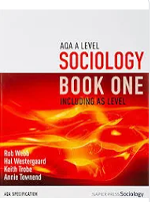  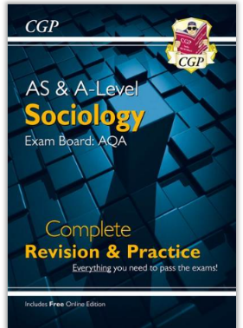
EXTENSION TASK – if you’d like to challenge yourself and develop your sociological knowledge further have a go at the task below

UNDERSTANDING HOW TO EVALUATE
A lot of marks in your A Level exam is allocated to evaluation. Evaluation involves picking apart key ideas and theories, finding strengths and weaknesses and highlighting how a theory is relevant or out of date. It might involve use of examples and evidence to criticise a theory or idea.

In order to prepare you for evaluating Marxism and Feminism you could research the following things:

1. Zero hr contracts – what are they and why have they been criticised?
2. White collar crime or corporate crime – what is it and can you find an example
3. What % of MPs and or Prime Ministers attended private schools? Why is this significant?
4. How much do private schools’ cost? Why is this significant?
5. research the Grenfell fire – who was to blame?
6. What is the gender pay gap?
7. How many female MPs are there?
8. Which industries are criticised for employing less women than men?
9. find a company that has been linked to pollution
10. find a company that has been linked to deforestation

Work to be submitted:
Glossary
mind maps or posters on Marxism and Feminism

