
Physical Education – A-Level PE
Year 12 Preparation Task

Key Info
Studying A-Level PE your lessons will be divided between three teachers based on the three individual papers covering a wide range of sporting aspects and developments:
Paper 1 - Physiological factors affecting performance
Paper 2 - Psychological factors affecting performance
Paper 3 - Socio-cultural issues in physical activity and sport
As such, your there are three separate preparation tasks to complete below, to best prepare you for each individual lesson accordingly.

Week beginning: July/Aug 2023 | Expected completion time:  2-3 hours
Activities to be completed | Location of resources | Additional resources/support
PAPER 1 TASK  Topic Area Content: Biomechanical principles  - Define and apply Newton’s laws of motion:  - Newton’s first law: inertia  - Newton’s second law: acceleration  - Newton’s third law: reaction  Begin to understand how Newtons Laws can affect sporting action ie/ how we kick a ball, hit a ball, start a sprint race etc.  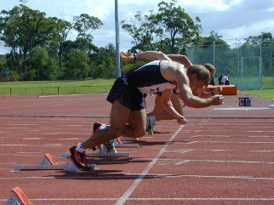  PAPER 2 TASK  Topic Area Content: Skill Acquisition – Classification of Skill  - Research the 6 skill classifications needed for OCR A Level PE and identify the name for each end of the continuum.  - Define the 12 ends of the continuums.  - Draw the 6 continua’s and provide two practical skills which demonstrate each end of the continuums.  - Justify your placing on the continua’s.  PAPER 3 TASK  Topic Area Content: Sport in Pre-Industrial Britain  - Research what and when is Preindustrial Britain.  - Research who were the upper class and who were the lower class in Preindustrial Britain?  - Identify and describe 3 sports which were played by the lower class and 3 sports which were played by the upper class in Preindustrial Britain.  - Describe ways that the availability of time affected participation in pre-industrial sport.  - Describe ways in which levels of education and literacy affected participation in sport in pre-industrial Britain.  - Describe the ways gender affected participation in sport in pre-industrial Britain | Everlearner  External candidates won’t have email to add to Everlearner.  BBC Bitesize (OCR A-Level PE)  OCR A Level PE PowerPoints which is on the OCR website  BrianMac.com
Work to be submitted:

For all of the above tasks bring your notes, activities and answers to your first lesson where your teachers will commence the unit around these topics and embed your work completed.

