

Religion, Philosophy and Ethics (OCR) transition work, Summer 2025
We are really looking forward to welcoming you to the study of Religion, Philosophy and Ethics at Chesterton Sixth Form.
Why this work?
Before starting the course, it is really useful to have some background knowledge about what Philosophy and Ethics is so the first preparation for sixth form study will focus on this to help you understand how the approaches and ways of thinking in this subject are very different to what you might be used to. You might find that people are using vocabulary that you have never heard and ideas that you’ve never come across. Do not worry - remember we will go through all of this when we teach you! We just want you to begin to develop some knowledge and understanding in these areas.

Where should I complete it?
Please complete any notes either on paper or on your computer and save them to bring into school at a later date.

How long will it take?
The work has been divided up to ensure it is manageable. It should take about 8 hours in total.

If any of the work brings up questions, do make a note of these, ready to ask in our first lesson.

Task one: What is Philosophy?
- Go to the two links below and summarise the main ideas of each video using subheadings:

- What is Philosophy (Crash Course)
https://www.youtube.com/watch?v=1A_CAkYt3GY

- Ancient Greek times and the beginning of Philosophy
- What is the world like and Metaphysics
- How we know the answers to questions and Epistemology
- How we should act and Value Theory (Ethics)
- Logic – and reasoning
- The two-step system

- Theory of Knowledge (Epistemology)
https://www.youtube.com/watch?v=r_Y3utIeTPg

- What kinds of things can you know?
- Comparison of the words ‘knowledge’ and ‘believe’.
- Confidence as a key feature of knowledge.
- Judgement needs a good basis to count as knowledge.

Task two: What is Ethics?
- Go to the link below:
- What is Ethics?
https://www.youtube.com/watch?v=Rr7U49RPpTs&t=302s

- Write a list of 10 interesting things you have learnt about ethics. Include new vocabulary.

Task three: What is Ethics?

‘What is Ethics’
- Read the information (word document - File 1) from start to finish.
- Summarise each sub-heading in a maximum of 30 words.

Sub-heading | 30 word summary
Moral absolutism
Moral relativism
Consequentialism
Non-consequentialism
Virtue ethics
Situation ethics
Ethics and ideology

Task four: Real World Ethics
- Listen to the podcast: Real World Ethics (File 2) which deals with questions about different methods of practical ethics and working out how to behave. As you listen, write a list of possible answers to the questions below.

- What are thought experiments? (Give an example). What is Wilson’s view on the use of thought experiments?
- What is meant by real world ethics?
- How are real world problems different from thought experiments?
- Why does context matter when thinking about ethical issues (according to Wilson)?
- Aside from thought experiments, what other techniques or tools could be used to help make ethical decisions?
- What does Wilson think about the use of principles in ethics? (strengths/weaknesses)

Task five: Making a Case
Philosophy and Ethics at A level will require you to make judgements about issues.
Create a for and against case for one of the following issues:

Being a philosopher

God does not exist.
Or
There is an afterlife.

Being an ethicist
Active euthanasia should be legal.
Or
The role of a business is just to make a profit.

Out and about in Cambridge?…
Ludwig Wittgenstein was an Austrian-British philosopher who worked primarily in logic and the philosophy of mind. He is considered by some to be the greatest philosopher of the 20th century. From 1929 to 1947 Wittgenstein taught at the University of Cambridge.
On his religious views, Wittgenstein was said to be greatly interested in Catholicism, and was sympathetic to it, but did not consider himself to be a Catholic. According to Norman Malcolm, Wittgenstein saw Catholicism more as a way of life than as a set of beliefs he held, considering that he did not accept any religious faith. Three of his four grandparents were of Jewish descent, and this fact was known to others.
Wittgenstein was given a Catholic burial at Ascension Parish Burial Ground off Huntingdon Road in Cambridge.
Your mission is to visit the burial ground and find Wittgenstein’s grave. The ledger gravestone was refurbished by the British Wittgenstein Society in 2015.
While you are at the graveside please consider this question:
Should Ludwig Wittgenstein have been given a Catholic burial?
Extra: You might also want to try and find a plaque in central Cambridge to where the Philosophy society used to meet (including Wittgenstein) and have some heated debates!

Additional resources
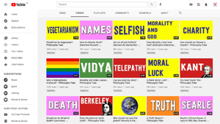
Philosophy Tube
There are hundreds of episodes, but if you scroll back to the beginning, their introductory episodes cover many A Level topics and texts. Or, you can extend yourself by exploring other areas of Philosophy.

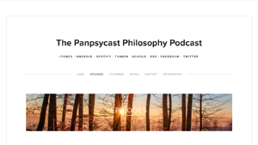
PanPsyCast
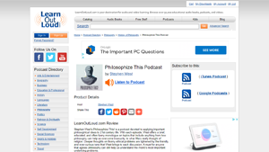
Listen: Philosophize This
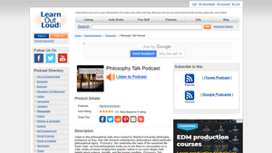
Listen: Philosophy Talk
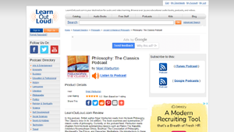
Listen: Philosophy: The Classics
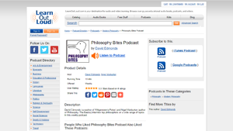
Listen: Philosophy Bites
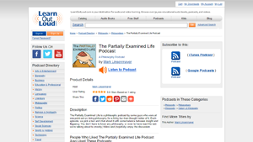
Listen: The Partially Examined Life

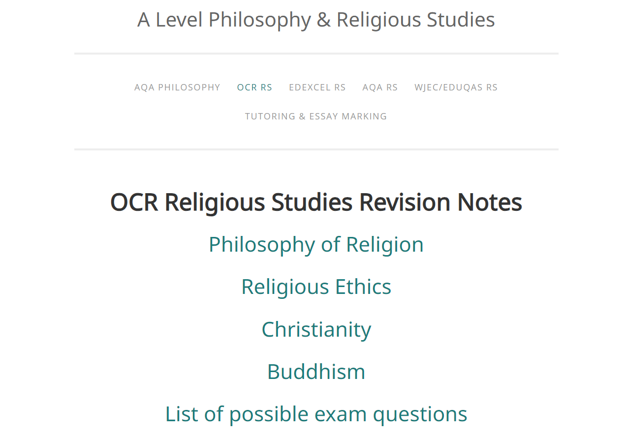
Read: alevelphilosophyandreligion.com

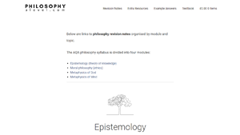
Read: philosophyalevel.com

