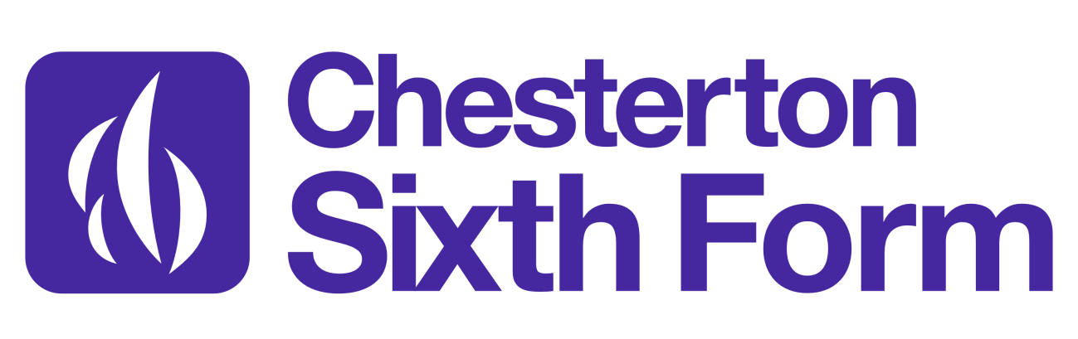
A Level Film Studies Transition Booklet
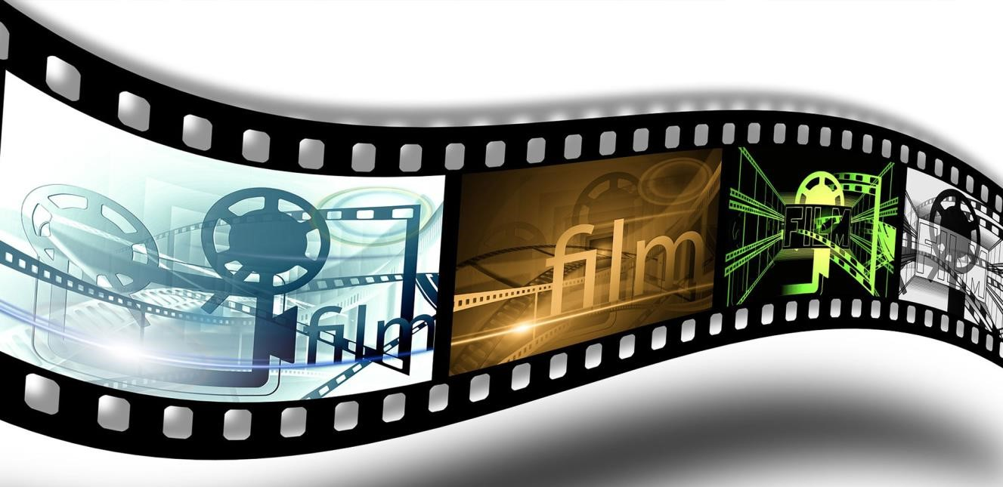

This pack contains information about A Level Film Studies and a programme of activities and
resources to prepare you to start an A Level in Film Studies in September. Please use this during the summer term and the summer holidays to prepare for your A Level course.

Please note the compulsory summer work which starts on page 3

About the course: The specification we teach is produced by Eduqas. The unit code is A670QS A (A level) and a full copy of this specification and other useful information is available at:
https://www.eduqas.co.uk/qualifications/film-studies-as-a-level/#tab_overview
The course consists of the study of eleven films over three components:
Component 1: Varieties of Film Making
Component 2: Global Filmmaking Perspectives
Component 3: Non-examination assessment

Films you can expect to study:
- Vertigo (Hitchcock, 1958) & Alien (Scott, 1979), 15
- Joker (Phillips, 2019), 15 & Captain Fantastic (Ross, 2015), 15.
- Shaun of the Dead (Wright, 2004), 15 & We Need to Talk about Kevin (Ramsay, 2011), 15
- Pan’s Labyrinth (Del Toro, 2006) & City of God (Mereilles, Brazil, 2002), 18
- Amy (Kapadia, UK, 2015), 15
- Sunrise (Murnau, US, 1927), U
- Memento (Nolan, US, 2000), 15

Learners will study all of their chosen films in relation to the following core study areas.

Area 1. The key elements of film form: cinematography, mise-en-scène, editing, sound and performance
Area 2. Meaning and response: how film functions as both a medium of representation and as an aesthetic medium
Area 3. The contexts of film: social, cultural, political, historical and institutional, including production. Examination:

You will have three components of assessment as outlined below.

- Varieties of Film Making, written examination, 2 hours 15 minutes, 35% of qualification
- Global Filmmaking Perspectives, written examination, 2 hours 15 minutes, 35% of qualification
- Non-examination unit, either the production of a short film or screenplay, with an evaluative analysis, 30% of qualification.

Compulsory Summer Work

Task 1: Film Aesthetics Terminology

Research and define these key terms for the study of film aesthetics. Create your own glossary of definitions document (hand written OR electronic is fine).

Denotation

Connotation

Cinematography
Mise en scene
 | Within each category, define the key terms
Camera Shots | Camera Movement | Lighting | Sound | Editing
Extreme close-up | Aerial | High key | Diegetic | Cut
Mid Shot | Pan | Low key | Non diegetic | Continuity  Editing
Close-up | Crane | Three point | Sound FX | Cross cutting
Long shot | Tilt | Natural | Contrapuntal | Cut away
Extreme long shot | Tracking | Filters | Foley sound | Dissolve
High angle | Dolly |  | Parallel | Eyeline match
Low angle | Steadicam |  |  | Fade
Dutch/canted angles | Zoom |  |  | Iris
POV shots |  |  |  | Montage
Establishing shot |  |  |  | Shot reverse shot

Task 2: Practice Scene Analysis

At the start of the Film Studies course, you will need to learn the basic skills of scene analysis using the key terminology of film aesthetics you have researched in task 1. For this activity, we would like you to watch the opening scene from Skyfall (0.00 – 2.15) several times and using the template below, develop an initial analysis of the scene.

Remember, where possible, use the terminology you have learned in task 1.

Skyfall clip: https://www.youtube.com/watch?v=8dcTNWOoZlg

Aesthetic Element | Denotations: | Connotations: | Meanings and  Representations:
Cinematography | Which camera shots and movements have been used? | Why do you think these camera shots and movements have been used? | What could be the wider meaning of these choices?
Mise en scene | What props, costumes, locations, colours have been used? | Why do you think these props, costumes, locations, colours have been used? | What could be the wider meaning of these choices?
Sound | What sound effects, music, dialogue have been used? | Why have these sound effects, music, dialogue been used? | What could be the wider meaning of these choices?
Editing | Which editing techniques have been used? | Why have these editing techniques been used? | What could be the wider meaning of these choices?

Task 3: Summer Film Diary
Over the summer, we would like you to create a diary of the films you watch and to make notes on:

- The themes, ideas and issues presented in the films
- The visual characteristics of the films. For example: the use of specific colours, camera angles, settings, editing techniques
- How individuals or groups are represented to the spectator. What do we learn about different people or communities?

Challenge 1: You may decide to watch some of the films we will be studying during the course such as:
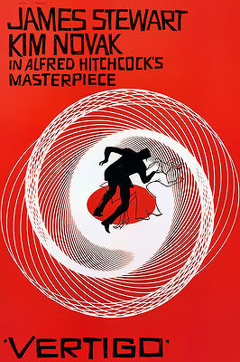
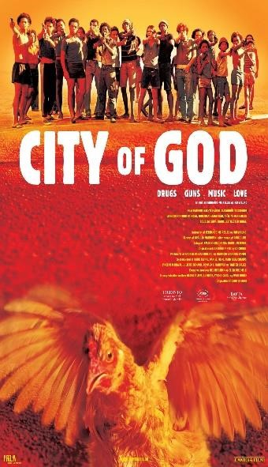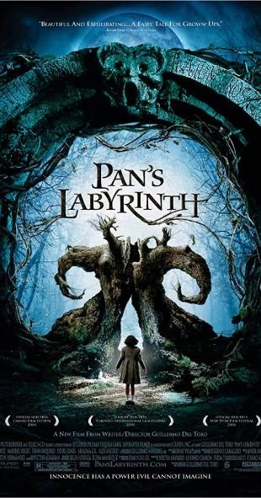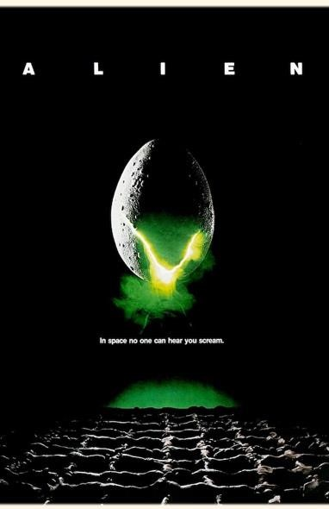
STU
DIES

Section B:

T
ask
4
:

Deep
-
s

Challenge 2: You may decide to watch some films from this arbitrary list made by Empire:
The 100 Best Movies Of All Time And Where To Watch Them


Challenge 3: You might decide to ask each of your friends and family for a recommendation, type it into a ‘spin the wheel’ random selector, and use that to pick films to watch.
(If you’d like mine, I recommend: The Wind Rises (dir. Hayao Miyazaki, 2013))

