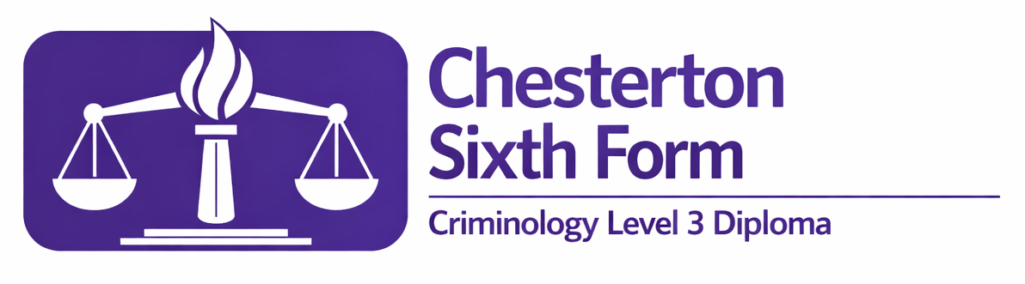

Criminology Transition Task
Year 11 into 12
Summer 2026

Answer all of the questions.
Type your answers into the placeholders ‘Click or tap here to enter text.’
Once you have completed all the questions, please email your document to:
Mr Reed creed@ccc.tela.org.uk
and
Dr Hutchinson khutchinson@ccc.tela.org.uk

You should do this by Friday 28 August.


Question 1 – Performance crime

- What is performance crime?
Click or tap here to enter text.
- Describe a real-life example of performance crime.
Click or tap here to enter text.
- Other than performance crime, how else can social media be used to commit crime? Use a real-life example to explain this.
Click or tap here to enter text.

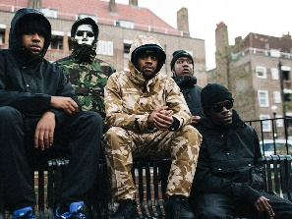
Question 2 – UK Drill Music
These two songs are examples of UK Drill Music.
Crooks and Criminals – M37
https://www.youtube.com/watch?v=dIoMJmksZd4
https://genius.com/M37-crooks-and-criminals-lyrics
From South – Skengdo and AM
https://www.youtube.com/watch?v=3CNqQtW9O_8
https://genius.com/Skengdo-and-am-from-south-lyrics
Listen to them both and study the lyrics.

- What is UK Drill Music?
Click or tap here to enter text.
- Complete the table.
 | Crooks and Criminals – M37 | From South – Skengdo and AM
What is the song about? | Click or tap here to enter text. | Click or tap here to enter text.
What does the song tell the audience? Include specific lyrics. Analyse them in the same way you would a GCSE English quote or a religious teaching from GCSE RS. | Click or tap here to enter text. | Click or tap here to enter text.
Is it a positive or negative portrayal of crime? | Click or tap here to enter text. | Click or tap here to enter text.

- Read this article: https://www.theguardian.com/music/2025/sep/29/uk-campaign-calls-for-restrictions-on-rap-lyrics-being-used-to-convict-people
Write a summary of the article. Use no more than 100 words.
Click or tap here to enter text.

Question 3
What other sources of entertainment in the media have been criticised for encouraging criminal behaviour? Give specific examples. You could consider gaming, films, TV shows, newspapers and any other media source you are aware of.
Click or tap here to enter text.

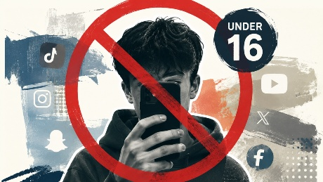
Question 4
Do you think the government should ban under-16s from using social media? Justify your answer. You should aim to write at least 400 words.
You should include reference to performance crime and drill music in your answer. You must include other ideas too.
Click or tap here to enter text.

