A Level Classical Civilisation
Transition Pack
General transition task:
Write a 200 word paragraph, explaining why you want to do Classics. Think about what you already know, what interests you, and what you’d like to know more about.
Remember, you don’t have to have studied Classics before, but just explain what made you pick it!

Imperial Image transition task:
Complete these two sections of the Khan Academy Ancient Rome unit:
Augustus of Prima Porta video

https://www.khanacademy.org/humanities/ap-art-history/ancient-mediterranean-ap/ap-ancient-rome/v/augustus-of-primaporta-1st-century-c-e-vatican-museums

Augustus of Prima Porta article

https://www.khanacademy.org/humanities/ap-art-history/ancient-mediterranean-ap/ap-ancient-rome/a/augustus-of-primaporta

From these sources, identify and write down any details you can for how the Prima Porta presented August as a military leader, a bringer of peace, a man favoured by the gods and as a benefactor to Rome.

An Introduction to Sappho transition task:
Complete the following TedEd Lesson on Sappho. You will need to create an account to access the quiz and the follow up article – please use your school email to do so.
https://ed.ted.com/lessons/ancient-greece-s-most-intriguing-erotic-poet-diane-j-rayor#watch

- Jot down a brief timeline of the creation, discovery and controversy surrounding Sappho’s work.
Now watch the following video:

https://www.youtube.com/watch?v=r_IWSbE1T9o
About Sappho
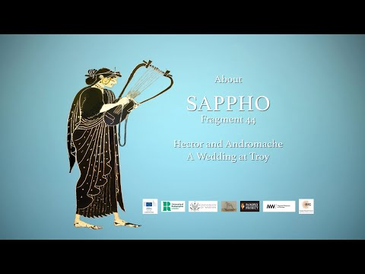
- Based on what you have found out about Sappho, choose one celebrity who you think is most similar to Sappho (think 20th/21st century). Write down 5 reasons why you think they share similarities.
This work will help prepare you for the Greek section of the Love and Relationships module which you will start in September.

