This document has been designed to aid you in your transition from Year 11 to Year 12. It will help you prepare for starting the A level Chemistry course by recapping some of the key concepts from GCSE that will be important for understanding the first module of the course as well as covering content that is unique to GCSE Chemistry. For students who studied combined science at GCSE, large parts of this content will be new.

To do:
- Read through each section and make
your own study notes
- Attempt the practice question at the
end of each section, and self-mark
using the mark scheme via this QR code
- Circle your confidence on each topic
- Write a list of any questions you have to discuss with your teacher

Practice booklet contents:
Section | Page number | Topic | Confidence
1 | 3 | Balancing Equations | ☺️ 😐 ☹️
2 | 4 | Ionic formulae | ☺️ 😐 ☹️
3 | 6 | Transition metals | ☺️ 😐 ☹️
4 | 8 | Moles and reacting masses | ☺️ 😐 ☹️
5 | 9 | Empirical formula | ☺️ 😐 ☹️
6 | 10 | Atom economy and yield | ☺️ 😐 ☹️
7 | 12 | Concentrations and volumes | ☺️ 😐 ☹️
8 | 13 | Titrations | ☺️ 😐 ☹️
9 | 15 | Cells and batteries | ☺️ 😐 ☹️
10 | 16 | Organic functional groups | ☺️ 😐 ☹️
11 | 18 | Polymerisation | ☺️ 😐 ☹️
12 | 19 | Qualitative tests for ions | ☺️ 😐 ☹️
13 | 22 | Haber process and fertilisers | ☺️ 😐 ☹️

Student name: ___________________________________________________
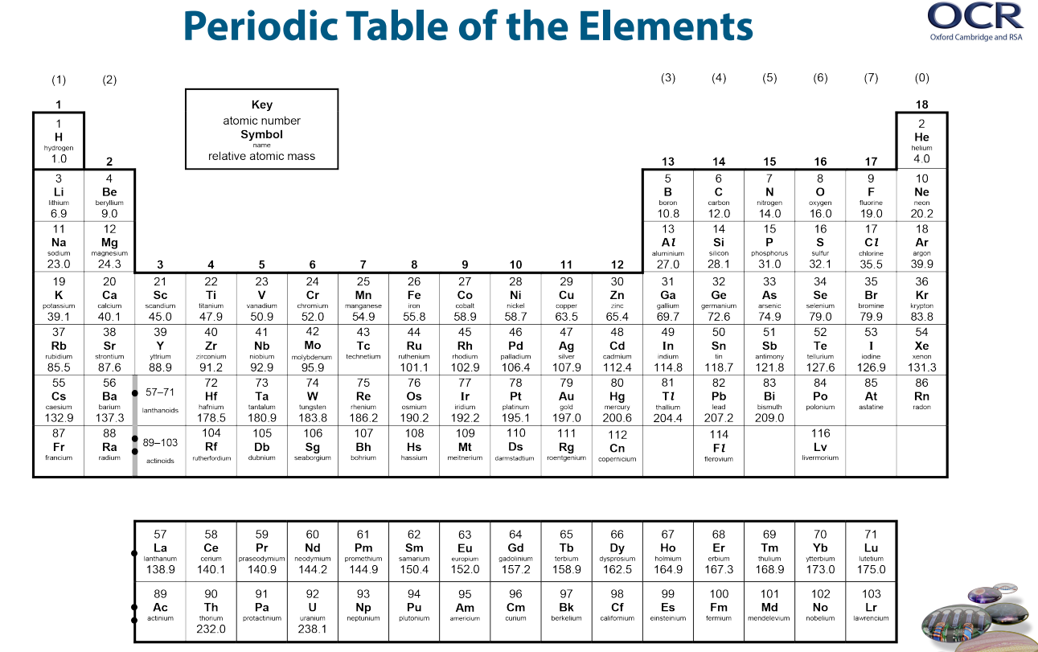
Section 1: Balancing equations

AQA GCSE Chemistry /Combined Science topic: C1 – C10
Triple-only content? No

You will have practices balancing equations at GCSE. For A level chemistry you will come across many more equations, but you should find balancing soon becomes second natures. By the end of the course you should be able to write equations for all the reactions you have studied and for some unfamiliar reactions
When balancing an equation, you can only change the “big number”. The “small numbers” are part of the chemical formula of the molecule and must not be changed under any circumstances – if you change the “small numbers” you change the identity of the chemical (e.g. H₂O = water, H₂O₂ = hydrogen peroxide)
At A level, you will find the “big numbers” are given a different name – the stoichiometry. The stoichiometry is the molar ratios of each substance in a chemical equation. Remember it is only these numbers you can change when balancing.

For more help on balancing equations, try the following game: https://phet.colorado.edu/sims/html/balancing-chemical-equations/latest/balancing-chemical-equations_en.html
Practice Questions:
Balance the following equations
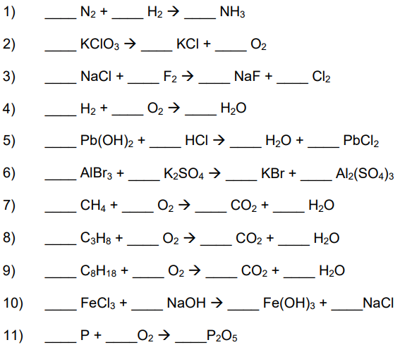
Section 2: Ionic formulae

AQA GCSE Chemistry /Combined Science topic: C2
Triple-only content? No
The formula of an ionic compound depends on the charges on the ions present in the substance.
From GCSE you should remember that many atoms lose or gain electrons to achieve the same electron structure as the nearest noble gas (from He – Rn).
- Atoms of metals appear on the left of the periodic table and lose electrons to form cations (positive ions)
- Atoms of non-metals appear on the right of the periodic table and gain electrons to form anions (negative ions)
For many elements you can use the element’s position in the periodic table to work out the likely charge on the ion
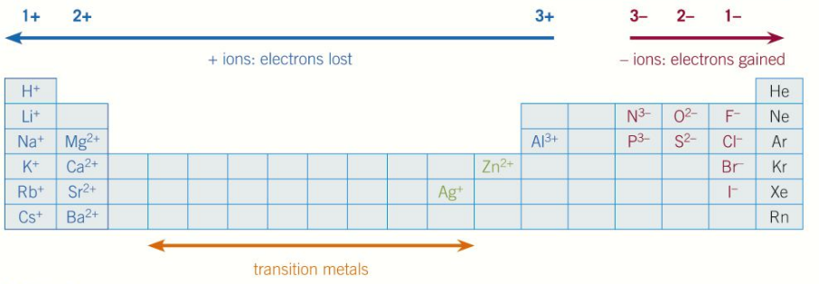
Some metals, mostly transition metals, can form ions with different charges. The ionic charge is then shown with a roman numeral in the name of the ion
e.g. Iron forms two ions: iron (II), Fe²⁺, and iron (III), Fe³⁺
Some ions are polyatomic – they contain multiple atoms bonded together but exist as a single ion
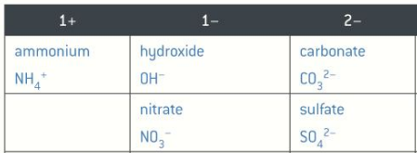

To calculate the formula of an ionic compound, you must ensure the overall charge of the compound is 0.
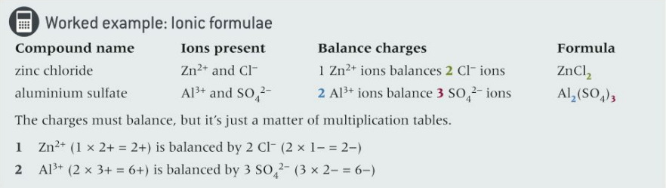

Practice questions:
Work out the formula of the following ionic compounds
- Aluminium chloride
- Magnesium sulfate
- Sodium oxide
- Iron (III) chloride
- Ammonium sulfate
- Copper (II) nitrate
- Lithium nitride
- Calcium oxide

Section 3: Transition metals

AQA GCSE Chemistry /Combined Science topic: C1
Triple-only content? Yes

Transition metals are found in the central part of the periodic table (‘d block’). While they share many physical properties with other metals, typically they have:
- Higher melting points
- Higher densities
- Greater strength
- Greater hardness
Unlike Group 1 and Group 2 metals, transition metals react slowly (or not at all) with oxygen and water. However, many still react with halogens.
Transition metals may form ions of different charges. For example, iron commonly forms Fe²⁺ and Fe³⁺ ions. Due to this chemical property, they can often act as good catalysts (as they can both accept and donate electrons).
Transition metals often form colourful compounds and ions. For example, this video shows the colours of different vanadium ions: https://www.youtube.com/watch?v=sFAGQLokym4

Practice question:
This question is about metals and the reactivity series.
(a) Which two statements are properties of most transition metals?
Tick (✓) two boxes.

They are soft metals. | 
They form colourless compounds.
They form ions with different charges.
They have high melting points.
They have low densities.
(2)
(b) A student added copper metal to colourless silver nitrate solution.
The student observed:
• pale grey crystals forming
• the solution turning blue.
Explain how these observations show that silver is less reactive than copper.
___________________________________________________________________
___________________________________________________________________
___________________________________________________________________
___________________________________________________________________
___________________________________________________________________
___________________________________________________________________
(3)

Section 4: Moles and reacting masses

AQA GCSE Chemistry /Combined Science topic: C3
Triple-only content? No
Chemists use a quantity called a mole to count the number of particles in substance. The number of particles in one mole can be calculated using Avogadro’s constant (N_{A})
One mole of a substance = 6.02 × 10²³ particles of a substance
This number may seem arbitrary however it is directly inked to the mass of carbon-12, the standard for the measurement of relative atomic mass. 12 g of carbon 12 contains 6.02 × 10²³ carbon atoms
Molar mass is a convenient way of linking moles with mass for any chemical substance. This molar mass gives the mass in grams in each mole of the substance
$$moles (mol)= \frac{mass (g)}{molar mass (g {mol}^{-1})}$$

You can use the mass of a reactant in a reaction and the stoichiometric relationship between reactants and products to predict the maximum theoretical yield of a product. This assumes 100% of your limiting reactant is converted into product. There are a number of ways of performing this calculation. Watch the following video to see an example of how it’s done: https://www.youtube.com/watch?v=5zOpoeN0dV0

Practice questions:
- Calculate the number of moles in 2.4 g of chlorine gas (Cl₂)
- Calculate the number of molecules in 2.4 g of chlorine gas (Cl₂)
- Calculate the mass of Al₂O₃ produced when 8.0 g of Al reacts with an excess of O₂
4 Al + 3 O₂ → 2 Al₂O₃
- Calculate the mass of H₂O produced when 2.4. g of H₂ reacts with an excess of O₂
2 H₂ + O₂ → 2 H₂O
- Calculate the mass of sodium chloride produced when 0.7 g of sodium reacts with an excess of chlorine
2 Na + Cl₂ → 2 NaCl

Section 5: Empirical formula

AQA GCSE Chemistry /Combined Science topic: C3
Triple-only content? No

The empirical formula is the simplest whole number ratios of atoms of each element in a compound. It is important for substances that do not exist as molecules, such as metals, giant covalent structures and ionic compounds.
Empirical formula can be calculate from molar ratios, reacting masses or percentage compositions. To see how its done, watch this video here: https://www.youtube.com/watch?v=k_GTEtK01Wg
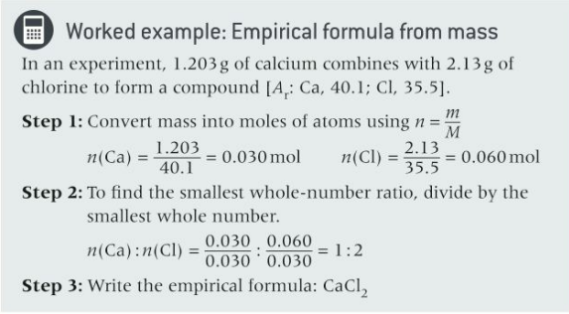
Practice Questions:
- In an experiment 3.65 g of magnesium reacts with 4.80 g of oxygen gas to form a compound. Calculate the empirical formula
- A molecule is 52.2% carbon, 13.0% hydrogen, 34.8% oxygen. Calculate the empirical formula
- A molecule is 82.2% nitrogen, 17.8% hydrogen. Calculate the empirical formula

Section 6: Atom economy and percentage yield

AQA GCSE Chemistry /Combined Science topic: C3
Triple-only content? Yes

Atom economy is a measure of the amount of starting materials that end up as useful products in a chemical reaction.
To equation for atom economy is: $atom economy= \frac{Mr of desired product}{Total Mr of reactants} x 100$

Theoretical yield is the maximum possible mass of product that can be made in a reaction. You can calculate this if you know the mass of the limiting reactant, and the molar ratio between this reactant and the product from a balanced chemical equation.
However, the theoretical yield is impossible to obtain in practice. Alternative reactions may occur. The reaction may not go to completion. Some product may be lost during transfer or filtering.
The percentage yield shows what percentage of the theoretical yield was actually obtained in a reaction.
The equation for percentage yield is: $percentage yield= \frac{mass of product}{theoretical yield} x 100$

Read about how both atom economy and percentage yield are important factors to consider when designing a synthetic pathway here: https://www.bbc.co.uk/bitesize/guides/z8wkh39/revision/3

Practice question:
Ethene and steam react to produce ethanol.
The equation for the reversible reaction is:
ethene + steam ⇌ ethanol
(c) The reaction produces a maximum theoretical mass of 400 kg of ethanol from 243 kg of ethene and 157 kg of steam.
A company produces 380 kg of ethanol from 243 kg of ethene and 157 kg of steam.
The percentage yield of ethanol is less than 100%
Calculate the percentage yield of ethanol.
Use the equation:
___________________________________________________________________
___________________________________________________________________
Percentage yield = _______________ %
(2)

Section 7: Concentration and volume

AQA GCSE Chemistry /Combined Science topic: C3
Triple-only content? Yes

Concentration can be measured in both gdm⁻³ and moldm⁻³. You can convert between these quantities using these equations:
$$moles= \frac{mass}{Mr}$$
$$moles=concentration x volume$$

Avogadro’s law states that equal volumes of different gases contain the same number of molecules at the same temperature and pressure. You can use this information along with the molar ratios from balanced chemical equations to calculate the volume of gas involved in a reaction.

The molar volume is the volume of one mole of any gas at room temperature and pressure (RTP): 24 dm³ (24,000 cm³). If you know the moles of gas present, multiplying this by the molar volume will give the volume occupied by this gas.

Practice question:
This question is about the reaction between hydrogen sulfide (H₂S) and oxygen.
The equation for the reaction is:
2 H₂S(g) + 3 O₂(g) → 2 H₂O(g) + 2 SO₂(g)
(a) What does H₂O(g) represent?
___________________________________________________________________
(1)
(b) Calculate the volume of oxygen required to react with 50 cm³ of hydrogen sulfide.
___________________________________________________________________
___________________________________________________________________
Volume = _______________cm³
(1)
Section 8: Titrations

AQA GCSE Chemistry /Combined Science topic: C3 + C4
Triple-only content? Yes

A titration is a reaction between a known ratio of two solutions. This allows the concentration of one of the solutions to be determined, if the concentration of the other solution and the volumes of both solutions are known.
Read about how to conduct a titration experiment here: https://www.bbc.co.uk/bitesize/guides/zx98pbk/revision/1#:~:text=Carrying%20out%20a%20titration%20to%20find%20out%20volumes%20of%20acid%20and%20alkali%20solutions%20that%20react

Practice question:
A student used a solution of citric acid to determine the concentration of a solution of sodium hydroxide by titration. The student made 250 cm3 of a solution of citric acid of concentration 0.0500 mol/dm3

This is part of the method the student used for the titration.

- Measure 25.0 cm3 of the sodium hydroxide solution into a conical flask using a pipette.

- Add a few drops of indicator to the flask.

- Fill a burette with citric acid solution.

- Describe how the student would complete the titration.

___________________________________________________________
___________________________________________________________
___________________________________________________________
___________________________________________________________
___________________________________________________________
___________________________________________________________

(3)

b) Give two reasons why a burette is used for the citric acid solution.

- _________________________________________________________

___________________________________________________________

- _________________________________________________________

___________________________________________________________

(2)

The equation for the reaction is:

3 NaOH + C6H8O7 → C6H5O7Na3 + 3 H2O

Calculate the concentration of the sodium hydroxide solution in mol/dm3

___________________________________________________________
___________________________________________________________
___________________________________________________________
___________________________________________________________
___________________________________________________________
___________________________________________________________

Concentration = _______________ mol/dm3

(2)

Section 9: Cells and batteries

AQA GCSE Chemistry /Combined Science topic: C5
Triple-only content? Yes

A simple cell can be made by connecting two different metals with an electrolyte. A voltage will be produced until one reactant is used up. The greater the difference in reactivity between the two metals, the greater the voltage produced.

Fuel cells produce a voltage continuously, as long as they are supplied with fuel and oxygen. In contrast to combustion, in fuel cells the fuel is oxidised electrochemically (not burned), and electrical energy is released (not thermal energy).

In hydrogen fuel cells, liquid water is the only product.
At the cathode, the following reaction occurs: 2H₂ + 4HO⁻ 4H₂O + 4e⁻
At the anode, the following reaction occurs: O₂ + 2H₂O + 4e⁻ 4HO⁻
Read more about how hydrogen fuel cells work here: https://www.savemyexams.co.uk/gcse/chemistry/aqa/18/revision-notes/5-energy-changes/5-2-chemical-cells--fuel-cells/5-2-2-fuel-cells/

Practice question:
The reaction between hydrogen and oxygen in a hydrogen fuel cell is used to produce electricity.
Hydrogen fuel cells and rechargeable cells are used to power some cars.
Give two advantages of using hydrogen fuel cells instead of using rechargeable cells to power cars.
1 _________________________________________________________________
___________________________________________________________________
2 _________________________________________________________________
___________________________________________________________________
(2)

Section 10: Organic functional groups

AQA GCSE Chemistry /Combined Science topic: C7
Triple-only content? Yes

Functional groups are groups of atoms that determine the main chemical properties of a compound.

The functional group of alkenes is the c=c double bond.
Alkenes typically undergo incomplete combustion in oxygen.
They undergo addition reactions with diatomic halogen molecules to form halogenoalkanes.
An example of this type of reaction is shown here:
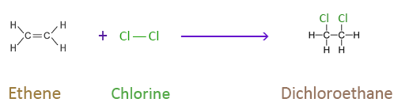
This reaction shown with aqueous bromine can be used to test for the presence of alkenes. Bromine water remains orange-brown when mixed with alkanes, but becomes colourless when mixed with alkenes as the above reaction occurs.
Alkenes undergo addition reactions with diatomic hydrogen (called hydrogenation) to form alkanes. This reaction requires a catalyst.
Alkenes undergo addition reactions with steam (called hydration) to form alcohols. This reaction requires a high temperature (~300°C) and a catalyst.
An example of a hydration reaction is shown here:
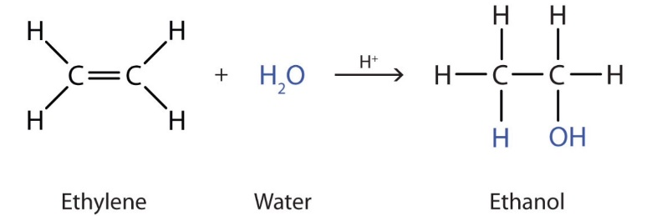

Alcohols are compounds with the functional group –OH (hydroxyl).
Alcohols are named in a similar way to alkanes and alkenes, depending on the number of carbons in their main chain. All alcohols have names ending in ‘ol’. For example, an alcohol with three carbons would be called propanol, and an alcohol with four carbons would be called butanol.
All alcohols undergo complete combustion. Many alcohols also undergo reactions with sodium. Read more about the details of this reaction and its uses here: https://www.chemguide.co.uk/organicprops/alcohols/sodium.html
Carboxylic acids contain the carboxyl functional group –COOH:
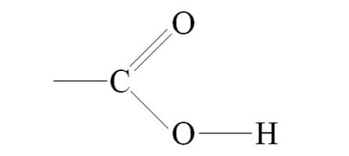
These display the typical properties of weak acids (eg reactions with metals and bases).
Carboxylic acids are named based on the number of carbons in their main chain, and their names end in ‘anoic acid’. For example, ethanoic acid contains two carbons.
Carboxylic acids and alcohols can react together to for esters. This reaction, called esterification, requires a catalyst and also produces water.
Esters contain the functional group -COO- :
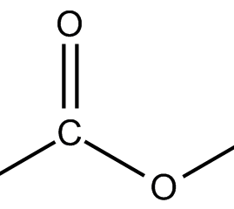
An example of an esterification reaction is shown here:
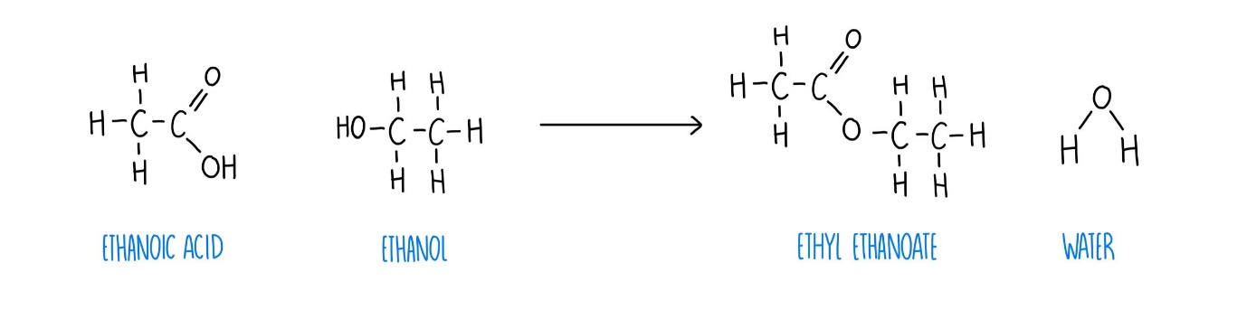
Practice questions:
- Draw the displayed formulae of ethene and butane.
- Name the alkane that would be formed from the hydrogenation of propene.
- Draw the displayed formula of the alcohol that would be formed from the hydration of butene.
- Draw the structural formula of propanoic acid.
- Draw the products of the esterification reaction between ethanol and butanoic acid.

Exam practice link: Question six
Section 11: Polymers

AQA GCSE Chemistry /Combined Science topic: C2 + C7
Triple-only content? Yes
Polymers are made of many small repeating units called monomers. For example, many ethene molecules (monomers) can form a long chain called poly(ethene), which is a polymer.
Read about how to draw the repeating units of addition polymers here (four examples): http://www.passmyexams.co.uk/GCSE/chemistry/addition-polymerisation.html

DNA, carbohydrates (eg starch), and proteins are all examples of polymers found in living organisms. The monomers of proteins are amino acids. Amino acids contain the functional groups –NH₂ (amino group) and –COOH (carboxyl group).
The general structure of an amino acid is shown below:
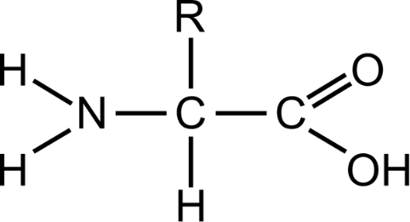
In this structure, R is not the symbol of an element! It means that this part of the molecule, called a side chain, can vary in structure. In some amino acids, the R group is small (eg in glycine it is a hydrogen atom). In others it is much larger (eg in tryptophan it is C₉H₈N).
Amino acids can undergo condensation polymerisation. Read about how this reaction works here: https://www.bbc.co.uk/bitesize/guides/z3v4xfr/revision/8
You may notice that the peptide bond formed between amino acids looks similar to an ester link. In fact, alcohols and carboxylic acids can form condensation polymers too!
Practice question:
Ethene is used to produce poly(ethene).
(a) Draw the bonds to complete the displayed formulae of ethene and poly(ethene) in the equation.
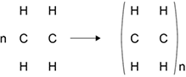
(2)
Section 12: Qualitative tests for ions

AQA GCSE Chemistry /Combined Science topic: C8
Triple-only content? Yes

Some metal ions can be identified by the colour of the flame when they are burned. Read about the flame test colours for some common metal ions here: https://www.bbc.co.uk/bitesize/guides/zxtvw6f/revision/1#:~:text=The%20table%20shows,Green
Metal ions that form insoluble hydroxides can be tested for by reaction with dilute sodium hydroxide solution. Read about the precipitate colours for some common metals here, and how to distinguish between metals that produce white precipitates, here: https://www.bbc.co.uk/bitesize/guides/zxtvw6f/revision/2#:~:text=The%20table%20shows%20the,calcium%20and%20magnesium%20ions.
A test for carbonate ions is reaction with dilute acid. Carbon dioxide bubbles are given off. The identity of this gas can be confirmed with limewater.
A test for sulfate ions is reaction with aqueous barium chloride. The positive result of this test is the formation of white barium sulfate precipitate. The solution should first be acidified with dilute acid, to remove any carbonate ions that would give a false positive result. This acid should not be sulfuric acid, as this would also give a false positive result!
The test for halide ions is reaction with aqueous silver nitrate. Chloride ions form a white precipitate, bromide ions form a cream precipitate, and iodide anions form a yellow precipitate. The solution should first be acidified with dilute nitric acid to remove any carbonate or hydroxide ions that would also form insoluble silver salts and obscure the results. As with the sulfate test, hydrochloric acid should not be used for this purpose, as it would give a false positive result.

Instrumental methods have a number of benefits over traditional qualitative tests. Read about these here: https://www.bbc.co.uk/bitesize/guides/zxtvw6f/revision/5

Practice question:
The formula of potash alum is KAl(SO₄)₂
(a) Give a test to identify the Group 1 metal ion in potash alum.
You should include the result of the test.
Test ______________________________________________________________
___________________________________________________________________
Result _____________________________________________________________
___________________________________________________________________
(2)
(b) Name one instrumental method that could identify the Group 1 metal ion and show the concentration of the ion in a solution of potash alum.
___________________________________________________________________
___________________________________________________________________
(1)
A student identifies the other metal ion in potash alum.
The student tests a solution of potash alum by adding sodium hydroxide solution until a change is seen.
(c) Give the result of this test.
___________________________________________________________________
___________________________________________________________________
(1)
(d) This test gives the same result for several metal ions.
What additional step is needed so that the other metal ion in potash alum can be identified?
Give the result of this additional step.
Additional step _____________________________________________________
___________________________________________________________________
Result _____________________________________________________________
___________________________________________________________________
(2)
(e) Describe a test to identify the presence of sulfate ions in a solution of potash alum.
Give the result of the test.
Test ______________________________________________________________
___________________________________________________________________
___________________________________________________________________
Result _____________________________________________________________
___________________________________________________________________
___________________________________________________________________
(3)

Section 13: The Haber process

AQA GCSE Chemistry /Combined Science topic: C6 + C10
Triple-only content? Yes

Ammonia can be manufactured in a reversible reaction between hydrogen and nitrogen called the Haber process. This requires an iron catalyst, and is typically performed at 200 atmospheres of pressure and between 350-450°C. The reaction mixture can be periodically cooled to remove ammonia, and the unreacted gases can be recycled for future reactions.

Ammonia can be used in the synthesis of ammonium and nitrate salts, which are a vital component of fertilisers as they provide a soluble source of nitrogen for plants. Phosphate and potassium ions are also vital components of most fertilisers, providing soluble sources of phosphorous and potassium respectively. Fertilisers containing all of these three elements are known as NPK fertilisers.
A key component of many NPK fertilisers is the salt ammonium sulfate. This can be produced by reacting aqueous ammonia and sulfuric acid. Sulfuric acid can be produced by reacting sulfur with oxygen in multiple stages, then reacting sulfur trioxide with water.

Practice question:
This question is about reversible reactions and equilibrium.Hydrogen is used to produce ammonia in the Haber process.The hydrogen is made in two stages.Stage 1 is the reaction of methane and steam to produce carbon monoxide and hydrogen.
The equation for the reaction is:
CH₄(g) + H₂O(g) ⇌ CO(g) + 3 H₂(g)
(a) Calculate the atom economy for the formation of hydrogen in stage 1.
Relative atomic masses (A_{r}): H = 1 C = 12 O = 16
___________________________________________________________________
___________________________________________________________________
___________________________________________________________________
___________________________________________________________________
Atom economy = _____________________%
(2)
(b) Explain why a low pressure is used in stage 1.
Give your answer in terms of equilibrium.
___________________________________________________________________
___________________________________________________________________
___________________________________________________________________
(2)
(c) Stage 2 uses the carbon monoxide produced in stage 1.
The carbon monoxide is reacted with more steam to produce carbon dioxide and more hydrogen.
The equation for the reaction in stage 2 is:
CO(g) + H₂O(g) ⇌ CO₂(g) + H₂(g)
What is the effect of increasing the pressure on the equilibrium yield of hydrogen in stage 2?
___________________________________________________________________
___________________________________________________________________
(1)
The graph below shows the percentage yield of ammonia produced at different temperatures and pressures in the Haber process.
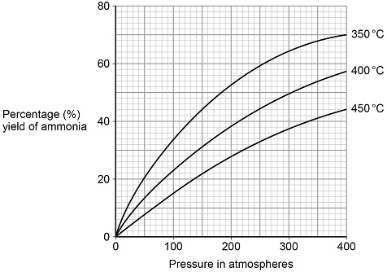

A temperature of 450 °C and a pressure of 200 atmospheres are used in the Haber process.
(d) A student suggested that a temperature of 350 °C and a pressure of 285 atmospheres could be used instead of those used in the Haber process.
Determine how many times greater the percentage yield of ammonia obtained would be.
Use the graph.
___________________________________________________________________
___________________________________________________________________
___________________________________________________________________
___________________________________________________________________
Percentage yield = _______________________ times greater
(3)

(e) A pressure of 285 atmospheres is not used in the Haber process instead of 200 atmospheres.
Give one reason why.
___________________________________________________________________
___________________________________________________________________
(1)
(f) How does the graph above show that the forward reaction in the Haber process is exothermic?
___________________________________________________________________
___________________________________________________________________
(1)

