Section 1
1, 3, 2
2, 2, 3
2, 1, 2, 1
2, 1, 2
1, 2, 2, 1
2, 3, 6, 1
1, 2, 1, 2
1, 5, 3, 4
2, 25, 16, 18
1, 3, 1, 3
4, 5, 2

Section 2
AlCl₃, MgSO₄, Na₂O, FeCl₃, (NH₄)₂SO₄, Cu(NO₃)₂, Li₃N, CaO

Section 3
(a) they form ions with different charges
1
they have high melting points
1
(b) the (grey) crystals are silver
1
the copper ions (produced) are blue
allow the copper nitrate / compound (produced) is blue
1
(because) copper displaces silver
1

Section 4
0.0338
2.04 x 10²²
11.11
26.1
1.84

Section 5
MgO
C₂H₆O
NH₃

Section 6
(c) (percentage yield =)
1
= 95 (%)
1

Section 7
(a) water vapour
allow steam
allow gaseous water
1
(b) 75 (cm³)
1

Section 8
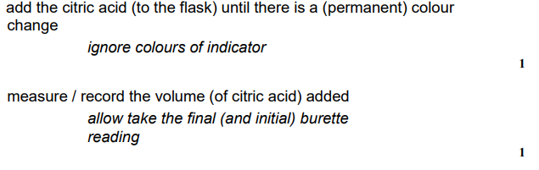
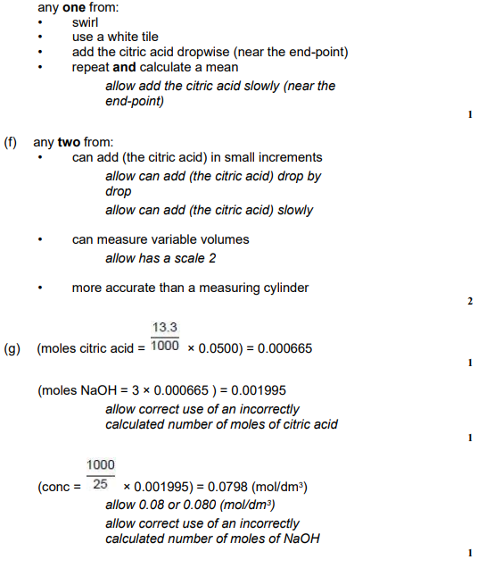
Section 9
) any two from: (hydrogen fuel cells)
allow converse arguments for a rechargeable cell
• no toxic chemicals to dispose of at the end of the cell's life
• take less time to refuel (than to recharge rechargeable cells)
• travel further before refuelling (than before recharging rechargeable cells)
allow has a greater range
• no loss of efficiency (over time)
allow does not lose capacity in cold
Section 10
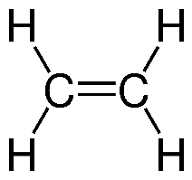
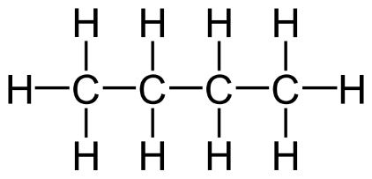
Propane
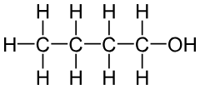
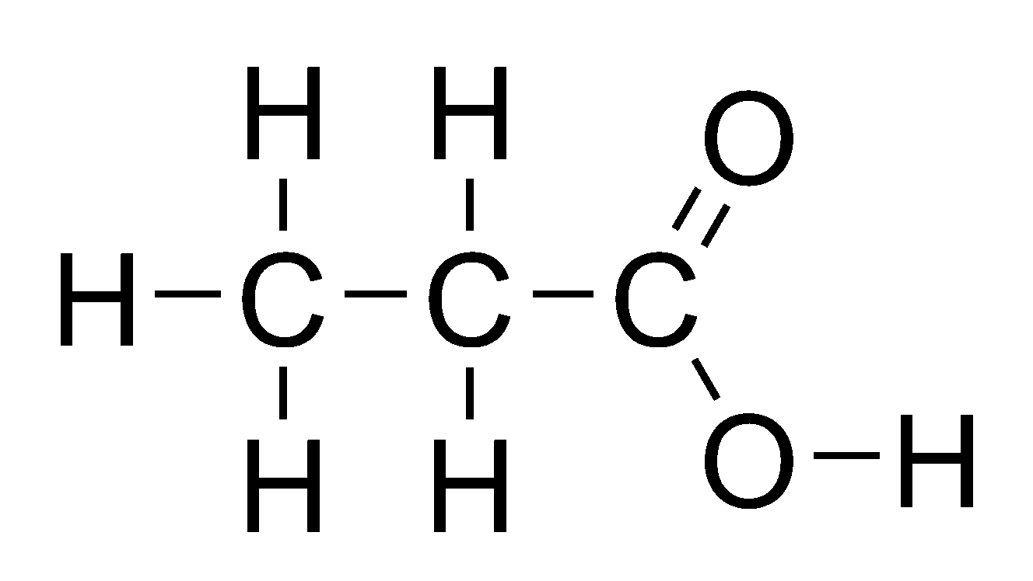
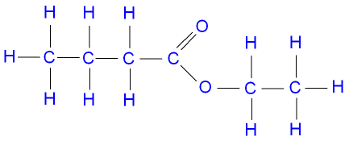

Section 11
(a) (ethene)
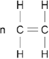
1
(polyethene)
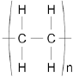
1

Section 12
(a) flame test
allow description of flame test
1
lilac (flame)
1
(b) flame emission spectroscopy
1
(c) white precipitate
ignore precipitate dissolves
1
(d) (add) excess sodium hydroxide (solution)
allow (add) more sodium hydroxide (solution)
1
precipitate dissolves
1
(e) add barium chloride (solution)
allow add barium nitrate (solution)
1
add (dilute) hydrochloric acid
allow add (dilute) nitric acid
1
white precipitate
dependent on MP1 being awarded
1
[9]

Section 13

(a)
an answer of 17.6470588 (%) correctly rounded to at least 2 significant figures scores 2 marks
1
= 17.6 (%)
allow 17.6470588 (%) correctly rounded to at least 2 significant figures
1
(b)
allow converse arguments in terms of higher pressure
ignore references to rate
higher yield (of hydrogen or carbon monoxide or product)
allow more hydrogen or more carbon monoxide or more product
allow equilibrium moves to the right
allow equilibrium moves in the forward direction
1
(because) fewer moles / molecules / particles on left hand side
or
(because) more moles / molecules / particles on right hand side
allow (because) the reverse reaction produces fewer moles / molecules / particles
or
allow (because) the forward reaction produces more moles / molecules / particles
do not accept fewer / more atoms
1
(c) no effect (on yield of hydrogen)
allow position of equilibrium unaffected by pressure
ignore references to rate of reaction
1
(d)
an answer of 2.25 scores 3 marks
350 (°C) and 285 (atmospheres) = 63 (%)
and
450 (°C) and 200 (atmospheres) = 28 (%)
allow a value between 62 (%) and 64 (%) inclusive
1
allow a correct expression using incorrectly determined value(s) for percentage yield
1
= 2.25 (times greater)
allow a correct calculation using incorrectly determined value(s) for percentage yield correctly evaluated and rounded to at least 2 significant figures
1
(e)
allow converse arguments in terms of low(er) pressure
any one from:
• the energy costs would be high(er)
ignore energy / cost unqualified
• the equipment would need to be strong(er)
allow the equipment would be (more) expensive (to build / maintain)
• high(er) pressures are (more) dangerous
allow (more) dangerous because (greater) risk of explosion
1
(f) higher temperatures produce a lower (percentage) yield (of ammonia)
allow converse
allow correct reference to shift in equilibrium
ignore references to pressure
1
(g) world population has increased
1

