Year 12 transition work: Biology


This document has been designed for students who have studied combined science at GCSE. It reviews the content that is unique to the Biology GCSE to help you prepare for starting the A Level Biology course.

To do:
- Read through each section and make your own study notes
- Attempt the practice question at the end of each section, and self-mark using the mark scheme via this QR code
- Fill in your marks in the table below, and circle your confidence on each topic
- Write a list of any questions you have on these topics to discuss with your teacher

Practice booklet contents:
Section | Page number | Topic | Marks | Confidence
One | 2 | Microbiology | ____ / 9 | ☺️ 😐 ☹️
Two | 5 | Monoclonal antibodies | ____ / 7 | ☺️ 😐 ☹️
Three | 7 | Plant diseases and defences | ____ / 8 | ☺️ 😐 ☹️
Four | 9 | The brain | ____ / 5 | ☺️ 😐 ☹️
Five | 11 | The eye | ____ / 3 | ☺️ 😐 ☹️
Six | 13 | Thermoregulation | ____ / 6 | ☺️ 😐 ☹️
Seven | 14 | Osmoregulation | ____ / 9 | ☺️ 😐 ☹️
Eight | 16 | Plant hormones | ____ / 1 | ☺️ 😐 ☹️
Nine | 17 | Reproduction | ____ / 3 | ☺️ 😐 ☹️
Ten | 19 | DNA | ____ / 6 | ☺️ 😐 ☹️
Eleven | 21 | Ideas about evolution | ____ / 8 | ☺️ 😐 ☹️
Twelve | 23 | Energy in ecosystems | ____ / 7 | ☺️ 😐 ☹️
Thirteen | 26 | Food security | ____ / 10 | ☺️ 😐 ☹️

Student name: ___________________________________________________

Section one
AQA GCSE Biology topic: B1
Triple-only content: microbiology

Organisms in the domains Bacteria and Archaea (prokaryotes) reproduce by a process called binary fission. This process can be compared to mitosis in eukaryotes. While the stages and biochemistry of these processes differ, both result in the production of two genetically identical daughter cells.
One way that bacteria can be grown (or ‘cultured’) is in a liquid medium known as nutrient broth. To calculate the number of bacteria (n_{F} ) in a population after a certain time, first divide the time (t) by the mean generation time (usually 20 minutes) to find the number of generations (g) that have passed. Then multiply the initial number of bacteria (n_{I}) by 2 to the power of g: n_{F} = n_{I} x 2^{g} . As population sizes are usually very large, these values should be reported in standard form.
Another way of growing bacteria is on agar plates. These are Petri dishes containing solid nutrient jelly. Bacteria can be spread on the surface where they will form colonies.
It is vital to prevent contamination when preparing agar plates, both for safety and as a control variable for any experiments. Watch this video on aseptic technique which describes how this can be achieved: https://www.youtube.com/watch?v=bRadiLXkqoU

Practice question:

A student investigated the effectiveness of three different antibiotics.
Figure 1 shows how the student set up an agar plate.
Figure 1
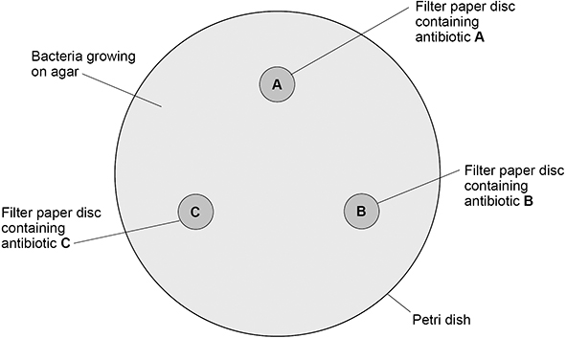
The student used aseptic techniques to make sure that only one type of bacterium was growing on the agar.
(a) Describe two aseptic techniques the student should have used.
1 ________________________________________________________________
___________________________________________________________________
___________________________________________________________________
2 ________________________________________________________________
___________________________________________________________________
___________________________________________________________________
(2)

The student placed the agar plate in an incubator at 25 °C for 48 hours.
The image on the next page shows the agar plate after 48 hours.
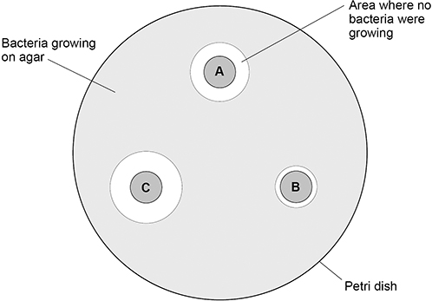

(b) Which antibiotic is the least effective?
Give a reason for your answer.
Least effective antibiotic _______________
Reason ____________________________________________________________
___________________________________________________________________
___________________________________________________________________
(1)

(c) Calculate the area where no bacteria were growing for antibiotic C.
Use π = 3.14
Give the unit.
___________________________________________________________________
___________________________________________________________________
___________________________________________________________________
___________________________________________________________________
___________________________________________________________________
Area = ____________________ Unit __________
(5)
(d) Suggest one way the student could improve the investigation.
___________________________________________________________________
___________________________________________________________________
(1)

Section two
AQA GCSE Biology topic: B3
Triple-only content: monoclonal antibodies

Some B lymphocytes (a type of white blood cell) produce proteins called antibodies. Antibodies bind to specific parts (epitopes) of specific molecules (antigens), and are an important part of your body’s immune response.
Your B lymphocytes generate antibodies randomly in response to infection, so a mixture of many antibodies will be produced, each specific to different epitopes or antigens on the surface of the pathogen. This mixture of antibodies is known as polyclonal.
It is possible for scientists to produce monoclonal antibodies: solutions containing just a single type of antibody. This is often more useful than the polyclonal mixture produced as part of the body’s natural immune response due to its specificity.
Monoclonal antibodies can be made using the hybridoma method:
- Inject an antigen into a mouse (whatever you want the monoclonal antibodies to bind to).
- Confirm that the mouse’s immune response has occurred and its B lymphocytes are producing antibodies against the antigen.
- The mouse is killed and many B lymphocytes are collected from its spleen.
- These B lymphocytes are fused with tumour cells to form hybridomas. These hybridomas produce antibodies like the original lymphocytes but can divide much more rapidly.
- A specific hybridoma is selected that produces the desired antibody at an optimal rate.
- This hybridoma is allowed to divide to produce many genetically identical cells. These will all produce the same antibody, which can be purified for its desired use.
Monoclonal antibodies have many uses. Many of these uses involve the production of conjugated antibodies: monoclonal antibodies chemically bound to other molecules, such as drugs, fluorescent dyes, or radioactive particles. Read more about the uses of monoclonal antibodies here: https://bbc.co.uk/bitesize/guides/zt8t3k7/revision/2

Practice question:
A virus called RSV causes severe respiratory disease.
(a) Suggest two precautions that a person with RSV could take to reduce the spread of the virus to other people.
1. _________________________________________________________________
___________________________________________________________________
2. _________________________________________________________________
___________________________________________________________________
(2)
(b) One treatment for RSV uses monoclonal antibodies which can be injected into the patient.
Scientists can produce monoclonal antibodies using mice.
The first step is to inject the virus into a mouse.
Describe the remaining steps in the procedure to produce monoclonal antibodies.
___________________________________________________________________
___________________________________________________________________
___________________________________________________________________
___________________________________________________________________
___________________________________________________________________
___________________________________________________________________
___________________________________________________________________
___________________________________________________________________
(3)
(c) Describe how injecting a monoclonal antibody for RSV helps to treat a patient suffering with the disease.
___________________________________________________________________
___________________________________________________________________
___________________________________________________________________
___________________________________________________________________
(2)

Section three
AQA GCSE Biology topic: B3
Triple-only content: plant diseases and defences

Plants are at risk from many pathogens and insects. Read about some common examples here: https://www.bbc.co.uk/bitesize/guides/z3tgw6f/revision/1
Plants, like other organisms, can also suffer from mineral deficiencies. Nitrates are required for amino acid synthesis, so nitrate deficiencies cause stunted growth. Many plants are unable to ‘fix’ atmospheric nitrogen and therefore require high nitrate ion concentration in the soil for optimal growth. Magnesium ions are a vital part of chlorophyll molecules. Magnesium deficiency causes yellowed leaves (chlorosis), and the impact on photosynthetic rate can lead to compromised growth.
Plant diseases or deficiencies can be identified by researching the symptoms in books or on the internet. Failing this, cuttings or photographs can be taken to local garden centres for identification. In difficult cases, plant material must be analysed by scientists using monoclonal antibody test kits.
Plants have evolved many ways of preventing infection by pathogens and damage by herbivores. Plant defences can be sorted into three broad categories:
- Physical defences: external physical barriers
- Chemical defences: producing chemicals to prevent infection or herbivory
- Mechanical defences: specialised structures or responses to deter herbivores
Watch this video to find out more about plant defences: https://www.youtube.com/watch?v=Hja0SLs2kus

Practice question:
Many plants have evolved defence mechanisms.
The image below shows part of a gorse plant and part of a deadly nightshade plant.
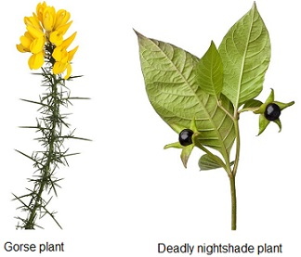
(a) The gorse plant has evolved to have sharp thorns.
What type of defence response are thorns?
___________________________________________________________________
(1)
(b) How do thorns defend the gorse plant?
___________________________________________________________________
(1)
(c) The deadly nightshade plant has poisonous berries.
What type of defence response are poisonous berries?
___________________________________________________________________
(1)

(d) A scientist noticed that in one area the gorse plants had yellow leaves and stunted growth.
One reason for yellow leaves and stunted growth is a deficiency of nitrate ions in the soil.
Explain two other possible reasons for the yellow leaves and stunted growth.
Do not refer to nitrate ions in your answer.
Reason 1
___________________________________________________________________
Explanation
___________________________________________________________________
___________________________________________________________________
___________________________________________________________________
Reason 2
___________________________________________________________________
Explanation
___________________________________________________________________
___________________________________________________________________
___________________________________________________________________
(5)

Section four
AQA GCSE Biology topic: B5
Triple-only content: the brain

The brain is a key part of the central nervous system. It controls the body’s other organs and behaviour. Read about the key regions of the brain here: https://www.bbc.co.uk/bitesize/guides/zprxy4j/revision/5
Historically, doctors studied patients with injuries to specific regions of their brain and recorded their symptoms. This allowed them to determine the regions of the brain that are associated with certain activities. Read about the most famous example here: https://www.smithsonianmag.com/history/phineas-gage-neurosciences-most-famous-patient-11390067/
Today, scientists can use a range non-invasive methods to study brain activity.
Electroencephalogram (EEG) tests use many small electrodes attached to the scalp to directly measure electrical activity in the brain. This technique has unparalleled temporal resolution (can pinpoint when a response happened), but poor spatial resolution (difficult to determine how deep in the brain the response occurred).
Magnetic resonance imaging (MRI) uses radio waves to determine the location of atoms in the brain. This is useful for producing an anatomical image, but gives no information about brain activity.
Functional magnetic resonance imaging (fMRI) uses the same principle to detect the level of oxygenated haemoglobin in the blood as it passes through different parts of the brain. This is an effective indirect measure of brain activity with excellent spatial resolution.

Practice question:
The diagram below shows the brain.
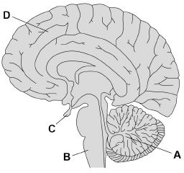

(a) Which part of the brain becomes more active if a person balances on one leg instead of standing on two legs?
Tick (✓) one box.

A |  |  | B |  |  | C |  |  | D
(1)
(b) Name the part of the brain that is responsible for making a decision.
___________________________________________________________________
(1)
(c) In most MRI scanners the person being scanned needs to stay completely still.
A functional MRI (fMRI) scanner allows a person to move while the scanner makes images of the person’s brain activity.
Suggest how the fMRI scanner could help to find out more about the brain damage a person has.
___________________________________________________________________
___________________________________________________________________
__________________________________________________________________
___________________________________________________________________
__________________________________________________________________
___________________________________________________________________
(3)

Section five
AQA GCSE Biology topic: B5
Triple-only content: the eye

The eye is a complex sensory organ. Read about the structure of the eye here: https://www.bbc.co.uk/bitesize/guides/zprxy4j/revision/7
The retina contains specialised receptor cells to detect light. Rod cells are sensitive to low levels of light, enabling limited night vision. Three types of cone cells are sensitive to different wavelengths of light, and work together to produce colour vision.

The amount of light entering the eye is controlled by the pupillary reflex, in which the muscles of the iris will change to either dilate or constrict the pupil.
In bright light conditions, the circular muscle of the iris (sphincter pupillae), which encircles the pupil, contracts. This contraction increases the distance between the inner and outer borders of the iris, reducing the diameter of the pupil. During this reflex, the radial muscle of the iris (dilator pupillae) is relaxed.
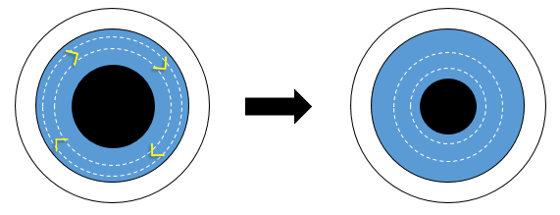
Diagram showing the contraction of the circular muscle in bright light.

In dim conditions, the radial muscle, which runs from the inner to the outer border of the iris, contracts. This pulls the muscles of the iris together into folds, reducing the distance between the inner and outer borders of the iris and increasing the diameter of the pupil. During this reflex, the circular muscle of the iris is relaxed.
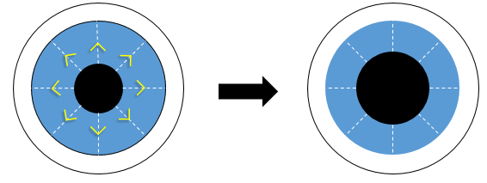
Diagram showing the contraction of the radial muscle in low light.

The angle that light is refracted as it passes through the lens can be changed to ensure that it always focuses on the retina. This occurs through the accommodation reflex. The mechanics of this process are still debated by scientists, but the most popular model describes how the shape of the lens could be controlled by the contraction or relaxation of ciliary muscles, which alters the tension of the suspensory ligaments directly attached to the sides of the lens. Read more about the changes that occur in the eye during this reflex here: https://www.bbc.co.uk/bitesize/guides/zprxy4j/revision/8

Two common visual defects are myopia and hyperopia. In both cases, patients suffer from blurred vision due to light not focusing on the retina. These defects can be corrected with spectacle lenses.
Read about which type of lens should be used to correct each defect here: https://flexbooks.ck12.org/cbook/ck-12-middle-school-life-science-2.0/section/11.49/primary/lesson/vision-correction-ms-ls/

Practice question:
Describe how the brain receives information about light entering the eye.
You should include the names of structures in your answer.
___________________________________________________________________
___________________________________________________________________
___________________________________________________________________
___________________________________________________________________
___________________________________________________________________
___________________________________________________________________
(3)

Section six
AQA GCSE Biology topic: B5
Triple-only content: thermoregulation

Core body temperature is monitored by the thermoregulatory centre of the hypothalamus. Here receptor cells detect the temperature of the blood, and impulses are sent via the nervous system to regulate the body’s temperature by negative feedback.
Key effectors in the thermoregulatory response are the arterioles that supply blood to the capillary beds near the skin. By constricting or dilating these arterioles (known as vasoconstriction and vasodilatation respectively), the amount of blood that flows close to the skin can be varied, thus controlling the amount of heat radiated to the environment.
Other important effectors are the sweat glands, which regulate evaporative cooling, and the skeletal muscles, which enable us to shiver.
Read more about control of body temperature here: https://www.bbc.co.uk/bitesize/guides/zxgmfcw/revision/1

Practice question:
Humans keep their internal conditions almost constant. Body temperature is kept within a narrow range. When the core body temperature is too low, this is detected by the thermoregulatory centre in the brain.
Describe how the body responds when a decrease in core body temperature is detected.
_____________________________________________________________________
_____________________________________________________________________
_____________________________________________________________________
_____________________________________________________________________
_____________________________________________________________________
_____________________________________________________________________
_____________________________________________________________________
_____________________________________________________________________
_____________________________________________________________________
_____________________________________________________________________
(Total 6 marks)

Section seven
AQA GCSE Biology topic: B5
Triple-only content: osmoregulation
The composition of the blood is controlled by the kidneys. Some compounds must be removed from the body via urine, while useful compounds such as glucose must be retained. In particular, urea (a product of amino acid breakdown produced by the liver) must be removed from the body as it is toxic at high concentrations.
Most small particles (eg ions, urea, sugars) and water in the blood are filtered into long tubes in the kidney called nephrons. Most useful molecules (eg glucose) are then returned to the blood in a process known as selective reabsorption. Finally, the remaining solution (mostly water, urea, and excess salts) form urine and are excreted from the body.
The amount of water in the urine is controlled by negative feedback. Receptor cells in the hypothalamus detect when the blood is too concentrated. In response, the pituitary gland will secrete the hormone ADH into the blood. In response to ADH, the permeability of the nephrons will change and more water will be reabsorbed into the blood. A smaller volume of more concentrated urine will be produced. If the blood is too dilute, less ADH will be secreted into the blood, so less water will be reabsorbed and a large volume of dilute urine will be produced.
Damage or disease can lead to kidney failure. Without treatment, waste products will build up in the blood, leading to death. Read about the treatment options for kidney failure here: https://www.kidney.org/atoz/content/choosingtreat

Practice question:
Water conservation is important to the human body.
(a) Which gland releases the hormone that controls water loss from the body?
Tick (✓) one box.
Adrenal | 
Pancreas
Pituitary
Thyroid
(1)
(b) Which hormone helps the kidneys to control water loss from the body?
___________________________________________________________________
(1)
(c) A man is walking across a desert.
The man has used up his supply of drinking water.
Explain how the gland you named in part (a) and the kidneys reduce water loss.
___________________________________________________________________
___________________________________________________________________
___________________________________________________________________
___________________________________________________________________
___________________________________________________________________
___________________________________________________________________
___________________________________________________________________
___________________________________________________________________
___________________________________________________________________
___________________________________________________________________
(3)
(d) Some people have kidney failure.
Doctors may treat patients with kidney failure by either dialysis or a kidney transplant.
Explain two biological reasons why most doctors think that a kidney transplant is a better method of treatment than dialysis.
Reason 1 __________________________________________________________
___________________________________________________________________
___________________________________________________________________
Reason 2 __________________________________________________________
___________________________________________________________________
___________________________________________________________________
___________________________________________________________________
(4)

Section eight
AQA GCSE Biology topic: B5
Triple-only content: plant growth regulators

Similar to hormones in animals, plants produce chemicals that help regulate their homeostasis, development, and health. While these chemicals are sometimes called ‘plant hormones’, most scientists prefer the term ‘plant growth regulators’ (PGRs) for several reasons:
- These chemicals are not made by glands
- These chemicals do not travel through blood
- The effect of the chemical can vary dramatically based on its location within the plant
Auxins are a family of PGRs that often control the rate of plant cell elongation. They are produced at high concentrations by meristem tissue.
An example of a plant response involving auxins is phototropism: growing towards or away from a light source. The plant detects when one side of a stem is receiving more light than the other, and responds by moving auxins towards the shaded side by active transport and bulk flow. This high concentration of auxins causes cell elongation in the stem, causing it to grow (not bend!) towards the light. A similar process happens in roots: in response to unequal exposure to light, auxins are concentrated on the shaded side of the root. However, root cells respond to this by reducing their rate of elongation, so the root grows away from the light source.
Auxins are also involved in geotropism, the response to the stimulus of gravity. Read more about this response here: https://www.bbc.co.uk/bitesize/guides/zc6cqhv/revision/2
Other examples of PGRs include:
- Gibberellins, which are involved in many aspects of plant development such as seed dormancy, flowering, and fruiting
- Ethene, which is involved in controlling fruit ripening and cell division

Practice question:

Plant hormones are used in horticulture.
(a) Name one plant hormone.
___________________________________________________________________
(1)

Section nine
AQA GCSE Biology topic: B6
Triple-only content: reproduction

In asexual reproduction, all offspring are genetically identical to the single parent organism.
In sexual reproduction, gametes of two different organisms are fused during fertilisation to create a zygote.
Read about the advantages and disadvantages of these processes here: https://www.bbc.co.uk/bitesize/guides/z9pkmsg/revision/3
Many eukaryotes can reproduce through both methods. For example, plants may produce seeds by sexual reproduction but also have the ability to reproduce asexually via runners, plantlets, or bulb splitting.

Practice question:
The diagram shows how new plants are produced using tissue culture.
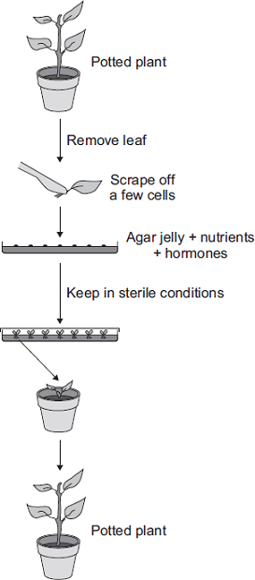
Tissue culture is a type of asexual reproduction.
Give the main features of asexual reproduction .
______________________________________________________________
______________________________________________________________
______________________________________________________________
______________________________________________________________
______________________________________________________________
______________________________________________________________
(3)

Section ten
AQA GCSE Biology topic: B6
Triple-only content: DNA

The genetic material in your cells is made of a chemical called DNA. DNA is a polymer made of many small molecules called nucleotides. Nucleotides contain three sections, bonded in order: a negatively charged phosphate group, a sugar, and a base. While the phosphate and sugar groups are always identical, there are four possible bases: thymine (T), adenine (A), cytosine (C), and guanine (G).
Long DNA molecules (called ‘strands’) are formed when the sugar and phosphate groups of many adjacent nucleotides chemically bind to each other.
The bases of two DNA strands can bind to each other. The two strands form a double-stranded spiral that looks like a twisted ladder, called a double helix. This is how DNA is commonly found in most cells. The bases in DNA always pair up in a specific way: A always binds to T, and C always binds to G. This is known as complementary base pairing.
The order of nucleotides in DNA is known as the genetic code, because it determines many of an organism’s characteristics. In the nucleus, DNA is found in large structures called chromosomes. Short sections of DNA called genes act as blueprints for the production of proteins. Chromosomes usually contain thousands of protein-coding genes.
All of an organism’s genetic information is called its genome. Read about the importance of understanding the human genome here: https://www.bbc.co.uk/bitesize/guides/z9pkmsg/revision/6
The order of nucleotides in a gene determines the order of amino acids in a protein. Every three consecutive bases in a gene correspond to one specific amino acid (for example, the bases TGG always correspond to the amino acid tryptophan). A set of three consecutive nucleotides that codes for an amino acid is called a codon.
A gene is not directly used as a template to build a protein. It acts as a master copy of the code, and remains in the nucleus. To make a protein, a single-stranded copy of the gene is first produced. This molecule, known as mRNA, travels into the cytoplasm for protein synthesis.
In the cytoplasm the mRNA travels to the ribosomes, where protein synthesis occurs. The correct amino acid is delivered to each codon on the mRNA by carrier molecules called tRNAs. The main job of the ribosome is to form chemical bonds between these different amino acids. Each protein is made of hundreds or thousands of amino acids joined together in a specific sequence and folded into a unique 3D shape. Each protein’s unique shape is vital for its function.
Not all of the DNA in a chromosome forms protein-coding genes. Other sections of DNA, known as non-coding DNA, can switch other protein-coding genes on or off (controlling whether the protein is produced or not).
Mutations are random changes in the order of nucleotides in DNA. Mutations in non-coding DNA can affect which genes are turned on or off. Mutations in protein-coding genes can cause different or faulty proteins to be made. The majority of mutations are neutral: they have no effect on function.

Practice question:
DNA is a polymer of nucleotides.
(a) Why is DNA described as a polymer?
___________________________________________________________________
___________________________________________________________________
(1)
The diagram below shows part of a DNA molecule.
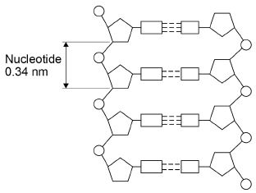
(b) Describe the structure of a nucleotide.
___________________________________________________________________
___________________________________________________________________
___________________________________________________________________
___________________________________________________________________
___________________________________________________________________
___________________________________________________________________
___________________________________________________________________
___________________________________________________________________
___________________________________________________________________
___________________________________________________________________
(4)
(c) Some parts of DNA do not code for proteins.
Describe how non-coding parts of DNA can affect the expression of genes.
___________________________________________________________________
___________________________________________________________________
(1)
Section eleven
AQA GCSE Biology topic: B6
Triple-only content: ideas about evolution

At the beginning of the 19th century, it was widely believed that acquired characteristics could be inherited. Around this time, Jean-Baptiste Lamarck proposed a framework for understanding evolution, based on two key principles: more complex organisms will arise steadily over time; organisms will adapt to their environment over time by inheriting acquired characteristics.
While it is now known that this type of inheritance cannot occur in the majority of cases, Lamarck’s descriptions were formative in developing our modern understanding of evolution. Alongside the work of Charles Lyell, who described how the Earth’s crust had gradually developed over millions of years, Lamarck’s writings were a great source of inspiration for Charles Darwin.
The idea of evolution, or ‘descent with modification’, was not new concept when Darwin published On the Origin of Species in 1859. What was so ground-breaking about Darwin’s theory was his description of the mechanism of natural selection: environmental selection pressures providing some organisms with a selective advantage due to their traits, these traits being inherited by the successful organisms’ offspring due to their hereditable nature, and this process causing changes in trait frequencies in populations over time due to the presence of intraspecific variation.
Darwin’s description of natural selection was based on substantial evidence from both field work and selective breeding. Read more about Darwin’s evidence and ideas here: https://www.bbc.co.uk/bitesize/guides/zcqbdxs/revision/3
Darwin initially presented his ideas on natural selection in 1858 in collaboration with fellow scientist Alfred Russel Wallace, who had independently proposed the same theory. Much of Wallace’s evidence came from his observations of allopatric speciation: when two new species arise from a common ancestor in geographically separate areas due to the different environmental selection pressures they face.
Darwin’s ideas were popularised upon his publication of Origin the following year. While these ideas were controversial in Victorian society, they were gradually accepted by scientists and now stand as one of the most fundamental and important concepts in modern biology. Read more about why Darwin’s ideas were only gradually accepted here: https://www.bbc.co.uk/bitesize/guides/zcqbdxs/revision/4

Practice question:
The eyes of some birds contain cells that detect ultraviolet (UV) light.
UV light is reflected by some fruits and the urine of small mammals.
Explain how birds that detect UV light have evolved from birds that could not detect UV light.
___________________________________________________________________
___________________________________________________________________
___________________________________________________________________
___________________________________________________________________
___________________________________________________________________
___________________________________________________________________
___________________________________________________________________
___________________________________________________________________
___________________________________________________________________
___________________________________________________________________
___________________________________________________________________
___________________________________________________________________
(6)

Darwin’s theory of evolution states that all species of living things have evolved from simple life forms.
Darwin’s theory was published in 1859.
Give two reasons why Darwin’s theory was only slowly accepted.
___________________________________________________________________
___________________________________________________________________
___________________________________________________________________
___________________________________________________________________
(2)

Section twelve
AQA GCSE Biology topic: B7
Triple-only content: energy in ecosystems

Food chains and food webs can be constructed to show how energy is transferred between organisms in ecosystems.
Photosynthetic organisms are at the base of almost every food chain. They are called producers, as they produce complex organic compounds like glucose using carbon from simple molecules like carbon dioxide that are abundant in their environment. Primary consumers obtain their source of chemical energy directly from producers. Above primary consumers are secondary consumers, and above these are tertiary consumers. These different positions in a food web are known as trophic levels.
The amount of biomass or energy at each trophic level can be represented in horizontal bar charts called pyramids. Read more about how to draw a pyramid of biomass here: https://www.bbc.co.uk/bitesize/guides/zs7gw6f/revision/2
At each trophic level, about 90% of biomass is lost (not passed on to the next level). Some biomass will be excreted from the organism in the form of molecules such as carbon dioxide, water, or urea (products of metabolic reactions) before the organism is eaten by consumers. Not all of the organism will be eaten. Some solid waste will also be egested as faeces by the consumer.
Decomposers are a vital component of all ecosystems. Decomposers are bacteria and fungi that secrete enzymes to digest dead matter, then absorb the broken down substances.
When decomposers break down dead matter in anaerobic conditions, methane and carbon dioxide are produced. These greenhouse gases contribute to global warming and the current climate crisis. However, this biogas can also be burned as a source of renewable energy.
Compost (made predominantly from dead plants) and manure (animal waste) can be added to soils to improve their fertility. As these products undergo aerobic decay, vital nutrients such as nitrates are returned to the soil.
Rates of decay can be affected by three main factors. Read more about these here: https://www.bbc.co.uk/bitesize/guides/zy7gw6f/revision/1

Practice question:
A food web contains several food chains. Figure 1 shows a food web.
Figure 1
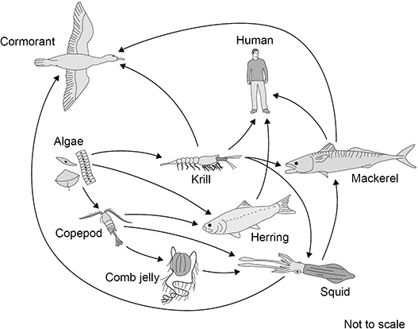
(a) The animals in Figure 1 get their energy by eating other organisms.
Describe how the algae get energy.
___________________________________________________________________
___________________________________________________________________
___________________________________________________________________
___________________________________________________________________
(2)
(b) Name one primary consumer in Figure 1.
___________________________________________________________________
(1)
(c) Name one producer in Figure 1.
___________________________________________________________________
(1)

(d) The different food chains in Figure 1 have different numbers of organisms.
Complete Figure 2 to show a food chain in Figure 1 with five organisms, including the human.
Figure 2
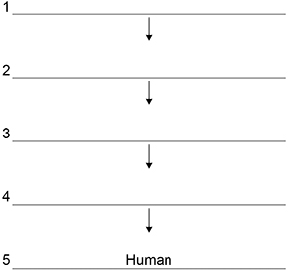
(1)
(e) Figure 1 shows that mackerel eat krill and squid.
The biomass of mackerel is much less than the combined biomass of krill and squid.
One reason for this is that the mackerel cannot digest all parts of the krill and squid.
Give two other reasons.
1 ________________________________________________________________
___________________________________________________________________
2 ________________________________________________________________
___________________________________________________________________
(2)

Section thirteen
AQA GCSE Biology topic: B7
Triple-only content: food security

Food security describes the ability of individuals in an area to access and afford adequate foodstuffs.
Animal agriculture is a major factor affecting global food security. Farming cattle for beef and dairy requires huge amounts of land, food crops, and water. The associated greenhouse gas emissions contribute significantly to climate change. A global shift towards alternative sources of protein, including plant-based meats made of mycoprotein, seitan, and soy/pea protein, could greatly increase food security. As these sources of protein become cheaper, their accessibility will increase. Learn about some of the advantages of plant-based meats for global food security here: https://www.youtube.com/watch?v=kCrQpbHW9_A
Read about some other factors that are reducing global food security here: https://www.bbc.co.uk/bitesize/guides/ztwvk2p/revision/1
New farming techniques can increase food security. Intensive arable farming uses machines, inorganic fertilisers, and pesticides to maximise the production of high-yield crops. Usually, only one crop is grown in an area – this is called monoculture. Many aspects of intensive arable farming – the use of inorganic fertilisers and pesticides, the removal of hedgerows, and monoculture planting – reduce biodiversity. Alternatives to intensive arable farming include organic farming and permaculture. Intensive animal farming involves keeping many animals in confined spaces at high temperatures. Preventing animals from moving or losing heat minimises energy losses, so the growth rate of these animals is accelerated. This is considered unethical by most people.
Many areas of the ocean are drastically overfished. Due to fishing, the populations of many marine organisms have been reduced to critically low numbers. Over 85% of fish species are currently overfished, and fishing has wiped out over 90% of the world’s large fish. Fishing also contributes to climate change and marine pollution. The principle of sustainable fishing promotes keeping the catch rate of fish below the birth rate of new fish, so overall populations do not decrease. Sustainable fishing strategies include designating marine reserves, restricting fishing to certain seasons, imposing quotas on the number of fish that can be caught, and incorporating gaps in nets so that juvenile fish can escape to mature and reproduce. Destructive fishing methods such as bottom trawling, long-line fishing, and blast fishing could be banned. However, sustainable fishing may be difficult to implement due to corruption, misreporting of catches, and illegal fishing. Some people are also concerned that sustainable fishing strategies do not give sufficient protections to mature organisms and large keystone species, which are vital for nutrient cycling and ecosystem stability.

Practice question:
Figure 3 shows how the biomass of adult herring in the North Sea has changed between 1950 and 2010.
Figure 3
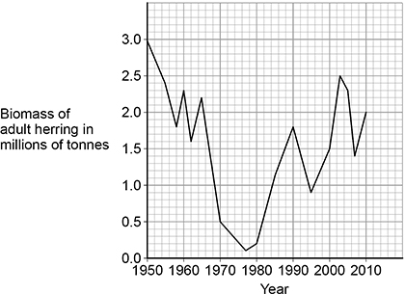
(f) Calculate the percentage decrease in the biomass of herring between 1960 and 1977.
Give your answer to the nearest whole number.
___________________________________________________________________
___________________________________________________________________
___________________________________________________________________
___________________________________________________________________
___________________________________________________________________
___________________________________________________________________
___________________________________________________________________
___________________________________________________________________
Percentage decrease = _______________ %
(4)

(g) Too many herring were caught by fishermen between 1960 and 1977.
Herring can live for up to 12 years and begin to reproduce when 3 to 4 years old.
Laws have been introduced to help conserve herring:
• 1977 to 1981 – herring fishing was banned in the North Sea
• 1984 to present day – control of mesh size of fishing nets
• 1997 to present day – fishing quotas were introduced
• 1998 to present day – herring fishing was banned in breeding grounds during the breeding season.
Figure 4 shows how a minimum mesh size helps to conserve herring.
Figure 4
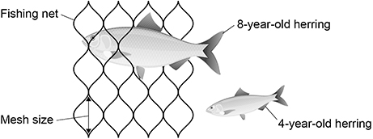
Figure 3 is repeated below.
Figure 3

Evaluate the effect of these laws on the conservation of herring stocks.
Use data from Figure 3 and information from Figure 4 in your answer.
___________________________________________________________________
___________________________________________________________________
___________________________________________________________________
___________________________________________________________________
___________________________________________________________________
___________________________________________________________________
___________________________________________________________________
___________________________________________________________________
___________________________________________________________________
___________________________________________________________________
___________________________________________________________________
___________________________________________________________________
(6)

