
Y8 German
Kapitel 4 – Schule ist klasse
Revision Checklist
I can…
- say which school subjects I like and don’t like
- say what I think of school subjects
- say why I like or don’t like a subject using weil (because)
- say the days of the week
- say on which day I have a subject
- ask and answer questions about times (24-hour clock)
- talk about my school timetable
- use time expressions at a beginning of a sentence
- describe my teachers
- use qualifiers when describing people
- use possessive adjectives sein (his) and ihr (her)
- use connectives and qualifers to raise the level of my writing
- identify items in school
- say what is or is not allowed in school
- use the prepositions in, an, auf and neben to say where things are
- use the verb es gibt to say what there is or there are
- use the singular forms of dürfen
- use man to mean people in general
- skim a reading text for general meaning and use clues to predict what it is about
- use a dictionary or glossary to find meanings and check whether a word is a verb, noun or adjective
- pronounce key sounds such as ei and ie
- ask and answer questions about my dream school
- give a short presentation about my dream school
- evaluate someone else’s presentation

Wörter
Schulfächer School subjects
Deutsch German
Englisch English
Erdkunde geography
Geschichte history
Informatik ICT
Kunst art
Mathe maths
Musik music
Naturwissenschaften science
Sport sport/PE
Technik technology
Theater drama

Meinungen Opinions
mein Lieblingsfach ist … my favourite subject is ...
ich mag … (sehr) I like ... (a lot)
ich liebe I love
ich mag … nicht I don’t like ...
ich hasse I hate
gut good
toll great
furchtbar awful
einfach easy
schwierig difficult
interessant interesting
langweilig boring
nützlich useful
nutzlos useless
faszinierend fascinating
nervig irritating
supercool really cool
stinklangweilig dead boring
Die Wochentage The days of the week
Montag (Mo.) Monday
Dienstag (Di.) Tuesday
Mittwoch (Mi.) Wednesday
Donnerstag (Do.) Thursday
Freitag (Fr.) Friday
Samstag (Sa.) Saturday
Sonntag (So.) Sunday
Was hast du am Montag? What do you have on
Monday?
Am Dienstag habe ich … I have ... on Tuesday
Am Sonntag haben wir We have no school on
keine Schule. Sunday.

Die Zeit Time
Wann? When?
Um wie viel Uhr? At what time?
Um 8:30 Uhr (acht Uhr dreißig). At 8.30.
Wie viel Uhr ist es? What time is it?
Es ist 9:50 Uhr (neun Uhr fünfzig). It’s 9.50.
in der ersten Stunde in the first lesson
vor der Pause before break
nach der Mittagspause after the lunch break

Eigenschaften Characteristics
Er/Sie ist … He/She is …
alt old
fair fair
freundlich friendly
jung young
launisch moody
lustig funny
nervig annoying
streng strict
unpünktlich unpunctual
In der Schule In school
die Lehrerin(-nen) teacher(s) (female)
die Deutschlehrerin(-nen) German teacher(s) (female)
der Lehrer(–) teacher(s) (male)
der Sportlehrer(–) sports teacher(s) (male)
Was gibt es? What is there?
Es gibt einen/eine/ein … There is a ...
Es gibt viele … There are lots of ...
das Klassenzimmer(–) classroom(s)
der Tisch(-e) table(s)
der Stuhl(-¨e) chair(s)
der Computer(–) computer(s)
das Whiteboard(-s) whiteboard(s)
das Poster(–) poster(s)
das Fenster(–) window(s)
die Wand(-¨e) wall(s)
die Tür(-en) door(s)
der Korridor(-e) corridor(s)
Wo ist das? Where is it?
in der Schule in the school
im Klassenzimmer in the classroom
im Korridor in the corridor
an der Wand on the wall
am Fenster by the window
am Tisch at the table
auf dem Tisch on the table
neben der Tür near/next to the door
Oft benutzte Wörter High-frequency words
weil because
sein/seine his
ihr/ihre her
zu too
sehr very
ziemlich quite, fairly
ein bisschen a bit
nicht not
haben to have
sein to be
in in
an at, by, on (wall)
auf on (top of)
neben near, next to
heute today
morgen tomorrow
vor before
nach after
Grammar

Using weil to give reasons and opinions

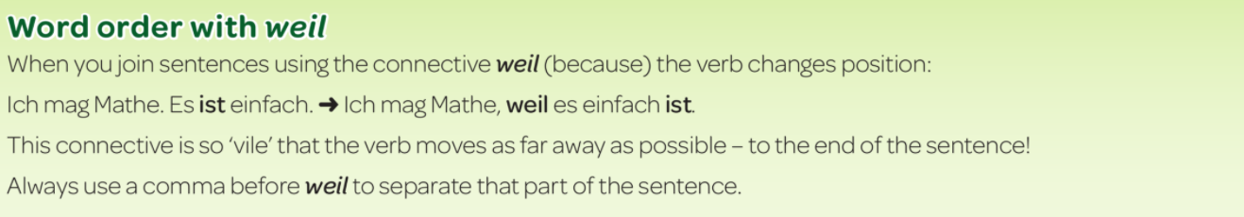

Using correct word order with time expressions

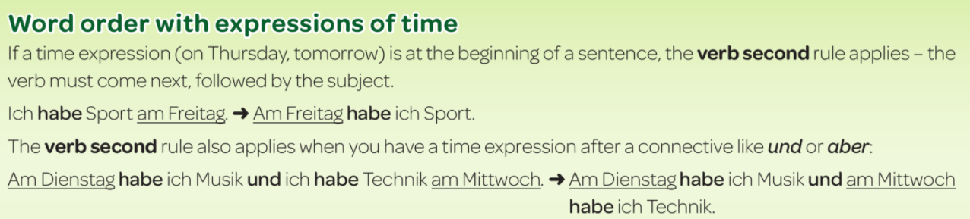

Using sein (his) and ihr (her)
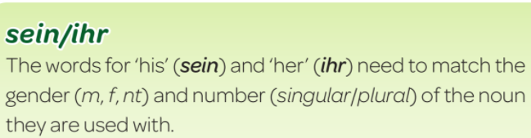

Using the prepositions in, an, auf, neben

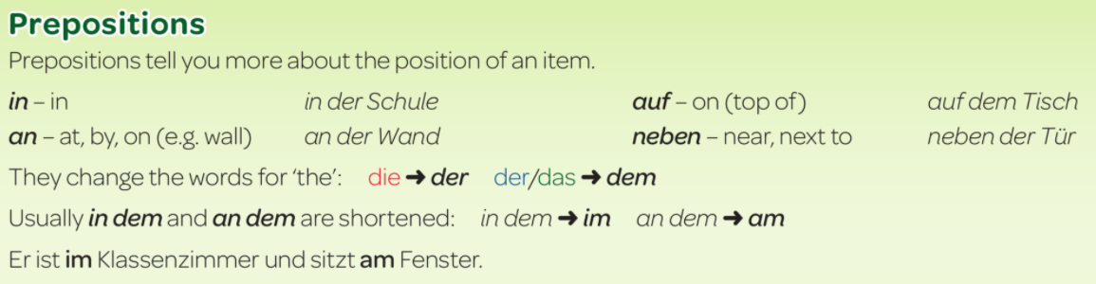

Using es gibt

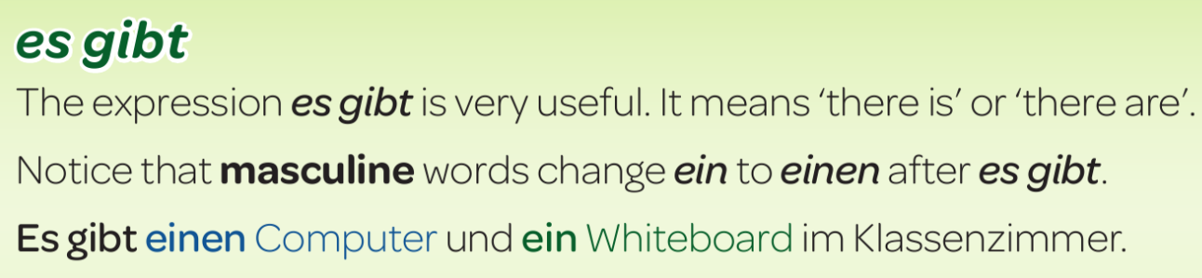

Using the modal verb dürfen

