

**Y8 Spanish**

**Module 1 – Mi vida**

**Revision List**

I can…

|  |  |
| --- | --- |
| * say hello and goodbye |  |
| * ask questions |  |
| * say what I am called |  |
| * say where I live |  |
| * ask someone how they are and say how I am |  |
| * use **el**, **la**, **los** and **las** correctly |  |
| * use phonics to help me pronounce words |  |
|  |  |
| * ask someone what they are like |  |
| * say what I am like |  |
| * say what my passion is and who my hero is |  |
| * use the verb **ser** (to be) |  |
| * make adjectives agree |  |
| * use connectives |  |
|  |  |
| * count up to 15 |  |
| * ask someone their age and say my age |  |
| * ask someone if they have any brothers or sisters |  |
| * say whether I have brothers and sisters |  |
| * use the verb **tener** (to have) |  |
|  |  |
| * count up to 31 |  |
| * ask someone when their birthday is |  |
| * say when my birthday is |  |
| * say the Spanish alphabet |  |
| * ask and say how to spell words |  |
|  |  |

|  |  |
| --- | --- |
| * ask someone whether they have a pet and say what pet I have |  |
| * say what colour my pet is |  |
| * describe my pet |  |
| * use adjectives correctly |  |
| * use intensifiers |  |

|  |  |
| --- | --- |
|  |  |
| * add variety to my writing by using connectives and intensifiers, different verb forms and adjectives |  |
| * assess my own and my partner’s written work |  |

Palabras

**Saludos *Greetings***

¡Hola! Hello!

¿Qué tal? *How are you?*

Bien, gracias. Fine, thanks.

fenomenal great

regular not bad

fatal awful

¿Cómo te llamas? What are you called?

Me llamo… I am called…

¿Dónde vives? Where do you live?

Vivo en… I live in…

¡Hasta luego! See you later!

¡Adiós! Goodbye!

**¿Qué tipo de persona eres? *What sort of person are you?***

Soy… I am...

divertido/a amusing

estupendo/a brilliant

fenomenal fantastic

generoso/a generous

genial great

guay cool

listo/a clever

serio/a serious

simpático/a nice, kind

sincero/a sincere

tímido/a shy

tonto/a silly

tranquilo/a quiet, calm

**Mi pasión *My passion***

Mi pasión es… My passion is…

Mi héroe es… My hero is…

el deporte sport

el fútbol football

la música music

el tenis tennis

**¿Tienes hermanos? *Do you have any brothers or sisters?***

Tengo… I have…

una hermana a sister

un hermano a brother

una hermanastra a half-sister/stepsister

un hermanastro a half-brother/stepbrother

No tengo hermanos. I don’t have any brothers or sisters.

Soy hijo único./Soy hija única. I am an only child. (male/female)

**Los números 1–31 *Numbers 1–31***

uno *1*

dos *2*

tres *3*

cuatro *4*

cinco *5*

seis *6*

siete *7*

ocho *8*

nueve *9*

diez *10*

once *11*

doce *12*

trece *13*

catorce *14*

quince *15*

dieciséis *16*

diecisiete *17*

dieciocho *18*

diecinueve *19*

veinte *20*

veintiuno *21*

veintidós *22*

veintitrés *23*

veinticuatro *24*

veinticinco *25*

veintiséis *26*

veintisiete *27*

veintiocho *28*

veintinueve *29*

treinta *30*

treinta y uno *31*

**¿Cuántos años tienes? *How old are you?***

Tengo… años. I am… years old.

¿Cuándo es tu cumpleaños? *When is your birthday?*

Mi cumpleaños es el… de… My birthday is the… of…

enero January

febrero February

marzo March

abril April

mayo May

junio June

julio July

agosto August

septiembre September

octubre October

noviembre November

diciembre December

**¿Tienes mascotas? *Do you have pets?***

Tengo… I have…

un caballo a horse

una cobaya a guinea pig

un conejo a rabbit

un gato a cat

un perro a dog

un pez a fish

un ratón a mouse

una serpiente a snake

No tengo mascotas. I don’t have any pets.

¿Cómo es? What is it like?

¿Cómo son? What are they like?

**Los colores *Colours***

blanco/a white

amarillo/a yellow

negro/a black

rojo/a red

verde green

gris grey

marrón brown

azul blue

rosa pink

naranja orange

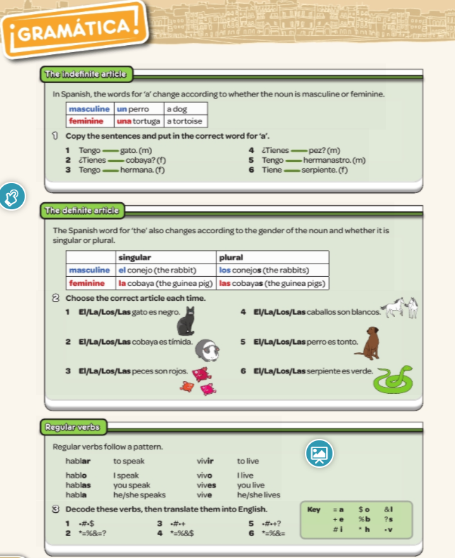

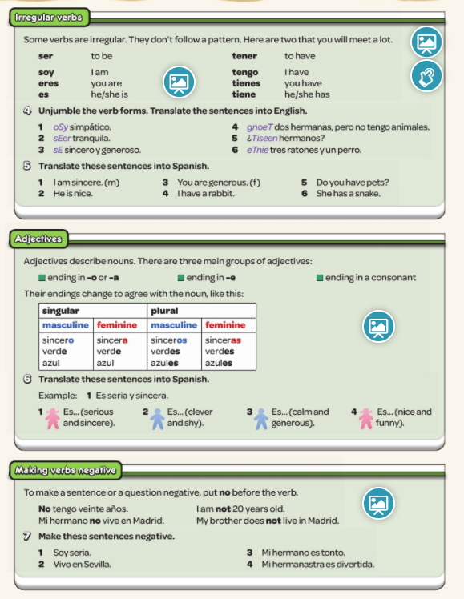

**Palabras muy frecuentes *High-frequency words***

bastante quite

no no/not

mi, mis my

muy very

pero but

también also, too

tu/tus your

un poco a bit

y and