Music
Year 7
In Year 7 students complete six projects, one per half-term. These are assessed formatively as well as summatively, based on students’ work across the unit.

Autumn 1: Arriba and Celebration Singing
Equipment you will need: Practical assessment - all equipment provided except own pen and iPad.
Assessment Guidance
You will complete a practical assessment where you will play the Arriba melody and your own newly composed ideas on the xylophone or glockenspiel. In order to achieve well, you will need to have rehearsed the melody in the lesson in the time given and used this to help devise your own ideas. Understanding the key vocabulary below will assist you with your assessment.
Revision List
Arriba
Content | Revised
I know what the word ‘pentatonic’ means
I know what the word ‘melody’ means
I know what the word ‘accompaniment’ means
I know what the word ‘scat’ means
I know what the word ‘chord’ means
I know what dynamics are
I know the order of the note names in the Arriba melody – GAGBAGD, GAGBAG, GAGBAGD, EGGEGAG
I can identify similarities and differences across the four lines of the Arriba melody
I can sing the melody confidently
I can perform the melody fluently and accurately on a barred instrument
I can give a musical performance

Music
Year 7
Autumn 2: West African Drumming and Stomp
Equipment you will need: Practical assessment – all equipment provided except own pen and iPad.
Assessment Guidance
You will complete a practical assessment whereby you will compose a polyrhythmic piece inspired by West African drumming and Stomp.
Revision List
Stomp and West African Drumming
Content | Revised
I know what the word ‘polyrhythm’ means
I know what the word ‘pulse’ means
I know what the word ‘rhythm’ means
I know what the word ‘tempo’ means
I know what the word ‘syncopation’ means
I know what texture is
I know what call and response means
I can recognise and explain note values including semiquaver, quaver, crotchet, minim and semibreve:

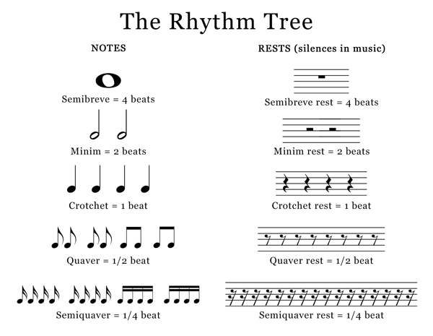
I can notate a four-beat rhythm using different note values
I can perform a four-beat rhythm using different note values
I can perform a four-beat rhythm using different note values and keep to a steady pulse whilst others perform different rhythms
I can alter my use of the musical elements to create variety within my group’s composition

Music
Year 7
Spring 1: Keyboard Skills
Equipment you will need: Practical assessment – all equipment provided except iPad and own pen.

Assessment Guidance
You will complete a practical assessment whereby you will perform a keyboard piece as a soloist or as part of a duet in front of the class.

Revision List
Keyboard Skills
Content | Revised
I can identify basic rhythm values (see Stomp and West African Drumming)
I can identify notes in the treble clef
I can identify notes in the bass clef
I can demonstrate a good keyboard hand position, with curved fingers and thumb on Middle C
I can find the notes CDEFGAB on the keyboard
I can play my given piece with one hand separately, fluently and confidently
Extension: I can play both hands together
Extension: I can add dynamics and phrasing to my performance
Extension: I can play as part of a duet with someone else

Music
Year 7
Spring 2: Ukulele Skills
Equipment you will need: Practical assessment – all equipment provided except iPad and own pen. Some students may like to bring in their own ukulele or guitar from home, but this is not essential.

Assessment Guidance
You will complete a practical assessment which will involve creating your own small group singing and ukulele performance.

Revision List
Ukulele and Guitar
Content | Revised
I know what the word ‘chord’ means
I know what the words ‘melody’ means
I know what the word ‘accompaniment’ means
I can explain how to form the C, F and Am chords on the ukulele
I can form the C, F, and Am chord on the ukulele
I can explain how to form the G chord on the ukulele
I can form the G chord on the ukulele
I can strum a chord progression using at least two chords, keeping a steady tempo
I can perform my given song as part of a small group, both playing the ukulele/guitar and singing.
I can add changes in texture to my performance to make it more interesting
I can add changes in dynamics to my performance to make it more interesting

Music
Year 7
Summer 1: Animal Music
Equipment you will need: Practical assessment – all equipment provided except iPad and own pen.

Assessment Guidance
You will complete a practical assessment whereby you will compose a piece that represents an animal through its use of the musical elements. You will compose as part of a pair using GarageBand.

Revision List
Animal Music
Content | Revised
I can define timbre
I can define instrumentation
I can define structure
I can aurally identify some common orchestral instruments
I can explain how I could alter the musical elements to create a particular mood
I can compose a catchy melody that represents my animal via its characteristics
I can use musical elements appropriately to accompany my melody and use these in a way that reflects the characteristics of the animal
I can choose an appropriate timbre to represent my animal
I can use dynamics appropriately to represent my animal

Music
Year 7
Summer 2: Steel Pans
Equipment you will need: Practical assessment – all equipment provided except iPad and own pen.

Assessment Guidance
You will complete a practical assessment whereby you will perform ‘Nice ‘n’ Easy’ as part of a whole class steel pan ensemble.

Revision List
Steel Pans
Content | Revised
I know where steel pans come from
I know how a steel pan is made
I can identify the four types of steel pan and their roles in an ensemble
I can define melody and accompaniment
I can name the notes in the C major chord
I can name the notes in the F major chord
I can name the notes in the G major chord
I can play a syncopated chord progression using the chords C, F and G, in time with a steady pulse, with a memory aid of the notes required in each chord
I can play a syncopated chord progression using the chords C, F and G, in time with a steady pulse, from memory
I can include ‘stops’ in my playing, without disrupting the fluency
(Tenor players): I can play the melody from memory
I can add dynamics and phrasing to my performance
I can play with good steel pan technique – holding sticks with a loose grip and mid-way down

