Year 11 Media Studies Homework Booklet
AUTUMN


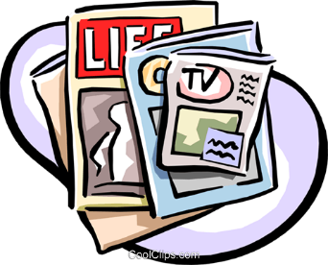

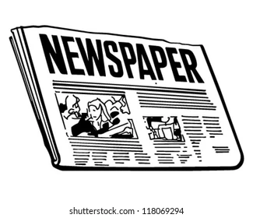


Each week you should complete one task from the booklet. You should spend 45 minutes on each task.

CONTENTS
Task 1: Television
Task 2: Television
Task 3: Television
Task 4: Television
Task 5: Television
Task 6: Newspapers
Task 7: Newspapers
Task 8: Newspapers
Task 1: TELEVISION
Research the television franchise Doctor Who and the television series His Dark Materials. Explore the following and create a mind map for each:
Doctor Who:
- Where the idea for the series came from
- How much money does it make the BBC
- Why Doctor Who is important to British culture
- How many spin offs Doctor Who has
- The basic premise of the programme
His Dark Materials:
- How Phillip Pullman feels about the television show
- How close is the series to the books
- How much money does it make the BBC and HBO
- What are some other programmes available for streaming that are similar to HDM?
- The basic premise of the programme

Task 2: TELEVISION
Create a basic character list for our episodes: An Unearthly Child – Doctor Who (1963) and The City of Magpies – His Dark Materials (2020). This can be done in your book or on flashcards. Include any relevant information that you feel is necessary to understanding the plot of each episode.
Use your remaining time for your homework to work on your coursework.

Task 3: TELEVISION
Answer the questions below in full sentences in your homework book.
- Define hybrid genre. Which of our episodes are hybrids? Explain your thinking in at least 3 sentences. 6 marks
- How is the genre of ‘The City of Magpies’ demonstrated in the episode? Use one scene from the episode we watched in lesson. Aim to write at least 6 sentences using both media terminology and specific examples from the episode. You can access the episode on iPlayer. 8 marks
- How are narrative features used to grab and hold the audience’s attention in the opening scene of The City of Magpies? Answer with reference to narrative development and the audience appeal of the narrative. Use the opening sequence that begins “Previously on His Dark Materials”. This can be accessed on iPlayer. 12 marks
Use your remaining time for your homework to work on your coursework.

Task 4: TELEVISION
Answer the questions below in full sentences in your homework book.
- List the 3 codes we use in Media Studies (using your flashcards!). Spend 10 minutes making notes for each code for each episode. For example, list a few common symbolic codes that we can see in An Unearthly Child & His Dark Materials.
- How is the genre of ‘An Unearthly Child demonstrated in the episode? Use one scene from the episode we watched in lesson. Aim to write at least 6 sentences using both media terminology and specific examples from the episode. You can access the episode in the files section on Teams. 8 marks
- How are narrative features used to grab and hold the audience’s attention in the Tardis scene of An Unearthly Child? Answer with reference to narrative development and the audience appeal of the narrative. This can be found in the files section of Teams. 12 marks
Use your remaining time for your homework to work on your coursework.

Task 5: TELEVISION
Spend 10 minutes planning your answer using your notes from lesson. Set a timer for 20 minutes and write a full response to the question below.
“Social and cultural contexts have always influenced the representation of young characters in television drama.” How far do you agree with this statement?
Answer with reference to:
- Dr Who “An Unearthly Child” (1963)
- His Dark Materials “The City of Magpies” (2020)

Use your remaining time for your homework to work on your coursework.

Task 6: NEWSPAPERS
- Google the Wikipedia page for “The Mirror” and “The Times” and create a brief mind map about the history of their newspaper. [10 minutes]
- You are going to have to find some additional ‘context’ about both papers. You need to find out what ‘wing’ they are and what genre of newspaper they fall under. ‘Wing’ refers to political alliance, meaning Liberal or Conservative. [15 minutes]
- Now that you have established the political alliance of both papers, you need to find out what it means to be left wing or right wing. Use your iPad to research the definition of both. [5 minutes]
Use your remaining time for your homework to work on your coursework.

Task 7: NEWSPAPERS
- What is the role of the Independent Press Standards Organisation (IPSO) 2 marks
- What is a broadsheet newspaper? Make a list of the codes and conventions. [10 minutes]
- What is a tabloid newspaper? Make a list of the codes and conventions. [10 minutes]
- Analyse both front covers of the newspapers on our exam. If you do not have printed copies, please go to Teams and find the digital copy. What do the various elements of it (colour, language, layout etc) suggest about the paper’s ideology and its intended audience? Write 2-3 sentences for each newspaper. [10 minutes]
Use your remaining time for your homework to work on your coursework.

Task 8: NEWSPAPERS
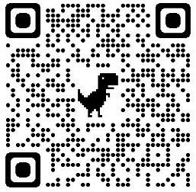
- You need to now make an audience profile for both the Mirror and the Times. Use the links below to find out some information. You will also want to take notes on circulation number.
https://www.hurstmediacompany.co.uk/daily-mirror-profile/

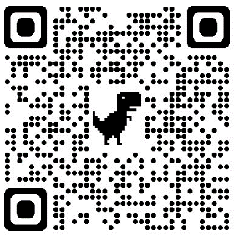
https://www.hurstmediacompany.co.uk/the-times-profile/

This should take about 15 minutes to complete.
- How are newspapers regulated? Go to their website and spend 10 minutes skimming through the editor’s codes of practice https://www.ipso.co.uk/editors-code-of-practice/. Please choose the 5 most important codes of practice and write a sentence explaining the purpose of each.
Use your remaining time for your homework to work on your coursework.

