Year 10 Media Studies Homework Booklet
AUTUMN
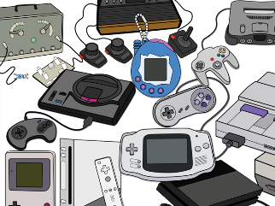






Each week you should complete one task from the booklet. You should spend 45 minutes on each task.

CONTENTS
Task 1: Introduction to Media Terminology
Task 2: Mediation Formative Assessment
Task 3: Magazines
Task 4: Magazines
Task 5: Magazines
Task 6: Magazines
Task 7: Advertising
Task 8: Advertising
Task 9: Advertising
Task 10: Advertising
Task 11: Advertising
Task 12: Advertising

Task 1: Introduction to Media Terminology
Create a mind map in your homework book about this front cover of Tatler from October 2023. Spend 5 minutes making notes about what you notice, the layout, the colours and the topics referenced in the coverlines (e.g. CHIC! The social season that rocked)
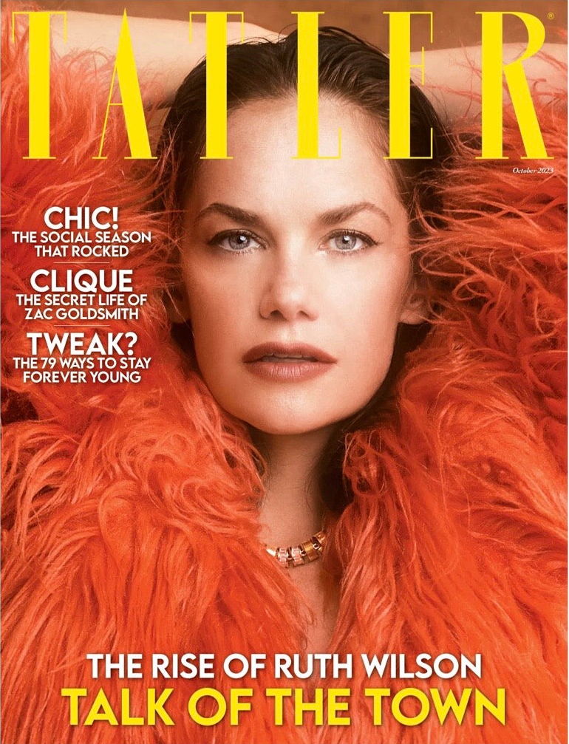
Now, add to your mind map who you think this magazine is targeting using the below prompts. Be sure to include a brief explanation as to why you think this way:
Geographic: where do they live?
Demographic: How old are they? What gender is the target audience? How much money do they make?
Psychographics: What does it say about their personality? Interests? Values? Beliefs?

Using some of the media terminology used in your most recent lessons, answer the below question in 1 paragraph:
How has Tatler organised their front cover to target a specific audience?

Task 2: Mediation Formative Assessment
Brief: You have been asked to create an upmarket magazine front page for CCC on the topic that we are an ‘Outstanding’ school.
Using the images you took in lesson and the app Moldiv (or one similar) you are to create a front cover of a magazine called ‘Chesterton Monthly’ that fits the brief. Use the success criteria below to help you:
‘Outstanding’ Magazine Front Cover: Success Criteria
- I have an edited main image
- I have edited all secondary images
- I have a ‘house style’
- I have a consistent font that connotes ‘outstanding’
- I have a main cover line for my main image
- I have the masthead ‘Chesterton Monthly’ at the top of the magazine
- I have demonstrated my creative understanding of the task
- I have considered how I will use my images and coverlines to draw the audience’s focus to the success of Chesterton.
Please submit your work as an attachment on Teams (not a screenshot!) and these will be printed and glued in your feedback book.
Task 3: Magazines

- Define ‘high brow’ and ‘low brow’ culture using your iPads.
- Bauer Media owns Heat magazine. Go to their website and read about them. https://www.bauermedia.co.uk/brands/heat/ Write down at least 3 key pieces of information that you think is important to know about Bauer Media’s brand and/or Heat magazine’s brand. Feel free to copy quotes directly from the website.
- How does the front cover engage audiences with possible narratives? Look for stories, cliff-hangers, dramatic cover lines etc. and copy a few down in your homework book. Why would an audience engage with these? Give at least 1 reason for each example.

- What are paparazzi images and why are they crucial to the front cover of Heat?

- What does this front cover suggest about representations of social class in the British media?

Task 4: Magazines
- Go to Tatler’s website and read about them. https://www.tatler.com/ Write down at least 3 key pieces of information that you think is important to know about Tatler’s brand. Feel free to copy quotes directly from the website.
- Looking at their website, find 3 ways in which Tatler tries to appeal to a younger audience. For each, explain why this method may or may not be successful.
- How old is Tatler? When was it founded?
- Who is their target audience?
- What kind of magazine are they? What sorts of topics/issues do they focus on?
- Are there other versions of Tatler in other countries?

Task 5: Magazines
- What differences can you find between the use of design and typography between Tatler and Heat? List at least three differences and explain the effect on audiences.
- How do Heat and Tatler represent social class? What different social classes can you find in the features and celebrities on the cover? (E.g. middle/upper class / working class)
- Choose 3 coverlines from each front cover that you would like to learn for the assessment. Spend some time making some notes on these (Media Language + Media Representations) and you can turn these into revision flashcards.

Task 6: Advertising Galaxy
- Watch the following YouTube videos https://www.youtube.com/watch?v=eXQyxbVoyAE (Quality Street all the fun of the share) and https://www.youtube.com/watch?v=cUXTN6ENsKQ (Cadbury roses advert). Now, watch the advert from our CSP list. You can find this on Teams or here: https://www.youtube.com/watch?v=Z6HKWuZPrdU
  - What similarities do you notice?
  - How are the adverts you’ve watched similar to the Galaxy ad?
  - Has attitudes towards confectionary advertising changed? Explain your reasoning.
- This CSP is a moving image! Meaning it is an advertisement created for television. You will need to know Media Language, Media Representations and Social/Cultural context for this CSP. Watch the Galaxy advert again and answer the following questions:
  - Do you like the advert? Why?
  - Who is in the advert?
  - Do you want to buy the chocolate bar? Why?
  - Who is the target audience for this product? Use examples from the CSP to support your reasoning.
  - What do you think is Galaxy’s Unique Selling Point (USP)?
- Media Representations (Of place, celebrity persona, Galaxy chocolate, a historical period, nostalgia, masculinity and femininity, class and age). Identify the stereotypes in the advert and explain their function in one sentence. How are the choices made by the producers of this advert in order to convey particular viewpoints, messages, values and beliefs?

Task 7: Advertising Galaxy
- MEDIA LANGUAGE: Describe the narrative of the advert from the perspective of Todorov (identify the disruption and attempt to repair), Propp (Hero, Villain, Helper, False Hero) and Strauss (identify 3 binaries).
- MEDIA LANGUAGE: Can you explain how the resolution and at least one binary are used to make the product more appealing to the audience?
- MEDIA REPRESENTATIONS: what extent does the advert reinforce or subvert gender stereotypes?
- MEDIA REPRESENTATIONS: How is the use of stereotypes intended to appeal to the audience of the advert?
- MEDIA REPRESENTATIONS: How does Hepburn’s Star Image help to promote the chocolate to the target audience?
- MEDIA CONTEXTS: What is consumer culture? Find out about it. What are the negatives/positives about it?
- MEDIA CONTEXTS: Compare the Hepburn ad with the earlier Galaxy ads we have watched. How have the brand’s messages and values changed? What has stayed the same?
Task 8: Advertising OMO
- Why do advertisers use stereotypes? How does this reflect the historical context in which it was created? Answer with reference to the OMO advertisement. [16 mark Question]
In your answer you should refer to:
a) Semiotic Analysis (denotation/connotation)
b) Audience reception
c) Marketing claim/strategies
d) Social attitudes/gender roles
Set a timer 5 minutes to plan an answer to this question. Set a timer for 20 minutes to answer this question. Aim to write 3 short paragraphs.
- Set a timer for 10 minutes and annotate the sample answer below for things that it has done well. Once you are done, make at least 2 changes to your original answer.
Advertisers generally use positive images of stereotypes to endorse products. In the OMO advertisement, an image of a happy, hardworking and proud mother is used to appeal to the target audience. This positive image is used because it is quickly recognised by the target audience – domestic working women in the context of this advert.
This instant recognition means that the advertiser can spend less time presenting the person or the scene. The hope is that the quick recognition will mean that the image will become imprinted on the mind. In the context of this advertisement, the stereotypical image that the advertisement wishes to imprint is one of a mother who takes exceptional pride in the ‘brilliantly bright’ whiteness of the washing and finds the OMO product that delivers this exciting.
Through this, the advertiser aims to compel the target audience to buy the product. In this case the target audience will feel compelled to buy OMO because they wish to add brightness to whiteness just like the stereotypical, hardworking and happy woman that they recognise and can identify with.
Task 9: Advertising OMO
- What core messages are created around the product through the mise en scene and the copy? Answer in full sentences. 8 marks
- How is gender represented throughout this advert for OMO? Answer in full sentences and provide specific examples from the print advert. Answer in full sentences. 8 marks
- Explain how the product helps us to appreciate the influence of context on the changing appearance, values and messages of adverts over time. Answer in full sentences. 12 marks. Read the sample answer below to the ‘contexts’ question before writing your own response.
Advertisements often reflect the social attitudes of their time and the OMO advert was produced in the 1950s; a time when fewer women worked in paid employment than today and many stayed at home. The image used in this advert reflect the stereotypical attitudes of that time where married women were judged by the quality of their domestic work and by their appearance. This is clearly different to today where there is much greater equality between genders, women in the workplace is much more common and the burden of home and family often falls between the genders.
In many 1950s adverts, there was often an authoritative male and a submissive female. This is the connotation of this OMO advert as the woman is expressing her satisfaction and self esteem that she is the ‘perfect’ housewife and links to Maslow’s hierarchy of needs in satisfying the self-esteem aspect of our human needs. This links to many images of women in film through role models like Audrey Hepburn and American TV programs like The Donna Reed Show.
The language used in the advert is very different to today. OMOs claim that it ‘makes whites bright’ may not be acceptable today as the advertising industry is closely regulated by the ASA. In the 1950s, exaggerated claims about products were commonplace. Greater policing of claims now means that claims by companies about the effectiveness of products have to be much more ‘provable’ in scientific terms.

Task 10: Advertising NHS
- What is a niche audience?
- What are the conventions of a music video and how do these make it a good format to mix with an advert aimed at a young, BAME audience?
- How successful do you think the hybridity of the advert is in appealing to the target audience?
- How effective do you think the lyrics are in combo with the visuals?

Task 11: Advertising NHS
- How does the shot encourage BAME people to donate blood? How does the shot establish a positive narrative around BAME communities? In order to answer these questions follow the steps below:
- Press play
- Pause on a shot that you think is significant
- Make notes on what messages are being created in the mise en scene
- Now write a paragraph for this question

- Set a timer for 10 minutes and answer the question: Intertextuality and hybridity are used to gain the attention of the audience. How far is this true of the Represent, NHS advert?

Task 12: Advertising
Compare and contrast the NHS ad with the Galaxy ad. First, compare their target audiences. Then compare their brand messages. Then compare how both organizations have tried to appeal to their target audience through the content of their adverts. [20 marks]
Set a timer 5 minutes to plan an answer to this question.
Set a timer for 15 minutes to answer this question. Aim to write at least 3 paragraphs.

