
OCR Classical Civilisation GCSE
Myth and Religion Unit 1.1
Greek & Roman Gods
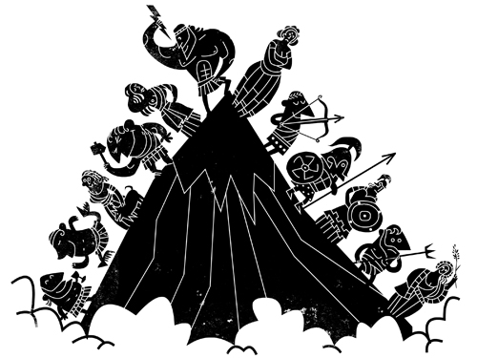
HOMEWORK SCHEDULE:
Week | Pages
1 | 1-4
2 | 5-6
3 | 7
4 | 8
5 | 9
6 | 11-12

Name & form: ________________________________

Topic Overview
Greek and Roman gods, their responsibilities and symbols and how they are typically represented in ancient Greek and Roman art
Greece: Zeus, Hera, Demeter, Poseidon, Hephaistos, Apollo, Artemis, Athena, Aphrodite, Ares, Dionysos, Hestia,Hermes, Hades
Rome: Jupiter, Neptune, Vulcan, Mercury, Mars, Pluto, Apollo, Juno, Venus, Minerva, Diana, Bacchus, Vesta and Ceres
The prescribed source for this topic is: Homeric Hymn to Demeter (in sources booklet)

Ancient Religion: Introduction
Ancient religion was very different from modern Christianity because its followers worshipped not just one God (monotheism) but several different gods (polytheism).
The ancient Greeks and Romans were a polytheistic culture.
The collective term used when referring to all of the gods together is the pantheon (we will also meet a temple with the same name later in the course – so don’t get confused!)
They believed that each of their many gods was responsible for a different area of life (e.g. music, farming, archery, the sea…) and they would choose which god/s to worship depending on what was important to them at the time.
Another important difference from Christianity is that the Greeks and Romans did not worship their gods because they loved them, or because they felt that it was the right thing to do. They presented gifts (animal sacrifices, war spoils, offerings of food, oil and wine) only in order to get something in return.
Worshipping a god was more like making a deal or a transaction – you were “paying” for a favour that you hoped to receive.
On the whole, gods were worshipped communally rather than privately. Sacrifices and offerings were made at temples and shrines, and festivals which involved the whole city took the place of individual prayer.
Although they believed that their gods had supernatural powers, these gods were also very human (they were anthropomorphic) – i.e. they had human forms and many human characteristics and vices.
The Greeks and Romans believed that the gods could easily become angry or jealous, that they had human favourites, and that they often misbehaved! According to the myths and stories, gods could appear to humans, interact with humans, and sometimes even have children with them.
In addition to their individual responsibilities, each Greek god or goddess had its own specific way of being represented in art (mostly on vases or in sculpture). Usually these were linked to their responsibilities – for example, Zeus often has a crown and an eagle because he is king of the gods, and he carries a thunderbolt because he is in charge of the weather. This is known as iconography.
The Greeks and Romans did not actually have a word for religion! Instead they used the words hiera (holy affairs) and religio (the correct worship of the state gods).
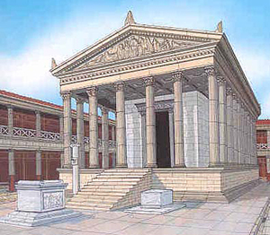
This is important as we should not think of Greek and Roman religion as purely based on faith. It was not enough to just believe in the gods; Greek and Roman religion was all about action (physically worshipping the gods through performing sacrifices and making offerings).
N.B. When talking about Greek and Roman religion, “gods” is written with a lower-case “g” – only use a capital when talking about the Christian “God” (His name)!

Answer in your books:
- What are the advantages of a religion with lots of gods?
- What are the disadvantages?
- Which areas of ancient life do you think the 12 most important gods would need to be in charge of?

Check that you know the key terms by matching them with the definitions – there is one new word which is matched up for you!
pantheon giving human form or characteristics to something non-human
iconography the belief in many gods
polytheism the symbols attached to a character when shown in a picture
hiera correct worship of state gods
religio collective term given to all gods
anthropomorphism holy affairs
epithets word or phrase applied to a god to describe a quality they had

GREECE VS. ROME
There are three sections in your final exam – the first is on Greece, the second is on Rome, and in the third section you have to compare and contrast both cultures.
Therefore it is very important that you know the names of and key facts about the Greek and Roman gods, as well as the key differences between the two.
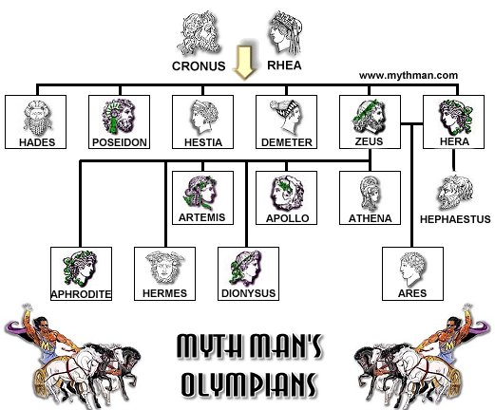
The 14 Greek gods you need to know are pictured here.

Why are they known as Olympians?

Which god is not an Olympian and why?
Before Rome was founded in 753 BC, Italy was divided into lots of different tribes. One of the biggest of these were the Etruscans. When the Roman empire began they took on lots of Etruscan customs and ideas.
Both the Romans and Etruscans were also very influenced by the Hellenes (another word for the Greeks). This is because lots of Greeks had migrated and taken over areas in Sicily and the south of Italy. These areas became known as Magna Graecia (Great Greece) because so many of them lived there.
As you might know, the Romans copied the Greeks and adapted many parts of their culture – religion was no exception.
Use the info above and p13 to write down the following definitions in the glossary at the end of this booklet: a) Etruscans b) Hellenes c) Magna Graecia?
Greek and Roman names | Responsibilities | Iconography | Extra Info.
Zeus/Jupiter

Poseidon/Neptune

Hades/Pluto

Hera/Juno

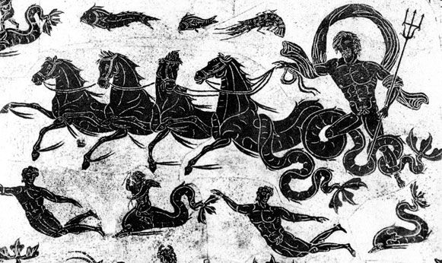
Answer in your books using the pages mentioned in the textbook:
Who were the Titans and Cronos? P7 yellow box
Why did Poseidon hate Odysseus in the Odyssey? P7
Why did Hera hate the Trojans? P8
Where was the temple of Jupiter Optimus Maximus in Rome? Why was this place important? P14

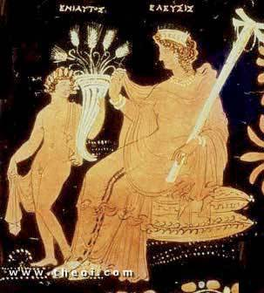
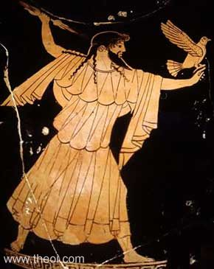
Label the iconography you recognise in the sources
Greek and Roman names | Responsibilities | Iconography | Extra Info.
Athene/Minerva

Demeter/Ceres

Hestia/Vesta

Hephaistos/Vulcan

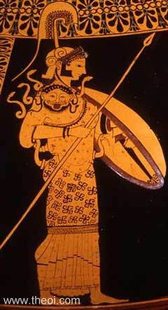
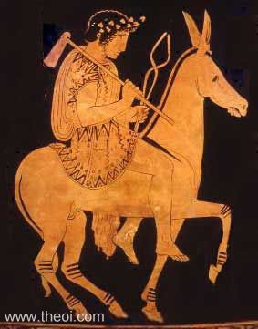
Label the symbols you recognise in the sources
Answer in your books referring to the pages in the textbook:
What was weird about Athene’s birth? Who was her mother? P9
What has the Parthenon got to do with Athene? P9
What were the Eleusinian Mysteries and the Cerealia? P9-10
Why did Hephaistos/Vulcan have a limp? P10

Greek and Roman names | Responsibilities | Iconography | Extra Info.
Aphrodite/Venus

Artemis/Diana

Apollo/Apollo

Hermes/Mercury

Answer in your books referring to the pages in the textbook:
Which god was Aphrodite married to and which one did she have an affair with? P10
Which god has the epithet Phoebus and why? P11
Who was Servius Tullius and how was he linked to the goddess Diana? P16

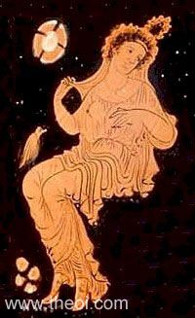
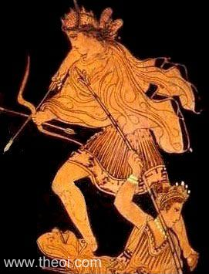
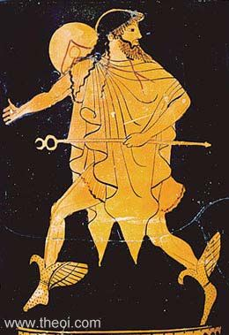
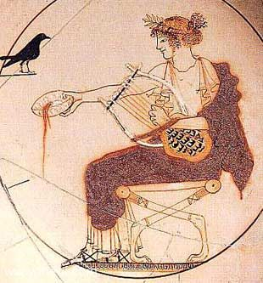
Label the symbols you recognise in the sources
Winged boots
Spear
Dove
Traveller’s cape
Thyrsus
Armour
Herald’s wand
Mirror
Leopard
Drinking cup
Apple
Vine/grapes
Scallop shell
wide-brimmed hat

Greek and Roman names | Responsibilities | Iconography | Extra Info.
Ares/Mars

Dionysos/Bacchus

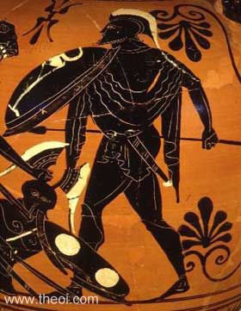
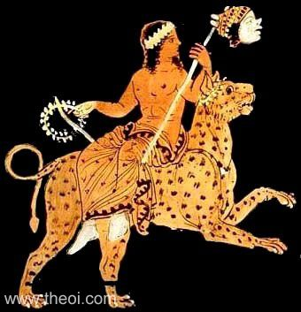
Label the iconography you recognise in the sources
Answer in your books referring to the pages in the textbook:
What was strange about the birth of Dionysos/Bacchus? P11 and 18
Who were the maenads and satyrs? P12 (look at definitions)
What was the Campus Martius or Field of Mars in Rome? P17
What was the Bacchanalia and why did some Roman officials disapprove of it? P18

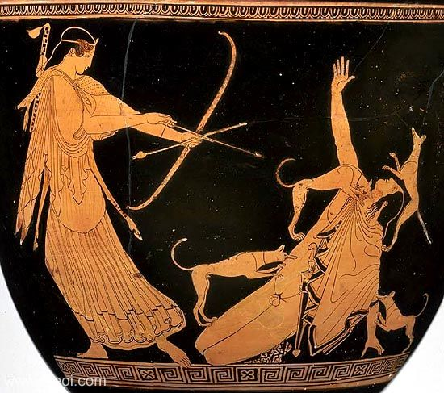
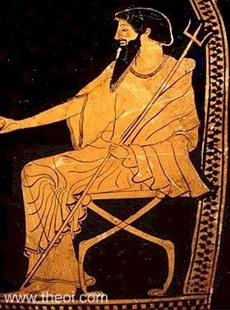
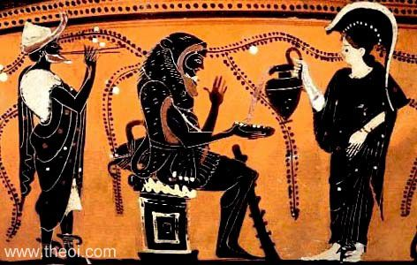
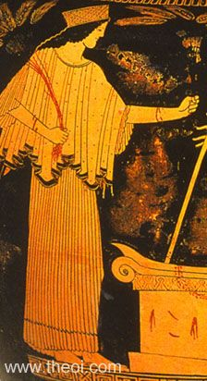
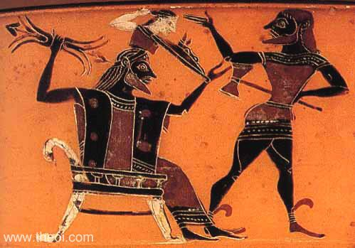
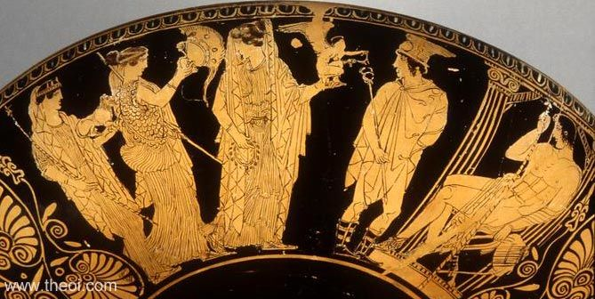
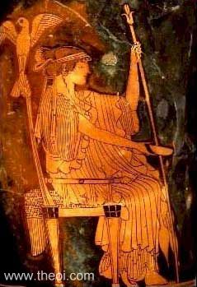
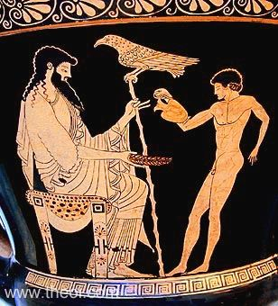
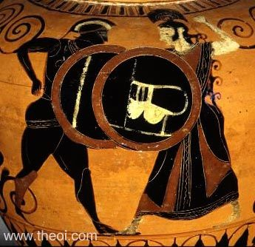
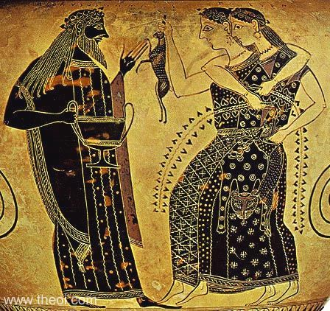
Test Yourself… Who’s Who?
Test yourself… Who’s who?

Topic Review: You should be able to
Describe:
- The key responsibilities of each of the Olympian Gods
- The symbols used to identify the Olympians, as well as Hades/Pluto
- Any differences between the Greek and Roman versions of the gods
- The storyline of the Homeric Hymn to Demeter
Explain
- The character of Greek and Roman religion, including polytheism and anthropomorphism
- The importance of epithets to describe the gods
- What the relationship between men and gods was like
- The importance of the Homeric Hymn to Demeter for the Greek understanding of the cycle of the seasons

Greek and Roman gods: Review Questions

Prepare for the end of topic test with these questions!

1. What was the name of the founder of Athens?

2. Who were the brothers of Zeus?

3. What is the Greek name for the Roman god Vulcan?

4. Why was Ceres so important to Roman worshippers?

5. Why might Mars be more important to Romans than Ares was to Greeks?

6. Give five responsibilities of the god Apollo.

7. Explain what oracles and prophecies were.

8. Explain what is meant by polytheism and anthropomorphism.

9. Describe what was weird about the birth of either Aphrodite or Dionysus.

10. Who were maenads and satyrs?

11. Which do you think would be the most important Roman god for a) a merchant or b) a slave?

12. Explain what either a lyre or a caduceus is.

13. Which gods are not Olympians and why?

14. Explain what happened to Persephone/Proserpina as told in the Homeric Hymn to Demeter

15. What is an epithet and why is it important?

16. Give one example of a god behaving in an anthropomorphic way.

17. Why do you think Persephone’s story is a popular one for decorating sarcophagi?

18. Explain why the Romans were so influenced by Greek religion.

Glossary
Use these definitions, and add your own:
Acropolis | large rocky outcrop overlooking Athens; full of temples
anthropomorphism | giving human attributes to something that is not human
communal | shared by all the members of a community
Iliad | ancient "epic" (adventure) poem about war, written down by Homer
immortal | able to live forever
invocation | calling upon a god in prayer
lyre | ancient stringed instrument
maenad | female follower of Dionysus
Olympians | The 12 Greek gods thought to live on Mount Olympus
Parthenon | major temple on the Acropolis, dedicated to Athene
polytheism | belief in many gods
prophecy | a prediction of what will happen in the future
sceptre | staff carried by kings and other rulers (like Zeus)
trident | three-pronged instrument, as carried by Poseidon
wreath | leaves or flowers arranged into a circular crown
pantheon
iconography
hiera
religio
epithet
chthonic
cornucopia
diadem
aegis
oracle
caduceus
Thebes | An ancient city in Greece where many myths are set
thyrsus
maenads
satyrs
Etruscans
Hellenes
Magna Graecia
sarcophagus
plebs
Cerealia
Vulcanalia
votive
lararium
Bacchanalia

