Classical Civilisation GCSE
Unit 1.2
Topic: The Universal Hero: Heracles/Hercules
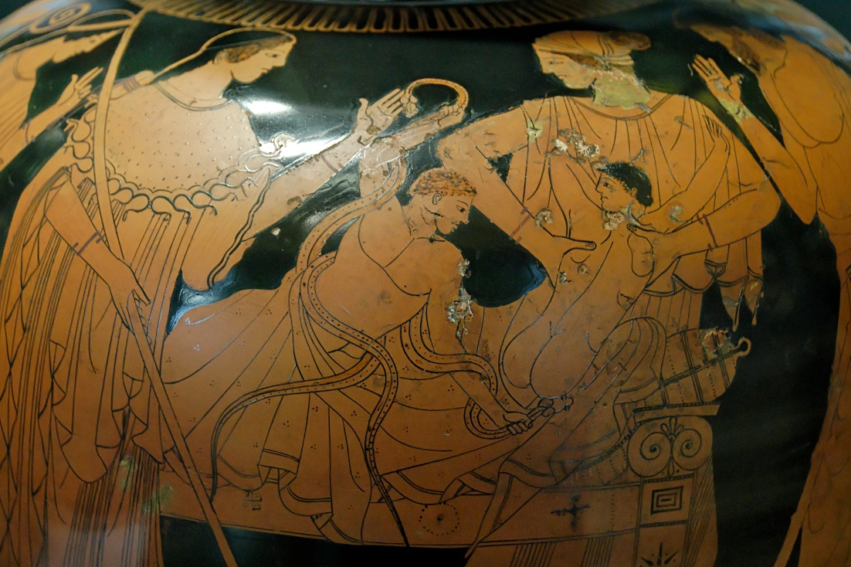

Name & form: ________________________________
HOMEWORK SCHEDULE:
Week | Pages
1 | 1-3
3 | 4-7 (make notes)
5 | 8-10 (make notes)
7 | 11-14
9 | 15-16
11 | 17

Topic Overview
The myths associated with Heracles (known to the Romans as Hercules) and how he is typically represented
Greece: Heracles and Olympia
- Heracles as founder of the Olympic Games
- The 12 Labours of Heracles as represented on the Temple of Zeus at Olympia
Rome: Hercules in Ovid and Virgil
- The myth of Hercules and Cacus, and Hercules as protector of Rome
- Battles with Acehlous and Nessus, and the death of Hercules
Prescribed sources for this topic:
Homeric Hymn to Heracles the Lion Hearted (p. 18 in sources booklet)
The Temple of Zeus at Olympia (metopes)
Virgil, Aeneid 8.154-279 (p. 13 in sources booklet)
Ovid, Metamorphoses 9.1-272 (p.2 in sources booklet)

The Birth/Early Life of Heracles
Heracles was born in Thebes from an affair that Zeus had with the mortal woman Alcmene. Zeus made love to her after disguising himself as her husband, Amphitryon, home early from war (Amphitryon did return later the same night, and Alcmene became pregnant with his son at the same time!) His twin mortal brother, son of Amphitryon was called Iphicles.
On the night the twins sharing the same mother were to be born, Hera, knowing of her husband Zeus's adultery, persuaded Zeus to swear an oath that the first son born that night to a member of the House of Perseus would be king. Once the oath was sworn, Hera hurried to Alcmene's house and asked her daughter Eileithyia, goddess of childbirth, to slow down the birth, causing Heracles to be trapped in the womb.
Meanwhile, Hera caused Eurystheus, the son of Amphitryon’s uncle Sthenelus, to be born prematurely, making him king in place of Heracles. She was hoping that the prolonged labour would kill the unborn baby Heracles and his mother Alcmene, but this part of the plan did not work.
A few months after he was born, Hera sent two snakes to kill him as he lay in his cot. Heracles strangled a snake in each hand and was found by his nurse playing with their limp bodies as if they were child's toys! Alcmene was scared by this and abandoned Heracles in the woods; Athena rescued him and took him to Mount Olympus, but Hera rejected him and sent him back to his mother. Athena was his protector from this point onwards.
Later in Thebes, Heracles married King Creon's daughter, Megara. However, Hera drove Heracles into a fit of madness during which he killed both Megara and their children. Upon realizing what he had done, he exiled himself from Thebes and went to ask the Oracle of Delphi what he should do. Unbeknown to him, the Oracle was guided by Hera. He was directed to serve King Eurystheus for 12 years and perform any task which he required, resulting in the Twelve Labors of Heracles.
Following the story so far…? Who are:
Alcmene –
Amphitryon –
Eileithyia –
Eurystheus –
Iphicles –
Sthenelus –
Megara –
Now read the Homeric Hymn to Heracles the Lion Hearted

Check that you
The Twelve Labours of Heracles
As punishment for killing his family, Eurystheus challenged Heracles with completing ten labours, which he believed would be impossible. During two of the labours Heracles either receieved help or payment so when he returned successful, Eurystheus demanded he complete a further two labours.

1. Nemean Lion

The first of Heracles’ labours was to slay the Nemean Lion and bring back its skin. In art he is sometimes shown to be more youthful here than in his later tasks. The Nemean lion had been terrorising the area around Nemea, and had a skin so thick that it was impenetrable to weapons. When Heracles first tackled it, his weapons - bow and arrow and bronze sword - were all ineffective. At last Heracles threw away his weapons and wrestled the lion to the ground, evetntually killing it by strangling it.

Heracles needed to present the lion’s skin to Eurystheus as proof of his victory, but could not even skin it with his knife. Eventually Athena told Heracles that the best tools to cut the hide were the creature's own claws. From this point Heracles is often shown wearing the lion skin as a cloak and its head as a helmet.

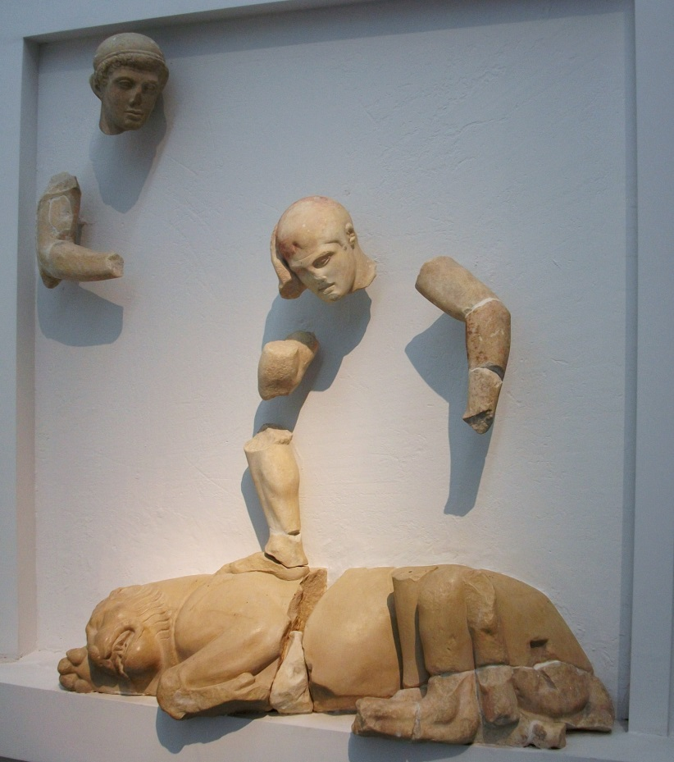
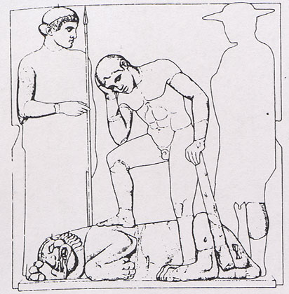

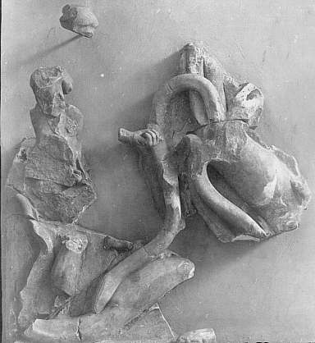
2. Lernaean Hydra

The second labour was kiling the hydra, a monster which had many heads and venom for blood. Upon cutting off each of its heads he found that two grew back. Realising that he could not defeat the Hydra in this way, Heracles called on his nephew Iolaus for help. His nephew came up with the idea of using a torch to burn the neck stumps after decapitation. Heracles cut off each head and Iolaus burned the open stump. Hera was annoyed at Heracles’ progress and sent a giant crab to bit his foot, but he crushed it and carried on with his attack. Eventually the hydra was dead and Heracles buried its head under a pile of rocks; he then used its venom as poison for his arrows.

3. Golden/Ceryneian Hind

The third task did not involve killing a beast, as it had already been established that Heracles could overcome even the most fearsome opponents, so Eurystheus decided to make him capture the Cerynian Hind – a deer that was bigger than a bull and golden from horns to hooves. It was also sacred to Artemis.

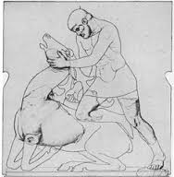
Although this task did not pose the same level of danger as the previous two, it was difficult because the deer was so fast – Heracles followed it for a whole year before he was able to catch it. On his way back Heracles was met by Apollo and Artemis, who was angry that he had caught her sacred deer. This was another reason that Eurysetheus had set the task – he hoped that Heracles would get into trouble with Artemis. However he told her that he had been forced into it by Eurystheus and that he only wanted to borrow the hind, so she let him go.

4. Erymanthian Boar

The Erymanthian Boar was a giant fear-inspiring creature of the wilds that lived on Mount Erymanthos. Eurystheus ordered Heracles to bring it back to him alive. Heracles tired out the boar by chasing it through the thick winter snow. After catching the boar, Heracles bound it and carried it back to Eurystheus, who was frightened of it and hid in his half-buried storage pithos jar.
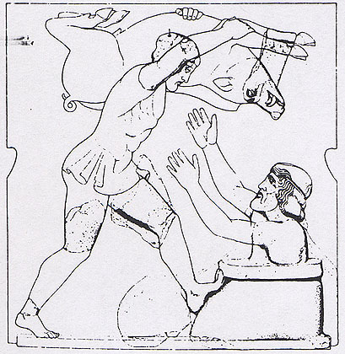

5. Augean Stables

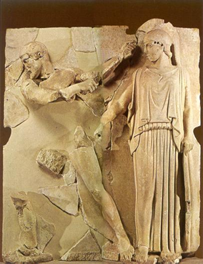
The fifth of the Twelve Labours set to Heracles was to clean the stables of Augeas, King of Elis, in a single day. Augeas was famed for having a herd of enormous cattle that produced an extremely large amount of dung and so Eursytheus thought the task impossible. Also, all the previous labours praised Heracles in the eyes of the people and this one would surely degrade him. However, Heracles once again rose to the challenge and with a combination of brains and brawn rerouted the rivers Alpheus and Peneius through the stables, cleaning them instantly.

Augeas was angry because he had promised Heracles payment if the job was finished in one day. He refused to honour the agreement, so Heracles returned with an army and defeated the king. To commemorate his victory Heracles founded the Olymoic Games for his father Zeus.

6. Stymphalian Birds
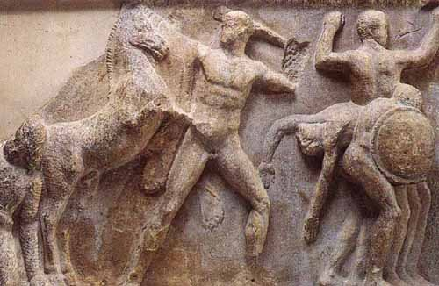
Stymphalian Birds were man-eating birds with wings of brass and sharp metallic feathers. Furthermore, their dung was highly toxic. They had migrated to Lake Stymphalia in Arcadia and took over the countryside, destroying local crops and fruit trees. Ridding the land of these birds was Heracles’ sixth task.

The forest around Lake Stymphalia was very dense, making it so dark that Heracles couldn’t see. Athena helped by giving Heracles a rattle made by the god Hephaistos. After shaking it the birds flew into the sky and Heracles shot them down with his arrows, or according to other versions, a catapult.
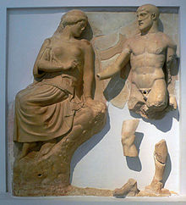

7. Cretan Bull

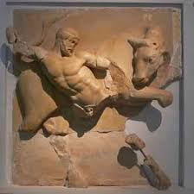
Heracles was forced to capture the bull as his seventh task. He sailed to Crete, and King Minos gave him permission to take the bull away, as it had been wreaking havoc on Crete. Heracles used his hands to strangle the bull, but released his grip before it passed out so he could ride it across the sea back to Greece. Eurystheus was afraid and hid in the pithos again. The bull was released and wandered into Marathon, where it was later defeated by Theseus.

8. Mares Of Diomedes

The Mares of Diomedes were four man-eating horses. They belonged to the giant king Diomedes who kept them tethered in a bronze manger with iron chains. He fed them on the limbs of defeated enemies and passing strangers.

Upon arriving Heracles defeated the stablemen looking after the horses. Diomedes found out and set out with some men to fight Heracles. Heracles left his friend Abderos in charge of them while he fought Diomedes, but the boy was eaten. In revenge, Heracles fed Diomedes to his own horses.
Eating made the horses calmer and Heracles easily took them back to King Eurystheus. In some versions, they were allowed to roam freely around Argos, having become permanently calm, but in others they were taken to Olympus and killed by wild amimals.
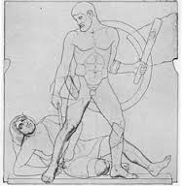
9. Belt of Hippolyte

Hippolyte was queen of the Amazons, a race of female warriors who lived near the black sea. She was given a magic belt by her father Ares, the god of war. Heracles was sent to retrieve this belt for Admeta, the daughter of king Eurystheus, who wanted it for herself. As with the last task, Heracles took an army with him because he expected trouble, but Hippolyte was an admirer of his deeds and offered him her belt freely. To stop him succeeding, Hera came down to the Amazons disguised as one of their own and ran through the land, crying that Heracles meant to kidnap their queen. Therefore the Amazons charged toward the ship to kill Heracles and his men. Thinking that Hippolyte had betrayed him, Heracles killed her and ripped the belt from her body.

10. Cattle of Geryon

Geryon was a fearsome giant who lived on the island Erytheia in the far west of the Mediterranean. Geryon had three heads and three sets of arms and legs. He owned a two-headed dog named Orthrus, and a herd of magnificent red cattle. Orthrus and a herdsman called Eurytion guarded the cattle.

Heracles was required to fetch the Cattle of Geryon as his tenth labour.
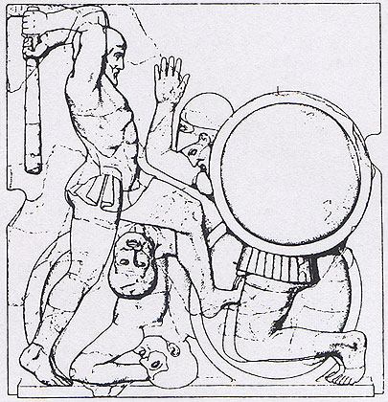
With one huge blow from his olive-wood club, Heracles killed the watchdog. Eurytion the herdsman came to assist Orthrus, but Heracles dealt with him the same way. Geryon then attempted to defend the cattle but Heracles eventually killed him too.

The journey back from Erytheia took Heracles through southern Italy and this is where the Roman version of his story started – you will learn about this late.

When Heracles returned, Eurystheus sacrificed the bulls from the herd to Hera. He then set Heracles two more tasks on top of the original ten as he did not count the Hydra (as Heracles got help) or the Stables (as Heracles got paid).

11. To Steal the Apples from the Garden of the Hesperides

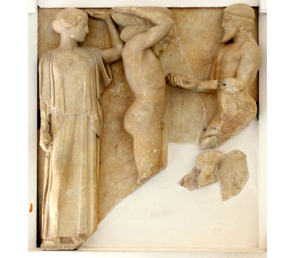
In Greek mythology, the Hesperides were nymphs who lived in a garden in a far western corner of the world. They had golden apples in their garden, which were originally a wedding present to Hera to Zeus from Gaia (Earth).
It took Heracles a lot of time and effort to steal the apples from the garden of the Hesperides. He got lost, going first to North Africa then the Near East then Illyria, and finally Mount Caucasus where he found out where the Golden Apples were and how to get them from Prometheus the Titan. Heracles killed the eagle that had been feeding on his liver every day as a punishment for defying the gods, and Prometheus helped him as a reward.

Finally making his way to the Garden of the Hesperides, Heracles tricked Atlas into retrieving some of the golden apples for him, by offering to hold up the heavens for a little while. Upon his return, Atlas decided that he did not want to take the heavens back, and instead offered to deliver the apples himself, but Heracles tricked him again by agreeing to take his place on condition that Atlas swapped with him briefly so he could put a pillow on his shoulders. Atlas agreed, but Heracles went back on the deal and walked away. As the apples were the property of Zeus, Eurystheus could not keep them ; once he had seen them, Athena took them back to the garden.

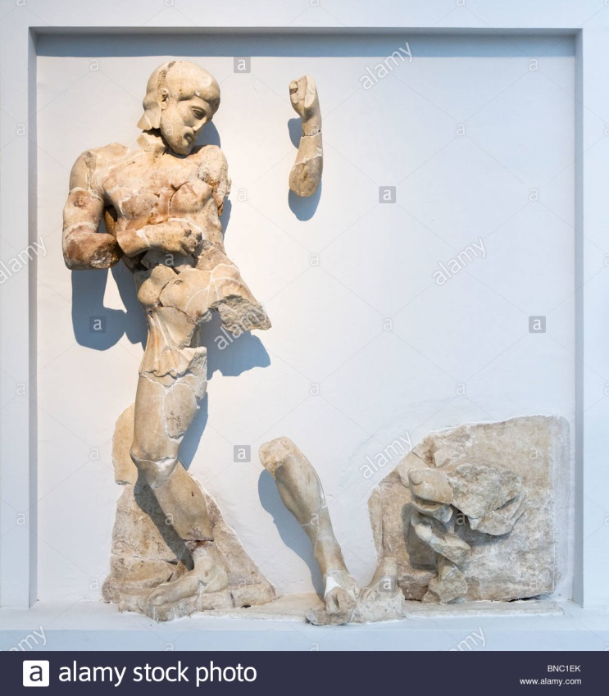
12. Cerberus

Heracles’ final task was to capture Cerberus from the Underworld. He was initiated in the Eleusinian Mysteries to gain the favour of Persephone.

Heracles presented himself before the throne of Hades and Persephone and asked permission to take Cerberus, to which the gods agreed as long as Heracles could capture the dog without any weapons. He used the same stranglehold that had worked on the Nemean Lion and the Cretan Bull and was successful. After presenting Cerberus to Eurystheus (who hid in the pithos again!) he returned him to guard the entrance of the underworld.

Heracles and Olympia
Olympia was in Elis. The traditional date for the founding of the games was 776 BC. Why would the Greeks come up with mythological stories to explain the founding of the games?
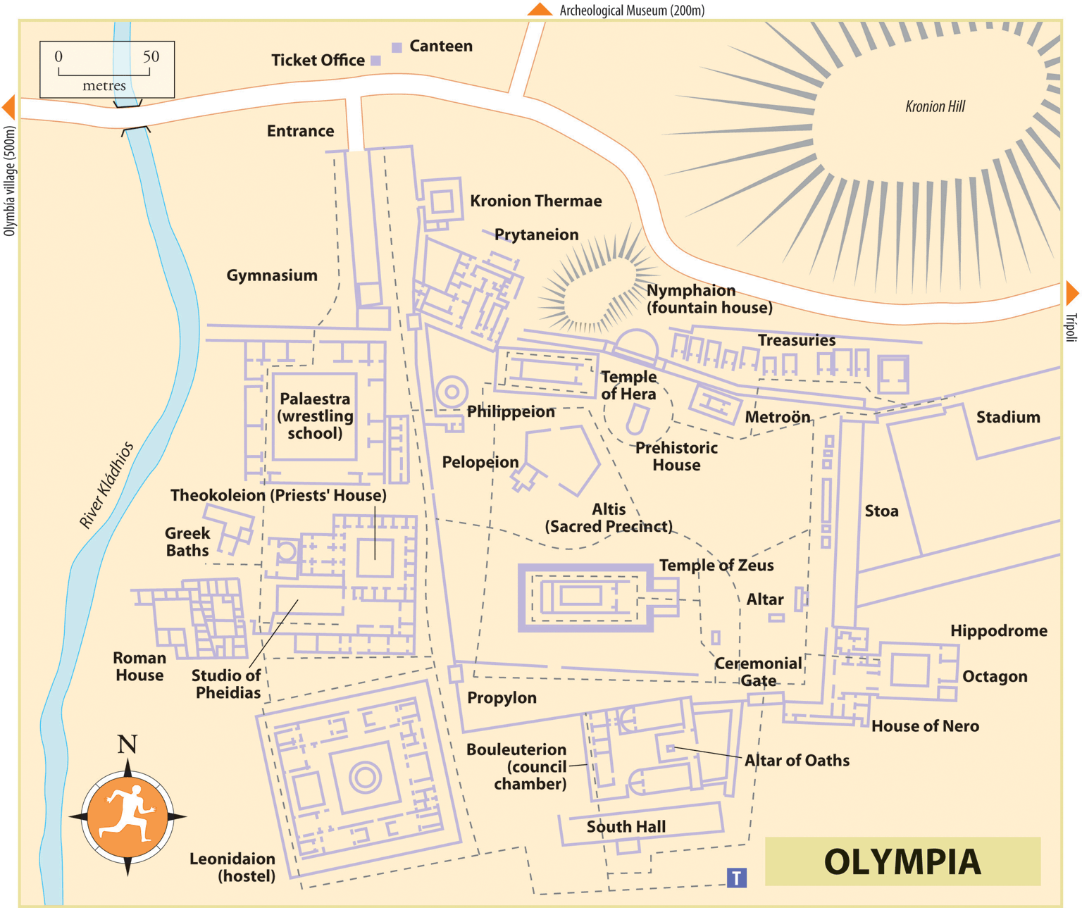
__________________________________________________________________________________
What can we learn about the Olympic Games from the site map?
__________________________________________________________________________________
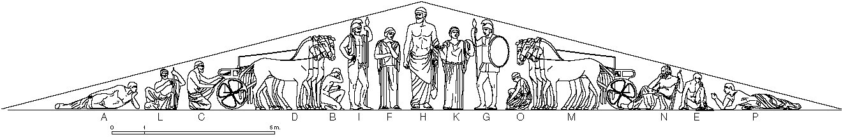
The eastern pediment (triangular bit at the top) of the temple of Zeus at Olymjpa shows the story of Pelops and Hippodamia. Hippodamia was the daughter of Oinomaos, king of a town near Olympia called Pisa. He had received an oracle saying that he would die once his daughter got married, so he set up a chariot competition challenging anyone who wanted to marry her to a race. Because he was a skilled charioteer he always beat them, until Pelops came along. Pelops bribed Oinomaos’ charioteer to replace the bronze linchpins of his chariot with wax. During the race, the heat from the wheel melted the wax and Oinomaos died. Pelops married Hippodamia and set up the Olympics as funeral games for Oinomaos.
Another theory is that Heracles started the Olympic Games to celebrate the completion of his fifth labour (cleaning the Augean stables). There are further theories as well!
Why are there different versions of the story behind the Olympic Games? What evidence is there that the ancient Greeks accepted both?
__________________________________________________________________________________
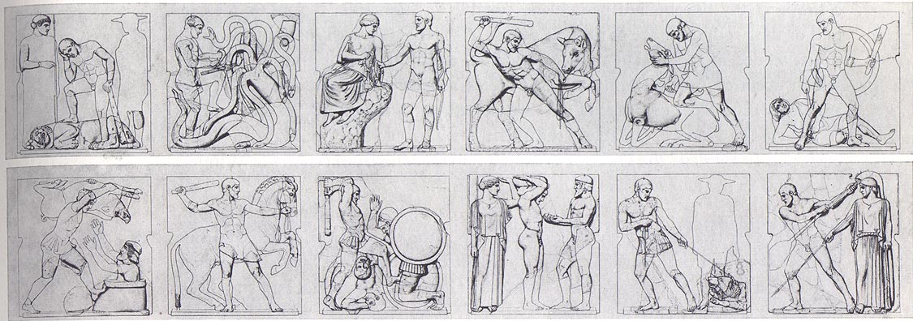
The metopes (square spaces that ran around the top of a temple) represented the twelve tasks of Heracles. Six are on the front of the temple and six on the back. Can you identify all twelve below?
The sculptor had three main aims when sculpting the metopes:
- create a scene that could be easily recognisable
- create realism in the scene
- fill in the space so as not to leave big blank areas
How does he achieve all three aims in the following metopes?

Try to use the correct spellings! Greek = Heracles Roman = Hercules
Hercules – the Roman version!
As with religion and lots of other ideas, the Romans inherited their ideas about Hercules from the Greeks. For the Roman section of this unit you will be working with literary sources in your booklet, reading the stories of Hercules and Cacus from Virgil’s Aeneid and Hercules and Nessus/Achelous from Ovid’s Metamorphoses. You will also read about the death of Hercules. Work through the following questions and activities as you read the stories:
Hercules and Cacus
This story took place during Hercules’ tenth labour, the cattle of Geryon. Although the myth of Geryon was originally Greek, the Romans wove their own history into the story, which took place around 500 years before Romulus founded Rome. Once Hercules had captured the cattle and killed Geryon, he had to get them back to Eurystheus. To do this he had to travel through Italy. As Rome had not yet been founded, the area around the River Tiber was inhabited by a race called the Arcadians and their king Evander. The cult of Hercules in Rome came from the story of Hercules and Cacus; he was a monster who terrorised the city of Pallantium until Hercules came along…
1. Who is Evander talking to on p. 13 and how does he feel about this person?
2. What impression of Cacus’ appearance and home do we form from Virgil’s description on p. 14?
3. Why is Hercules described as a god by Evander although he has not yet completed his twelve labours?
4. Explain how Cacus tricks Hercules as described on p. 15. How is he found out?
5. How does Virgil emphasise the huge size of the boulder that Cacus uses to trap himself in the cave?
6. How does Hercules eventually defeat Cacus as detailed on p. 16 and how does Virgil make this vivid and dramatic?
7. Explain how the cult of Hercules in Rome was linked to this story.
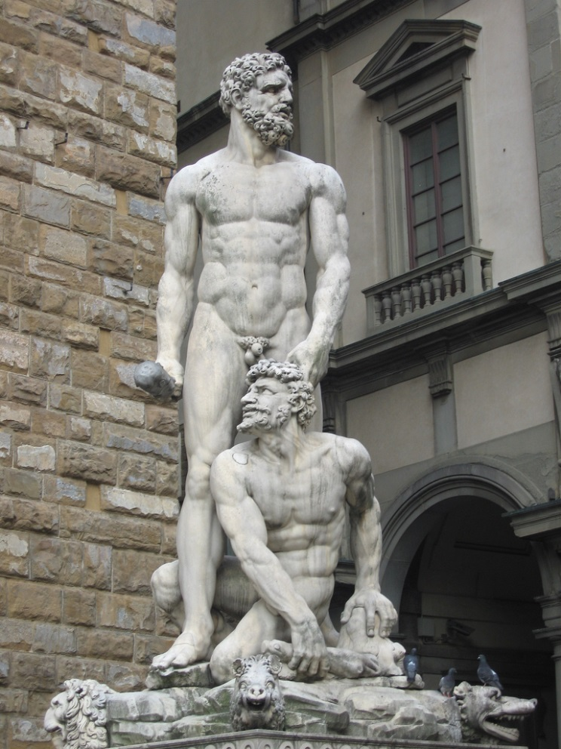
Study questions:
- How heroic was Hercules when he fought Cacus? Justify your answer with evidence from Virgil’s Aeneid
- How does Cacus compare to the monsters Hercules met during his twelve labours?
- How and why did the people of Rome honour Hercules?

Hercules and Achelous
Achelous is a river god who fought with Hercules for the hand of the princess Deianira. He tells his story to another hero, Theseus, in Ovid;s version of the story…

1. What injury does Achelous have? Why does he say that he didn’t mind losing to Hercules?

2. What reasons did Achelous and Hercules each put forward to convince Deianira’s father that they should marry her?
3. Describe the fight of Hercules and Achelous. How does Ovid make it exciting?
4. How does Achelous try to trick Hercules and how does Hercules finally defeat him? Where has he used this technique before?
5. What happens to Achelous at the end of the fight?
Hercules and Nessus
1. What is a centaur? How does the centaur Nessus say he will help Hercules and Deianira, and what does he then do instead?
2. How does Hercules punish Nessus, and what do Nessus’ last words suggest?
3. What lie does Juno tell in the hope that she will ruin Hercules’ marriage?
4, How does Deianira attempt to improve the situation?
The death of Hercules
1. How does Deianira’s attempt to restore Hercules’ love go horribly wrong?
2. How does Ovid create a vivid and dramatic picture of Hercules’ death?
3. Who is Lichas and how is he unfairly punished by Hercules?
4. What does Jupiter ask the gods and how does he convince them?
5. How successfully does Ovid describe the transformation of Hercules?
Study questions:
- How would you characterise both Hercules and Nessus?
- How rational were the actions of Deianira?
- “Only the gods were to blame for Hercules’ death.” How far do you agree?
- What do we learn about the relationship between gods in Jupiter’s speech?

Topic Review: You should be able to
Describe:
- How Heracles was born
- the key events of each of Heracles’ twelve labours
- Hercules’ battles with Cacus, Achelous and Nessus
- How Hercules died
Explain
- Why Heracles’ birth made him a demi-god
- Why Heracles was sent on his ten labours, and why he was given two more
- why Heracles was important to the site of Olympia and how the Greeks honoured him
- why Hercules was important to Rome and how the Romans honoured him
Heracles/Hercules end-of-mini-topic test score:

My comment on this:

Teacher’s comment:

Targets for next time:

Exam practice q:
- Who honoured Hercules more, the people of Olympia or Rome? (15)

Glossary
hydra
hind
pithos
Pisa
linchpin
pediment
metope
Tiber
Pallas
centaur
pyre

