Politics GCSE Topic 9 booklet

UK and wider world

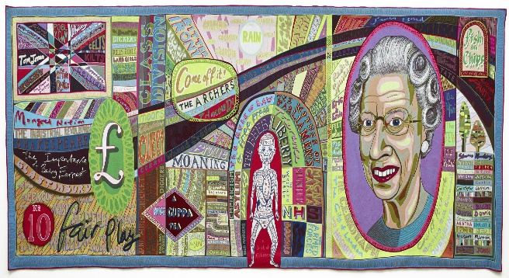

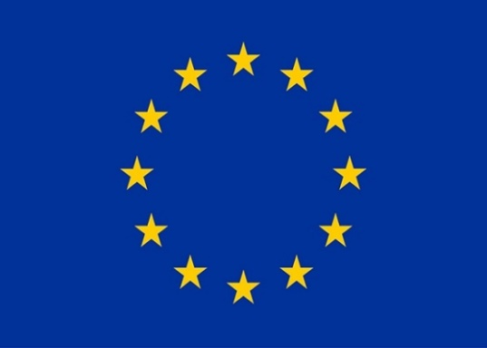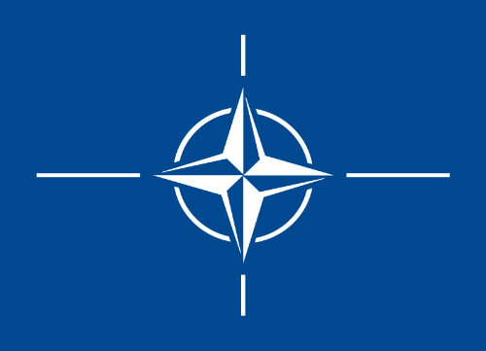



**Big Topic: UK and the wider world**

**Lesson 1: Migration, Community cohesion and our sense of identity**

Task 1: Key terms:

How is the term **migration** different from **immigration?**

……………………………………………………………………………………………………………………………………………………………………………………………………………………………………………………………………………………………………………………………………………………………………………

What do you think the difference is?

……………………………………………………………………………………………………………………………………………………………………………………………………………………………………………………………………………………………………………………………………………………………………………..

What is the actual difference between the two terms?

……………………………………………………………………………………………………………………………………………………………………………………………………………………………………………………………………………………………………………………………………………………………………………

Why do people choose to migrate from one country to another?

**Task 2: Note down the push and pull factors from emigration**

|  |  |
| --- | --- |
| **Push factors:** reasons why people might choose to leave the UK | **Pull factors:** reasons why people choose to move to the UK |
|  |  |
|  |  |
|  |  |
|  |  |
|  |  |
|  |  |
|  |  |

**Task 3:net migration**

**Define Net migration:**

……………………………………………………………………………………………………………………………………………………………………………………………………………………………………………………………………………………………………………………………………………………………………………

**Task 4: Work out the UK’s net migration figure for 2022**

1.2 million people migrated into the UK

557,000 emigrated from the UK

Net migration for the UK 2022 =

**Task 5: Patterns of UK migration**

1. During the 18th and early 19th century Britain’s involvement in the………….. ……………. Small black communities began to be established in Britain.
2. During the period UK was ………………… land across the world this brought a great deal of wealth. Due to Britain’s industrial revolution many people from the……….. …………………. Came to settle in Britain
3. Another group who emigrated to the UK for protection were…………. From Europe
4. During the twentieth century many British colonies gained independence when they joined the commonwealth in particular a large number of migrants arrived from the……………….. on HMS Windrush.

**Colonising, Caribbean, slave trade, Indian subcontinent,**

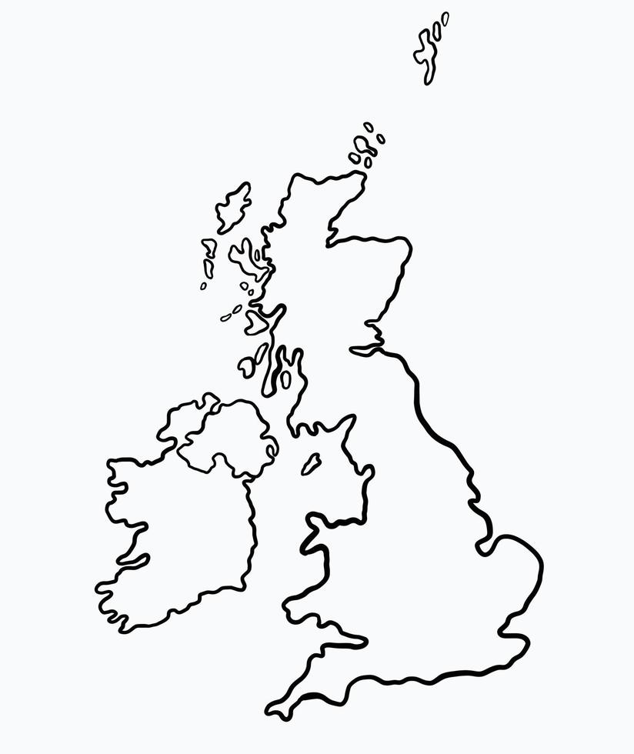

Scotland, North of England, and Midlands

Norwich

**Bristol, Cardiff and Liverpool**

London:

**Task 6: Migration debate**

**Find two arguments which support migration to the UK**

* **………………………………………………………………………………**
* **……………………………………………………………………………..**

**Which political party is the most supportive of migration to the UK?**

________________________________________________________________

**Why are they supportive of migration? Explain this in at least two sentences**

_________________________________________________________________________________________________________________________________________________________________________________________________________________________________

Find two arguments oppose migration to the UK

* **………………………………………………………………………………**
* **……………………………………………………………………………..**

Name the political parties which regularly promise to restrict migration to the UK

**1……………………………………………………………………………………………………………………….**

**2…………………………………………………………………………………………………………………………**

**Task 7: Community Cohesion**

1. Define community cohesion

……………………………………………………………………………………………………………………………………………………………………………………………………………………………………………………………………………………………………………………………………………………………………………………………………………………………………………………………………………………..

1. Name 3 things Slough borough council does to promote community cohesion:

<https://www.slough.gov.uk/downloads/file/2392/community-cohesion-statement>

1..………………………………………………………………………………………………………………

2. ………………………………………………………………………………………………………………

3. ………………………………………………………………………………………………………………

**Task 8: How has migration contributed to our sense of identity**

What factors contribute to our individual identity and how we view ourselves?

A sense of identity is:

………………………………………………………………………………………………………………………………………………………………………………………………………………………………………………………………………………………………………………………………………………………………………………………………………………………………

**Using the handout on teams complete add to your own spider diagram** about how each of the below add to British culture.

**Task 9: Complex identities in Britain**

Use the enlarged version of the slide on teams to identify the various things he thinks makes up British identity plot these around your mini version below



**Below using the textbook and what we have learned this lesson to summarise why British identity is complex**

________________________________________________________________________________________________________________________________________________________________________________________________________________________________________________________________________________________________________________________________________________________________________________________________________________________________________________________________________________________________________________________________________________________________________________________________

**Homework:**

Task 1: British values – around the mind map below can recall from today’s lesson and our course any examples which can evidence our British values

*Challenge: Is there one value that you believe is wrong for us to promote as a country*

Task 2: Create a fact file on one of the following prominent BAME individuals who have all held important positions within British society. Create a fact file in your booklets about their background and career. Find their profiles on the lesson homework power point

- Sajid Javid MP

- Assem Allam

- Baroness Scotland of Asthal

- Shazia Mirza

Fact file:

Name:

Education:

Career:

Achievements:

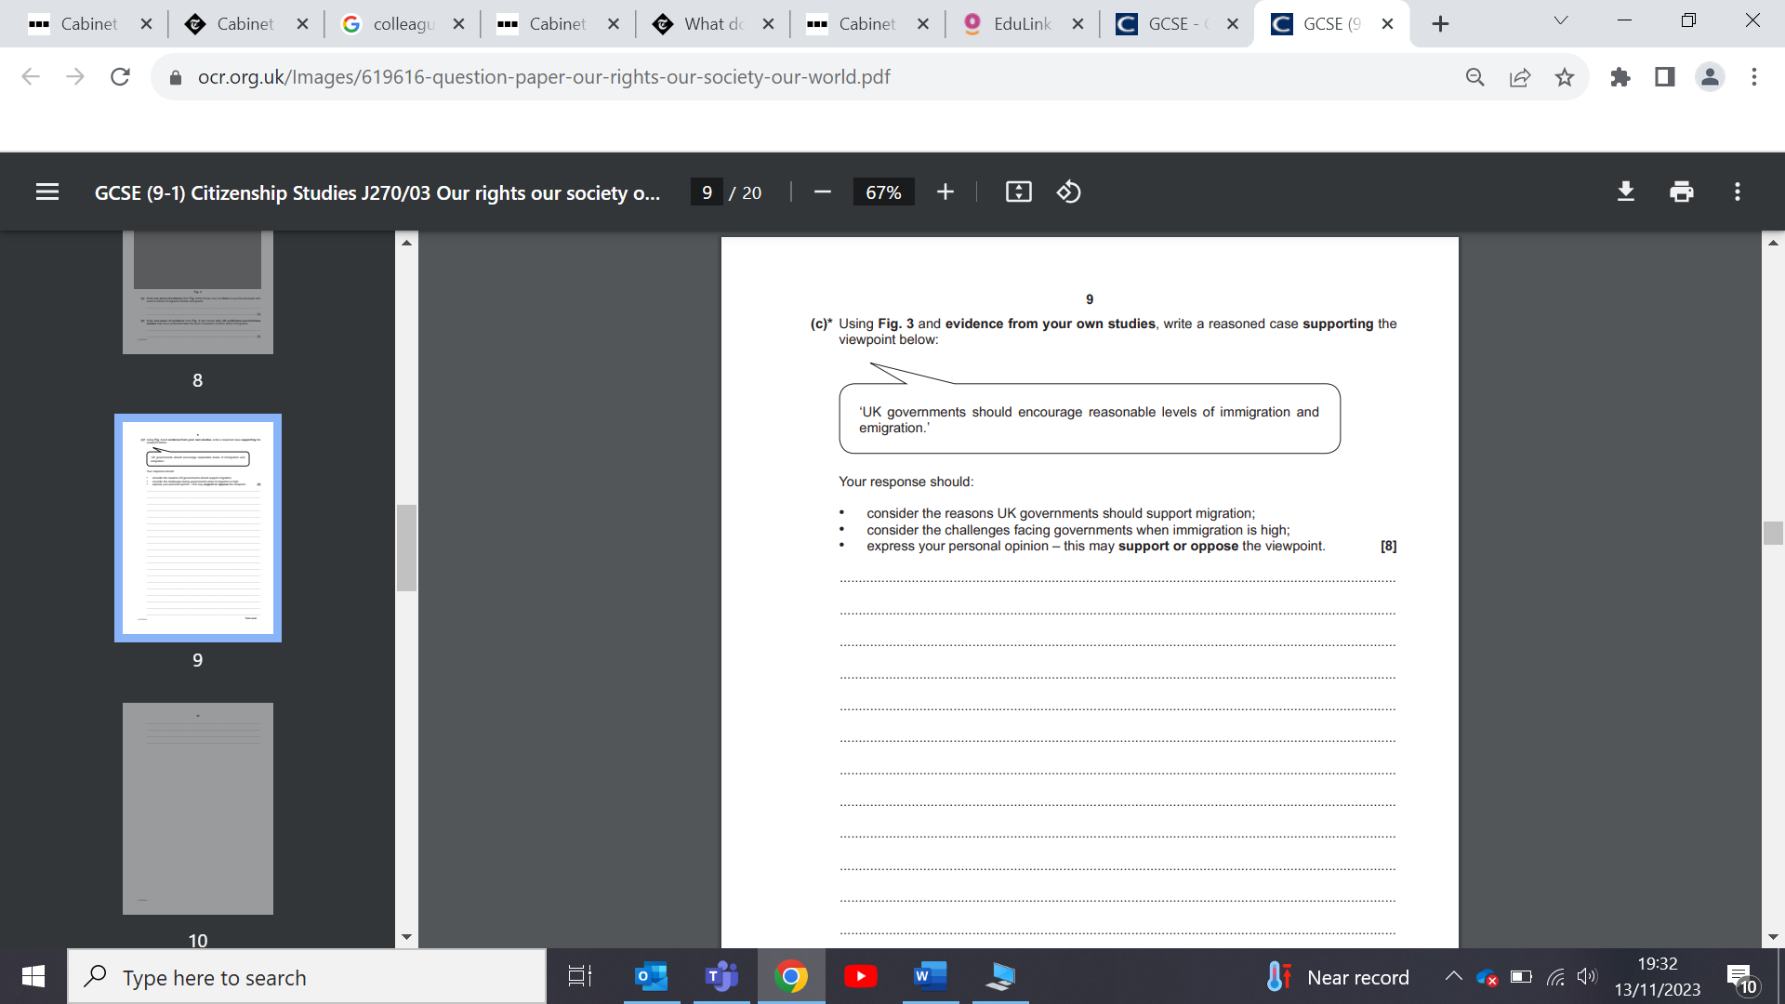

**Evaluate the viewpoint below**:



**Lesson 2 International organisations, international humanitarian law, Asylum and NGOs**

**Task 1: Match up the key terms**

International organisation

When a country intervenes in another country/state’s affairs.

Intervention

An organisation or charity who carry out work either within the UK or abroad to provide help and aid.

Non-governmental organisation (NGO)

A set of agreements made by countries that should be followed in times of war.

International humanitarian law

A group of countries that agree political and or economic priorities and work together on projects.

**Why should countries form partnerships and groups?**

**Task 2: International organisations**



Match these logos go with the following organisations

NATO

Commonwealth

World Trade organisation

Council or Europe





**Task3: The commonwealth:**

[**https://www.youtube.com/watch?v=TbmoGe1zoDc**](https://www.youtube.com/watch?v=TbmoGe1zoDc)

**Using the link find 3 facts, which help explain why Britain views the commonwealth as an important organisation**

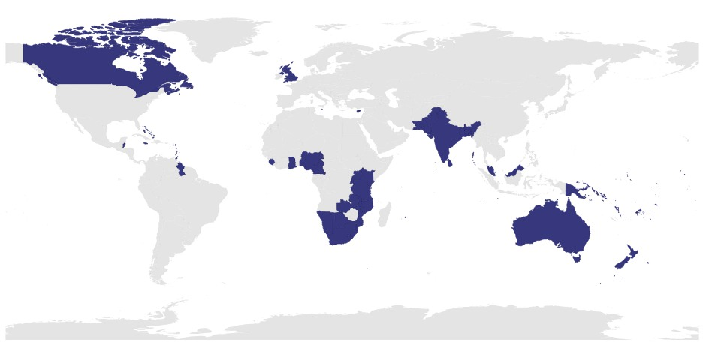

* What fraction of the world is part of the commonwealth?

_______________________________________________

* Why have some countries who were not part of the empire decided to join the commonwealth?

_______________________________________________

* Does the monarch have to lead the organisation?

_________________________________________

|  |  |  |  |  |
| --- | --- | --- | --- | --- |
| **Organisation** | **Purpose of the organisation**  **Must state whether it is political, economic, or military can be more than one.** | **Membership**  **(Name at least 5 countries)** | **UK’s contribution** | **UK Government’s policy ( approach to the organisation)** |
| **Commonwealth** |  |  |  |  |
| **Council or Europe** |  |  |  |  |
| **North Atlantic Treaty organisation ( NATO)** |  |  |  |  |
| **World Trade organisation**  **(WTO)** |  |  |  |  |

**Task 1: International agreements**:

Fill in the missing word sheet

International humanitarian law is a set of __________ that aims to protect people’s rights in times of war. It is different to ­­­­­­­­­­­__________ rights law as it is only relevant in times of war whereas human rights law applies at all times. A main part of international humanitarian law is in the _____________ Conventions of 1949, which nearly every state in the world has agreed to be bound to. Parts of the conventions also apply in times of _________war (i.e. when there is a war between groups in the same country. Sadly, there are many instances when international humanitarian law is _________. However, there have also been many successes of International Humanitarian Law.

**Ignored, civil, Geneva, human, rules**

**Task 2:** As you, watch the clip

<https://www.youtube.com/watch?v=HwpzzAefx9M>

note down the **seven** basic international rules of conflict, as set out in International human rights law around the

1.

2.

3.

4.

5.

6.

7.

**Task 3: International crises:**

**B)** Match the following terms to the correct definitions (number first if you are unsure)

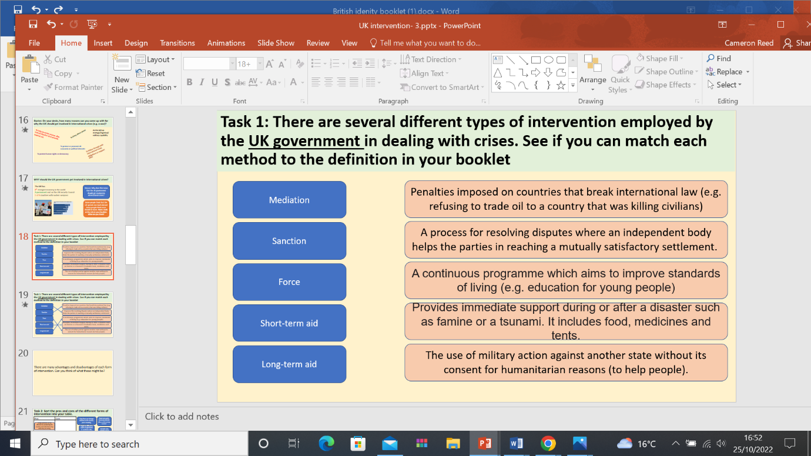

**C)** What are the pros and cons of different forms of intervention?

|  |  |
| --- | --- |
| **Pros** | **Cons** |
|  |  |

**Task 4: Asylum**

1. What is the term used to describe someone needing refuge or protection?

**______________________________________________________________**

1. How is **political migration** different to **economic migration?**

**_______________________________________________________________**

1. Name 4 reasons which explain why people choose to see refuge or asylum in the UK?

* **_______________________________________________________________________**
* **_______________________________________________________________________**
* **_______________________________________________________________________**
* **_______________________________________________________________________**

Name two countries who receive more asylum applications than the UK.

* **________________________________________________________**
* **________________________________________________________**

**Task 5: Non-governmental organisations**

[**https://www.bbc.co.uk/bitesize/guides/zqh8wxs/video**](https://www.bbc.co.uk/bitesize/guides/zqh8wxs/video)

**A)** As you watch, the clip answer the following questions:

1. What does NGO stand for?

___________________________________________________________________________

1. What type of work do they do?

__________________________________________________________________________________

1. How are they funded and work?

___________________________________________________________________________________________________________________________________________________________________

**Task 6: Between 2014-15 Save the Children worked in Sierra Leone in response to an outbreak of a deadly Ebola disease:**

Use the word document to make notes underneath each of the following sections in your booklets.

1. Name of the NGO involved

__________________________________________________________________________________

1. Any evidence on their funding?

___________________________________________________________________________________________________________________________________________________________________

1. Short term aid

___________________________________________________________________________________________________________________________________________________________________

1. Long term aid

_____________________________________________________________________________________________________________________________________________________________

1. Any evidence to show that they had expertise and experience?

_____________________________________________________________________________________________________________________________________________________________

1. Work with the UK government

______________________________________________________________________________________________________________________________________________________________

**Task 7:**

1. Compare the advantages and disadvantages government intervention vs NGO intervention. For each statement tick the box that you think it applies to (NGOs OR governmental & international organisations

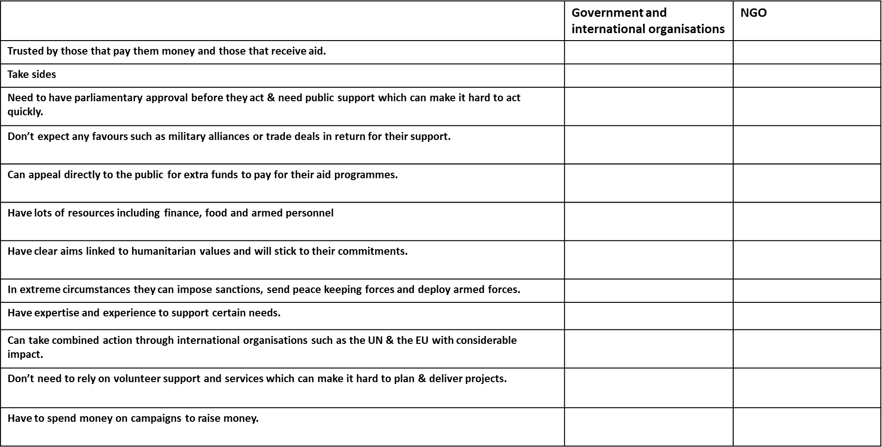

1. 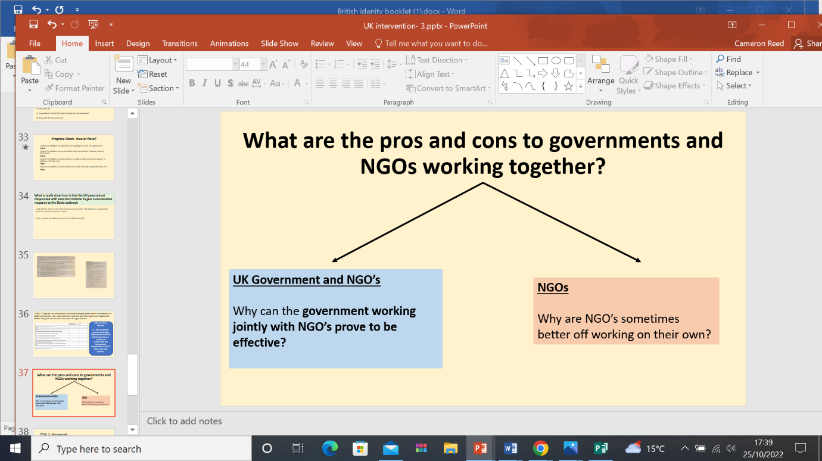Using what we have learned so far this lesson complete the following task below:

Pros Cons

**Homework:**

Write a reasoned case supporting the viewpoint below:

‘International non-governmental organisations (NGOs), such as Save the Children and Oxfam, are more effective than national governments at responding to crises caused by war, natural disasters and famine.’ **[8]**

................................................................................................................................................... ................................................................................................................................................... ................................................................................................................................................... ................................................................................................................................................... ................................................................................................................................................... ................................................................................................................................................... ...................................................................................................................................................

................................................................................................................................................... ................................................................................................................................................... ................................................................................................................................................... ................................................................................................................................................... ...................................................................................................................................................

................................................................................................................................................... ................................................................................................................................................... ................................................................................................................................................... ................................................................................................................................................... ................................................................................................................................................... ................................................................................................................................................... ...................................................................................................................................................

................................................................................................................................................... ................................................................................................................................................... ................................................................................................................................................... ................................................................................................................................................... ...................................................................................................................................................

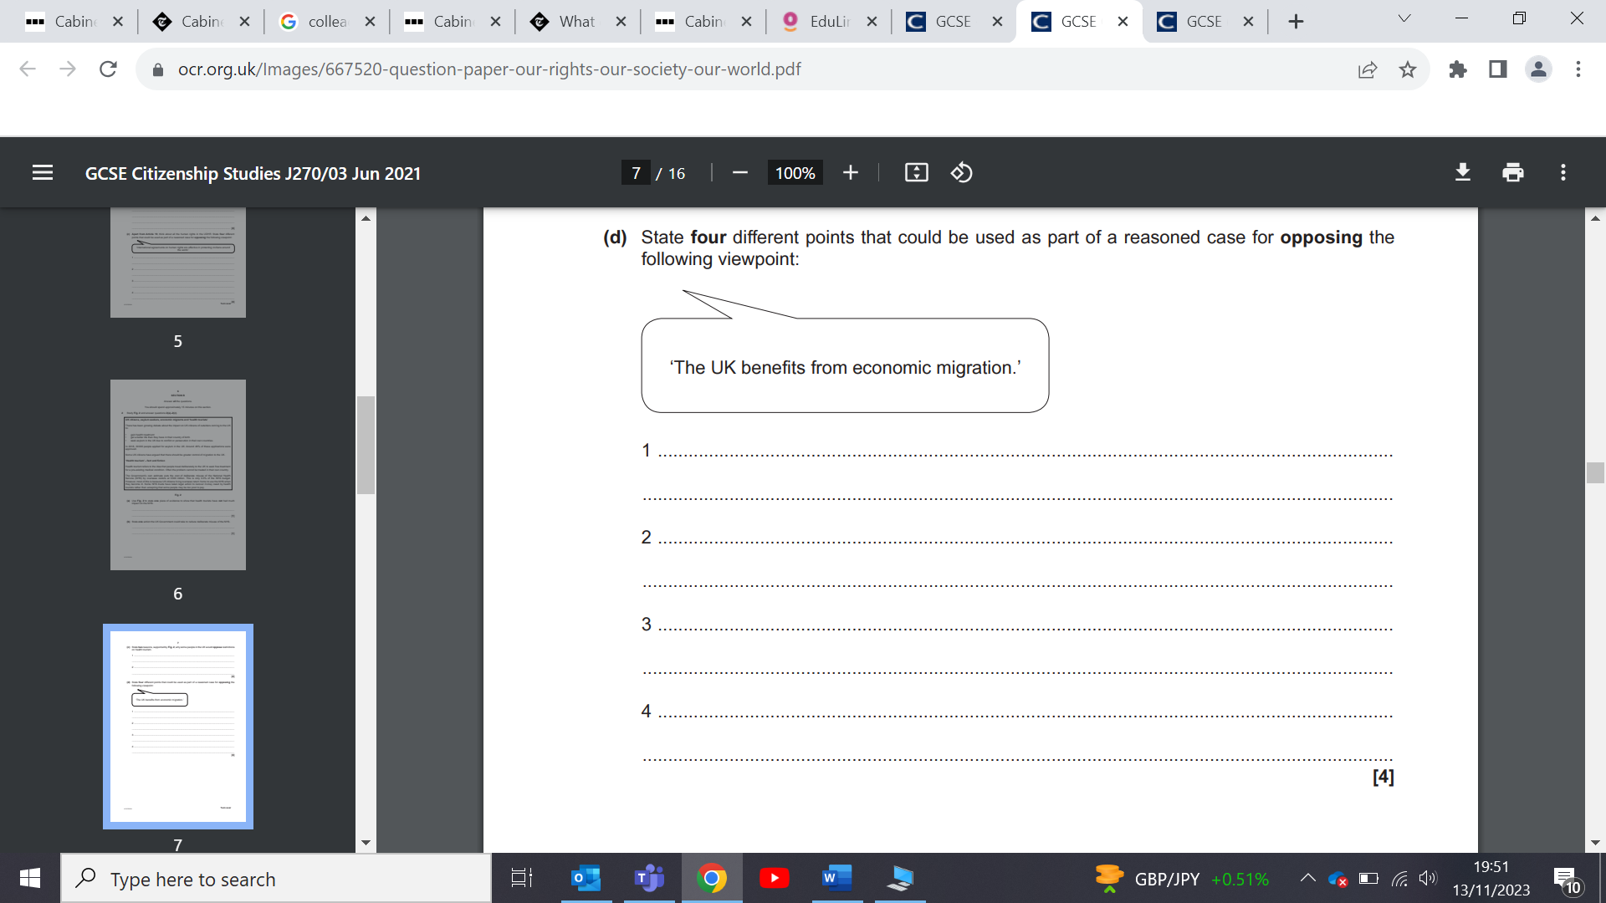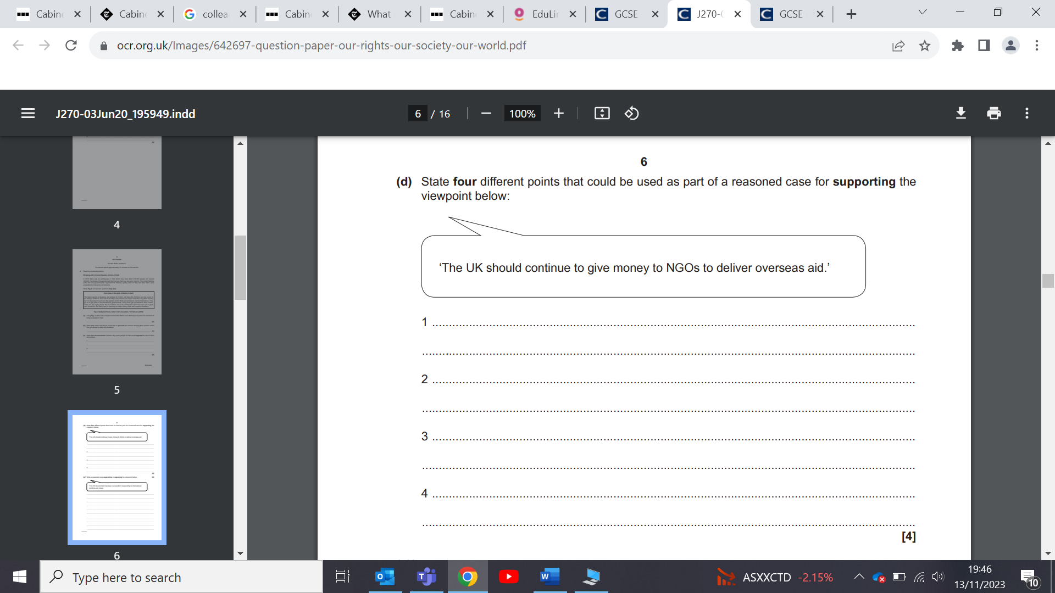

**Lesson 3: UK wider world: United nations and the European Union**

**Task 1: Which of these is the logo for the following:**

* **United nations**
* 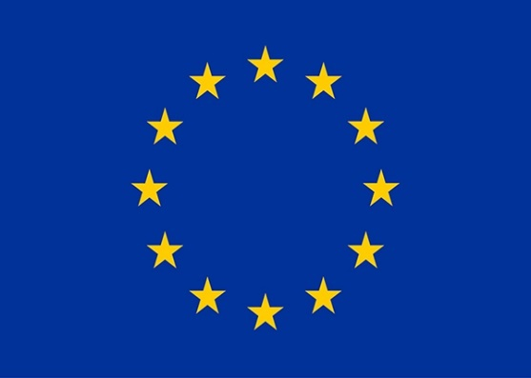**European Union**

**Task 1: The European Union**

1. Aims of the EU:

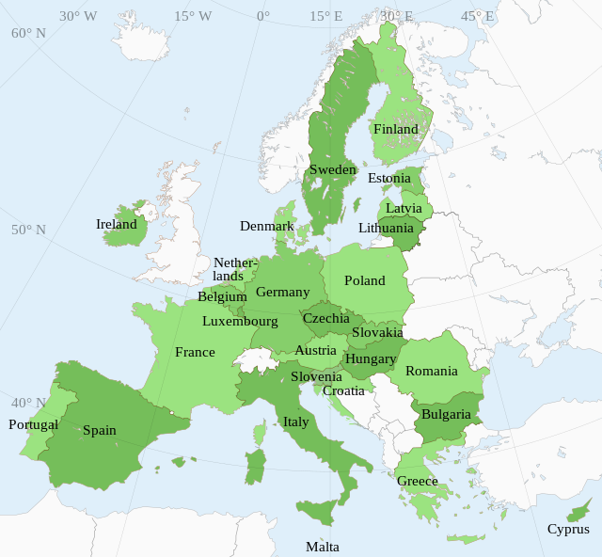

* Military aim of the EU

………………………………………………………………………..

……………………………………………………………………….

* Political aim of the EU:

…………………………………………………………………………………..

…………………………………………………………………………………….

* Legal aim of the EU

…………………………………………………………………………………………

………………………………………………………………………………………..

* Economic aim of the EU

………………………………………………………………………

……………………………………………………………………..

**Task 2: Special rights of EU citizens:**

* Right, which links to democracy and participation:

……………………………………………………………………………………………

* Right, which protects you when travelling abroad

……………………………………………………………………………………………..

* Right which links to where you choose to live

**Task 3:** Using Page 188 of the textbook chapter handout note down one examples of an EU law

Then explain the impact it has had on people’s day to day lives in the UK

EU law:

Impact:

**Task 4: Brexit 2016**

[**https://www.youtube.com/watch?v=kgaL0jOQNR8**](https://www.youtube.com/watch?v=kgaL0jOQNR8)

Give 3 reasons behind the UK’s decision to leave the EU

1.

2.

3.

|  |  |
| --- | --- |
| **Benefits of leaving the EU** | **Costs of leaving the EU** |
|  |  |

Using the handout on teams fill in the table below: Note down at least 4 benefits and 4 costs of leaving the EU.

What is your stance on Brexit? Explain your own personal view on whether the UK was right or wrong to leave the EU

**…………………………………………………………………………………………………………………………………………………………………………………………………………………………………………………………………………………………………………….…………………………………………………………………………………………………………………………………………………………………………………………………………………………………………………………………………………………………………….……………………………………………………………………………………………………………………………………………………………………………………………………………………………………………………………………………………………………………………**

**Task 5: United Nations**

1. What Human rights documents was signed by all members of the UN in 1948?

|  |  |  |  |  |
| --- | --- | --- | --- | --- |
| **Organisation** | **UN’s aims**  **(use page 192 of the text book)** | **Membership**  **(Name at least 5 countries)**  **Name the countries which are not members** | **UK’s contribution** | **UK Government’s policy ( approach to the organisation)** |
| **United nations** |  |  |  |  |

**To help you remember the UN’s aims**

**You have PHIL**

**Look back at your table and try and work out what Phil stands for:**

* **P…………**
* **H………**
* **I………………**
* **L……………..**

**Task 6: UN Millennium goals**

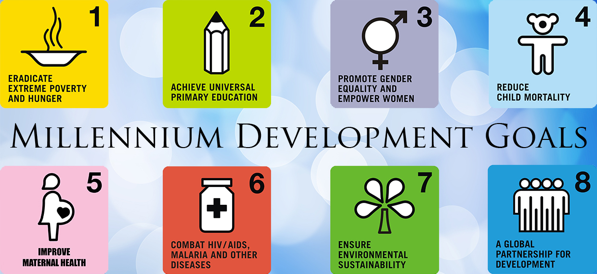

Evidence to show the UN is close to meeting the aim of promoting gender equality and empowering women

Evidence to show the UN is close to meeting the aim of achieving universal primary education?

Evidence to show the UN has is close to meeting the aim of eradicating extreme poverty and hunger

Evidence, which shows that the UN is failing to meet the aim of promoting gender equality and empowering women

Evidence, which shows that the UN is failing to meet the aim of eradicating extreme poverty and hunger

Evidence, which shows that the UN is failing to meet the aim of achieving universal primary education?

Overall, the UN has………….

I believe this due to the following reasons (name at least 2)

**Task 7: How successful has the UN been in achieving its aims**

1. **Maintaining international peace and security**

* What two things are required for the UN to be successful in peacekeeping

1. ...................................................................................................................................................

2. ...................................................................................................................................................

1. **Co- operating in solving international problems**

Why can the Paris climate change conference be used to show that the UN had succeeded in fulfilling its aim to deal with international problems

Explain in 2-3 sentences

................................................................................................................................................... ................................................................................................................................................... ................................................................................................................................................... ................................................................................................................................................... ...................................................................................................................................................

Overall based on what you have learned in today’s lesson has the UN succeeded or failed to date in fulfilling its aims

................................................................................................................................................... ................................................................................................................................................... ................................................................................................................................................... ................................................................................................................................................... ...................................................................................................................................................

**Homework:**

“The UK was right to leave the EU as the costs outweighed the benefits”

You should consider in your answer

The benefits of the UK’s membership with the EU

The costs of the UK’s membership with the EU

The realities of what has happened since the UK left the EU

**(12 marks)**

................................................................................................................................................... ................................................................................................................................................... ................................................................................................................................................... ................................................................................................................................................... ................................................................................................................................................... ................................................................................................................................................... ................................................................................................................................................... ................................................................................................................................................... ................................................................................................................................................... ................................................................................................................................................... ................................................................................................................................................... ................................................................................................................................................... ................................................................................................................................................... ................................................................................................................................................... ................................................................................................................................................... ................................................................................................................................................... ................................................................................................................................................... ................................................................................................................................................... ................................................................................................................................................... ................................................................................................................................................... ................................................................................................................................................... ................................................................................................................................................... ................................................................................................................................................... ................................................................................................................................................... ................................................................................................................................................... ................................................................................................................................................... ................................................................................................................................................... ................................................................................................................................................... ................................................................................................................................................... ................................................................................................................................................... ................................................................................................................................................... ................................................................................................................................................... ................................................................................................................................................... ................................................................................................................................................... ................................................................................................................................................... ................................................................................................................................................... ................................................................................................................................................... ................................................................................................................................................... ................................................................................................................................................... ................................................................................................................................................... ................................................................................................................................................... ................................................................................................................................................... ................................................................................................................................................... ................................................................................................................................................... ................................................................................................................................................... ................................................................................................................................................... ................................................................................................................................................... ...................................................................................................................................................

................................................................................................................................................... ................................................................................................................................................... ................................................................................................................................................... ................................................................................................................................................... ................................................................................................................................................... ................................................................................................................................................... ...................................................................................................................................................

................................................................................................................................................... ................................................................................................................................................... ................................................................................................................................................... ................................................................................................................................................... ................................................................................................................................................... ................................................................................................................................................... ...................................................................................................................................................

................................................................................................................................................... ................................................................................................................................................... ................................................................................................................................................... ................................................................................................................................................... ................................................................................................................................................... ................................................................................................................................................... ...................................................................................................................................................

................................................................................................................................................... ................................................................................................................................................... ................................................................................................................................................... ................................................................................................................................................... ...................................................................................................................................................

How effective has, the international rescue committee been in Syria which seeks to apply humanitarian law?

<https://www.rescue.org/country/syria>

Answer the question using the link above.

................................................................................................................................................... ................................................................................................................................................... ................................................................................................................................................... ................................................................................................................................................... ................................................................................................................................................... ................................................................................................................................................... ...................................................................................................................................................

................................................................................................................................................... ................................................................................................................................................... ................................................................................................................................................... ................................................................................................................................................... ...................................................................................................................................................