Media homework booklet

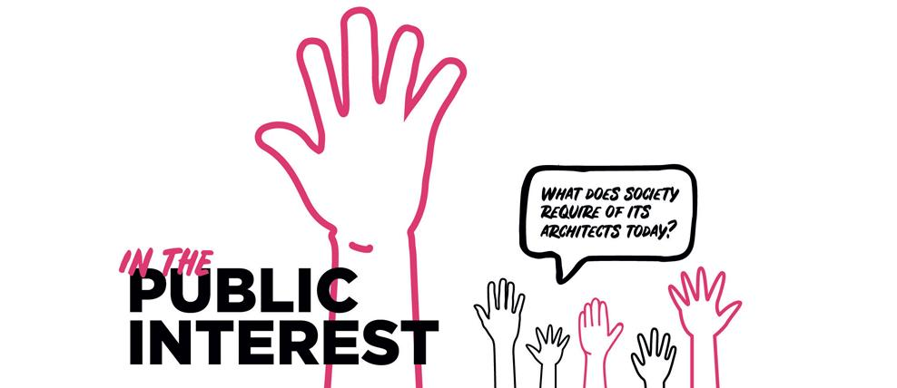

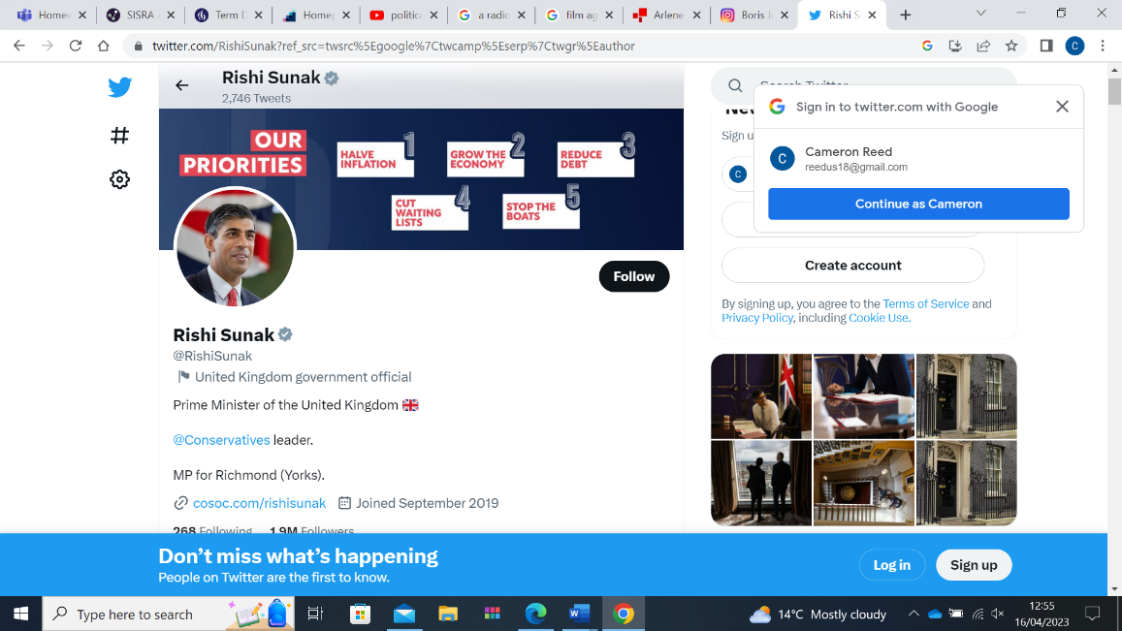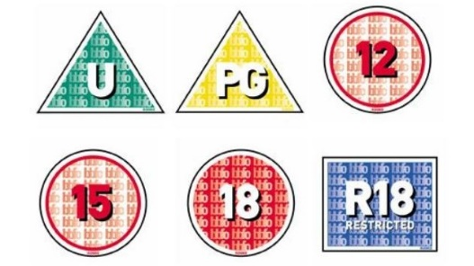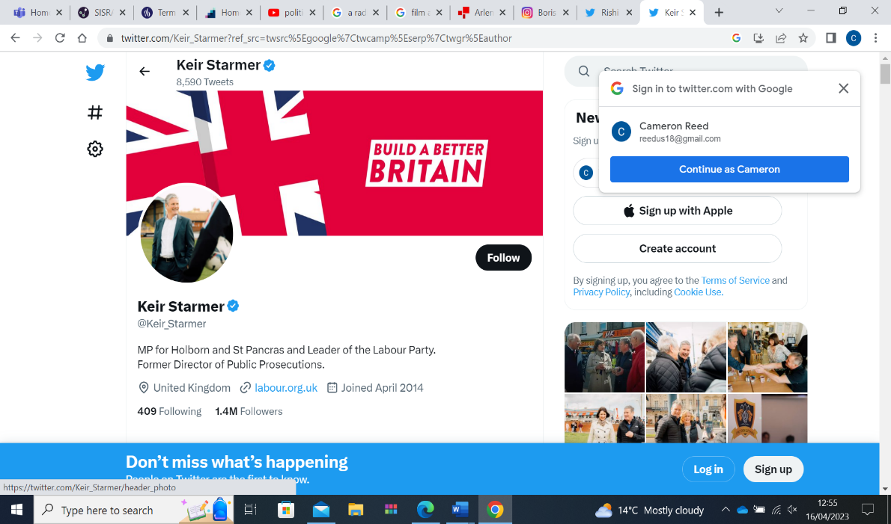

**Homework lesson 1:**

1. State 4 reasons which prove that the media plays an important role within the UK’s democracy

1.

2.

3.

4.

**3. Complete the following using the missing words**

**In order for the media to balance its right to investigate stories with the public’s right to privacy, the media only publishes what is in the ______ __________. This means that it only publishes what the public have a right to know, for example information about a ________. It does not mean that the media should publish information about _____________ private lives. However, the media has sometimes tried to justify such stories by saying that they are in the public interest.**

Missing words:

Celebrities

Interest

Hospital

Public

**The media effectively carries out its role to support democracy.**

**Evaluate this statement.**

You must include:

* ways in which the media supports democracy – exposing wrongdoing holding those to account.
* ways in which the media can mislead or influence the public/ voters.
* ideas of your own

………………………………………………………………………………………………………………………………………………………………………………………………………………………………………………………………………………………………………………………………………………………………………………………………………………………………………………………………………………………………………………………………………………………………………………………………………………………………………………………………………………………………………………………………………………………………………………………………………………………………………………………………………………………………

………………………………………………………………………………………………………………………………………………………………………………………………………………………………………………………………………………………………………………………………………………………………………………………………………………………………………………………………………………………………………………………………………………………………………………………………………………………………………………………………………………………………………………………………………………………………………………………………………………………………………………………………………………………………

………………………………………………………………………………………………………………………………………………………………………………………………………………………………………………………………………………………………………………………………………………………………………………………………………………………………………………………………………………………………………………………………………………………………………………………………………………………………………………………………………………………………………………………………………………………………………………………………………………………………………………………………………………………………

**Homework Lesson 2:**

Practice your exam skills in preparation for mocks in June by answering the following questions:

Exam tips:

For a four marker aim to have three points with three explanations.

For a state question your answers can be bullet pointed and you do not need to include explanations.

Finish this practice question ‘Describe the role of the media in a democracy’ [4 marks]

One role of the media is to hold those in power to account (POINT) For example when journalists conduct interviews with politicians and scrutinise their actions ( Evidence) This means that the media scrutinises the work of groups such as political parties and exposes any wrongdoings to inform the public which they can use to inform their decision at the next election. (EXPLANATION). ..……………………………………………………………………………………………………………………………………………………………………………………………………………………………………………………………………………………………………………………………………………………………………………………………………………………………………………………………………………………………………………………………………………………………………………………………………………………………………………………………………………………………………………………………………………

……………………………………………………………………………………………………………………………………………………………………………………………………………………………………………………………………………………………………………………………………………………………………………………………………………………………………………………………………………………………………………………………………………………………………………………………..

State two reasons why the media may be censored in the United Kingdom [2 marks]

1. …………………………………………………………………………………………………………………………………………………………………………………………………………………………………………………………………………
2. …………………………………………………………………………………………………………………………………………………………………………………………………………………………………………………………………………

State two reasons why digital campaigning /social media can be more effective than using traditional media [2 marks]

1. ..………………………………………………………………………………………………………………………………………………………………………………………………………………………………………………………………………
2. ..………………………………………………………………………………………………………………………………………………………………………………………………………………………………………………………………………

**The media should be more regulated in the United kingdom**

**Evaluate this statement.**

You must include:

* Examples of wrongdoing by the media
* Importance of the media in democracy
* Your own knowledge

………………………………………………………………………………………………………………………………………………………………………………………………………………………………………………………………………………………………………………………………………………………………………………………………………………………………………………………………………………………………………………………………………………………………………………………………………………………………………………………………………………………………………………………………………………………………………………………………………………………………………………………………………………………………

………………………………………………………………………………………………………………………………………………………………………………………………………………………………………………………………………………………………………………………………………………………………………………………………………………………………………………………………………………………………………………………………………………………………………………………………………………………………………………………………………………………………………………………………………………………………………………………………………………………………………………………………………………………………

………………………………………………………………………………………………………………………………………………………………………………………………………………………………………………………………………………………………………………………………………………………………………………………………………………………………………………………………………………………………………………………………………………………………………………………………………………………………………………………………………………………………………………………………………………………………………………………………………………………………………………………………………………………………