Topic 5 and 6: Law and Legal system homework booklet

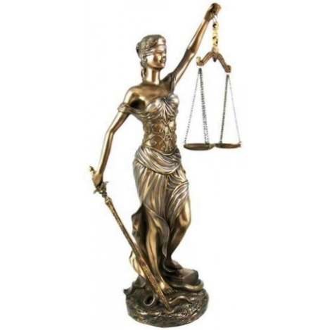

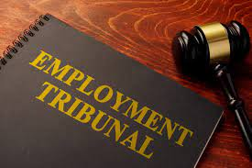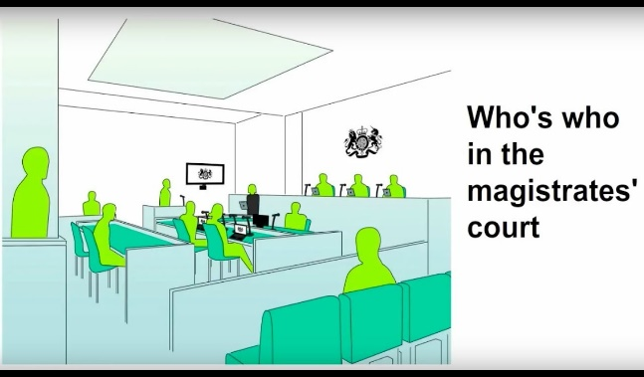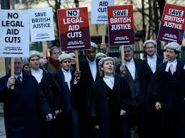

Homework lesson 1:

Assessment 9 marker prep:

|  |  |  |
| --- | --- | --- |
| **Paragraph focus** | **Find 1 right which is positive/good** | **Find 1 right Kingdom which is negative/bad** |
| Rights |  |  |

|  |  |  |
| --- | --- | --- |
| **Paragraph focus** | **Find 1 aspect of the UK’s democracy and 1 aspect of the UK’s government/constitution which is positive/good** | **Find 1 aspect of the UK’s democracy and 1 aspect of the UK’s government/constitution which is negative/bad** |
| Democracy and government |  |  |

|  |  |  |
| --- | --- | --- |
| **Paragraph focus** | **Name two protected characteristics named within the equality act and two advantages of trade unions** | **Name two ways people are still not treated equally within the UK and two downsides of trade unions** |
| Equalities opportunities |  |  |

Lesson 2: Homework:

**Task 6: Speed plan this question in your booklets:**  
**Equality before the law and innocence until proven guilty in the UK are no longer effective. (8 marks)**

**Write a case supporting this statement.**   
  
You should include (but not be limited to):

* Counter-Terrorism detainees
* An explanation of what each of the key principles means

*TOP TIP: An 8 mark question needs 4 points, each with an example or a sentence explaining.*

Point 1 –

Point 2 –

Point 3 –

Point 4 –

Write out your full answer to the 8-mark question. You should aim to write it in 10 minutes!

………………………………………………………………………………………………………………………………………………………………………………………………………………………………………………………………………………………………………………………………………………………………………………………………………………………………………………………………………………………………………………………………………………………………………………………………………………………………………………………………………………………………………………………………………………………………………………………………………………………………………………………………………………………………………………………………………………………………………………………………………………………………………………………………………………………………………………………………………………………………………………………………………………………………………………………………………………………………………………………………………………………………………………………………………………………………………………………………………………………………………………………………………………………………………………………………………………………………………………………………………………………………………………………………………………………………………………………………………………………………………………………………………………………………………………………………………………………………………………………………………………………………………………………………………………………………………………………………………………………………………………………………………………………………………………………………………………………………………………………………………………………………………………………………………………………………………………………………………………………………………………………………………………………………………………………………………………………………………………………………………………………………………………………………………………………………………………………………………………………………………………………………………………………………………………………………………………………………………………………………………………………………………………………………………………………………………………………………………………………………………………………………………………………………………………………………………………………………………………………………………………………………………………………………………………………………………………………………………………………………………………………………………………………………………………………………………………………………………………………………………………………………………………………………………………………………………………………………………………………………………………………………………………………………………………………………………………………………………………………………………………………………………………………………………………………………………………………………………………………………………………………………………………………………………………………………………………………………………………………………………………………………………………………………………………………………………………………………………………………………………………………………………………………………………………………………………………………………………………………………………………………………………………………………………………

Homework Lesson 3:

**Task 1: Special Constables –what are they and what do they do?**

1. Record the main activities/duties of a special constables.

………………………………………………………………………………………………………………………………………………………………………………………………………………………………………………………………………………………………………………

1. How are special constables different to police officers?

………………………………………………………………………………………………………………………………………………………………………………………………………………………………………………………………………………………………………………………..

Task 2: Police and Crime Commissioners – Fill the gaps in using the information provided:

Police and Crime Commissioners are known for short as .It is an position meaning they are voted for in local elections. They are tasked with maintaining the integrity, efficiency and of local police forces. Unfortunately, at elections for this position is quite low. This is because…

Elected, operation, turnout, PCCS

Task 3: What are County Courts and what do they do?

1. What examples of cases are there that can be dealt by County Courts?​

………………………………………………………………………………………………………………………………………………………………………………………………………………………………………………………………………………………………………………………..

1. Which judges sit on a country court?​

……………………………………………………………………………………………………………………………………………………………

1. What happens in the judgment process?​

………………………………………………………………………………………………………………………………………………………………………………………………………………………………………………………………………………………………………………………..

1. How are costs dealt with?

………………………………………………………………………………………………………………………………………………………………………………………………………………………………………………………………………………………………………………………..

Task 4: What are mediation services?

………………………………………………………………………………………………………………………………………………………………………………………………………………………………………………………………………………………………………………………..

Homework Lesson 4:

12 marker mock prep:

Using the lesson PowerPoint complete the following tables

|  |  |  |
| --- | --- | --- |
| **Paragraph focus** | **Find 1 right and 1 aspect of the law in the United Kingdom which is positive/good** | **Find 1 right and 1 aspect of the law in the United Kingdom which is negative/bad** |
| Rights and the Law. |  |  |

|  |  |  |
| --- | --- | --- |
| **Paragraph focus** | **Find 1 aspect of the UK’s democracy and 1 aspect of the UK’s government/constitution which is positive/good** | **Find 1 aspect of the UK’s democracy and 1 aspect of the UK’s government/constitution which is negative/bad** |
| Democracy and government |  |  |

|  |  |  |
| --- | --- | --- |
| **Paragraph focus** | **Name two protected characteristics named within the equality act and two advantages of trade unions** | **Name two ways people are still not treated equally within the UK and two downsides of trade unions** |
| Equalities opportunities |  |  |