GCSe politics topic 5:

The economy, money, and finance

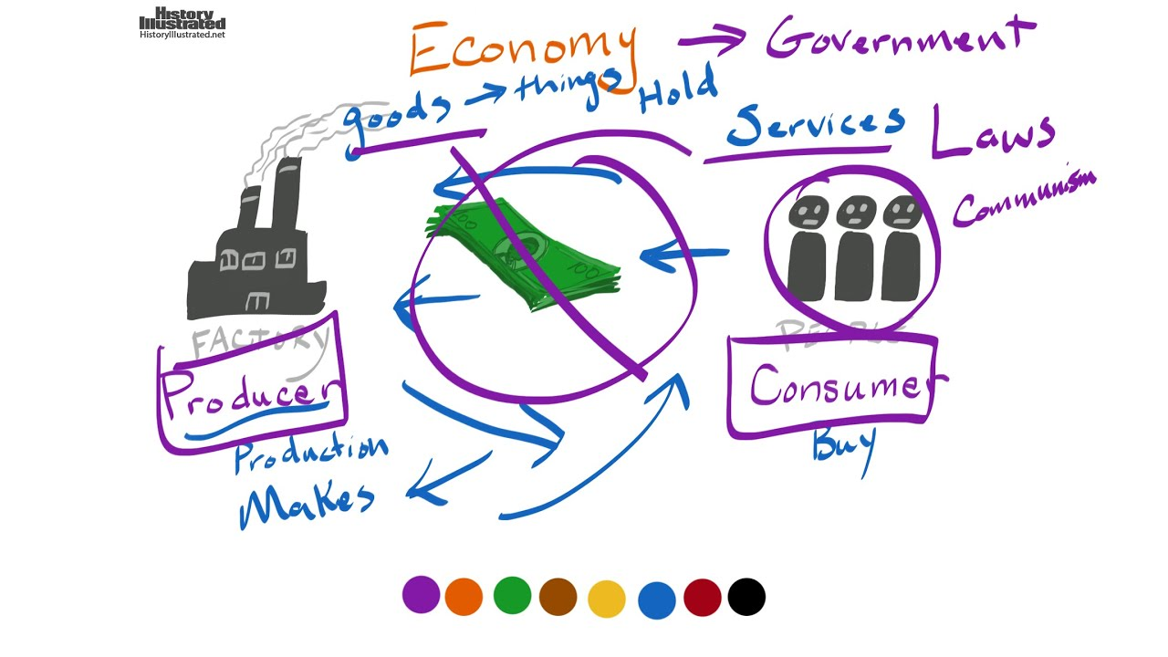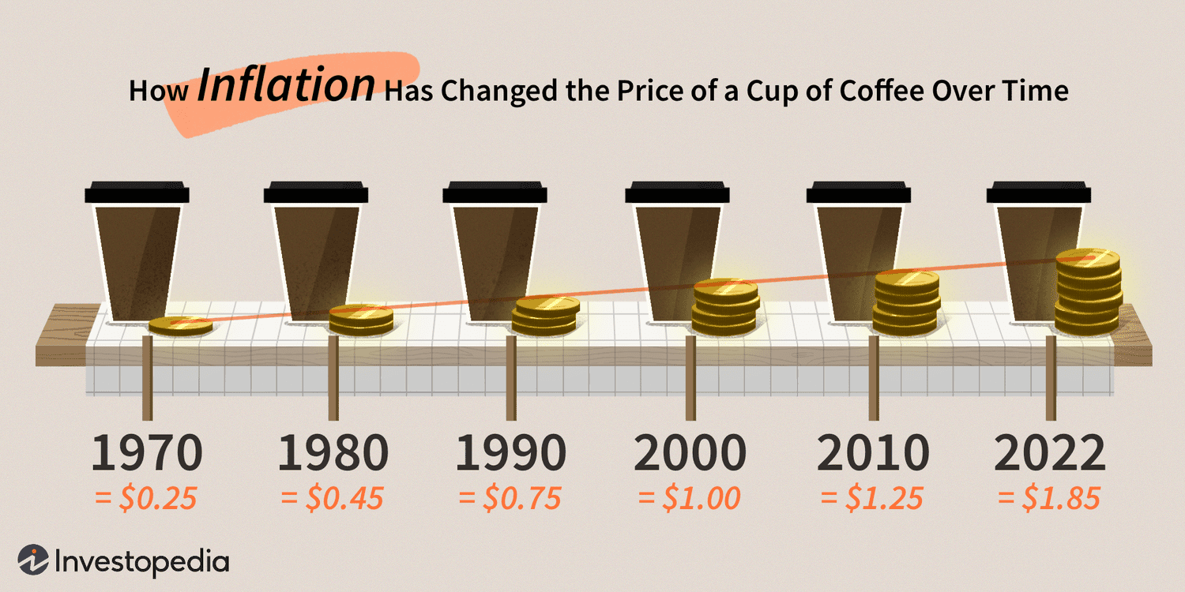

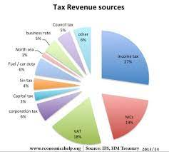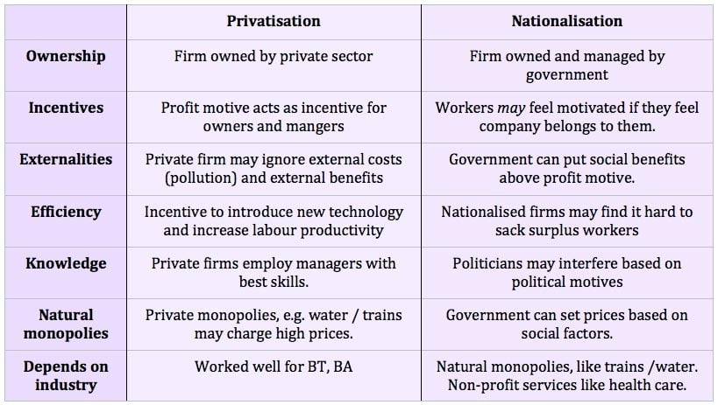

**Lesson 1: What is the economy and how is it managed?**

***In this topic you will look at:***

***What the economy is and how it goes from being strong to being weak.***

***What different political parties and people believe about how we should manage our economy. Is it up to the individual to take care of themselves? Or should we be working together to support one another?***

**Task 1: Sort the different features into the correct columns to identify the differences between the two types of economy.**

An economy in recession

A Growing Economy

**Extension: Use the space below to create a diagram showing the connections between the different stages. Choose either type of economy for this task (you don’t have to do both!).**

**Task 2: How does the government manage the economy? Use the words below to fill in the blanks in your booklets.**

* ﻿Encouraging **investment** in new and equipment
* Creating work by funding major **public** **projects** such as housebuilding or____________
* ﻿Encouraging consumer spending by **cutting** – so giving businesses a welcome sales boost and encouraging them to employ more .

Products, Taxes, workers, road improvement

**Task 3: What do we mean by supply and demand?***.*

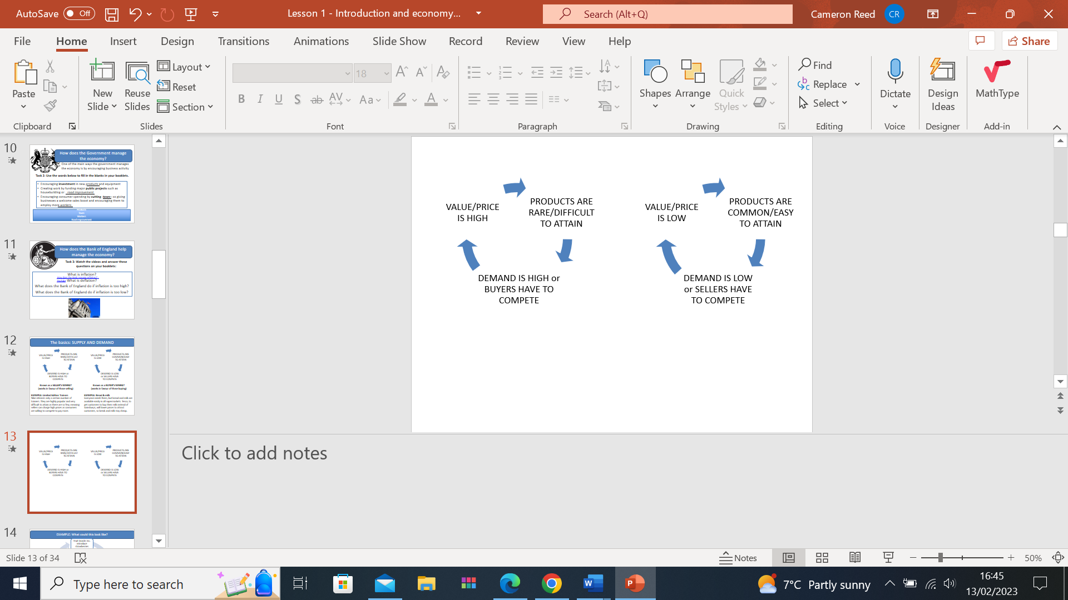……………………………………………………………………………………………………………………………………………………………………………………………………………………………………………………………………………………………………………………………………………………………………………………………………………………………………………………………………………………………………………………………………………………………………………………………………………………………………………………

PRODUCTS ARE……..

**Use the missing words on the slide fill in the missing gaps.**

VALUE/PRICE IS HIGH

DEMAND IS……..

OR SELLERS HAVE TO COMPETE

PRODUCTS ARE…..

VALUE/PRICE IS…..

**Known as a ………….. MARKET  
(works in favour of those ………………)**

**EXAMPLE:**

…………. releases only a certain number of ……….. They are highly popular and very difficult to……….as there are so few, meaning sellers can charge………… prices as consumers are willing to compete to ……………..

**Known as a ………….MARKET**

**(works in favour of those ……………)**

**EXAMPLE:**

Everyone needs them, but …………………. items are available easily in all …………….……………… For example …………….. to get customers to buy their……………. instead of …………., they will …………. prices to attract customers, so these essential ……………….. stay cheap.

**Task 4: Watch the videos and answer these questions on your booklets:**

What is inflation?

What is deflation?

What does the Bank of England do if inflation is too high?

What does the Bank of England do if inflation is too low?

Use the links to find out the causes behind inflation and deflation

**Task 5: Causes of inflation and deflation**

|  |  |
| --- | --- |
| Causes of inflation increasing | Causes of deflation |
|  |  |

<https://corporatefinanceinstitute.com/resources/economics/deflation/>

[**https://www.studysmarter.co.uk/explanations/macroeconomics/economic-performance/inflation/**](https://www.studysmarter.co.uk/explanations/macroeconomics/economic-performance/inflation/)

**Task 6: complete the diagrams below**

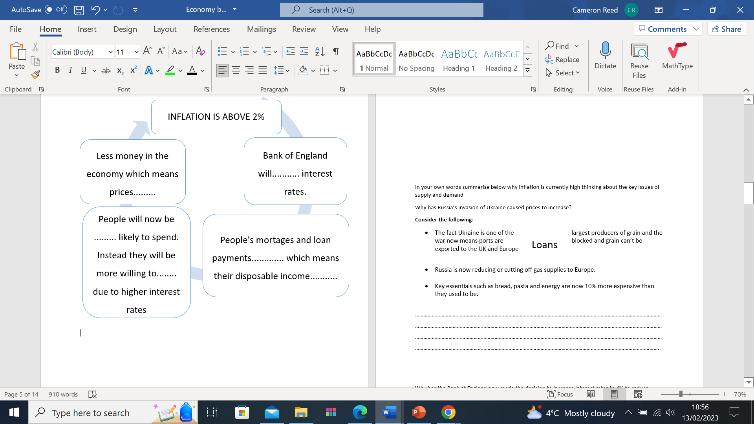

Decrease, go up, rise, less, spend, likely, grows, declines, save, drop, increase, pay

Task 7:

In your own words summarise below why inflation is currently high thinking about the key issues of supply and demand

Why has Russia’s invasion of Ukraine caused prices to increase?

**Consider the following:**

* The fact Ukraine is one of the largest producers of grain and the war now means ports are blocked and grain can’t be exported to the UK and Europe
* Russia is now reducing or cutting off gas supplies to Europe.
* Key essentials such as bread, pasta and energy are now 10% more expensive than they used to be.

…………………………………………………………………………………………………………………………………………………………………………………………………………………………………………………………………………………………………………………………………………………………………………………………………………………………………………………………………………………………………………………………………………………………………………………………………………………………………………………..

Why has the Bank of England now made the decision to increase interest rates to 4% to reduce inflation?

…………………………………………………………………………………………………………………………………………………………………………………………………………………………………………………………………………………………………………………………………………………………………………………………………………………………………………………………………………………………………………………………………………………………………………………………………………………………………………………..

Who has benefited from this decision and which groups of people are now worse off due to this decision?

…………………………………………………………………………………………………………………………………………………………………………………………………………………………………………………………………………………………………………………………………………………………………………………………………………………………………………………………………………………………………………………………………………………………………………………………………………………………………………………..

**Homework:**

**1. Identify 4 features of deflation**

1. Inflation is above 2%
2. More supply than demand
3. Price of goods and services increases
4. Inflation is below 2%
5. More demand than supply
6. If people know prices are going down, they are less willing to buy anticipating lower prices
7. Price of goods and services decreases

2. State two ways consumer’s benefit from a buyers’ market

…………………………………………………………………………………………………………………………………………………………………………………………………………………………………………………………………………………………………………………………

3. State two ways businesses benefit from a seller’s market

…………………………………………………………………………………………………………………………………………………………………………………………………………………………………………………………………………………………………………………………

State one type of economy

..............................................................................................................................................

State two reasons why inflation increases ................................................................................................................................................ ...................................................................................................................................................

**Lesson 2: What are the debates over our economy?**

Task 1: Using your iPad, and the handout workout the meaning of these different forms of tax.

Add in next to your explanations how much can be made from each tax

|  |
| --- |
|  |
|  |
|  |
|  |
|  |
|  |
|  |
|  |

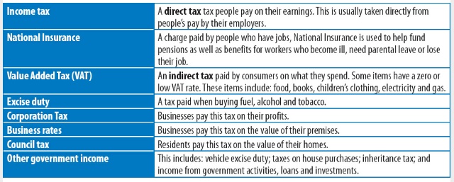

**Task 2:**

1. **Then use the data to create a pie chart in the space below in to show how much of the total each type of tax generates as a proportion of our country’s total income**

**Task 3: Political parties and money recap**

**Conservatives**

**Prefer taxes to be?**



**When it comes to welfare spending, they would rather …**

**Typically, the polices above make them more popular among…**

**Labour**

**Prefer taxes to be?**



**When it comes to welfare spending, they would rather …**

**Typically, the polices above make them more popular among…**

**Conservatives**

**Task 3: State Vs Private provision**

**PRIVATE PROVISION**

Government sell contracts to run public services to competing private companies

**STATE PROVISION**

(aka direct government or nationalisation)

Government run services themselves

After you have discussed with your partner, add some ideas to the following table:

|  |  |
| --- | --- |
| **Benefits of state provision** | **Benefits of private provision** |
| Standard of service:  How the provision/service meets people’s needs:  How standards are maintained:  Who runs the provision/service?  Role politicians play: | Standard of service:  How the provision/ service meets people’s needs:  How standards are maintained:  Who runs the provision/ service?  Role politicians play: |

**Task 4: What is the state vs private provision debate?**

|  |  |  |
| --- | --- | --- |
|  | **INDIVIDUALIST APPROACH**  **People should take as much responsibility as possible for their own lives** | **COLLECTIVIST APPROACH**  **Governments should provided services & support for everyone according to need** |
| **Which parties?** |  |  |
| **Welfare** |  |  |
| **Health** |  |  |
| **Education** |  |  |
| **Needs of the elderly** |  |  |

**Task 5: Exam practice:**

**Provide a challenge against this statement.**

***‘The Government should provide services and support for everyone according to their needs.’***

**You should include reference to:**

* **Examples of major political parties’ views**
* **State provision**
* **Private provision**

Planning box:

Arguments for:

Arguments against:

My argument:

Use the space below to write out your answer:

…………………………………………………………………………………………………………………………………………………………………………………………………………………………………………………………………………………………………………………………………………………………………………………………………………………………………………………………………………………………………………………………………………………………………………………………………………………………………………………….…………………………………………………………………………………………………………………………………………………………………………………………………………………………………………………………………………………………………………………………………………………………………………………………………………………………………………………………………………………………………………………………………………………………………………………………………………………………………………………….…………………………………………………………………………………………………………………………………………………………………………………………………………………………………………………………………………………………………………………………………………………………………………………………………………………………………………………………………………………………………………………………………………………………………………………………………………………………………………………….…………………………………………………………………………………………………………………………………………………………………………………………………………………………………………………………………………………………………………………………………………………………………………………………………………………………………………………………………………………………………………………………………………………………………………………………………………………………………………………….…………………………………………………………………………………………………………………………………………………………………………………………………………………………………………………………………………………………………………………………………………………………………………………………………………………………………………………………………………………………………………………………………………………………………………………………………………………………………………………….…………………………………………………………………………………………………………………………………………………………………………………………………………………………………………………………………………………………………………………………………………………………………………………………………………………………………………………………………………………………………………………………………………………………………………………………………………………………………………………….……………………………………………………………………………………………………………………………………………………………

……………………………………………………………………………………………………………………………………………………………………………………………………………………………………………………………………………………………………………………………………………………………………………………………………………………………………………………………………………………….…………………………………………………………………………………………………………………………………………………………………………………………………………………………………………………………………………………………………………………………………………………………………………………………………………………………………………………………………………………………………………………………………………………………………………………………………………………………………………………….………………………………………………………………………………………………………………………………………………………………………………………………………………………………………………………………………………………………………………………………………………………………………………………………………………………………………………………………………………………

……………………………………………………………………………………………………………………………………………………………………………………………………………………………………………………………………………………………………………………………………………………………………………………………………………………………………………………………………………………….…………………………………………………………………………………………………………………………………………………………………………………………………………………………………………………………………………………………………………………………………………………………………………………………………………………………………………………………………………………………………………………………………………………………………………………………………………………………………………………….………………………………………………………………………………………………………………………………………………………………………………………………………………………………………………………………………………………………………………………………………………………………………………………………………………………………………………………………………………………