Politics GCSE Topic 10 booklet

Citizenship Action





**Lesson 1: Planning Citizenship action project**

What is our action project?

……………………………………………………………………………………………………………………………………………………………………………………………………………………………………………………

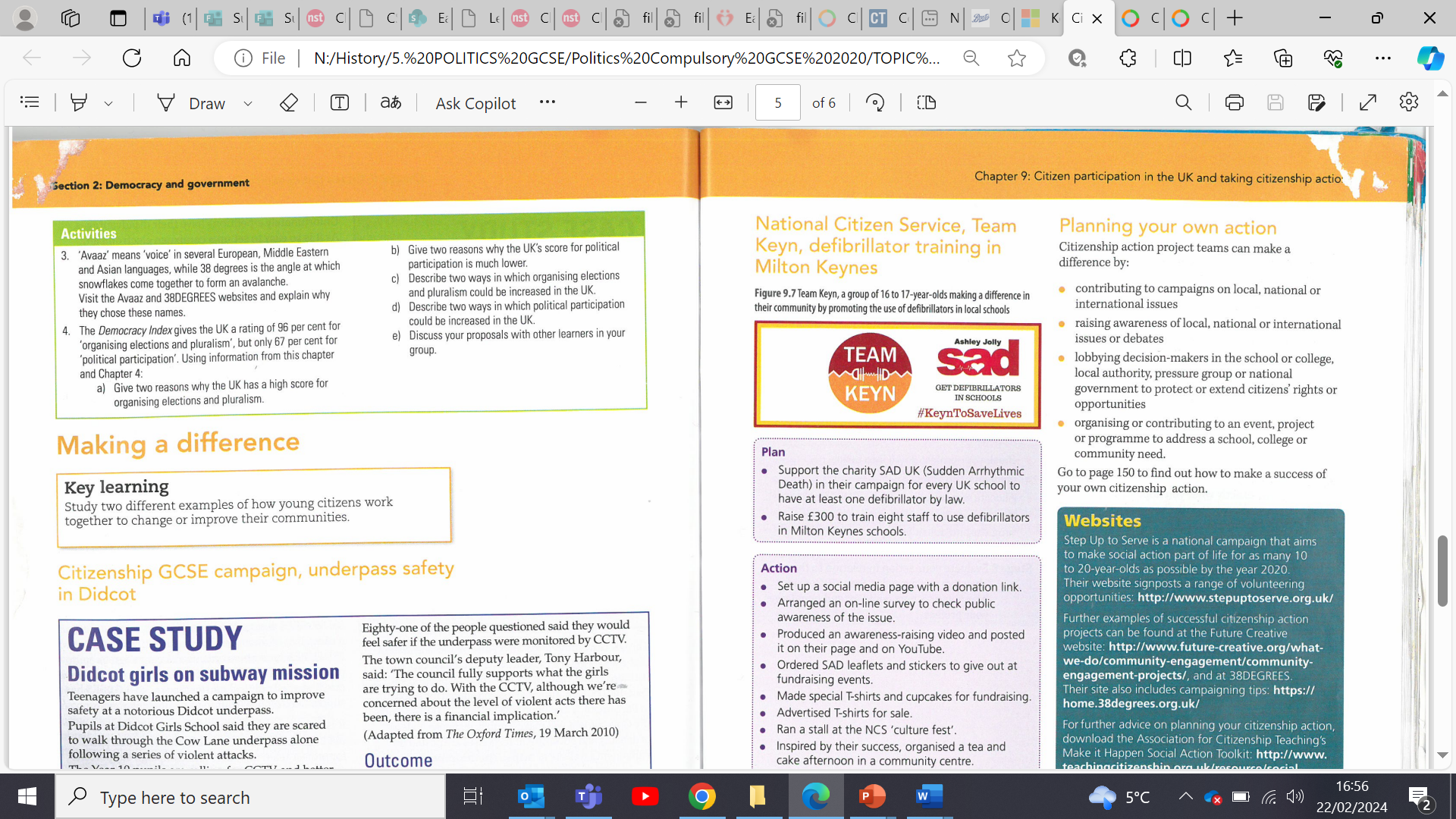

**Task 1:**

Highlight circle the points which are relevant to our school’s action project

**Task 2:**

**Why are cities introducing congestion charges?**

**Challenge: What is the difference between a congestion charge and green levy?**

**Secondary Research:**

Why is secondary research important?

________________________________________________________________________________________________________________________________________________________________________________________________

**Secondary source 1: Cambridge air quality annual status report**

1. Has air quality in Cambridge city been declining or improving since 2004?

…………………………………………………………………………………………………………………………

1. What is the main source of nitrogen dioxide in Cambridge city?

…………………………………………………………………………………………………………………………

………………………………………………………………………………………………………………………..

1. How many deaths occurred in 2020 due to suspected air pollution?

……………………………………………………………………………………………………………………….

1. Post Covid what has happened to traffic levels within Cambridge city?

…………………………………………………………………………………………………………………………

**Secondary Source 2, The Greater Cambridge Partnership:**

1. How many more daily car journeys are there projected to be in and around Cambridge city in 2031 compared to 2011?

_________________________________________________________________________________

1. What would need to happen to our public transport capacity to meet this demand?

_________________________________________________________________________________

1. What were the 3 main findings of the autumn 2023 big conversation?
2. ___________________________________________________________________________
3. ___________________________________________________________________________
4. ___________________________________________________________________________

What are the Cambridge Partnerships 4 proposed solutions to reducing congestion?

1. _____________________________________________________________________
2. _____________________________________________________________________
3. _____________________________________________________________________

**What was announced on the** **9th of November 2021?**

__________________________________________________________________

**21st of March 2022**

__________________________________________________________________

**27th August 2022**

__________________________________________________________________

**27th November 2022**

__________________________________________________________________

**10th December 2022**

__________________________________________________________________

**21st of March 2023**

__________________________________________________________________

**26th May 2023**

__________________________________________________________________

**5th of July 2023**

__________________________________________________________________

**Task 2: The timeline of the proposed Cambridge Congestion charge**

**25th of August 2023**

__________________________________________________________________

**5th September 2023**

__________________________________________________________________

**6th September 2023**

__________________________________________________________________

**18th October 2023:**

__________________________________________________________________

Evaluating the previous proposed congestion charge

1. In your own words why did the original proposed congestion charge fail?

------------------------------------------------------------------------------------------------------------------------------------------------------------------------------------------------------------------------------------------------------------------------------------------------------------------------------------------------------------------------------------------------------------------------------------

1. Was the plan fundamentally flawed from the beginning?

---------------------------------------------------------------------------------------------------------------------------------------------------------------------------------------------------------------------------------------------------------------------------------------------------------------------------

3. What are the main issues with the proposed boundary zone?

Add your ideas around the map below:

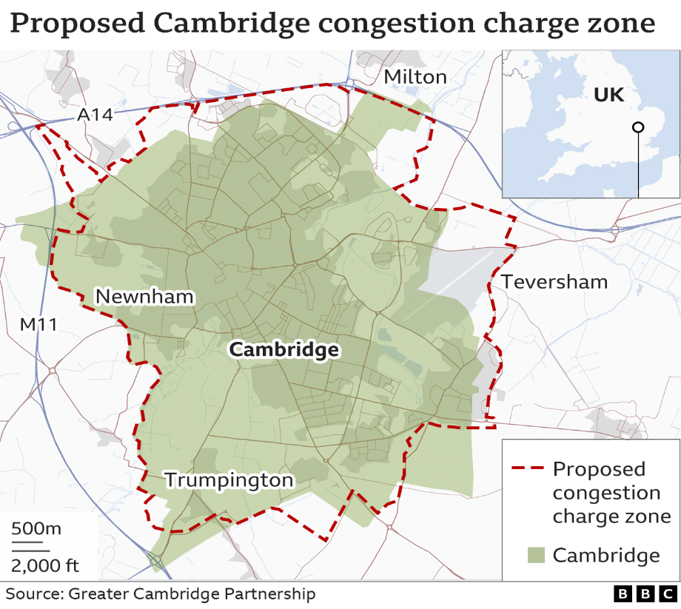

**Your action project:**

Get into groups of 4-6

Do you believe that Cambridge needs a Congestion charge to help reduce traffic congestion and encourage the use of alternative transportation?

Yes or no will determine the path of your secondary research

Yes

Of the reasons discussed above which 3 do you think best explain why the Congestion charge failed

1.

2.

3.

**Secondary research:**

Sweden

<https://www.bbc.co.uk/news/uk-england-cambridgeshire-64496836>

How much does the Swedish city of Gothenburg charge?

………………………………………………………………………………………………………………………….

How much does the city of Gothenburg raise in a year?

………………………………………………………………………………………………………………………….

What ideas could you potentially borrow from Gothenburg’s congestion charge?

………………………………………………………………………………………………………………………………………………………………………………………………………………………………………………………………………………………………………………………………………………………………………………

………………………………………………………………………………………………………………………………………………………………………………………………………………………………………………………………………………………………………………………………………………………………………………

**Secondary Research Oxford**

1. What does ZEZ stand for?

…………………………………………………………………………………………………………………

1. What type of vehicles do not pay the charge?

…………………………………………………………………………………………………………………………………………………………………………………………………………………………………………………………………………………………………………………………………………………………………………….

1. What is the range in price motorists pay?

………………………………………………………………………………………………………………….

4. Who qualifies for a discount?

……………………………………………………………………………………………………………………………………………………………………………………………………………………………………………………………………………………………………………………………………………………………………………...

What ideas could you borrow from Oxford with your proposed congestion charge for Cambridge city?

……………………………………………………………………………………………………………………………………………………………………………………………………………………………………………………………………………………………………………………………………………………………………………..

**How could the Cambridge congestion charge be improved?**

Rationale: Should it be levied to reduce pollution or cut congestion of vehicles

……………………………………………………………………………………………………………………………………………………………………………………………………………………………………………………………………………………………………………………………………………………………………………..

How much should drivers pay and at what times of day? (the proposed charge times were between 7 am and 7pm)

……………………………………………………………………………………………………………………………………………………………………………………………………………………………………………………………………………………………………………………………………………………………………………..

Draw your own boundary zone

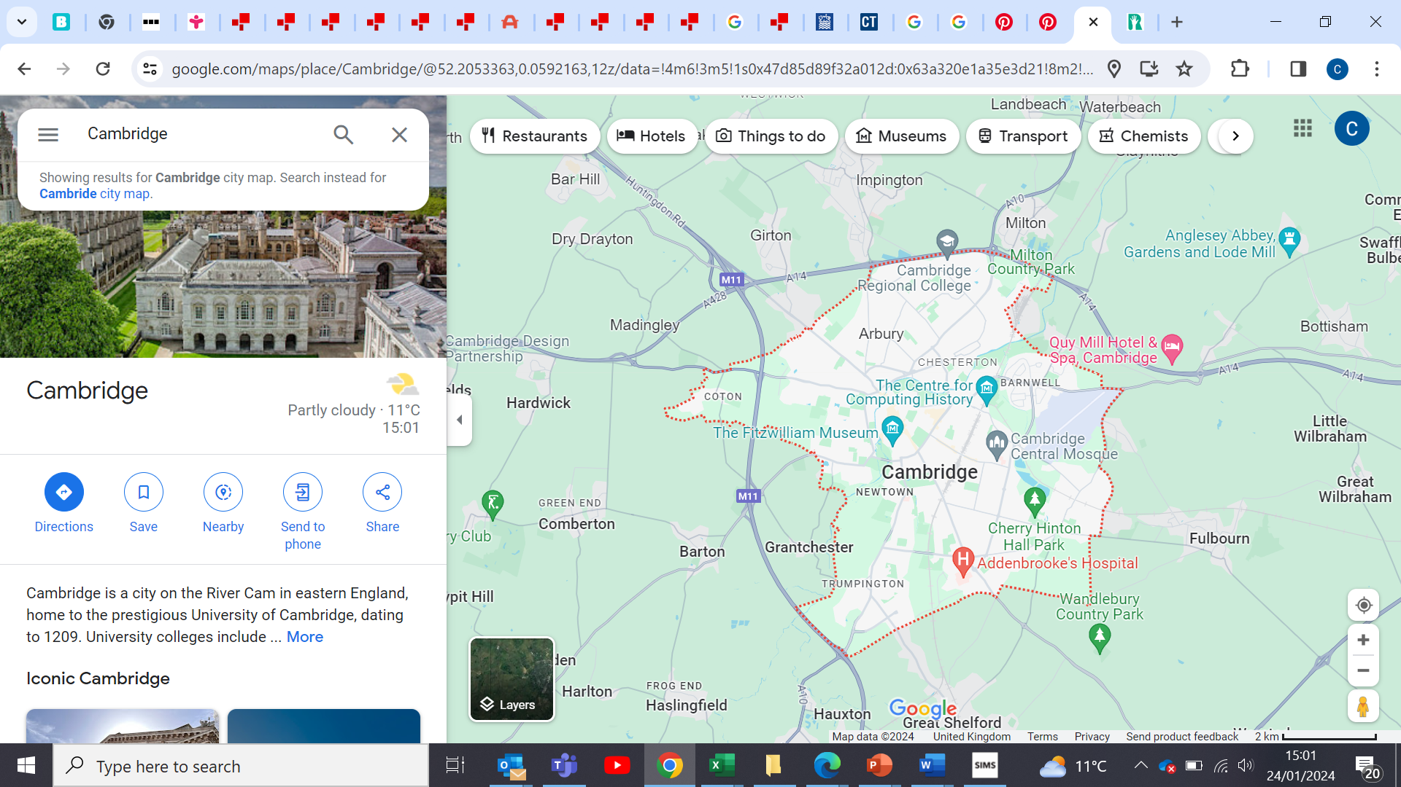

**Explain the rationale behind your proposed boundary zone**

……………………………………………………………………………………………………………………………………………………………………………………………………………………………………………………………………………………………………………………………………………………………………………..

……………………………………………………………………………………………………………………………………………………………………………………………………………………………………………………………………………………………………………………………………………………………………………..

……………………………………………………………………………………………………………………………………………………………………………………………………………………………………………………………………………………………………………………………………………………………………………..

If you have chosen, no

Look at the comments from the petition to stop the congestion charge which comments

List the comments which you think could be used to form an effective argument against the congestion charge

<https://www.change.org/p/opposition-to-the-cambridge-congestion-charge>

……………………………………………………………………………………………………………………………………………………………………………………………………………………………………………………………………………………………………………………………………………………………………………..

……………………………………………………………………………………………………………………………………………………………………………………………………………………………………………………………………………………………………………………………………………………………………………..

……………………………………………………………………………………………………………………………………………………………………………………………………………………………………………………………………………………………………………………………………………………………………………..

……………………………………………………………………………………………………………………………………………………………………………………………………………………………………………………………………………………………………………………………………………………………………………..

**Alternatives to the congestion charge**

|  |  |
| --- | --- |
| Parking controls advantages | Parking controls disadvantages |
|  |  |

|  |  |
| --- | --- |
| Workplace parking levy advantages | Workplace parking levy disadvantages |
|  |  |

|  |  |
| --- | --- |
| Flexible charge advantages | Flexible charge disadvantages |
|  |  |

Which one or two do you think are the better alternatives to a congestion charge

1. ………………………………………………………………………………………………..

2 …………………………………………………………………………………………………

State your reasons why

……………………………………………………………………………………………………………………………………………………………………………………………………………………………………………………………………………………………………………………………………………………………………………..

……………………………………………………………………………………………………………………………………………………………………………………………………………………………………………………………………………………………………………………………………………………………………………..

……………………………………………………………………………………………………………………………………………………………………………………………………………………………………………………………………………………………………………………………………………………………………………..

**Lesson 2: How to be an active citizen**

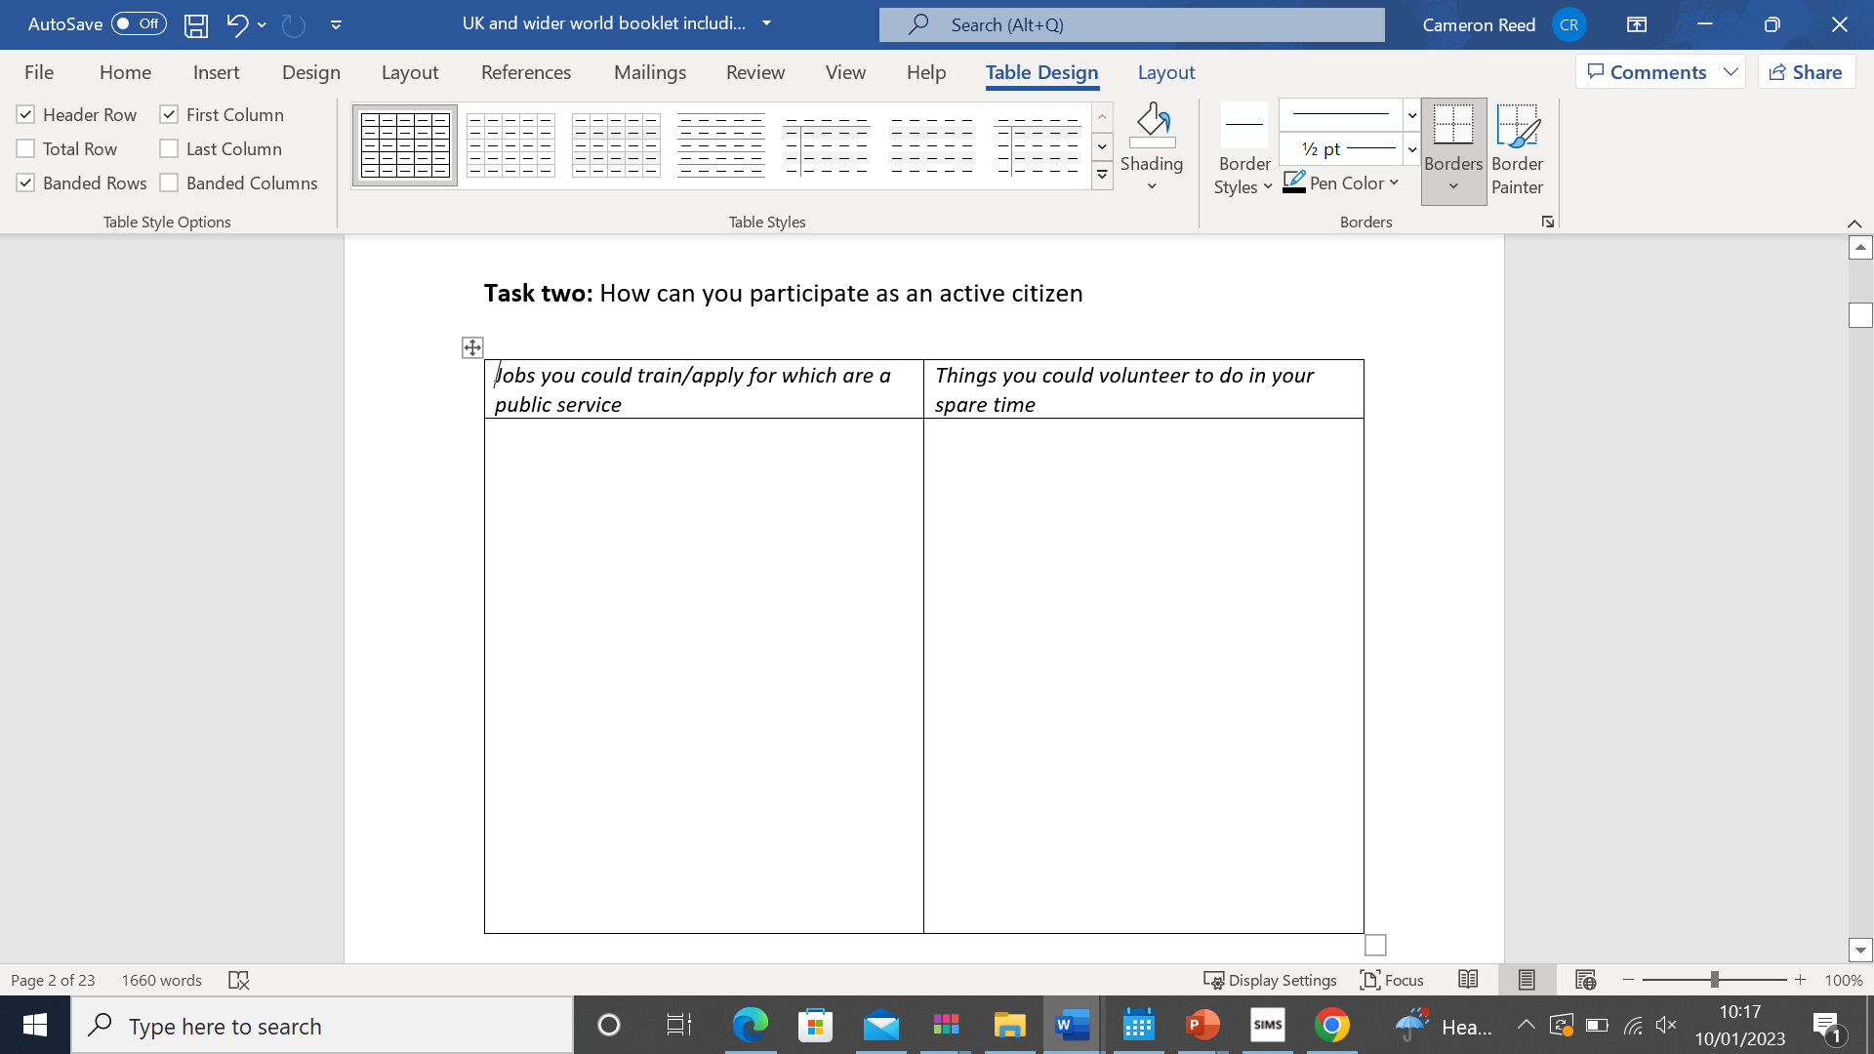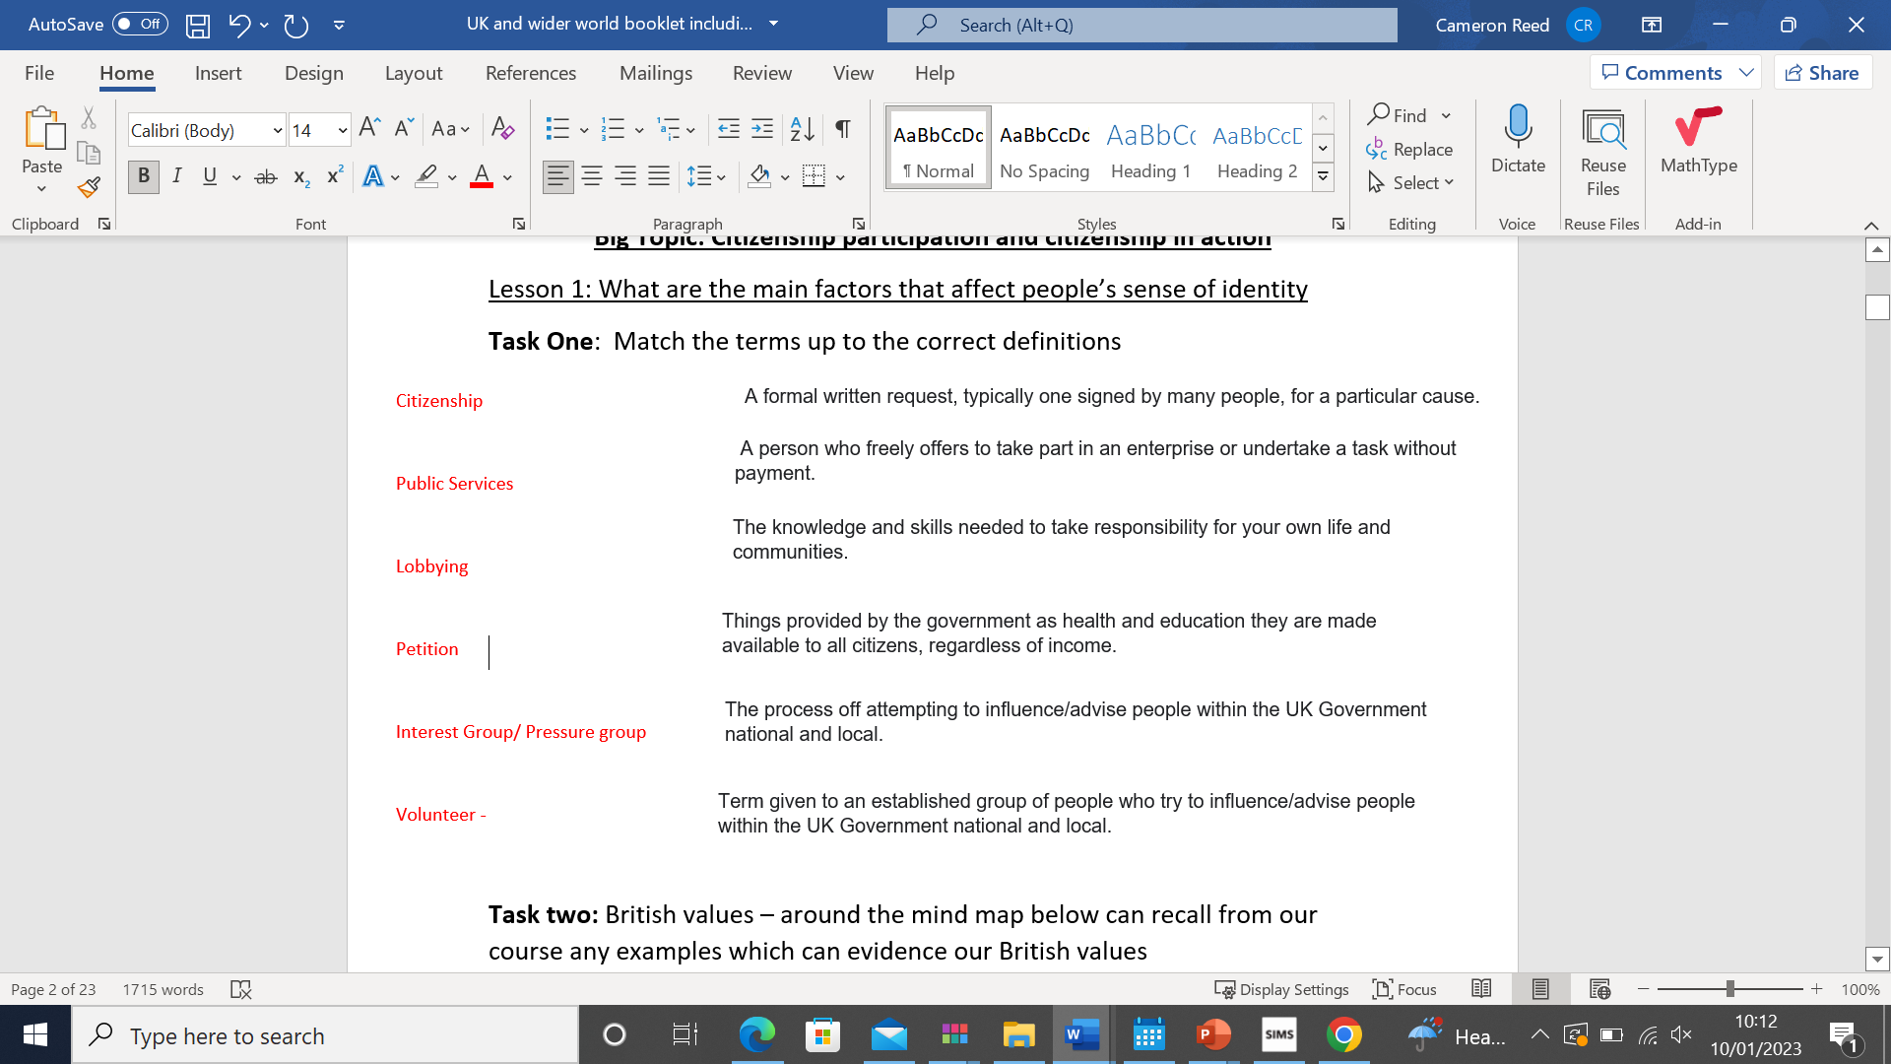

*Task 3: On the next page: Use the textbook page 140 – 141 and the links to answer the questions around your mind maps on the National citizenship service and UK Youth parliament*

[*https://wearencs.com/*](https://wearencs.com/)

[*https://www.byc.org.uk/campaigns*](https://www.byc.org.uk/campaigns)

Ultimately a pressure group is different from a political party because..

Describe what Lobbying is

Name two examples of pressure groups:

Task 7: The importance of community participation for democracy ( page 143)

Why is citizenship participation vital for a healthy democracy?

What does community participation do?

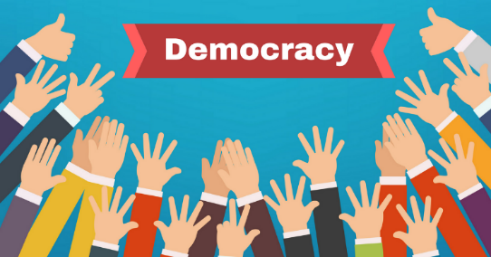

Why is it important that community’s campaign for change?

Task 7: How does this link with our citizenship course?

Rights and responsibilities

By helping reduce emission and congestion levels how are we in turn helping our local communities

……………………………………………………………………………………………………………………………………………………………………………………………………………………………………………………………………………………………………………………………………………………………………………..

……………………………………………………………………………………………………………………………………………………………………………………………………………………………………………………………………………………………………………………………………………………………………………..

……………………………………………………………………………………………………………………………………………………………………………………………………………………………………………………………………………………………………………………………………………………………………………..

**Lesson 3 primary evidence and evaluation**

1. **Summarise the key findings from our parent – questionnaire**

……………………………………………………………………………………………………………………………………………………………………………………………………………………………………………………………………………………………………………………………………………………………………………..……………………………………………………………………………………………………………………………………………………………………………………………………………………………………………………

………………………………………………………………………………………………………………………..……………………………………………………………………………………………………………………………………………………………………………………………………………………………………………………………………………………………………………………………………………………………………………..

………………………………………………………………………………………………………………………..……………………………………………………………………………………………………………………………………………………………………………………………………………………………………………………………………………………………………………………………………………………………………………..

**To complete our action project, we have /will**

……………………………………………………………………………………………………………………………………………………………………………………………………………………………………………………………………………………………………………………………………………………………………………..……………………………………………………………………………………………………………………………………………………………………………………………………………………………………………………

**What were the difficulties we overcame during our action project?**

**To gain accurate comprehensive primary data we…**

……………………………………………………………………………………………………………………………………………………………………………………………………………………………………………………………………………………………………………………………………………………………………………..…………………………………………………………………………………………………………………………………………………………………………………………………………………………………………………………………………………………………………………………………………………………………………………………………………………………………………………………………………………………………………………………………………………………………………………………………………………………………..…………………………………………………………………………………………………………………………………………………………………………………………………………………………………………………

**A key challenge is that the congestion charge is a very contentious local issue we had to ensure that..**

……………………………………………………………………………………………………………………………………………………………………………………………………………………………………………………………………………………………………………………………………………………………………………..……………………………………………………………………………………………………………………………………………………………………………………………………………………………………………………

**Based on the feedback from parents/Cambridge residents**

|  |  |
| --- | --- |
| **Successes/ What parts of your plan have proved popular** | **Things that could be improved based on the primary evidence** |
|  |  |

**Your new proposed congestion charge plan based on the primary evidence**

………………………………………………………………………………………………………………………..……………………………………………………………………………………………………………………………………………………………………………………………………………………………………………………………………………………………………………………………………………………………………………..

………………………………………………………………………………………………………………………..……………………………………………………………………………………………………………………………………………………………………………………………………………………………………………………………………………………………………………………………………………………………………………..…………………………………………………………………………………………………………………………………………………………………………………………………………………………………………………..

…………………………………………………………………………………………………………………………

………………………………………………………………………………………………………………………..

…………………………………………………………………………………………………………………………

…………………………………………………………………………………………………………………………

………………………………………………………………………………………………………………………..

**Your new case for an alternative for the congestion charge?**

………………………………………………………………………………………………………………………..……………………………………………………………………………………………………………………………………………………………………………………………………………………………………………………………………………………………………………………………………………………………………………..………………………………………………………………………………………………………………………..……………………………………………………………………………………………………………………………………………………………………………………………………………………………………………………………………………………………………………………………………………………………………………..…………………………………………………………………………………………………………………………

…………………………………………………………………………………………………………………………………………………………………………………………………………………………………………………..………………………………………………………………………………………………………………………..……………………………………………………………………………………………………………………………………………………………………………………………………………………………………………………………………………………………………………………………………………………………………………..

Using your own experience of citizenship action, describe what you achieved and how you overcame any difficulties. Your response should:

• describe your secondary research you undertook as part of your citizenship action

• describe how you overcame any difficulties

• evaluate how you used your primary research to reflect on your action

. You should also use information from examples of citizenship action that you have studied or know about.

[12]

………………………………………………………………………………………………………………………..……………………………………………………………………………………………………………………………………………………………………………………………………………………………………………………………………………………………………………………………………………………………………………..………………………………………………………………………………………………………………………..……………………………………………………………………………………………………………………………………………………………………………………………………………………………………………………………………………………………………………………………………………………………………………..…………………………………………………………………………………………………………………………

…………………………………………………………………………………………………………………………………………………………………………………………………………………………………………………..………………………………………………………………………………………………………………………..……………………………………………………………………………………………………………………………………………………………………………………………………………………………………………………………………………………………………………………………………………………………………………..

………………………………………………………………………………………………………………………..……………………………………………………………………………………………………………………………………………………………………………………………………………………………………………………………………………………………………………………………………………………………………………..………………………………………………………………………………………………………………………..……………………………………………………………………………………………………………………………………………………………………………………………………………………………………………………………………………………………………………………………………………………………………………..…………………………………………………………………………………………………………………………

…………………………………………………………………………………………………………………………………………………………………………………………………………………………………………………..………………………………………………………………………………………………………………………..……………………………………………………………………………………………………………………………………………………………………………………………………………………………………………………………………………………………………………………………………………………………………………..

…………………………………………………………………………………………………………………………………………………………………………………………………………………………………………………..………………………………………………………………………………………………………………………..……………………………………………………………………………………………………………………………………………………………………………………………………………………………………………………………………………………………………………………………………………………………………………..

…………………………………………………………………………………………………………………………………………………………………………………………………………………………………………………..………………………………………………………………………………………………………………………..……………………………………………………………………………………………………………………………………………………………………………………………………………………………………………………………………………………………………………………………………………………………………………..

…………………………………………………………………………………………………………………………………………………………………………………………………………………………………………………..………………………………………………………………………………………………………………………..……………………………………………………………………………………………………………………………………………………………………………………………………………………………………………………………………………………………………………………………………………………………………………..

…………………………………………………………………………………………………………………………………………………………………………………………………………………………………………………..………………………………………………………………………………………………………………………..……………………………………………………………………………………………………………………………