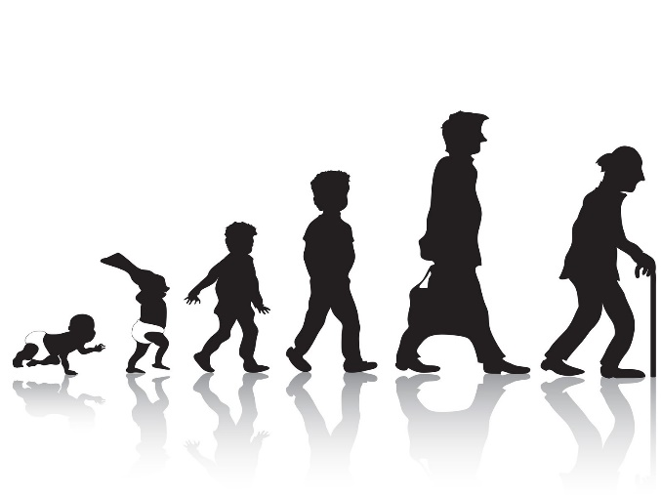HEALTH & SOCIAL CARE HOMEWORK BOOKLET

(Y11 Autumn term)

Many of the tasks in this booklet are research based so will need access to the internet to complete them. If this is a problem for whatever reason please do let me know.

It will be up to you how you want to present your research

|  |  |
| --- | --- |
| Week 1 | You should have decided what health campaign you are going to work. Research statistics on how your public health challenge has affected your chosen target group. You need to collect at least 3 statistics. Ensure it is UK only.  (for example, There are 122,780 children and young adults under the age of 40 years with type 2 diabetes) |

|  |  |
| --- | --- |
| Week 2 | Using the specification, make notes on R032 Topic area number 1 & 2 |

|  |  |
| --- | --- |
| Week 3 | Using the specification, make notes on R032 Topic area number 3 |

|  |  |
| --- | --- |
| Week 4 | Using the specification, make notes on R032 Topic area number 4 |

|  |  |
| --- | --- |
| Week 5 | Revise R032 for your exam in January. This can be done by completing exam questions, making notes, making flashcards or making a quiz |
| Week 6 | Revise R032 for your exam in January. This can be done by completing exam questions, making notes, making flashcards or making a quiz |