**Classical Civilisation GCSE**

**Unit 3.1**

Topic: Roman Housing

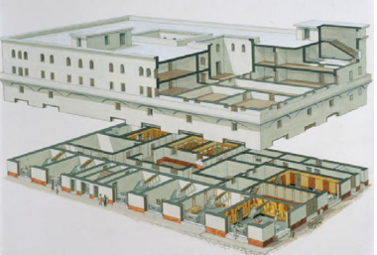

Name: ________________________________

|  |
| --- |
| My 3+ targets: |

|  |
| --- |
| **Topic Overview** |
| This topic explores the two many types of Roman Housing: the town house and the block of flats (insula).  Think about the design features of each and the experience of living in the houses. |
| **Confidence Checklist:**   * I can understand the layout and decoration of a typical Pompeian, atrium-style house * I can understand the design of apartment blocks (insula) * I can evaluate the different living conditions between the rich and the poor. * I can compare the different living conditions in each setting. |
| **Prescribed Sources**   * Insula of Diana at Ostia * The house of the Wooden Partition at Herculaneum * The house of Menander at Pompeii * The house of Octavius Quartio at Pompeii |
| **Additional Sources:**   * Juvenal, Satires III.180 * House of the Tragic Poet at Pompeii * House of the Lovers at Pompeii * Ruins of Insula near Palatine Hill at Rome * Vitruvius *On Architecture 6* * Cicero, To Atticus 14.9 * Aulus Gellius, Attic Nights, 15.1 * House of Sallust: https://www.youtube.com/watch?v=RSd8f5780GM |
| **Key Vocab:**  domus, insula, mezzanine, atrium, peristyle, impluvium, compluvium, triclinium, tablinum |

**First Impressions:**

**What type of houses do you think the Romans lived in?**

**Did all Roman houses have elaborate decorations?**

**Would every Roman house have had gardens?**

**What do you think the difference would be living circumstances of a rich and poor Roman?**

**The Insula**

There is a clear difference between our understanding of what is was like for the everyday roman and their usual living circumstances. Not every Roman had a highly decorated house, with plenty of living space and room for entertaining many guests. The typical large Roman private house in a city or town was known as a **domus**. Only the very wealthy could afford these homes and this meant that there were very few Romans who lived in them.

Most cities would be generated with apartment blocks; the literary sources suggested that these were often cramped and dangerous, although evidence near Ostia suggests that it was an exaggeration, they varied in size and quality. The apartment blocks were known as **insula (pl insulae)**. A 4th Century AD source recorded that the city of Rome had fewer than 2,000 domus-type homes, but more than 40,000 insulae.

Unfortunately, due to the development of Rome, there are not many insulae withstanding, the best evidence of insulae are in Rome’s port **Ostia**, 20 miles away.

The insula commonly consisted of 3-5 storeys, though there has been evidence to suggest that they could be between 6-7 storeys high. The access to the higher floors came from external staircases leading off the street.

From the 1st Century AD, the insulae were constructed of brick-faced concrete, roofs were made of wooden beams covered with terracotta tiles. In Ostia, we see large glazed windows on the upper floors. The ground floor often faced onto the street and tended to be shops which had an upper mezzanine for storage or living space.

At Ostia, there were a few blocks which were clearly designed for wealthy occupant. There are exampled of large apartments which have two large reception rooms as well as smaller rooms including a kitchen, and toilet facilities. However, this is not the standard type, the city has far more examples with two to four rooms.

Many Roman writers mention how unsafe insulae can be including Juvenal, who we will hear from later. Writers tend to focus on two concerns: he buildings were poorly constructed and tended to collapse, and that they were likely to catch fire.

Cicero, a statesman and property owner, made a joke in a letter to a friend:

Two of my buildings have fallen down, and the rest have large cracks .Not only the tenants, but even the mice have moved out!

Another writer, Aulus Gellius, reflected on a wealthy man’s concern over buying a property in Rome:

We were accompanying him home when, while climbing the Cispian Hill, we saw a tall multi- storey block of flats overrun with ﬂames, and all the neighbouring buildings burning in a great ﬁreball. Then one of Julianus’ companions said: “The income from urban property is great, but the dangers are far greater. But if some solution could be found to stop houses in Rome from catching ﬁre all the time, by the gods I would sell my country property and buy in the city”.

Consider what do the attitudes of these writers suggest about purchasing properties in the city?

What does this reflect about the difference in wealth division for Roman citizens?

What does Aulus’ writing suggest about the difference in property value between his country house and city flats?

What do both Cicero and Aulus’ writings suggest about property as a means of income?

Prescribed Source:

The Insula of Diana Built: c. **150 AD**

Location: **Ostia** Number of storeys: **4**

Significance: A very good example of a Roman insula

Named after the relief depicting the goddess Diana on the inner courtyard wall.



1. This is one of the best preserved insulae at Ostia. The dimensions of this insula are approximately **39x23 meters.**
2. The south and west wall face out onto the street, while the other two back onto other buildings. They contained no doors or windows.
3. A central roofless courtyard allowed light into the building.
4. It contained a cistern which provided waters to the building, as there was not individual access to water.
5. The ground floor contained many shops, which opened out onto the street, and each had a small mezzanine.
6. The floor had its own shared toiles which were probably available to all the tenants.
7. There were three staircases, two external and one internal.
8. On he south and west side, some fairly large four roomed apartments
9. On the other side some communal living space.
10. This consisted of a long corridor off which were small, poorly lit rooms; at one end of the corridor was a larger room that was probably a shared living space

Who might have lived here?

It is interesting to speculate as to who might have lived in these apartments. Insulae were mainly rental properties owned by the wealthy (who could make a good proﬁt on the rental income). The four- room apartments may have been rented by people who might be thought of as moderately wealthy, and who may have taken out leases of six months or a year. By contrast, the small rooms in the communal area were perhaps rented by the day or week, most likely to people who were passing through the busy harbour city, or working there for a short period of time.

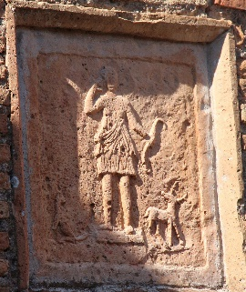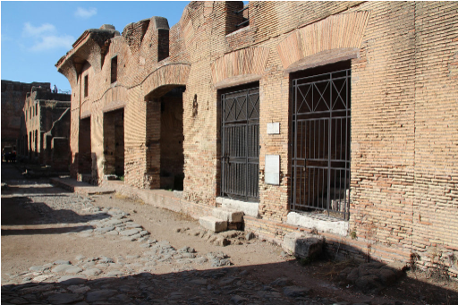

View from south-east. Relief of Diana in courtyard

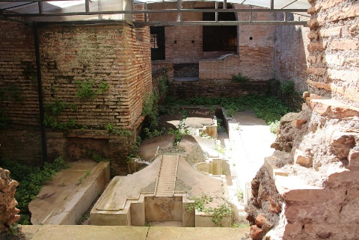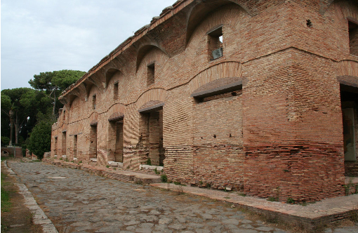

View from south-west The fountain in the courtyard

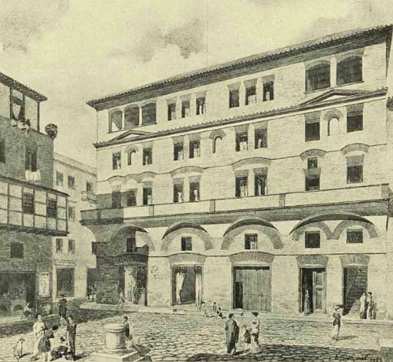 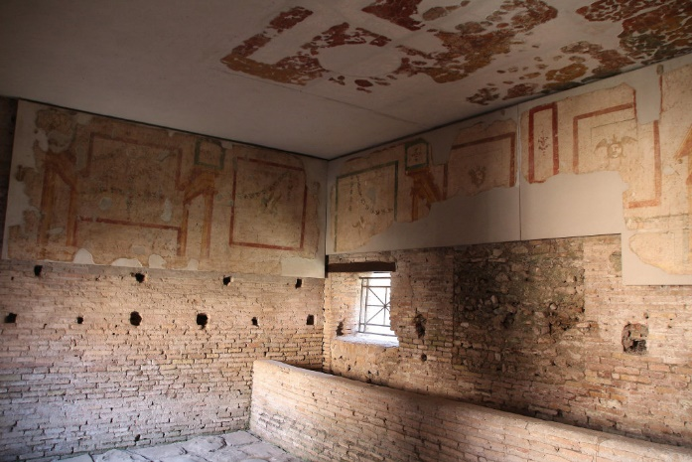

Reconstruction from south view Room 30 seen from north-west, note trough aaaaaaa at some point in time room became a stable.

Here is what Juvenal has to says about the insulae in Rome:

Here in Rome we live in a city that’s propped up with matchsticks – most of it anyway. That’s the way the landlord stops the building from falling down, papering over the cracks in the old walls, telling us all not to worry, to sleep easy, and all the time the place is about to collapse around us. I think I’d rather live somewhere where there aren’t any fires or sudden alarms in the middle of the night. The man on the ground floor is already calling for water and moving his bits and pieces to safety; your third-floor flat is already smoking, but you’re blissfully unaware; for if the alarm is sounded at ground level, the last to burn will be the man in the attic, whose neighbours are nesting pigeons, with only the roof tiles between him and the rain.

Remains of an Insula near the Palatine Hill at Rome

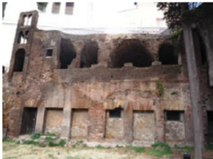

Reconstructed version of Roman Insulae

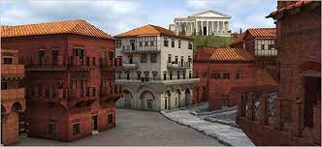

<https://www.youtube.com/watch?v=jIWQvdZdaAA> 3D Insula Reconstruction

**Insula Review**

How similar are the Roman Insula to the modern flats?

|  |  |
| --- | --- |
| Roman Insula | Modern Flats |
|  |  |

Imagine you were a wealthy Roman who was looking to purchase a block of flats, write a short advertisement that would attract you to purchase the property.

________________________________________________________________________________________________________________________________________________________________________________________________________________________________________________________________________________________________________________________________________________________________________________________________________________________________________________________________________________________________________________________________________________________________________________________________________________________

Now you have purchased the property, one similar to the insula Diana, write a short advert to attract new tenants.

________________________________________________________________________________________________________________________________________________________________________________________________________________________________________________________________________________________________________________________________________________________________________________________________________________________________________________________________________________________________________________________________________________________________________________________________________________________

**The Domus**

Although the number of domus-style houses in any Roman city was fairly small, they played a significant role in daily life. Wealthy Roman men used the living space to work, greet friends, and clients, and conduct politics. There were not any typical offices in the way we understand them, so everything took place at home.

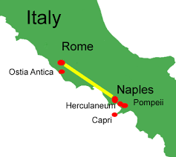Our main evidence for the domus comes from Pompeii and Herculaneum. These are best preserved thanks to the eruption of Mt. Vesuvius. Archaeologists generally accredit different rooms of the house to certain areas such as kitchens, dining rooms, bedrooms, and studies. However, we cannot assume that the Romans used the rooms as strictly as we believe. Similar to us the Romans would have used the rooms in a variety of ways and potentially used different rooms based on the décor etc.

The following diagram outlines the layout of a typical house with its key features. The design is focused around two important areas – the **atrium** (reception hall) and, beyond this, the **peristyle** (colonnaded garden). The atrium was the most public area of the house, and it was here that the owner would meet his visitors and guests, including his clients. The owner of the house might use this room to display signs of his wealth – one Pompeian house had large chests of money in the atrium. In the centre of an atrium was usually an **impluvium** – a rectangular pool into which rain water fell from a specially designed opening in the roof (the compluvium ). This was a source of water supply for the house since the impluvium was linked to a reservoir below. The atrium might also contain a shrine to the house hold gods called the **lararium**, while according to ancient sources ceremonial wax masks of the family’s ancestors could be kept in the open recesses on each side of the atrium. The whole space could therefore be designed to hold the presence of the living, the ancestors and the gods.

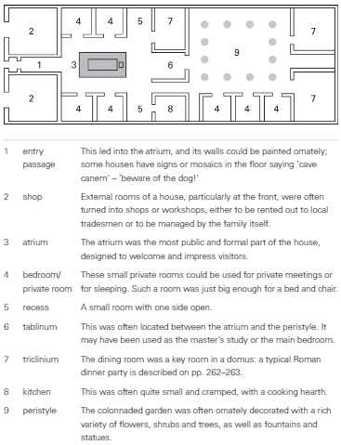

The peristyle was designed to bring a little bit of the country to the city. This was somewhat similar to when we see gardens in houses in central London. The peristyle would contain ornate fountains as well as flowers, plants and shrubs. The art work on the walls nearby would reflect the them from the countryside painted carefully.

It was common for the houses to have a **triclinium** which looked out into the garden (**hortus**). The house would be built around these two rooms and the other room which was important was the **tablinum**, which was considered the master’s study. This was located between the atrium and peristyle. Some sources state that this is not where private business was conducted but it would contain the marital bed. Rooms at the front of the house would be converted into shops which provided the family with an extra source of income.

The house would also have a number of small rooms which may be used for bedrooms, but not in the same way we do. The role of the bedroom primarily was to sleep, not entertain. A slave would not often have their own room and we can imagine they spent most their time sleeping in corridors.

It is hard for us to know some aspects about the domus for absolute certainty, such as whether they had upper floors. These rooms would not always be grand and most likely used for storage, sleeping, or renting out. Like Anglo-Saxon homes, it is likely whole families lived in them and with slaves and other members a household could have potentially twenty or more people living there.

Wall paintings here often come in vivid colours, most commonly red, orange and blue- green, but also yellows, purples and black. Onto these were painted scenes, frequently taken from Greek mythology (a source of great fascination for the Romans, who borrowed much of their own mythology from the Greeks) or country landscapes; still- life scenes such as ﬂowers, fruit and animals. In many houses, painters represented architectural features such as buildings and pillars, giving the images greater perspective and suggesting that the room was more spacious than it really was.

Houses had many of the items, generally made of wood, which we might use in our homes today: tables, chairs, beds, screens, shelves, chests and cupboards. In one house in Pompeii, the contents of a large cupboard were found in the atrium, including bronze jugs and plates, a bronze basin and cake mould, two bronze signet rings and other pieces of jewellery, nine dice and bits of gaming equipment, as well as some coins made of gold, silver or bronze.

Vitruvius, *On Architecture*, 6

 1. First of all the salubrity of the situation must be examined, according to the rules given in the first book for the position of a city, and the site may be then determined. Their size should be dependent on the extent of the land attached to them, and its produce. The courts and their dimensions will be determined by the number of cattle, and the yokes of oxen employed. The kitchen is to be placed in the warmest part of the court; adjoining to this are placed the stalls for oxen, with the mangers at the same time towards the fire and towards the east, for oxen with their faces to the light and fire do not become rough-coated. Hence it is that husbandmen, who are altogether ignorant of the nature of aspects, think that oxen should look towards no other region than that of the east.

2. The width of the stalls should not be less than ten feet, nor more than fifteen; lengthwise, each yoke is to be at least seven feet. The baths should be contiguous to the kitchen, for they will be then serviceable also for agricultural purposes. The press-room should also be near the kitchen, for the convenience of expressing the oil from the olive; and near that the cellar, lighted from the north, for if it have any opening through which the heat of the sun can penetrate, the wine affected by the heat becomes vapid.

 3. The oil room is to be lighted from the southern and warmer parts of the heaven, that the oil may not be congealed, but be preserved liquid by means of a gentle heat. Its size must be proportioned to the quantity of fruit yielded on the estate, and the number of vessels, which, if of twenty amphoræ (cullearia), are about four feet diameter. The press, if worked by levers instead of screws, should occupy an apartment not less than forty feet long, so as to allow room for the revolution of the levers. Its width must not be less than sixteen feet, which will give ample room to turn and expedite the work. If two presses are employed, the width must be twenty-four feet.

 4. The sheep and goat houses are to be constructed so that not less than ºan area of four feet and a half, nor more than six feet, be allotted to each animal. The granaries are raised, and must be towards the north or east, so that the grain may not heat, but be preserved by the coolness of the air; if towards other aspects, the weevil, and other insects injurious to corn,º will be generated. The stable, especially in the villa, should be in the warmest place, and not with an aspect towards the fire, for if horses are stalled near a fire, their coats soon become rough.

 5 Hence those stalls are excellent which are away from the kitchen in the open space towards the east; for when the weather is clear in the winter season, the cattle brought thither in the morning to feed, may be then rubbed down. The barn, hay-room, meal-room, and mill, may be without the boundaries of the villa, which will be thereby rendered more secure from fire. If villas are required to be erected of more magnificence than ordinary, they must be formed according to the proportions laid down for town houses above described, but with the precautions necessary to prevent the purposes of a country house being interfered with.

 6. Care should be taken that all buildings are well lighted: in those of the country this point is easily accomplished, because the wall of a neighbour is not likely to interfere with the light. But in the city the height of party walls, or the narrowness of the situation may obscure the light. In this case we should proceed as follows. In that direction from which the light is to be received, let a line be drawn from the top of the obstructing wall, to that part where the light is to be introduced, and if, looking upwards along that line, a large space of open sky be seen, the light may be obtained from that quarter without fear of obstruction thereof;

 7. but if there be any impediment from beams, lintels, or floors, upper lights must be opened, and the light thus introduced. In short, it may be taken as a general rule, that where the sky is seen, in such part apertures are to be left for windows, so that the building may be light. Necessary as light may be in triclinia and other apartments, not less is it so in passages, ascents, and staircases, in which persons carrying loads frequently meet each other. I have explained to the best of my ability the arrangement used in our buildings, so that it may be clearly known by builders, and in order that the Greek arrangement may be also understood, I shall now briefly explain it.

**Prescribed Source**

**The House of the Wooden Partition**

**Location: Herculaneum**

**Significance: Well-preserved Roman domus**

**Name: Given to from the preserved partition that separates the tablinum and atrium.**

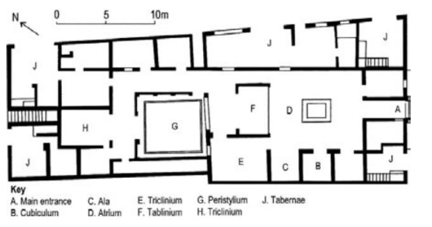

The house’s facade is remark ably well- preserved; indeed, what can be seen today – a two- storey front with roof beams still in place at the top – is probably very similar to what was visible in the ﬁrst century AD . Outside the front door are the benches for clients; high in the walls above them, small windows look out onto the street from the upper ﬂoor, while carbonised wooden beams supporting the roof are still in place. Moving into the house through the entrance way, one walks into an impressive atrium, decorated with red, black and yellow panels. In pride of place was a marble display table in front of the impluvium, while the impluvium itself, with a fountain at its centre, was also lined with marble.

The item of most interest is at the back of the atrium: the ‘wooden partition’ from which the house takes its name. It is assumed that this was used as a screen to separate the tablinum from the atrium, giving the owner some privacy when required. The partition was originally made of three beautifully panelled sliding double doors, although the middle panel was hacked through by early excavators. Thankfully, the other two panels have survived in carbonised form, together with their hinges and bronze lamp supports, each in the form of a ship’s ﬁgurehead. Another carbonised relic can be seen in a small room on the west side of the atrium – a bed or couch, which stood on legs shaped by a lathe.

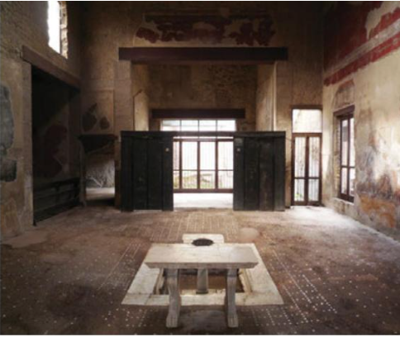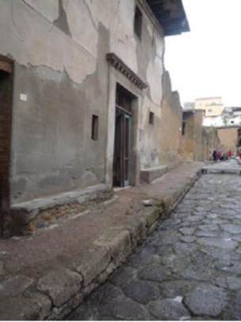Beyond the tablinum, the peristyle was colonnaded on three sides. There were small family rooms around it, and the house’s main dining room lay the other side of it. One of the rooms off the peri style linked through to one of the various shops bordering the house; these would still have been owned by the owner of the house. At the back of the house was a ﬂight of stairs, which led to a set of rooms above. Steps too can be found in the shop on the front side of the house, and these led up to a small apartment, perhaps the living space of the person who ran the shop – it is unclear if this was attached to the house or not.

**Prescribed Source**

**House of Menander**

**Location: Pompeii**

**Significance: One of the largest and most impressive houses in Pompeii**

**Name: The house takes its name from a wall painting of the Greek comic playwright.**

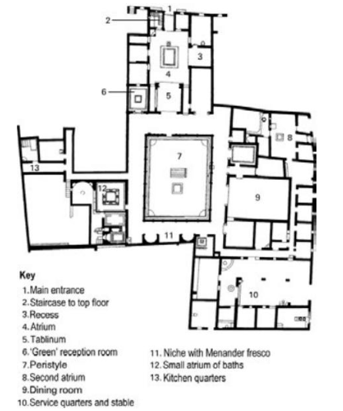

The house is named after a portrait on one of the walls of the peristyle of the Greek comic playwright Menander, who greatly influenced the Roman comic play wrights Plautus and Terence. Scholars are not clear who owned the house at the time of Pompeii’s destruction.

The house has acquired neighbouring buildings to produce an even larger property. From the entrance, one could see right the way through to the back wall of the peri style. The impressive atrium contained an elaborate household shrine, next to which was a stair case to an upper ﬂoor. The recess off the atrium had complementary paintings on its three walls, each one depicting a scene from the Trojan War, including the arrival of the wooden horse at Troy in one of them. The south end of the atrium led into the tablinum, which itself led through to a large peristyle.

In the north- west corner was a room coloured predominantly in green, with a ﬂoor mosaic depicting scenes from the river Nile. In the south- west corner was a suite of baths – only the very wealthiest houses could afford to have their own private set of baths like this. On the south end of the peristyle was a second house hold shrine, as well as three frescos – one the famous image of Menander, another depicting theatrical masks, and a third another portrait, perhaps of the Greek tragic playwright Euripides. On the east side of the peristyle was a vast dining room, one of the largest reception rooms discovered in Pompeii

The house had two service areas. The east side has a long corridor with a number of small rooms; at one end was a large stable, where a wagon, and many amphorae were found, suggesting that the owner may have had a large farming estate as well. At the other end of the corridor was a small atrium which may have been the head slave’s headquarters. The other service area, on the west side of the house, consisted of a kitchen, latrine and service rooms, with access to cellars below. It was here that the house’s silver service was found by excavators – a large collection of decorated silver vessels, wrapped in cloth and neatly stacked, including plates, trays, spoons, ladles, bowls and cups.

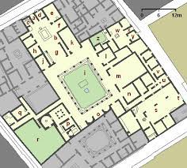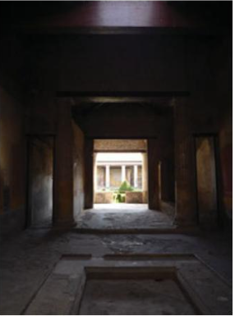

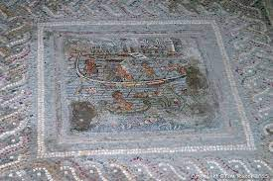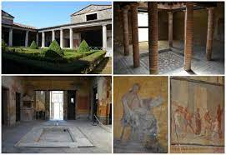

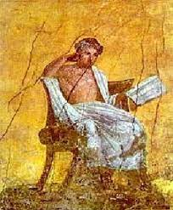

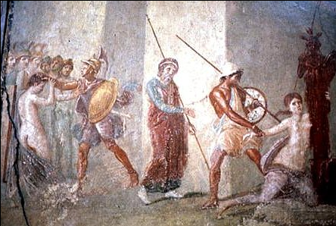

🡨 Ajax dragging Cassandra

**Prescribed Source:**

**House of Octavius Quarto**

**Renovated between 60-70AD Location: Pompeii**

**Significance: The focus of the domus is the magnificent garden and water features.**

**Name: Named after Octavius Quartio, whose signet ring was found there.**

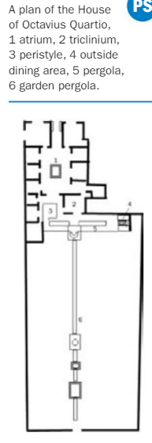

The design of the house of Octavius Quartio shows how, over time, the design focus of a domus could move away from the atrium to the peristyle. The greatest feature of this house was its large and wonderful garden, enhanced by impressive water features, shrines and fountains.

The house is found on one of Pompeii’s main streets. Outside the front was stone seating, which may have been used by clients, while the two front rooms opened out onto the street as shops; it is in one of these that a signet ring with the name ‘Octavius Quartio’ was found, giving the house its modern name. The entrance passage led into a rectangular atrium; its impluvium had a fountain jet and was surrounded by ﬂower boxes, hinting at the beautiful garden that lay beyond. The rooms around the atrium were standard; the south side led directly into a small peristyle, colonnaded on three sides.

The fourth side of the peristyle opened onto a pergola that over looked the garden. Under the pergola ran a narrow canal, lined with garden statues and probably home to ﬁsh; mid-way along was a bridge. Painted on the walls at the west end of the pergola were two scenes from the myth of Diana and Actaeon – Actaeon discovering Diana bathing, and then about to be ripped to death by his own hunting dogs. A large reception room, probably used for dining, opened onto the north side of the pergola; its walls were decorated with scenes from the life of Hercules, as well as from the Trojan War. On the outer north wall of the pergola were painted hunting scenes, and to its east was an outside dining area, with space for two couches rather than the conventional three. Next to the couches on the east wall was a small house hold shrine ﬂanked by two more paintings – to the left the myth of Narcissus, to the right the story of Pyramus and Thisbe.

The south side of this pergola led off into the garden, which was on a lower level. It was divided by a second, longer pergola and canal. Where the two pergolas met was a fountain shrine dedicated to Diana and Actaeon. The lower canal ran all the way along the garden, about 50 metres in all, and it too was decorated with statues, paintings and crossing bridges. Midway along this lower canal was another fountain, and beyond that a small temple.

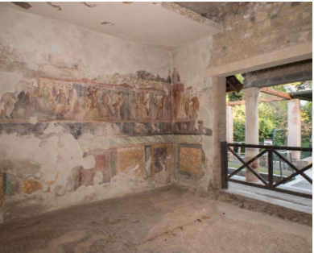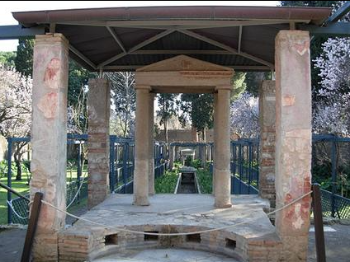

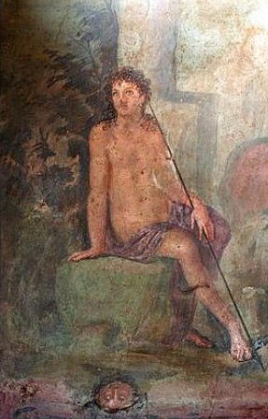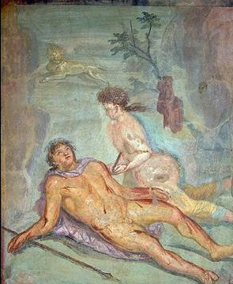 Narcissus at the Spring

Pyramus committing suicide

Death brought about by passion

Lucius pinxit.

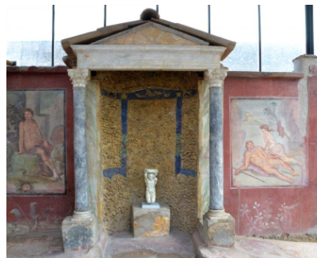

Roman Real Estate

Imagine you have been asked by the wealthy inhabitants of Rome to sell one of the domus. Considering the fine selling points and give some detail below:

House: ______________________

What is the house’s unique selling point and why?

________________________________________________________________________________________________________________________________________________________________________________________________________________________________

How does the house’s layout differ from another domus?

________________________________________________________________________________________________________________________________________________________________________________________________________________________________

What type of decoration would you expect to find in this house?

________________________________________________________________________________________________________________________________________________________________________________________________________________________________

How significant is the outside spaces and atrium for entertaining your guests?

________________________________________________________________________________________________________________________________________________________________________________________________________________________________

Does the house have any space for slaves or anything else?

________________________________________________________________________________________________________________

|  |
| --- |
| **Topic Review: You should be able to** |
| **Describe:**   * The layout and key features of the Insula of Diana, the House of the wooden Partition, the House of Menander, the House of Octavius Quartio |
| **Explain**   * The difference for wealthy and poor Roman citizens living in the city. * The key uses of rooms in a Roman Domus * What the art and furnishing can tell us about the inhabitants |

|  |
| --- |
| **Roman Housing -** end-of-mini-topic test score: |
| My comment on this: |
| Teacher’s comment (please see Google Classroom): |
| Targets for next time: |

|  |  |
| --- | --- |
| Glossary | |
| domus |  |
| insula/ insulae |  |
| mezzanine |  |
| atrium |  |
| peristyle |  |
| impluvium |  |
| compluvium |  |
| triclinium |  |
| tablinum |  |