**GCSE Politics Topic 4**

**National and Devolved Government Homework Booklet**

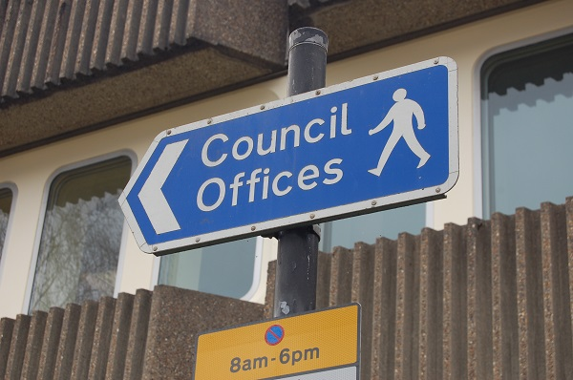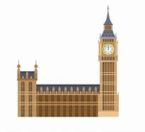

Lesson 1 Homework:

6 Study the two statements. Choose option A, B, C or D to describe their accuracy.

***First statement: There are four nations in the UK.***

***Second statement: Three UK nations have their own parliaments or assemblies.***

A both statements are false

B both statements are true

C the first statement is false, but the second statement is true

D the first statement is true, but the second statement is false

Your answer

………………………

Study the two statements. Choose option A, B, C or D to describe their accuracy.

***First statement: Scotland is an independent country***

***Second statement: there are no longer any Scottish MPs in the UK parliament***

A both statements are false

B the first statement is false but the second statement is true

C both statements are true … and the second statement is a correct explanation of the first

D both statements are true … but the second statement is not a correct explanation of the first

Your answer

……………………………………………………

**Source 1:**

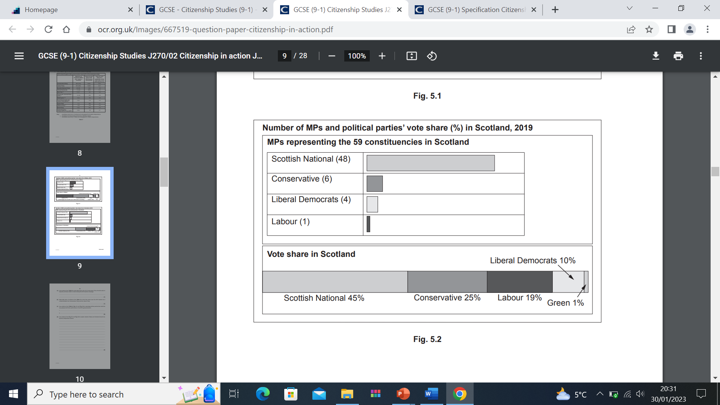

**Source 2:**

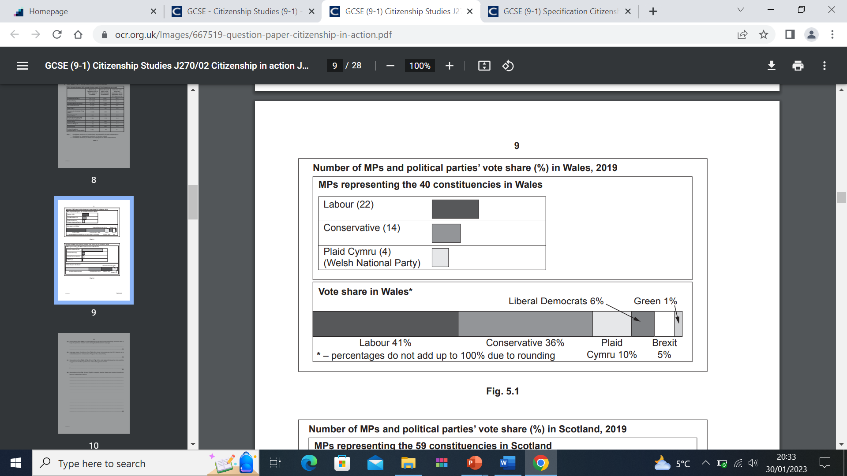

**Use evidence from source 1 and source 2 and your own knowledge to explain whether Wales and Scotland should now become independent nations.** ................................................................................................................................................... ................................................................................................................................................... ................................................................................................................................................... ................................................................................................................................................... ...................................................................................................................................................

...................................................................................................................................................

.................................................................................................................................................. ................................................................................................................................................... ................................................................................................................................................... ................................................................................................................................................... ................................................................................................................................................... ................................................................................................................................................... .............................................................................................................................................. [4]

**Lesson 2 Homework: Revision for assessment**

**Look over your notes and then complete this revision mat for the national, devolved and local government topic without peeking!**

List three powers of the National The three devolved governments are:

Government

-

-

-

Three arguments against devolution

-

-

-

Three arguments for devolution are:

-

-

-

Assessment practice:

Have a go at planning an answer to this 12 mark question (consider all of the bullet points and make sure you have two points for, two points against and a conclusion)

‘The nations of the UK should not have devolved governments’

Evaluate this statement.

Consider:

* The arguments in favour of devolution
* The arguments against devolution
* The powers of the National government
* The powers of devolved governments

................................................................................................................................................... ................................................................................................................................................... ................................................................................................................................................... ................................................................................................................................................... ................................................................................................................................................... ................................................................................................................................................... ..................................................................................................................................................

.................................................................................................................................................. ................................................................................................................................................... ................................................................................................................................................... ................................................................................................................................................... ................................................................................................................................................... ................................................................................................................................................... ..................................................................................................................................................

................................................................................................................................................... ................................................................................................................................................... ................................................................................................................................................... ................................................................................................................................................... ................................................................................................................................................... ................................................................................................................................................... ..................................................................................................................................................

................................................................................................................................................... ................................................................................................................................................... ................................................................................................................................................... ................................................................................................................................................... ................................................................................................................................................... ................................................................................................................................................... ..................................................................................................................................................