**British constitution homework booklet**

[Document subtitle]

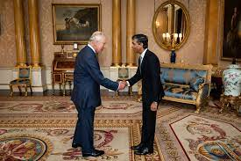



**Homework:**

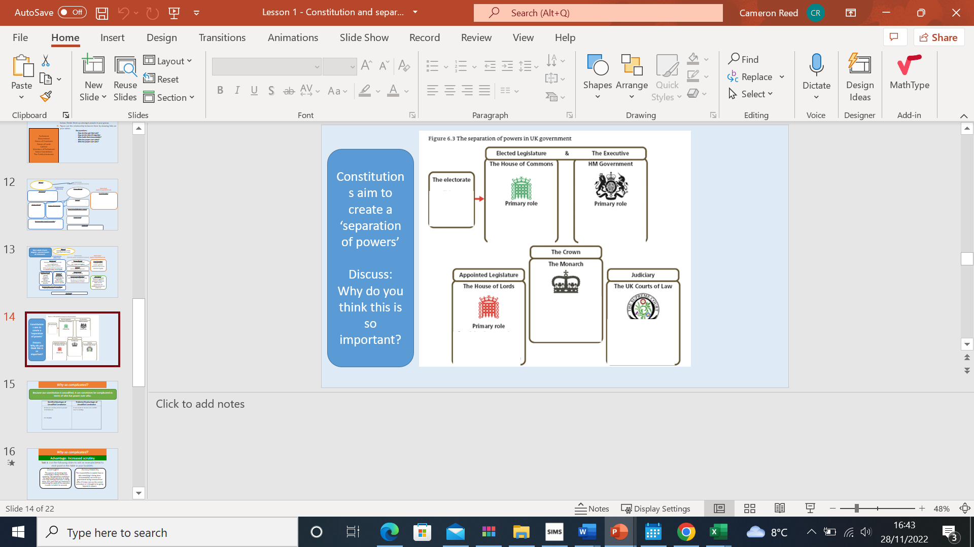**Using the work from today summarise 1 -2 sentences of the primary role each part of our constitution**

**Homework task 2:**

Evaluate the following statement:

*“The British political system is both effective and democratic. It fully serves and represents the British people”*

You should consider:

• how the political system works in the UK

• whether or not the system and government serve and represents the people

• whether changes to the system could make it more democratic or effective

**(8 marks)**

**Top tip: Do a paragraph on each bullet point and make sure your answer is balanced because of the key command word evaluate. Also, a mini conclusion summarising why you agree or disagree with the question.**

................................................................................................................................................... ................................................................................................................................................... ................................................................................................................................................... ................................................................................................................................................... ................................................................................................................................................... ................................................................................................................................................... ...................................................................................................................................................

................................................................................................................................................... ................................................................................................................................................... ................................................................................................................................................... ................................................................................................................................................... ................................................................................................................................................... ................................................................................................................................................... ...................................................................................................................................................

................................................................................................................................................... ................................................................................................................................................... ................................................................................................................................................... ................................................................................................................................................... ................................................................................................................................................... ................................................................................................................................................... ................................................................................................................................................... ................................................................................................................................................... ...................................................................................................................................................

**Homework task 3:**

**Create 6 flash cards on what we have done on lesson 1**

**Use the link below:**

**Lesson 2 homework**

**Task 1: Answer the following questions below:**

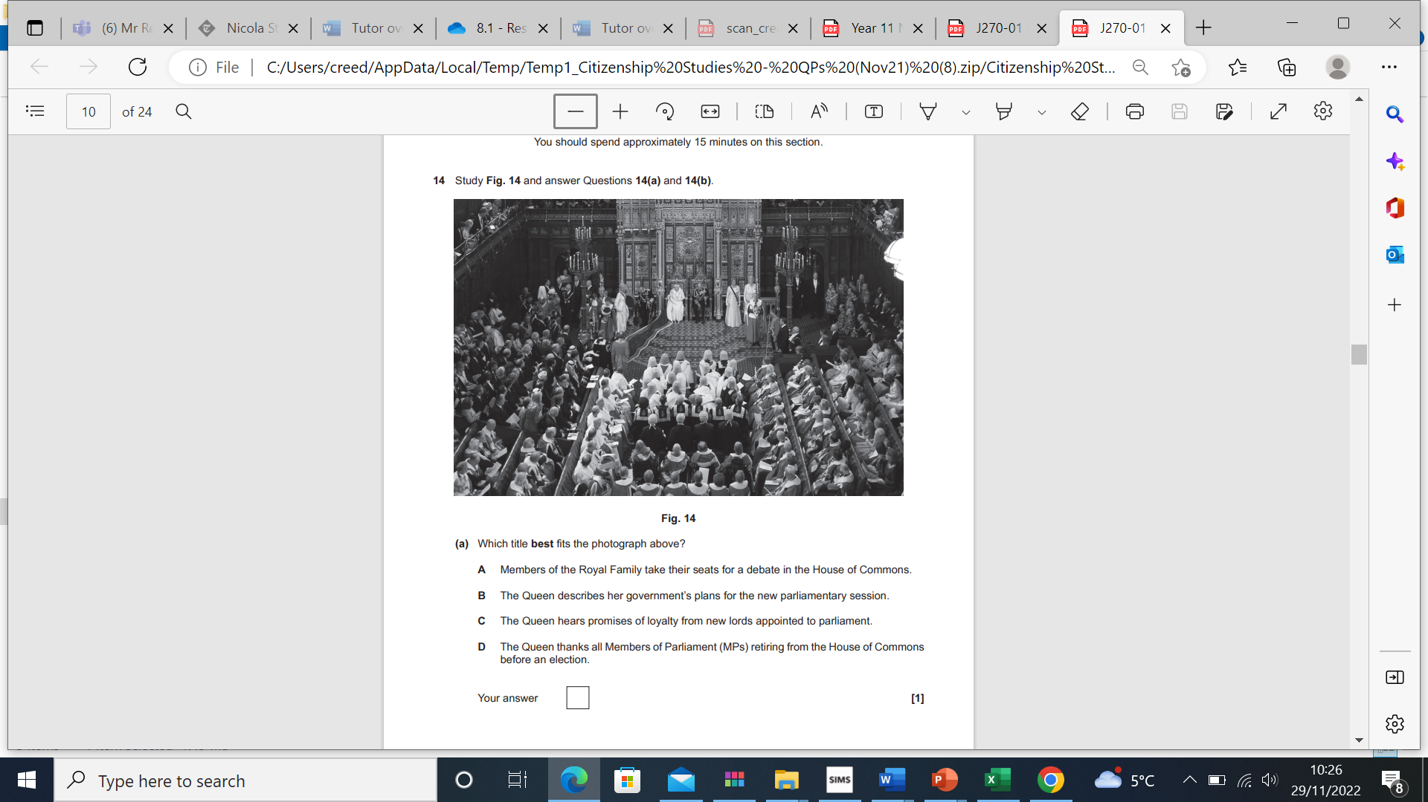

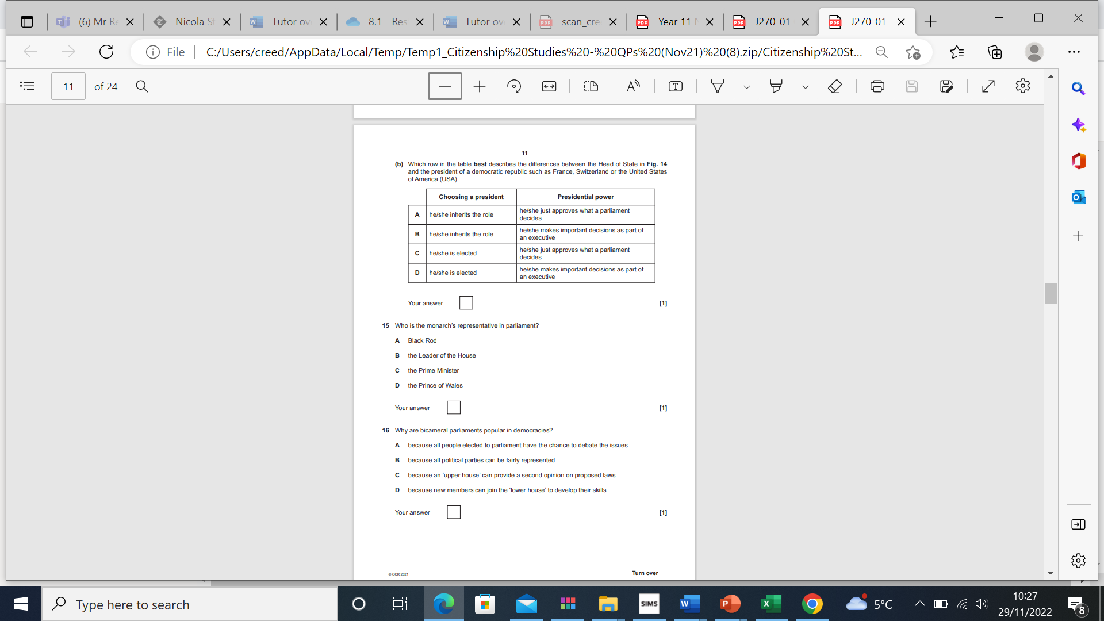

**Task 3:**

Study source 1: An article from the Guardian Newspaper from the leader of the opposition Keir Starmer of the Labour Party.

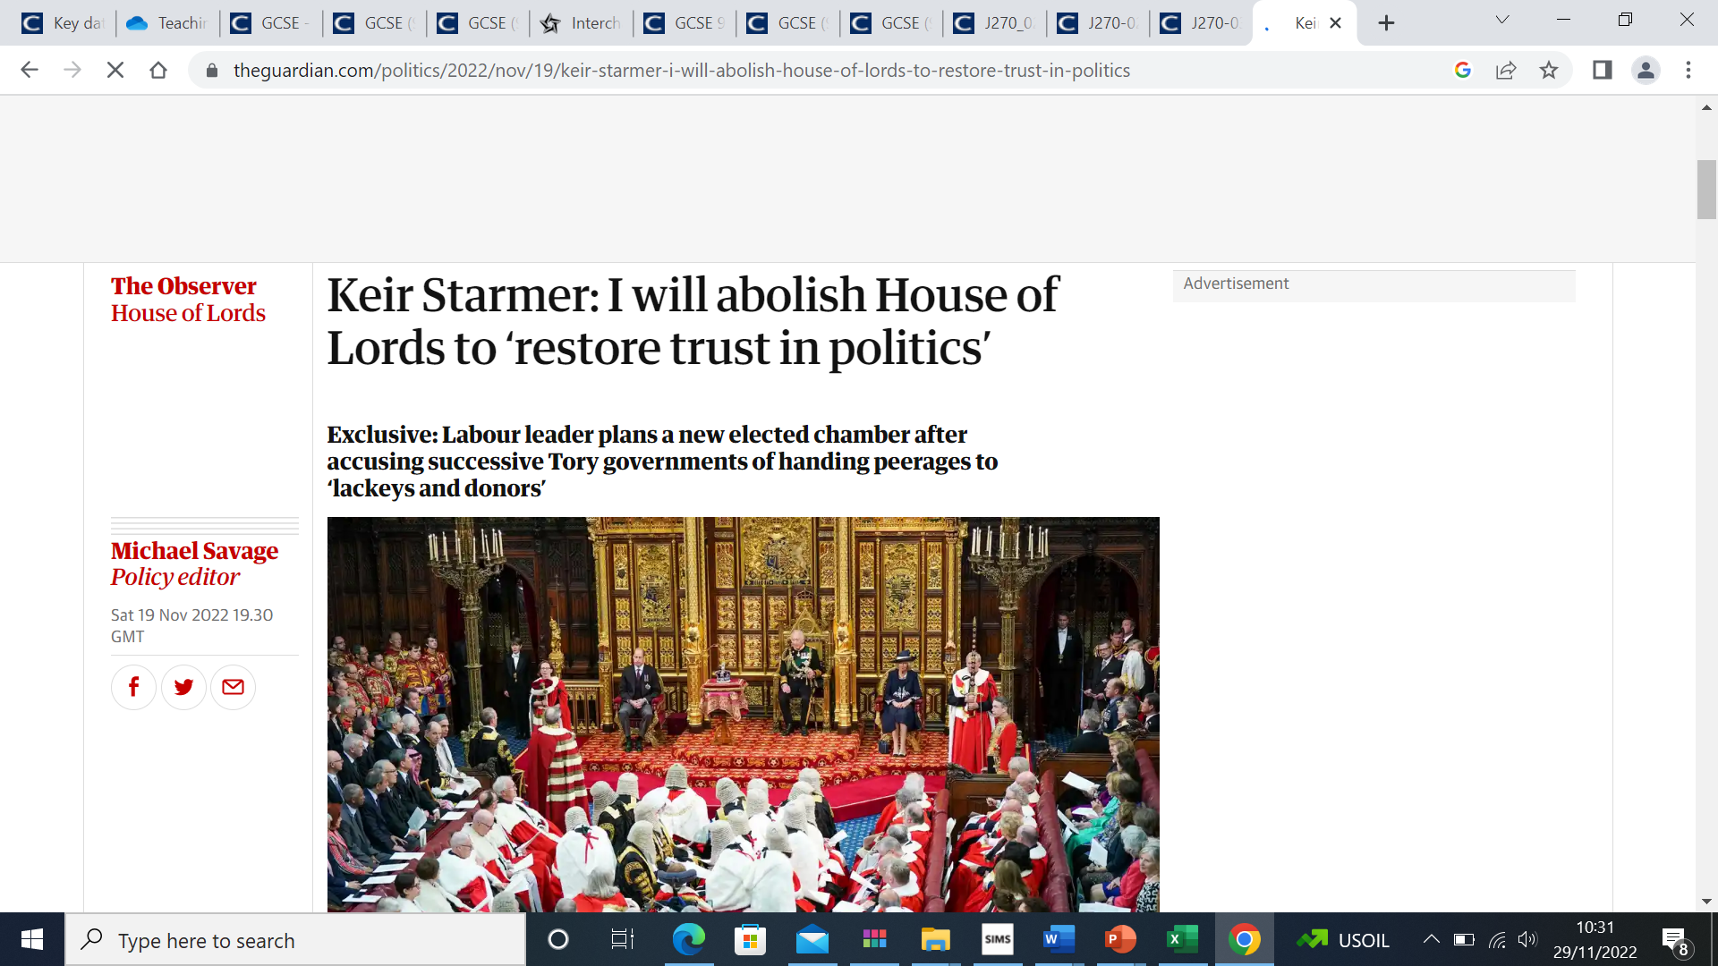

State two reasons in support of Keir Starmer’s proposal to abolish the House of Lords

................................................................................................................................................ ................................................................................................................................................... ................................................................................................................................................ ................................................................................................................................................... [2]

b. State two opposing reasons to justify keeping the house of Lords as it stands

................................................................................................................................................ ................................................................................................................................................... ................................................................................................................................................ ................................................................................................................................................... [2]

Explain why Keir Starmer can be said to be safeguarding/promoting democracy. ................................................................................................................................................... ................................................................................................................................................... ................................................................................................................................................... ...................................................................................................................................................

................................................................................................................................................... ................................................................................................................................................... ................................................................................................................................................... ...................................................................................................................................................

................................................................................................................................................... ................................................................................................................................................... ................................................................................................................................................... .............................................................................................................................................. [4]

**Create 6 more flash cards to your British constitution set on quizlet what we have done on lesson 2**

**Lesson 3 Homework The Civil Service**

**Homework task 1:**

Use the document on Teams to answer the questions on the Civil Service below:

Who is in the Civil Service?

**………………………………………………………………………………………………………………………………………………………………………………………………………………………………………………………………………………………………………………**

Who is not included in the Civil Service?

**………………………………………………………………………………………………………………………………………………………………………………………………………………………………………………………………………………………………………………**

What examples of services do they provide?

**………………………………………………………………………………………………………………………………………………………………………………………………………………………………………………………………………………………………………………**

What four core values do they hold?

**………………………………………………………………………………………………………………………………………………………………………………………………………………………………………………………………………………………………………………**

Who manages the Civil Service?

**………………………………………………………………………………………………………………………………………………………………………………………………………………………………………………………………………………………………………………**

**Task 2 Complete the table**

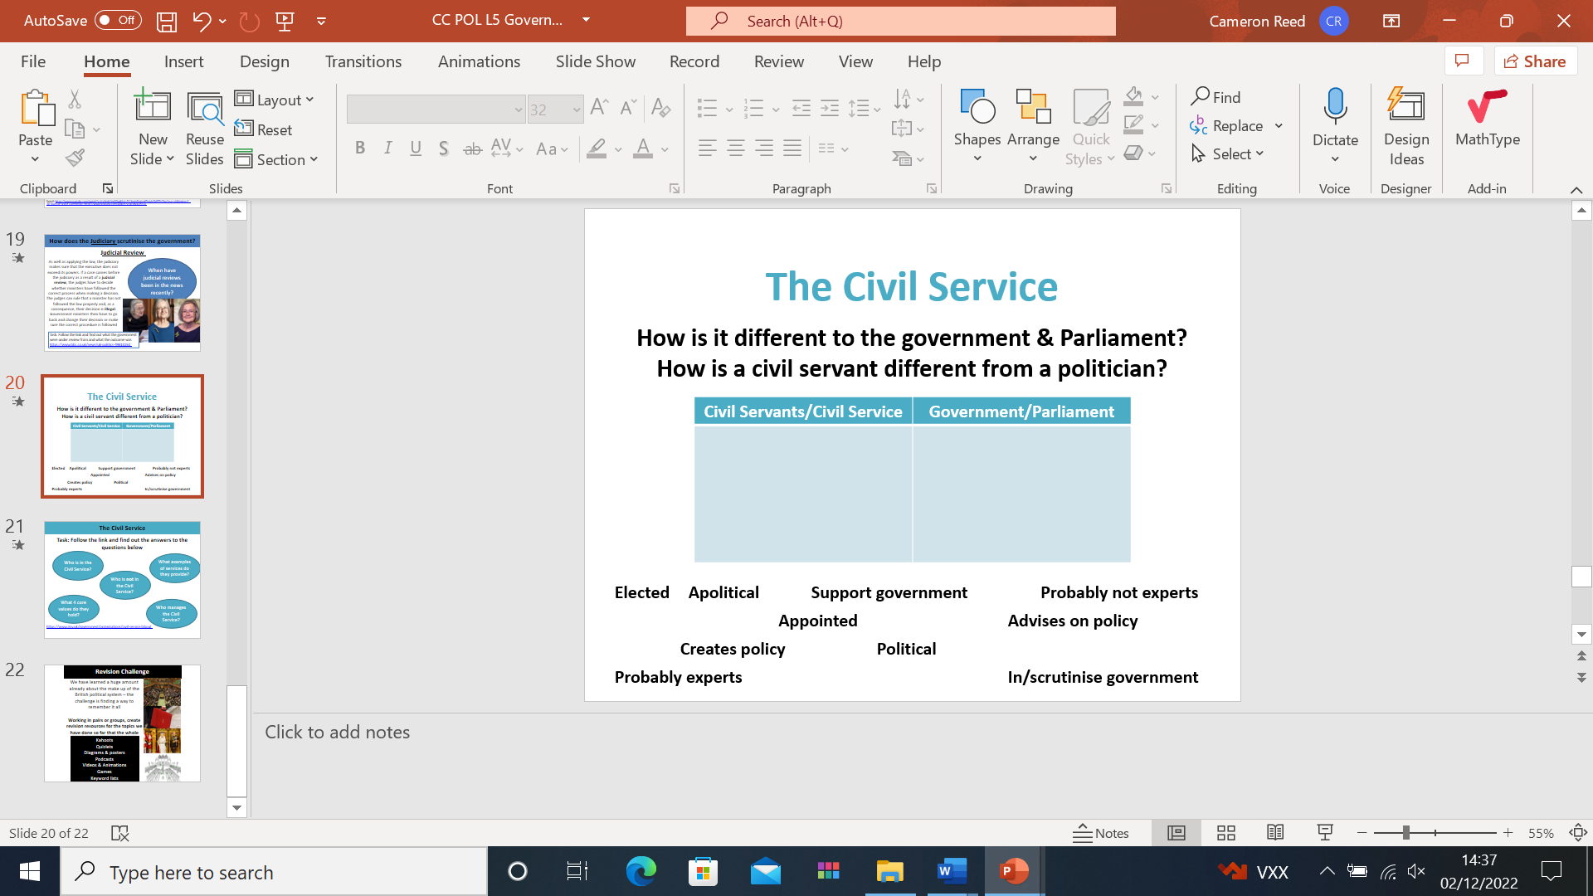

**Homework task 3:**

Study Fig. 1 and answer questions 1(a)–1(d).

Prime Minister plans greater control over senior civil servants

When Boris Johnson became prime minister in 2019, he promised that senior civil servants would be expected to put the government’s plans into action without delay. Civil servants would risk losing their jobs if they obstructed the government’s ideas or failed to put its plans into action. Existing civil servants would take exams to make sure they had the specialist knowledge to make the right decisions. Opposition politicians were concerned that the Prime Minister’s plans went against the principle that senior civil servants should not take sides politically. They reminded him that civil servants work for the Crown, not parliament or its political parties.

1 (a) State two actions a prime minister should take before making the changes described in Fig. 2. 1 ..................................................................................................................................................................................................................................................................................................................................................................................................................................................................................................... ..............................................................................................................................................................[2]

1 (b) State two reasons against civil servants taking sides politically. ................................................................................................................................................ ................................................................................................................................................... ................................................................................................................................................ ................................................................................................................................................... [2]

(c) Explain why the Prime Minister’s plans in Fig. 2 can be said to be ‘good for democracy’. ................................................................................................................................................... ................................................................................................................................................... ................................................................................................................................................... ................................................................................................................................................... ................................................................................................................................................... ................................................................................................................................................... ................................................................................................................................................... ................................................................................................................................................... ................................................................................................................................................... ................................................................................................................................................... ................................................................................................................................................... .............................................................................................................................................. [4]

(d) State two reasons why government ministers usually agree with their prime minister. ................................................................................................................................................ ................................................................................................................................................... ................................................................................................................................................ ................................................................................................................................................... (2)

Last Homework task:

Add to your quizlet flash cards 6 more based on the content from our last lesson