Rights and REsponsabilities Homework Booklet

[Document subtitle]





Lesson 1 Homework:

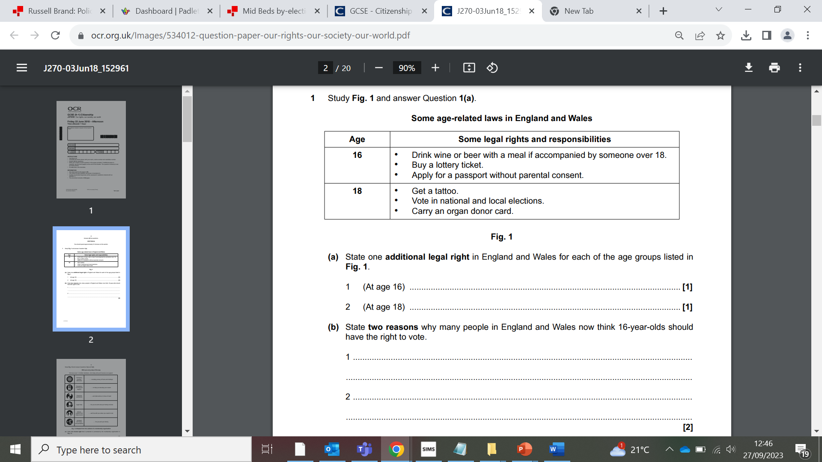

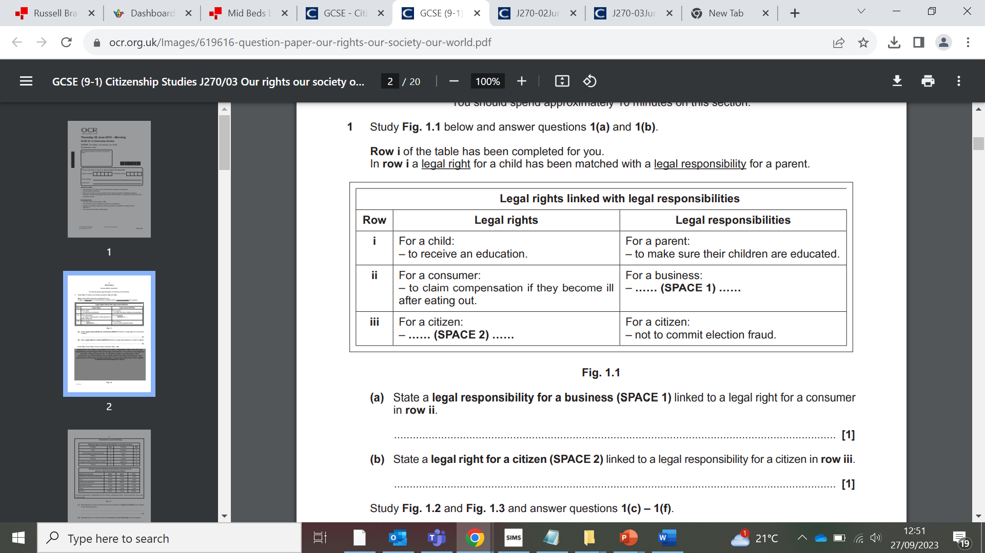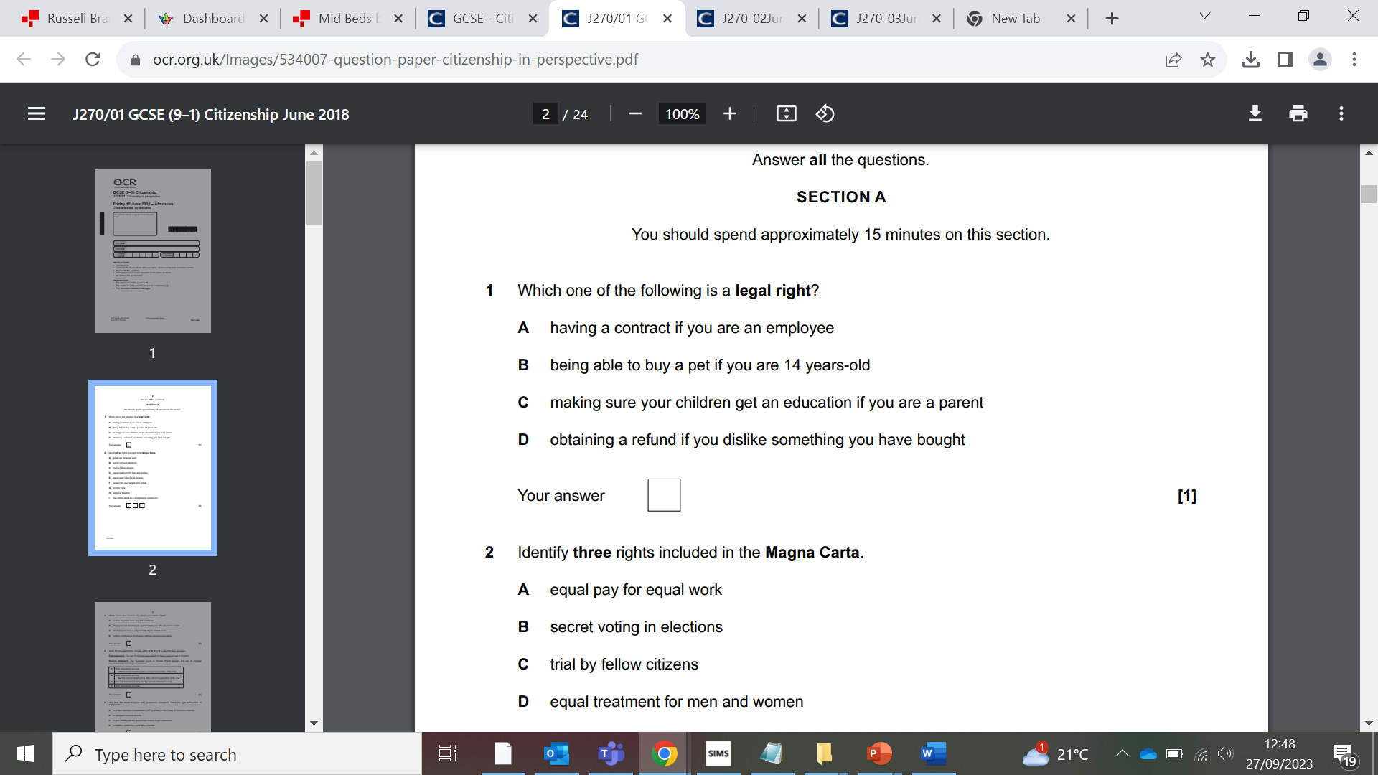

**State four points in favour of increasing the age of criminal responsibility to 12 in England from 10**

………………………………………………………………………………………………………

………………………………………………………………………………………………………

………………………………………………………………………………………………………

………………………………………………………………………………………………………

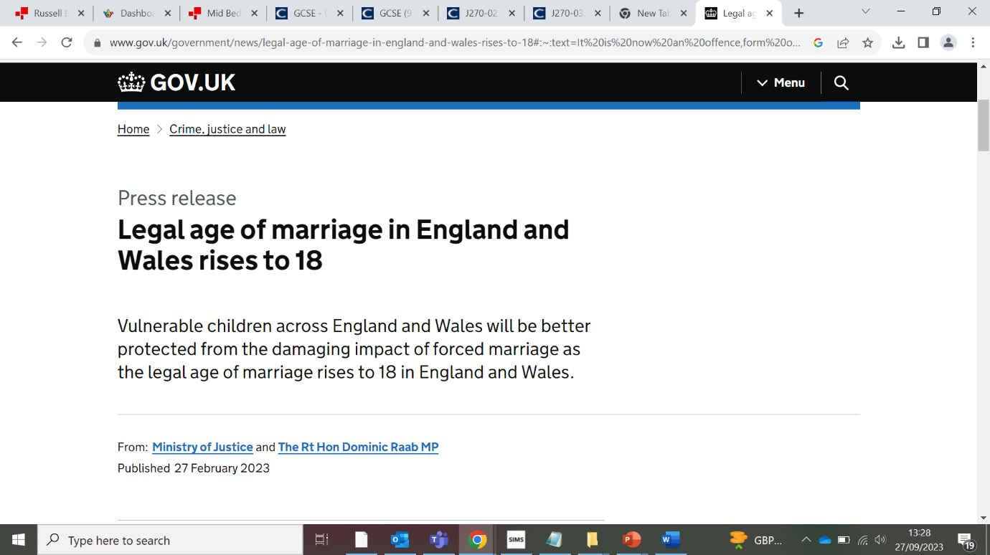**Study figure 2 below: UK government press release from Feb 2023**

**Summarise in your own words, why the government chose to increase the legal age of marriage from 16 to 18.**

………………………………………………………………………………………………………………………….

………………………………………………………………………………………………………………………….

………………………………………………………………………………………………………………………….

………………………………………………………………………………………………………………………….

………………………………………………………………………………………………………………………….

………………………………………………………………………………………………………………………….

………………………………………………………………………………………………………………………….

…………………………………………………………………………………………………………………………

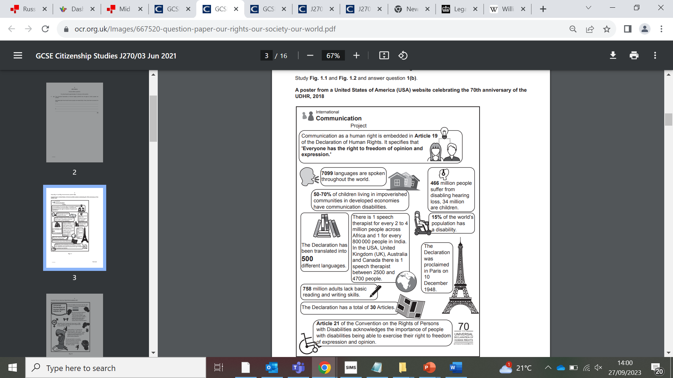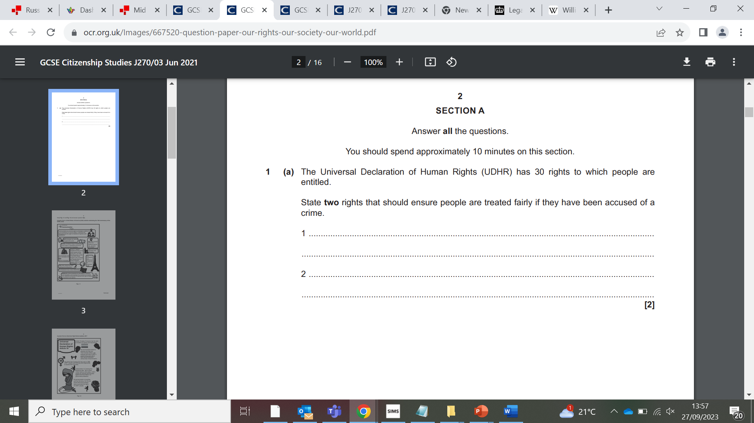Lesson 2 Homework:

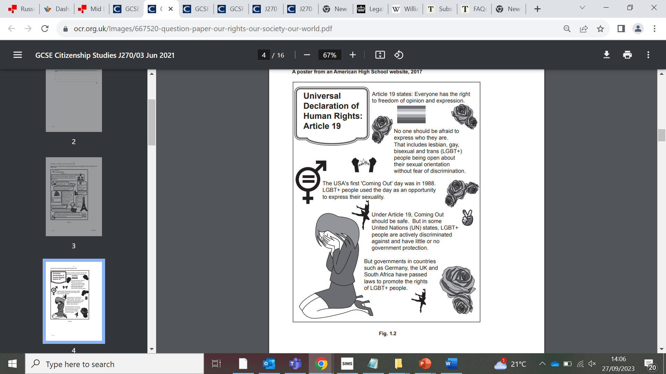

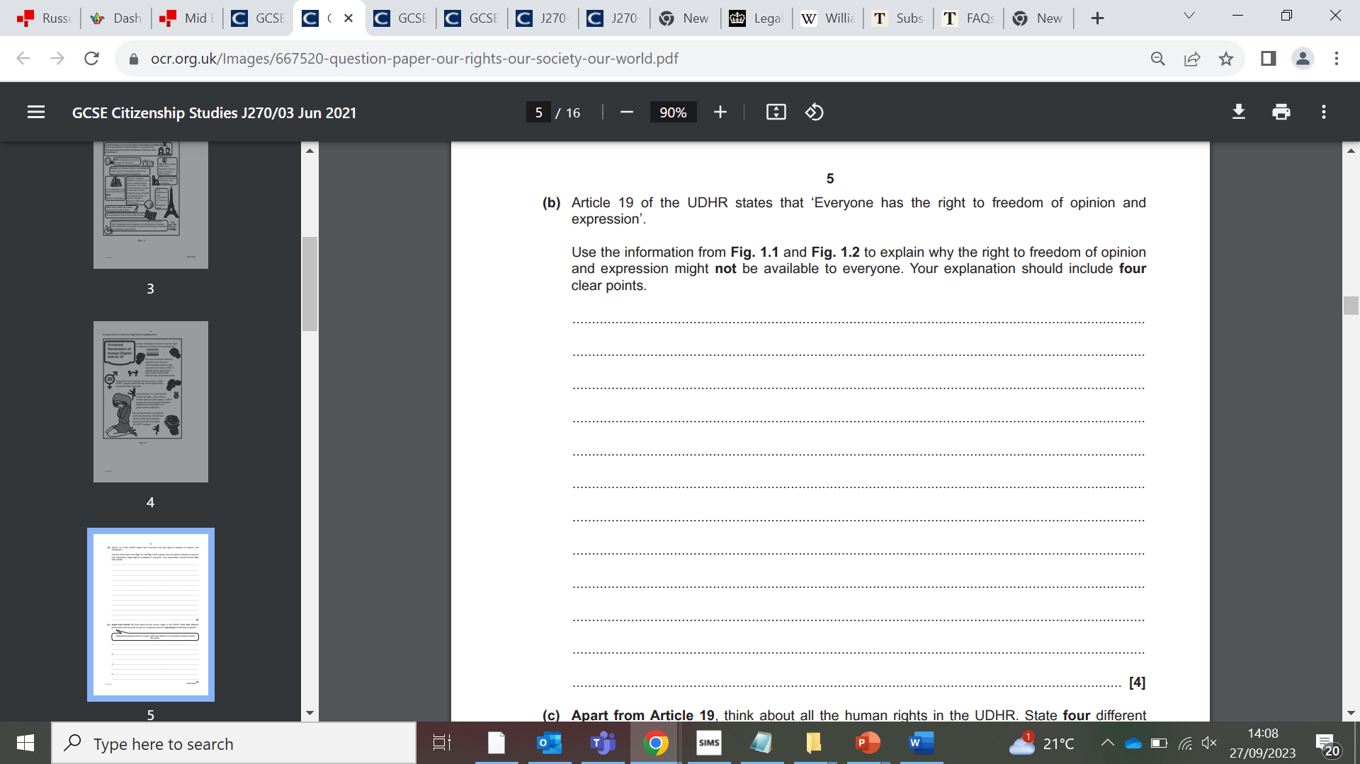

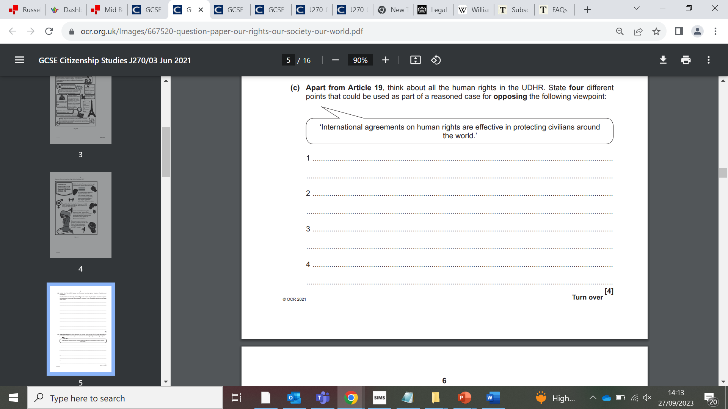

Lesson 3 Homework:

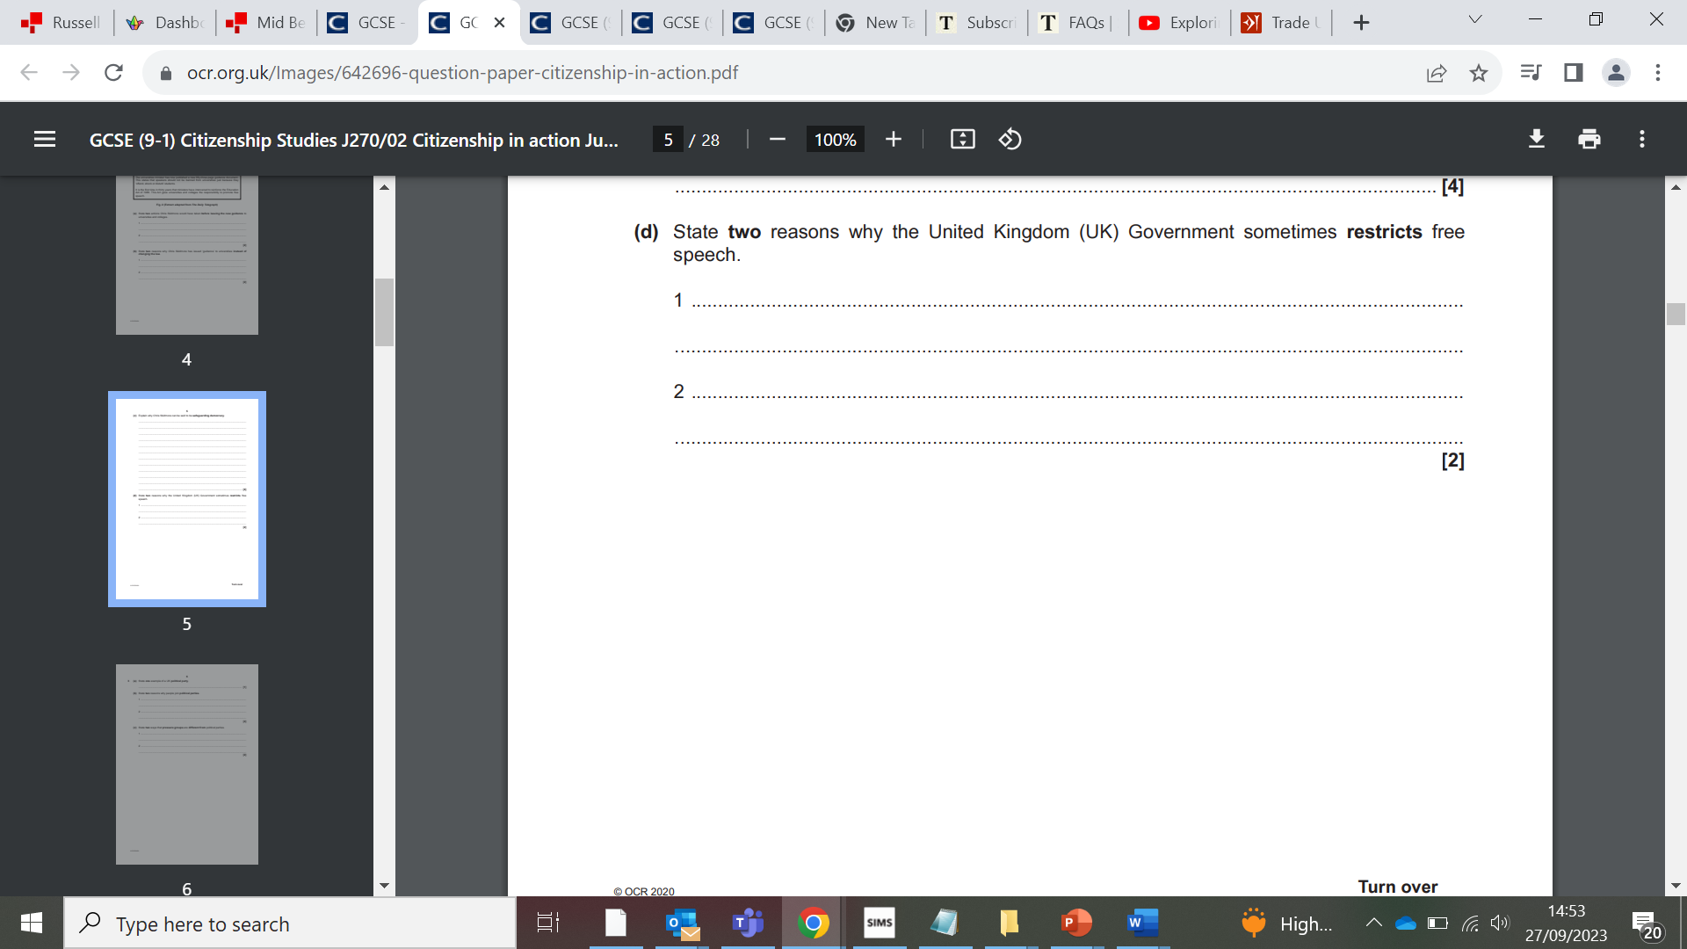

1. State 4 points which support the view that Trade unions are good for workers?
2. ……………………………………………………………………………………………………………………………………
3. ……………………………………………………………………………………………………………………………………
4. .…………………………………………………………………………………………………………………………………
5. ……………………………………………………………………………………………………………………………………
6. State 4 points which oppose the view that Trade unions are good for workers?
7. ……………………………………………………………………………………………………………………………………
8. ……………………………………………………………………………………………………………………………………
9. .…………………………………………………………………………………………………………………………………
10. ……………………………………………………………………………………………………………………………………
11. ‘Counter terror laws may infringe people’s rights, but you have nothing to fear if you have done nothing wrong’

Evaluate this statement

Make sure you discuss the following:

* How anti-terror laws infringe our human rights
* Case for the police being able to access our communications
* Case against the police accessing our communications
* Your opinion ( with evidence and reasons)

………………………………………………………………………………………………………………………………………………………………………………………………………………………………………………………………………………………………………………………………………………………………………………………………………………………………………………………………………………………………………………………………………………………………………………………………

……………………………………………………………………………………………………………………………………………………………………………………………………………………………………………………………………………………………………………………………………………………………………………………………………………………………………………………………………………………………………………………………………………………………………………………………….

………………………………………………………………………………………………………………………………………………………………………………………………………………………………………………………………………………………………………………………………………………………………………………………………………………………………………………………………………………………………………………………………………………………………………………………………

……………………………………………………………………………………………………………………………………………………………………………………………………………………………………………………………………………………………………………………………………………………………………………………………………………………………………………………………………………………………………………………………………………………………………………………………….