**Chesterton Community College**

**Classical Civilisation GCSE**

**Unit 1.5**

Topic: Festivals

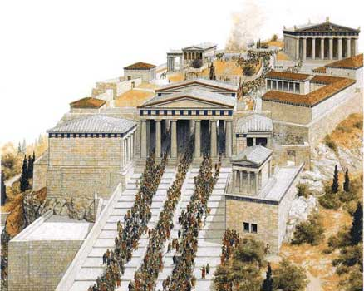

Name & form: ________________________________

Starting date: ________________________________

|  |
| --- |
| **Topic Overview** |
| Greek and Roman festivals, including the origins of the festival; officials; sacrifice; the programme; the participants |
| **Greece:**   * The Great Panathenaia * The City Dionysia |
| **Rome:**   * The Lupercalia * The Saturnalia |

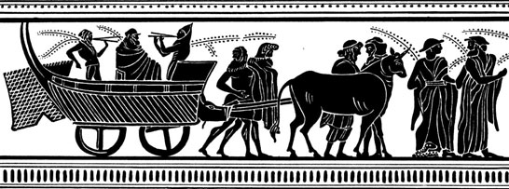

**Questions for discussion: Why were festivals so important to the Greeks and Romans? How many did they have in a year?**

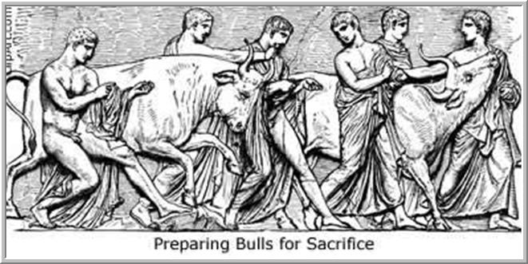**The Panathenaia**

* **What was the Panathenaia?**

One vital aspect of Athenian religion was the celebration of religious festivals, and the Panathenaia was their most important one. It was Athens' great celebration of the goddess that protected them – occurring at the end of July every year, it was thought of as Athene’s birthday.

Every four years the Panathenaia festival was even grander and was known as the “Greater Panathenaia”. It lasted for about 8 days, and saw a whole range of sporting, musical and religious events in Athene’s honour.

At its heart it was a big parade to bring a new ‘peplos’ (robe) to the goddess, in the form of her cult statue inside the Parthenon temple on the Acropolis.

***In your own words…***

* **Which goddess did the Panathenaia honour, and what were her responsibilities?**

…………………………………………………………..………………………………………

………………………………………………………………………………………………..…

* **When, and how often, did the Panathenaia occur?**

…………………………………………………………..………………………………………

………………………………………………………………………………………………..…

* **Who could take part?**

…………………………………………………………..………………………………………

………………………………………………………………………………………………..…

………………………………………………………………………………………………..…

* **What did the Panathenaia consist of?**

**1. Pannychia**

The day of the parade was preceded by an all-night performance of hymns and sacrifices in honour of the goddess (a pannychia).

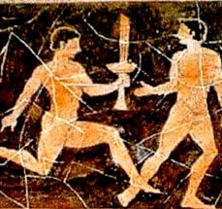

**2. Sacred Fire and Torch Race**

At sunrise the sacred fire was fetched from the altar of Eros, where a sacrifice was made to Eros and Athena. Before the parade a torch-race was held to light the altar on the Acropolis. 4 runners from each of the 10 tribes of Athens ran from an altar at the Dipylon gate to the Acropolis. The winning tribe would get a bull and 100 drachmas.

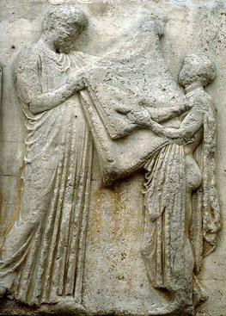

**3. The Robe**

Every fourth year the Greater Panathenaia was held, for which a new peplos (robe) is woven for the Goddess (her birthday present). The robe was gold and blue, and was woven by priestesses and young girls. Its middle stripe of panels displayed the Gigantomachy, the battle of the Giants and the Olympians (symbolizing the triumph of civilization over savagery).

**4(a) The Procession and Ship-Cart**

The procession brings the peplos through the city from the Diplyon Gate to the Acropolis, hung like a sail on the mast of a wheeled ship, which is steered by priests and priestesses adorned with colourful garlands; young men on horseback accompanied the procession. The ship was left at the entrance of the sacred precincts and the peplos was carried the rest of the way. The procession contains at least 100 sacrificial animals and people to represent all of Athenian society (young and old men and women, musicians, soldiers, metics, and horsemen).

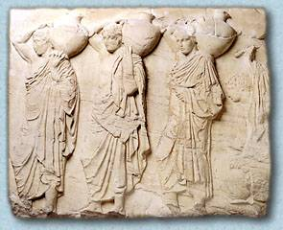**4(b) The Holy Baskets**

At the head of the Panathenaic procession were the Kanephoroi, the gold-covered girls who carried the holy offering baskets, which they gave to the attendants at the altar. The baskets contained the barley and knife necessary for sacrifice.

Next come the workers who wove the new peplos, and more girls bring the other things needed for the sacrifice. Also in the procession would have been musicians, contest winners, craftsmen, infantry and cavalry, etc.

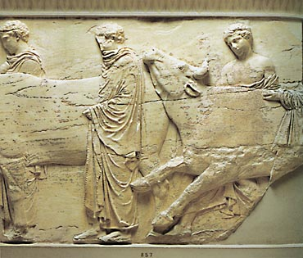**4(c) The sacrifices**

The procession was split into two lines: the north line brought a cow for Athena Polias, and a ewe for Pandrosos (one of the daughters of Cecrops). These were sacrificed at the altar inside the "Old Temple," which the goddesses shared, and the roasted meat was eaten by the priests and officials. The south line headed for the outdoor sacrifice, bringing brought cattle to Athena Parthenos, the patron of democracy, at the "Big Altar" outside the Parthenon, where the roasted meat was given to the public. Only Athenian citizens were allowed into the sanctuary.

**5. Winners of the Torch Race**

In the northern procession the victors of the torch race brought water to the sacrifice in the water jugs they had won. They served as the water bearers. They were followed by elegantly dressed musicians, such as lyre players and flautists. The torch was then used to light the altar of Athene.

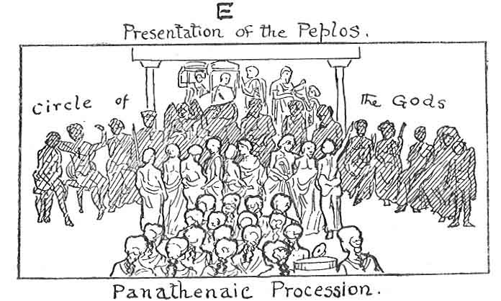

**6. Presentation of the Robe**

The peplos was folded by a young boy or girl and a priest, who gave it to the priestess of Athena Polias. The new peplos was placed on Athena's knees as a gift, and later stored in the treasury (the statue of Athene was about 40 foot tall). She was not re-robed at this time, which was done in the Plunteria (mid-June).

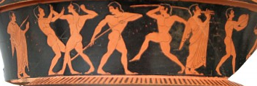

**7. Contests and Prizes**

In the Greater Pananthenaia, the three or four days following the procession are occupied by contests of sport (races, chariot racing, boxing and wrestling) and art (music – choral/kithara/aulos, poetry/drama). There was also the Pyrrhic dance contest, which consisted of citizens dancing in full armour, just as Athene had danced after beating the giants. There was also a boat race between the tribes of Athens. Traditionally the prize for athletes was a "Panathenaic amphora" containing olive oil from the Goddess's sacred grove, and the prize for artists was a gilded crown of olives and sometimes money. There could be contests for children, for which they were awarded plain crowns of olive.

**TASK**!

* **Write an eye-witness** **account** of the Panathenaia festival, including as much factual detail as you can.
* **Create a video** for presentation to the class talking us through the main events in the Panathenaia.
* **Make a pamphlet** advertising the Panathenaia to foreigners – what is there to see, and what might they need to know?

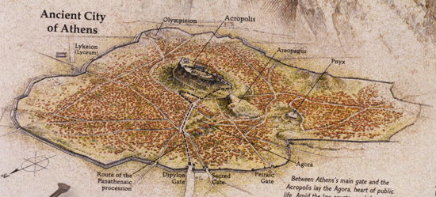

* **What happened in the contests?**

**Musical events**

There were various musical events, where winning competitors were awarded valuable prizes, including large sums of money and golden crowns. Rhapsodes (reciters of epic poetry) competing over telling stories from the *Iliad* and the *Odyssey*, while lyre and aulos competitions were also popular. These events were open to all Greeks in attendance at the festival.

**Sporting events**

The sporting contests at the Panathenaia made up one of the most important athletics events in the Greek world, attracting competitors from all over Greece. Most events were the same as in the Olympics, including the stade race, pentathlon, wrestling, boxing and equestrian events. Just like the music events, these sporting contests were open to all Greeks, not just Athenians.

In contrast to the Olympic games, victors here could win great prizes – large jars of olive oil, each of which had a picture of Athene on one side and the winning event on the other. Olive oil was an expensive and valuable commodity in the ancient world – a charioteer could win 140 jars of it!

**Tribal contests**

Since both the musical and sporting events were open to all Greeks, the Athenians produced some contests which were only for Athenian citizens. These events were competitions between the ten tribes of the city. Included were: a torch race from the Diplyon Gate to the Acropolis, the “euandria”, a male beauty contest that incorporated looks, size, strength and manliness, and boat races in a great regatta at Piraeus, the harbour of Athens.

|  |  |  |  |
| --- | --- | --- | --- |
| ***Category*** | ***Examples of contests*** | ***Who could take part?*** | ***Prizes available*** |
| ***Musical*** |  |  |  |
| ***Sporting*** |  |  |  |
| ***Tribal*** |  |  |  |

* **What was the significance of the Panathenaia?**

As well as an extravagant way to worship the Athenians’ most important god, the Panathenaia festival was an important opportunity for the Athenians to show off their city to the rest of the Greek world.

Non-Athenians were welcome to attend, and would have been impressed by the wealth, power and religious observance of the largest city in Greece.

Athenians believed that their city had become so powerful because of their democratic system (which they were the first to come up with), and so these public festivals were a chance for them to display their democracy and its success in action.

A democracy is …………………………………………………………………………

………………………………………………………………………………………………

Athens was not a true democracy because …………………………………….

………………………………………………………………………………………………

………………………………………………………………………………………………

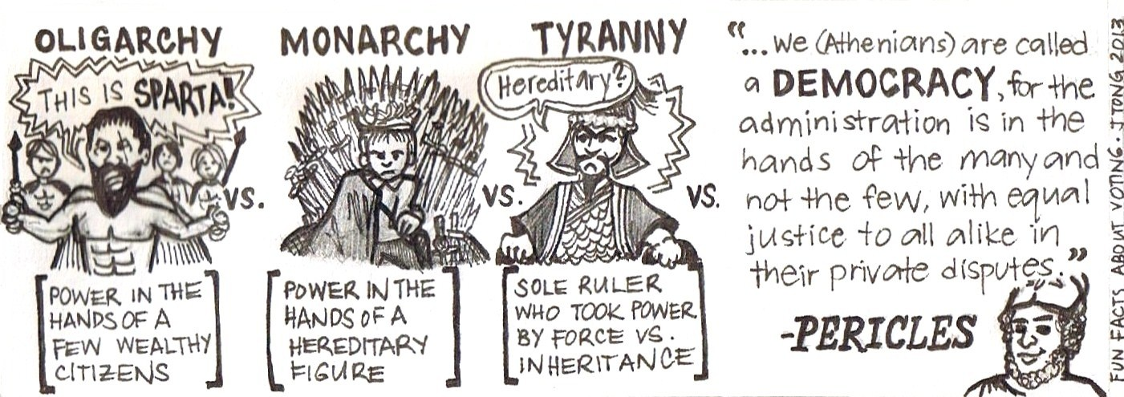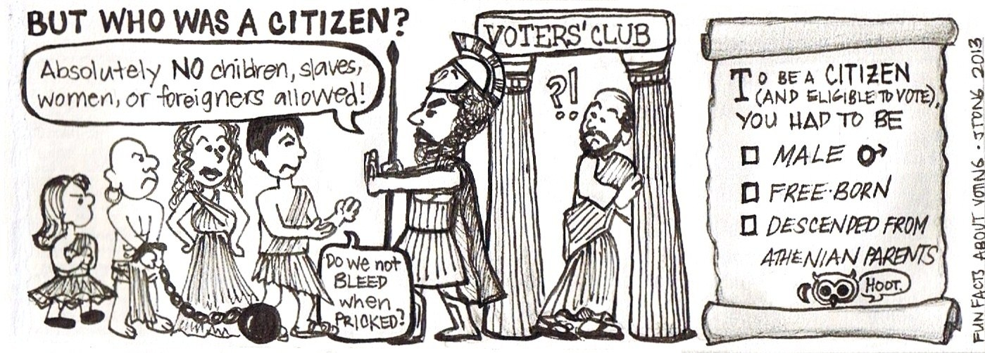

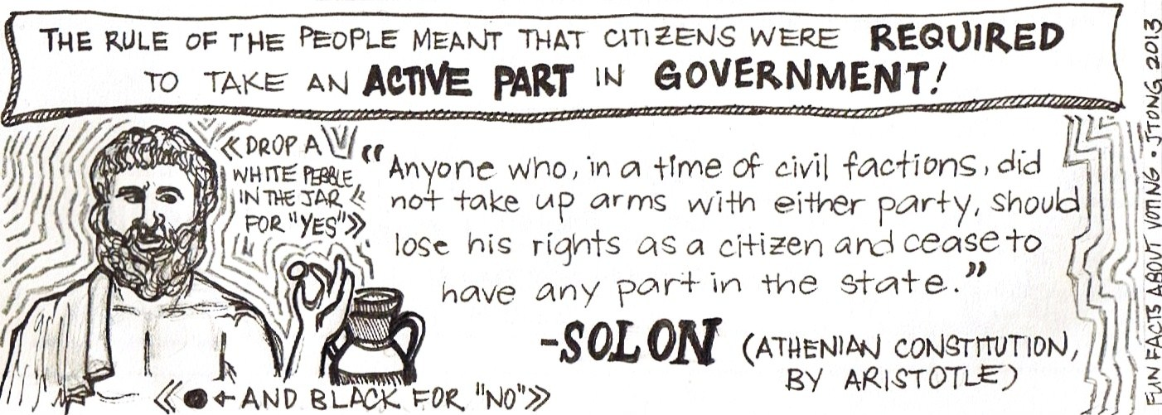

These were the most important aspects of Athenian democracy:

**The Assembly**

Every citizens was a member of the city’s assembly, which voted to make new laws.

**The Council**

500 citizens selected by lot sat on this each year; they suggested laws for the assembly to vote on.

**The Tribes**

Each citizen was a member of the one of the city’s ten tribes. Each tribe had to produce 50 men per year to sit on the council.

**The Magistrates**

There were 9 magistrates, who each served for a year, looking after the law courts.

* **Panathenaia Summary:**

The parade itself displayed Athens' wealth (in the form of the animals to be sacrificed), its military prowess (in the cavalry and chariot manoeuvres), and its well-behaved, industrious women (who wove the new dress).

The Greater Panathenaia included athletic, poetry, and musical contests open to all, and confirmed Athens' position as a major city in the Greek world.

Panathenaia Essay Plan

* **Do you think the Panathenaia festival was more a celebration of Athens or Athene?**

Athens Athene

* -
* -
* -
* -
* -

Conclusion?

**The City Dionysia**

The *City Dionysia* was a festival to honour the god Dionysos.

It was held at the Theatre of Dionysos in Athens, and took place in March, lasting for several days.

It began in the 6th century BC as a result of the alliance between **Eleutherae** and Athens. The people of Eleutherae gave the Athenians a wooden image of Dionysus, which they rejected, but the city was then hit by a plague that affected mens’ genitals! Therefore they accepted Dionysus into the city and initiated the festival, and the men were cured.

It took the form of a theatrical competition – playwrights put on tragedies, comedies and a satyr play and judges chose the winners.

The whole city attended (including slaves) – it was a major public event and all business was put on hold during these days. It was never cancelled.

**Programme of events:**

|  |  |
| --- | --- |
| **Pre-contest** | **Torchlight procession** |
| **Day 1** | **Pompe (procession)**  **Dithyramb Contests**  **Komos** |
| **Day 2** | **Opening Ceremony**  **3 tragedies, 1 satyr-play, 1 comedy** |
| **Day 3** | **3 tragedies, 1 satyr-play, 1 comedy** |
| **Day 4** | **3 tragedies, 1 satyr-play, 1 comedy** |
| **Day 5** | **Judging and prize-giving** |
| **A few days later** | **The Review** |

* ***Note down what happened at each stage:***
* **Before the event…**
* **The PROAGON (contest preliminaries)**
* **The “BRINGING IN”**
* 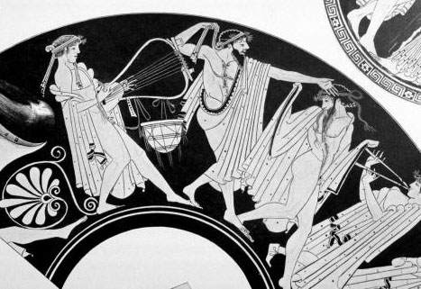**The POMPE (procession)**
* **The REVEL (KOMOS)**



* **The GRAND OPENING CEREMONY**
* **The CONTESTS**

Competitions in religious festivals were a way of giving one’s best to the gods.

The City Dionysia featured dramatic and dithyrambic (singing) competitions.

The City Dionysia had **FIVE** days of contests.

* **The AWARDS**
* **The REVIEW**

**Personnel: *Who did what?***

* *eponymous archon*
* *choregus*
* city
* chorus
* actors

**The importance of the festival:**

* It *brought the Athenians together* to join in the entertainment and fun.
* It gave them 5 days off work which was good as they had *no weekends*
* The opening ceremony was a *statement of the success and wealth of Athens*, particularly when the tribute of the allies was brought out and when the leading citizens were honoured.
* The sacrifices meant that the poor could have *meat in their diet*, which was rare.
* The procession and komos was a chance to *enjoy a pageant and then a wild party*.
* It was an *act of communal worship* and the Greeks liked to honour their gods
* It was a chance to *include the resident foreigners (metics) in a communal festival*.
* People sat with others from their own tribe or district, so they could make *useful connections*.
* The *content of the plays was often political* – a bit like modern satire
* The festival tended to *represent Athens’ democratic spirit* – it was organised by one of the city’s elected officials
* It allowed playwrights *freedom of expression* so that they were allowed to write plays which even questioned and criticised their society
* It was *democratic* *as even* *Athenian citizens could take part* in various ways - Athenian drama was performed by the people, for the people.

**The City Dionysia: Check Your Understanding Questions**

*Use your notes to answer these questions. Write in your exercise book in full sentences.*

1. What were the two types of drama in Athens, and how different were their themes and storylines? Give plenty of detail. (5)
2. What sort of costumes would comic actors wear, and why? (5)
3. What sort of costumes would tragic actors wear, and why? (5)
4. What was the chorus, and how did it add to the theatre experience?

***Total marks = 20***

**DIONYSIA REVIEW TASK**

**Create a pamphlet advertising the City Dionysia**

You should include (along with as much detail as possible)…

* + What happens (not just plays!)
  + Where things will take place
  + Which god is being honoured
  + The programme for the festival
  + Pictures
  + Any other draws… (wine? parties?)

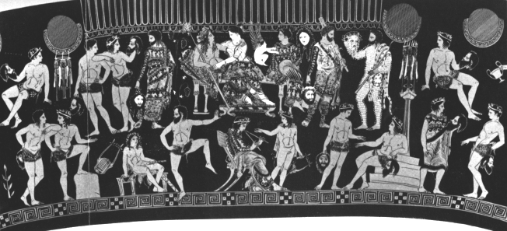

**CITY DIONYSIA –** *Match up the words with their definitions*

March cost of attending the theatre

tragedy trained the chorus and paid for the plays

Dionysus chose which playwrights took part

choregos grand procession

5 big party held the night before the festival

archon month in which the festival was held

statue of Dionysos one type of play put on at the festival

komos number of days the festival lasted

pompe god the festival was in honour of

2 obols carried into festival on a ship-cart

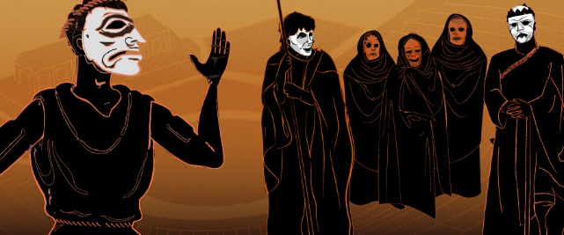

**Practice question: Which do you think the Greeks would enjoy more, the Panathenaia or the Dionysia festival? (8)**

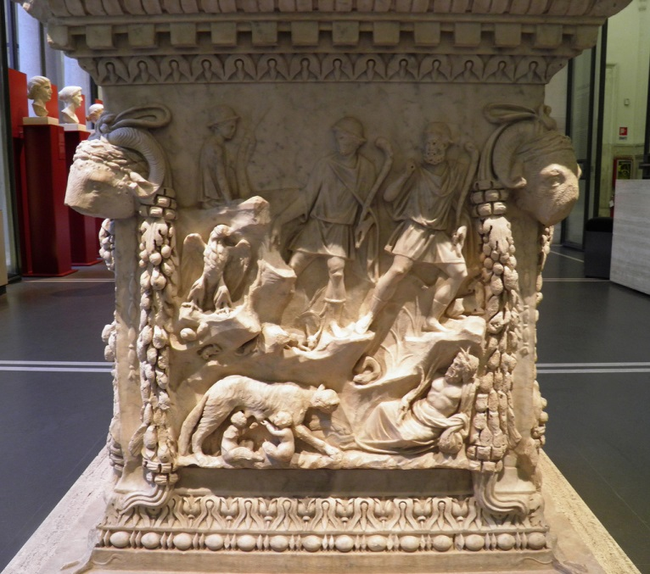**The Lupercalia**

The festival originally celebrated purification and fertility, and was in honour of the god **Lupercus**. In Latin lupus means wolf and so the festival also honoured Rome’s founder **Romulus**. He was once known as the “King of Shepherds” but as Rome lost its identity as a nation of farmers the festival was less to do with shepherds and more to do with Romulus himself. The festival developed and changed over time and the Romans themselves were not sure of its origins. It took place on**15th February** every year.

* **The Officials**

…………………………………………………………..………………………………………

………………………………………………………………………………………………..…

* **The programme**

…………………………………………………………..………………………………………

………………………………………………………………………………………………..…

………………………………………………………………………………………………..…

* **The sacrifice**

…………………………………………………………..………………………………………

………………………………………………………………………………………………..…

………………………………………………………………………………………………..…

………………………………………………………………………………………………..

………………………………………………………………………………………………..…

* **The race**

…………………………………………………………..………………………………………

………………………………………………………………………………………………..…

………………………………………………………………………………………………..…

………………………………………………………………………………………………..

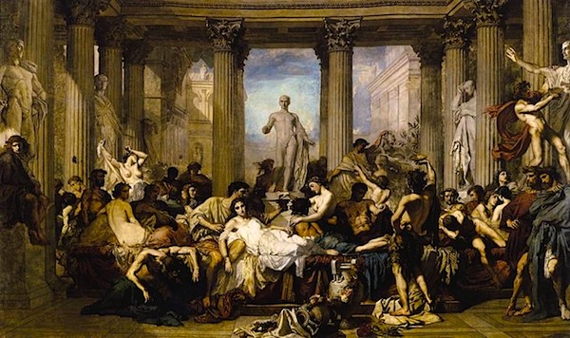**The Saturnalia**

The festival was in honour of the Roman god Saturn. It celebrated the following things:

* **The end of the winter sowing (Saturn was god of sowing and seed)**
* **The coming of new light, rebirth and a positive future (it was held in winter)**
* **The hope of a return of a “Golden Age” (when Saturn was believed to have ruled), when men and gods lived together in wealth and happiness.**
* The Saturnalia was thought to be unique as all levels of society took part including men, women, children and slaves. The festival originally took place from 17th-23rd December; Augustus shortened it to three days then Claudius lengthened it again to five! In the 4th Century AD it was incorporated into the Christian celebration of Christmas…
* **The officials**

…………………………………………………………..………………………………………

………………………………………………………………………………………………..…

* **The programme**

…………………………………………………………..………………………………………

………………………………………………………………………………………………..…

* **The sacrifice**

…………………………………………………………..………………………………………

………………………………………………………………………………………………..…

………………………………………………………………………………………………..…

* **The feast**

…………………………………………………………..………………………………………

………………………………………………………………………………………………..…

………………………………………………………………………………………………..…

………………………………………………………………………………………………..…

………………………………………………………………………………………………..…

**ROMAN FESTIVALS REVIEW TASK**

Write a diary entry for the days of **either** the Lupercalia **or** the Saturnalia festival. Explain in detail what happened…

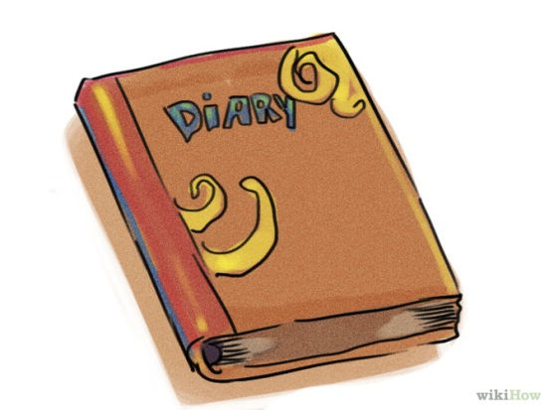

**Exam practice qs:**

**Explain why participants enjoyed ancient festivals (6)**

**Explain why festivals were important for honouring the gods (3)**

**Do you think Romans would have enjoyed the Lupercalia or Saturnalia more? Explain your answer (8)**

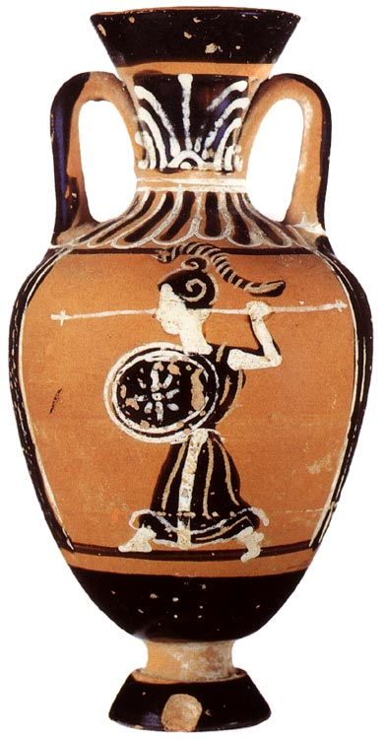

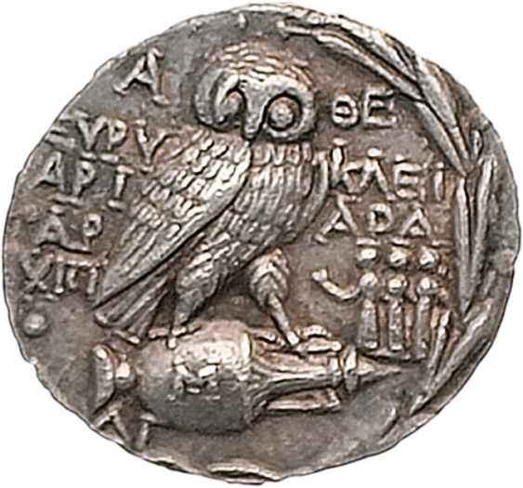

|  |
| --- |
| **Festivals** end-of-mini-topic test score: |
| My comment on this: |
| Teacher’s comment: |
| My response: |
| Memo/targets for next time: |

|  |
| --- |
| **Topic Review: You should be able to** |
| **Describe:**   * How the Great Panathenaia and City Dionysia were founded * what happened on each day of the Great Panathenaia and City Dionysia * what happened at the Lupercalia and Saturnalia * the sacrifices that took place at each festival |
| **Explain**   * Why the Great Panathenaia and City Dionysia were important to the Athenians * how Athena and Dionysus were worshipped at their festivals * why the Lupercalia and Saturnalia were important to the Romans * how Lupercus and Saturn were worshipped at their festivals |

**Glossary**

|  |  |
| --- | --- |
| rhapsode |  |
| Panathenaic amphora |  |
| apobates |  |
| peplos |  |
| Eleutherae |  |
| eponymous archon |  |
| choregos |  |
| dithyramb |  |
| pompe |  |
| komos |  |
| libation |  |
| Theoric fund |  |
| Lupercus |  |
| Luperci |  |
| Lupercal |  |