**Chesterton Community College**

**Classical Civilisation GCSE**

**Roman City Life**

Name: ________________________________

**HOMEWORK SCHEDULE:**

|  |  |
| --- | --- |
| Week | Pages |
| 1 | 2-3 |
| 2 | Read pages 4-6 |
| 3 | 7 |
| 4 | Read pages 8-12 |
| 5 | Make revision notes for 13-16 |
| 6 | Make revision notes for 13-17 |
| 7 | Make revision notes for 18-20 |
| 8 | 21 |
| 9 | 22-25 |
| 10 | 26-28 |
| 11 | 29-34 |
| 12 | 35-39 |

**First Impressions:**

**What type of houses do you think the Romans lived in?**

**Did all Roman houses have elaborate decorations?**

**Would every Roman house have had gardens?**

**What do you think the difference would be living circumstances of a rich and poor Roman?**

**The Insula**

There is a clear difference between our understanding of what is was like for the everyday roman and their usual living circumstances. Not every Roman had a highly decorated house, with plenty of living space and room for entertaining many guests. The typical large Roman private house in a city or town was known as a **domus**. Only the very wealthy could afford these homes and this meant that there were very few Romans who lived in them.

Most cities would be generated with apartment blocks; the literary sources suggested that these were often cramped and dangerous, although evidence near Ostia suggests that it was an exaggeration, they varied in size and quality. The apartment blocks were known as **insula (pl insulae)**. A 4th Century AD source recorded that the city of Rome had fewer than 2,000 domus-type homes, but more than 40,000 insulae.

Unfortunately, due to the development of Rome, there are not many insulae withstanding, the best evidence of insulae are in Rome’s port **Ostia**, 20 miles away.

The insula commonly consisted of 3-5 storeys, though there has been evidence to suggest that they could be between 6-7 storeys high. The access to the higher floors came from external staircases leading off the street.

From the 1st Century AD, the insulae were constructed of brick-faced concrete, roofs were made of wooden beams covered with terracotta tiles. In Ostia, we see large glazed windows on the upper floors. The ground floor often faced onto the street and tended to be shops which had an upper mezzanine for storage or living space.

At Ostia, there were a few blocks which were clearly designed for wealthy occupant. There are exampled of large apartments which have two large reception rooms as well as smaller rooms including a kitchen, and toilet facilities. However, this is not the standard type, the city has far more examples with two to four rooms.

Many Roman writers mention how unsafe insulae can be including Juvenal, who we will hear from later. Writers tend to focus on two concerns: he buildings were poorly constructed and tended to collapse, and that they were likely to catch fire.

Cicero, a statesman and property owner, made a joke in a letter to a friend:

Two of my buildings have fallen down, and the rest have large cracks .Not only the tenants, but even the mice have moved out!

Another writer, Aulus Gellius, reflected on a wealthy man’s concern over buying a property in Rome:

We were accompanying him home when, while climbing the Cispian Hill, we saw a tall multi- storey block of flats overrun with ﬂames, and all the neighbouring buildings burning in a great ﬁreball. Then one of Julianus’ companions said: “The income from urban property is great, but the dangers are far greater. But if some solution could be found to stop houses in Rome from catching ﬁre all the time, by the gods I would sell my country property and buy in the city”.

Consider what do the attitudes of these writers suggest about purchasing properties in the city?

What does this reflect about the difference in wealth division for Roman citizens?

What does Aulus’ writing suggest about the difference in property value between his country house and city flats?

What do both Cicero and Aulus’ writings suggest about property as a means of income?

Prescribed Source:

The Insula of Diana Built: c. **150 AD**

Location: **Ostia** Number of storeys: **4**

Significance: A very good example of a Roman insula

Named after the relief depicting the goddess Diana on the inner courtyard wall.

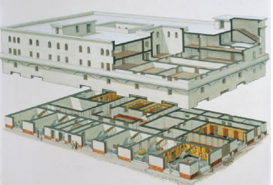

1. This is one of the best preserved insulae at Ostia. The dimensions of this insula are approximately **39x23 meters.**
2. The south and west wall face out onto the street, while the other two back onto other buildings. They contained no doors or windows.
3. A central roofless courtyard allowed light into the building.
4. It contained a cistern which provided waters to the building, as there was not individual access to water.
5. The ground floor contained many shops, which opened out onto the street, and each had a small mezzanine.
6. The floor had its own shared toiles which were probably available to all the tenants.
7. There were three staircases, two external and one internal.
8. On he south and west side, some fairly large four roomed apartments
9. On the other side some communal living space.
10. This consisted of a long corridor off which were small, poorly lit rooms; at one end of the corridor was a larger room that was probably a shared living space

Who might have lived here?

It is interesting to speculate as to who might have lived in these apartments. Insulae were mainly rental properties owned by the wealthy (who could make a good proﬁt on the rental income). The four- room apartments may have been rented by people who might be thought of as moderately wealthy, and who may have taken out leases of six months or a year. By contrast, the small rooms in the communal area were perhaps rented by the day or week, most likely to people who were passing through the busy harbour city, or working there for a short period of time.

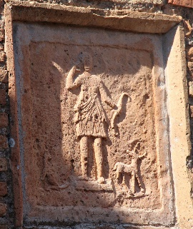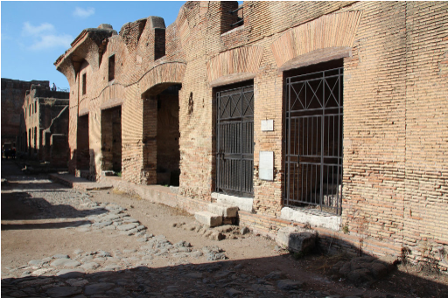

View from south-east. Relief of Diana in courtyard

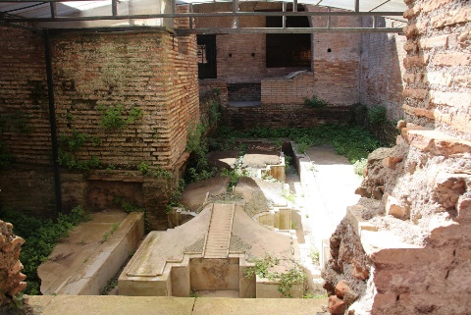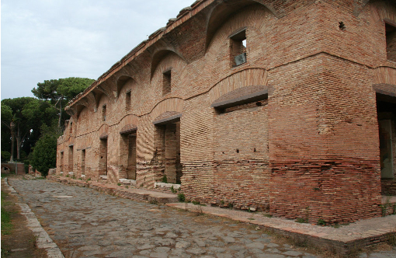

View from south-west The fountain in the courtyard

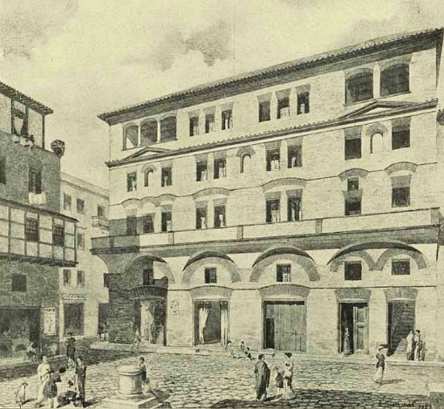 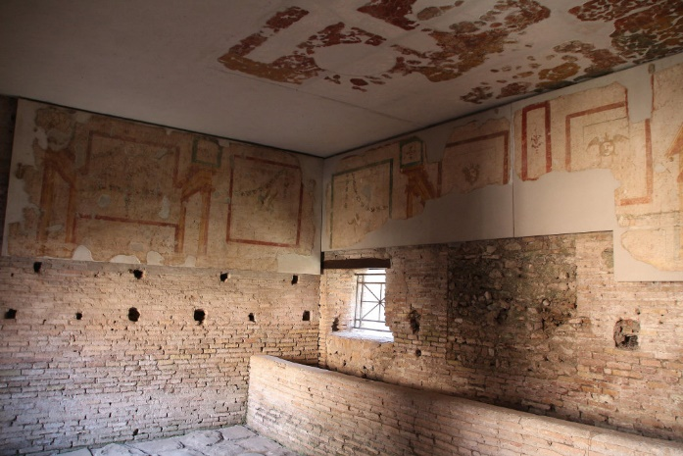

Reconstruction from south view Room 30 seen from north-west, note trough aaaaaaa at some point in time room became a stable.

Here is what Juvenal has to says about the insulae in Rome:

Here in Rome we live in a city that’s propped up with matchsticks – most of it anyway. That’s the way the landlord stops the building from falling down, papering over the cracks in the old walls, telling us all not to worry, to sleep easy, and all the time the place is about to collapse around us. I think I’d rather live somewhere where there aren’t any fires or sudden alarms in the middle of the night. The man on the ground floor is already calling for water and moving his bits and pieces to safety; your third-floor flat is already smoking, but you’re blissfully unaware; for if the alarm is sounded at ground level, the last to burn will be the man in the attic, whose neighbours are nesting pigeons, with only the roof tiles between him and the rain.

Remains of an Insula near the Palatine Hill at Rome

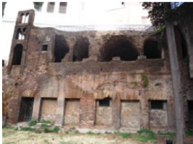

Reconstructed version of Roman Insulae

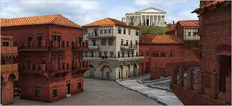

<https://www.youtube.com/watch?v=jIWQvdZdaAA> 3D Insula Reconstruction

**Insula Review**

How similar are the Roman Insula to the modern flats?

|  |  |
| --- | --- |
| Roman Insula | Modern Flats |
|  |  |

Imagine you were a wealthy Roman who was looking to purchase a block of flats, write a short advertisement that would attract you to purchase the property.

________________________________________________________________________________________________________________________________________________________________________________________________________________________________________________________________________________________________________________________________________________________________________________________________________________________________________________________________________________________________________________________________________________________________________________________________________________________

Now you have purchased the property, one similar to the insula Diana, write a short advert to attract new tenants.

________________________________________________________________________________________________________________________________________________________________________________________________________________________________________________________________________________________________________________________________________________________________________________________________________________________________________________________________________________________________________________________________________________________________________________________________________________________

**The Domus**

Although the number of domus-style houses in any Roman city was fairly small, they played a significant role in daily life. Wealthy Roman men used the living space to work, greet friends, and clients, and conduct politics. There were not any typical offices in the way we understand them, so everything took place at home.

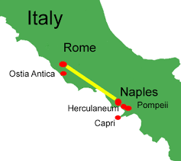Our main evidence for the domus comes from Pompeii and Herculaneum. These are best preserved thanks to the eruption of Mt. Vesuvius. Archaeologists generally accredit different rooms of the house to certain areas such as kitchens, dining rooms, bedrooms, and studies. However, we cannot assume that the Romans used the rooms as strictly as we believe. Similar to us the Romans would have used the rooms in a variety of ways and potentially used different rooms based on the décor etc.

The following diagram outlines the layout of a typical house with its key features. The design is focused around two important areas – the **atrium** (reception hall) and, beyond this, the **peristyle** (colonnaded garden). The atrium was the most public area of the house, and it was here that the owner would meet his visitors and guests, including his clients. The owner of the house might use this room to display signs of his wealth – one Pompeian house had large chests of money in the atrium. In the centre of an atrium was usually an **impluvium** – a rectangular pool into which rain water fell from a specially designed opening in the roof (the compluvium ). This was a source of water supply for the house since the impluvium was linked to a reservoir below. The atrium might also contain a shrine to the house hold gods called the **lararium**, while according to ancient sources ceremonial wax masks of the family’s ancestors could be kept in the open recesses on each side of the atrium. The whole space could therefore be designed to hold the presence of the living, the ancestors and the gods.

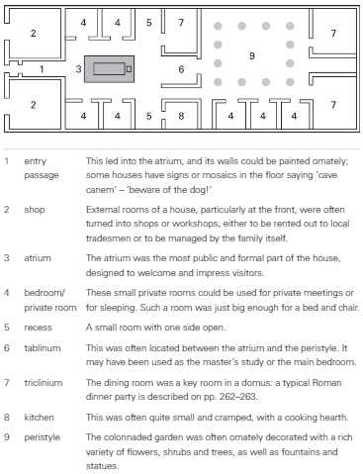

The peristyle was designed to bring a little bit of the country to the city. This was somewhat similar to when we see gardens in houses in central London. The peristyle would contain ornate fountains as well as flowers, plants and shrubs. The art work on the walls nearby would reflect the them from the countryside painted carefully.

It was common for the houses to have a **triclinium** which looked out into the garden (**hortus**). The house would be built around these two rooms and the other room which was important was the **tablinum**, which was considered the master’s study. This was located between the atrium and peristyle. Some sources state that this is not where private business was conducted but it would contain the marital bed. Rooms at the front of the house would be converted into shops which provided the family with an extra source of income.

The house would also have a number of small rooms which may be used for bedrooms, but not in the same way we do. The role of the bedroom primarily was to sleep, not entertain. A slave would not often have their own room and we can imagine they spent most their time sleeping in corridors.

It is hard for us to know some aspects about the domus for absolute certainty, such as whether they had upper floors. These rooms would not always be grand and most likely used for storage, sleeping, or renting out. Like Anglo-Saxon homes, it is likely whole families lived in them and with slaves and other members a household could have potentially twenty or more people living there.

Wall paintings here often come in vivid colours, most commonly red, orange and blue- green, but also yellows, purples and black. Onto these were painted scenes, frequently taken from Greek mythology (a source of great fascination for the Romans, who borrowed much of their own mythology from the Greeks) or country landscapes; still- life scenes such as ﬂowers, fruit and animals. In many houses, painters represented architectural features such as buildings and pillars, giving the images greater perspective and suggesting that the room was more spacious than it really was.

Houses had many of the items, generally made of wood, which we might use in our homes today: tables, chairs, beds, screens, shelves, chests and cupboards. In one house in Pompeii, the contents of a large cupboard were found in the atrium, including bronze jugs and plates, a bronze basin and cake mould, two bronze signet rings and other pieces of jewellery, nine dice and bits of gaming equipment, as well as some coins made of gold, silver or bronze.

Vitruvius, *On Architecture*, 6

 1. First of all the salubrity of the situation must be examined, according to the rules given in the first book for the position of a city, and the site may be then determined. Their size should be dependent on the extent of the land attached to them, and its produce. The courts and their dimensions will be determined by the number of cattle, and the yokes of oxen employed. The kitchen is to be placed in the warmest part of the court; adjoining to this are placed the stalls for oxen, with the mangers at the same time towards the fire and towards the east, for oxen with their faces to the light and fire do not become rough-coated. Hence it is that husbandmen, who are altogether ignorant of the nature of aspects, think that oxen should look towards no other region than that of the east.

2. The width of the stalls should not be less than ten feet, nor more than fifteen; lengthwise, each yoke is to be at least seven feet. The baths should be contiguous to the kitchen, for they will be then serviceable also for agricultural purposes. The press-room should also be near the kitchen, for the convenience of expressing the oil from the olive; and near that the cellar, lighted from the north, for if it have any opening through which the heat of the sun can penetrate, the wine affected by the heat becomes vapid.

 3. The oil room is to be lighted from the southern and warmer parts of the heaven, that the oil may not be congealed, but be preserved liquid by means of a gentle heat. Its size must be proportioned to the quantity of fruit yielded on the estate, and the number of vessels, which, if of twenty amphoræ (cullearia), are about four feet diameter. The press, if worked by levers instead of screws, should occupy an apartment not less than forty feet long, so as to allow room for the revolution of the levers. Its width must not be less than sixteen feet, which will give ample room to turn and expedite the work. If two presses are employed, the width must be twenty-four feet.

 4. The sheep and goat houses are to be constructed so that not less than ºan area of four feet and a half, nor more than six feet, be allotted to each animal. The granaries are raised, and must be towards the north or east, so that the grain may not heat, but be preserved by the coolness of the air; if towards other aspects, the weevil, and other insects injurious to corn,º will be generated. The stable, especially in the villa, should be in the warmest place, and not with an aspect towards the fire, for if horses are stalled near a fire, their coats soon become rough.

 5 Hence those stalls are excellent which are away from the kitchen in the open space towards the east; for when the weather is clear in the winter season, the cattle brought thither in the morning to feed, may be then rubbed down. The barn, hay-room, meal-room, and mill, may be without the boundaries of the villa, which will be thereby rendered more secure from fire. If villas are required to be erected of more magnificence than ordinary, they must be formed according to the proportions laid down for town houses above described, but with the precautions necessary to prevent the purposes of a country house being interfered with.

 6. Care should be taken that all buildings are well lighted: in those of the country this point is easily accomplished, because the wall of a neighbour is not likely to interfere with the light. But in the city the height of party walls, or the narrowness of the situation may obscure the light. In this case we should proceed as follows. In that direction from which the light is to be received, let a line be drawn from the top of the obstructing wall, to that part where the light is to be introduced, and if, looking upwards along that line, a large space of open sky be seen, the light may be obtained from that quarter without fear of obstruction thereof;

 7. but if there be any impediment from beams, lintels, or floors, upper lights must be opened, and the light thus introduced. In short, it may be taken as a general rule, that where the sky is seen, in such part apertures are to be left for windows, so that the building may be light. Necessary as light may be in triclinia and other apartments, not less is it so in passages, ascents, and staircases, in which persons carrying loads frequently meet each other. I have explained to the best of my ability the arrangement used in our buildings, so that it may be clearly known by builders, and in order that the Greek arrangement may be also understood, I shall now briefly explain it.

**Prescribed Source**

**The House of the Wooden Partition**

**Location: Herculaneum**

**Significance: Well-preserved Roman domus**

**Name: Given to from the preserved partition that separates the tablinum and atrium.**

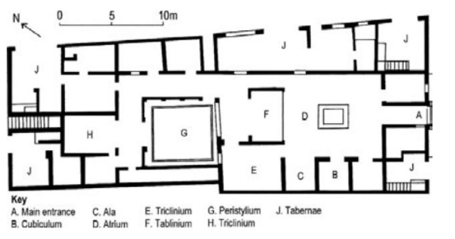

The house’s facade is remark ably well- preserved; indeed, what can be seen today – a two- storey front with roof beams still in place at the top – is probably very similar to what was visible in the ﬁrst century AD . Outside the front door are the benches for clients; high in the walls above them, small windows look out onto the street from the upper ﬂoor, while carbonised wooden beams supporting the roof are still in place. Moving into the house through the entrance way, one walks into an impressive atrium, decorated with red, black and yellow panels. In pride of place was a marble display table in front of the impluvium, while the impluvium itself, with a fountain at its centre, was also lined with marble.

The item of most interest is at the back of the atrium: the ‘wooden partition’ from which the house takes its name. It is assumed that this was used as a screen to separate the tablinum from the atrium, giving the owner some privacy when required. The partition was originally made of three beautifully panelled sliding double doors, although the middle panel was hacked through by early excavators. Thankfully, the other two panels have survived in carbonised form, together with their hinges and bronze lamp supports, each in the form of a ship’s ﬁgurehead. Another carbonised relic can be seen in a small room on the west side of the atrium – a bed or couch, which stood on legs shaped by a lathe.

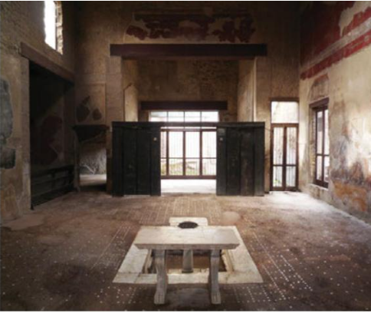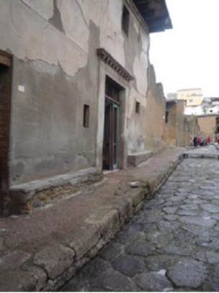Beyond the tablinum, the peristyle was colonnaded on three sides. There were small family rooms around it, and the house’s main dining room lay the other side of it. One of the rooms off the peri style linked through to one of the various shops bordering the house; these would still have been owned by the owner of the house. At the back of the house was a ﬂight of stairs, which led to a set of rooms above. Steps too can be found in the shop on the front side of the house, and these led up to a small apartment, perhaps the living space of the person who ran the shop – it is unclear if this was attached to the house or not.

**Prescribed Source**

**House of Menander**

**Location: Pompeii**

**Significance: One of the largest and most impressive houses in Pompeii**

**Name: The house takes its name from a wall painting of the Greek comic playwright.**

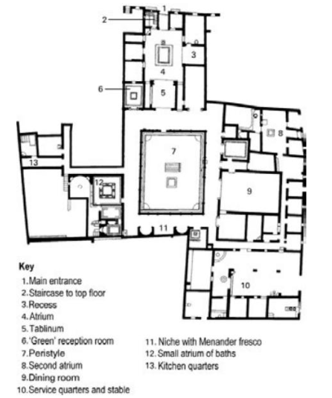

The house is named after a portrait on one of the walls of the peristyle of the Greek comic playwright Menander, who greatly influenced the Roman comic play wrights Plautus and Terence. Scholars are not clear who owned the house at the time of Pompeii’s destruction.

The house has acquired neighbouring buildings to produce an even larger property. From the entrance, one could see right the way through to the back wall of the peri style. The impressive atrium contained an elaborate household shrine, next to which was a stair case to an upper ﬂoor. The recess off the atrium had complementary paintings on its three walls, each one depicting a scene from the Trojan War, including the arrival of the wooden horse at Troy in one of them. The south end of the atrium led into the tablinum, which itself led through to a large peristyle.

In the north- west corner was a room coloured predominantly in green, with a ﬂoor mosaic depicting scenes from the river Nile. In the south- west corner was a suite of baths – only the very wealthiest houses could afford to have their own private set of baths like this. On the south end of the peristyle was a second house hold shrine, as well as three frescos – one the famous image of Menander, another depicting theatrical masks, and a third another portrait, perhaps of the Greek tragic playwright Euripides. On the east side of the peristyle was a vast dining room, one of the largest reception rooms discovered in Pompeii

The house had two service areas. The east side has a long corridor with a number of small rooms; at one end was a large stable, where a wagon, and many amphorae were found, suggesting that the owner may have had a large farming estate as well. At the other end of the corridor was a small atrium which may have been the head slave’s headquarters. The other service area, on the west side of the house, consisted of a kitchen, latrine and service rooms, with access to cellars below. It was here that the house’s silver service was found by excavators – a large collection of decorated silver vessels, wrapped in cloth and neatly stacked, including plates, trays, spoons, ladles, bowls and cups.

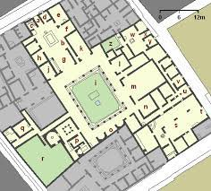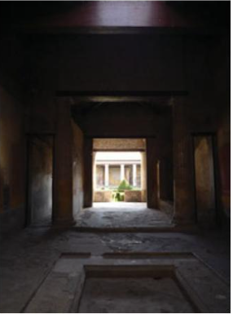

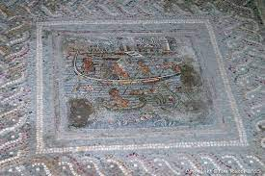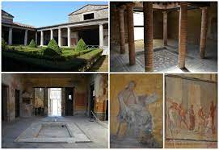

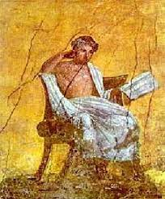

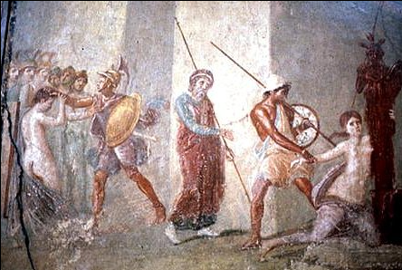

🡨 Ajax dragging Cassandra

**Prescribed Source:**

**House of Octavius Quarto**

**Renovated between 60-70AD Location: Pompeii**

**Significance: The focus of the domus is the magnificent garden and water features.**

**Name: Named after Octavius Quartio, whose signet ring was found there.**

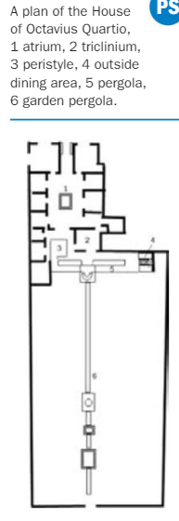

The design of the house of Octavius Quartio shows how, over time, the design focus of a domus could move away from the atrium to the peristyle. The greatest feature of this house was its large and wonderful garden, enhanced by impressive water features, shrines and fountains.

The house is found on one of Pompeii’s main streets. Outside the front was stone seating, which may have been used by clients, while the two front rooms opened out onto the street as shops; it is in one of these that a signet ring with the name ‘Octavius Quartio’ was found, giving the house its modern name. The entrance passage led into a rectangular atrium; its impluvium had a fountain jet and was surrounded by ﬂower boxes, hinting at the beautiful garden that lay beyond. The rooms around the atrium were standard; the south side led directly into a small peristyle, colonnaded on three sides.

The fourth side of the peristyle opened onto a pergola that over looked the garden. Under the pergola ran a narrow canal, lined with garden statues and probably home to ﬁsh; mid-way along was a bridge. Painted on the walls at the west end of the pergola were two scenes from the myth of Diana and Actaeon – Actaeon discovering Diana bathing, and then about to be ripped to death by his own hunting dogs. A large reception room, probably used for dining, opened onto the north side of the pergola; its walls were decorated with scenes from the life of Hercules, as well as from the Trojan War. On the outer north wall of the pergola were painted hunting scenes, and to its east was an outside dining area, with space for two couches rather than the conventional three. Next to the couches on the east wall was a small house hold shrine ﬂanked by two more paintings – to the left the myth of Narcissus, to the right the story of Pyramus and Thisbe.

The south side of this pergola led off into the garden, which was on a lower level. It was divided by a second, longer pergola and canal. Where the two pergolas met was a fountain shrine dedicated to Diana and Actaeon. The lower canal ran all the way along the garden, about 50 metres in all, and it too was decorated with statues, paintings and crossing bridges. Midway along this lower canal was another fountain, and beyond that a small temple.

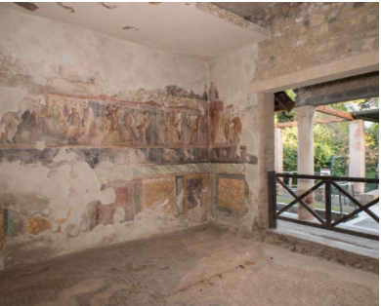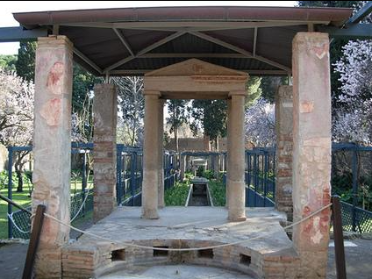

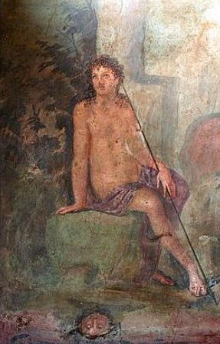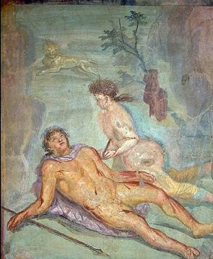 Narcissus at the Spring

Pyramus committing suicide

Death brought about by passion

Lucius pinxit.

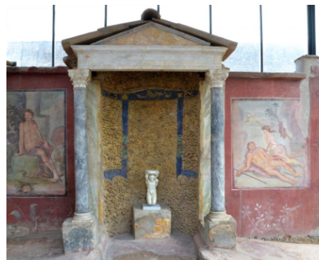

Roman Real Estate

Imagine you have been asked by the wealthy inhabitants of Rome to sell one of the domus. Considering the fine selling points and give some detail below:

House: ______________________

What is the house’s unique selling point and why?

________________________________________________________________________________________________________________________________________________________________________________________________________________________________

How does the house’s layout differ from another domus?

________________________________________________________________________________________________________________________________________________________________________________________________________________________________

What type of decoration would you expect to find in this house?

________________________________________________________________________________________________________________________________________________________________________________________________________________________________

How significant is the outside spaces and atrium for entertaining your guests?

________________________________________________________________________________________________________________________________________________________________________________________________________________________________

Does the house have any space for slaves or anything else?

________________________________________________________________________________________________________________

**First Impressions:**

**Who is the head of your household and why?**

**What do you think would be different about our education and the Roman system?**

**How do we support each other in society? Are there any situations for mentors or people to develop others and provide financial security?**

**What type of activities would you consider if you were to throw a dinner party? What type of food would you provide for your guests?**

**The Paterfamilias**

The ***paterfamilias*** was the important and senior male in a Roman household. The term is Latin for "father of the family." The concept of family for the Romans was not just the immediate, but included the slaves and the property of the house.

The power held by the *paterfamilias* was called ***patria potestas***, "paternal power." Potestas is distinct from *auctoritas*, also held by the *pater*. Under the laws of the Twelve Tables, the *paterfamilias* had ***vitae necisque potestas***—the "power of life and death"—over his children, his wife (in some cases), and his slaves, all of whom were said to be *sub manu*, "under his hand." For a slave to become a freedman, he would have to be delivered "out of the hand" of the *paterfamilias*, hence the terms ***manumissio*** and ***emancipatio***. Something similar was often done with even grown-up sons, before they could get married and start their own household. At law, at any rate, his word was absolute and final. If a child was unwanted, under the Roman Republic the *paterfamilias* had the power to order the child put to death by exposure.

He had the power to sell his children into slavery; Roman law provided, however, that if a child had been sold as a slave three times, he was no longer subject to the ***patria potestas*.** The *paterfamilias* has the power to approve or reject marriages of his sons and daughters; however, an edict of the Emperor Caesar Augustus provided that the *paterfamilias* could not withhold that permission lightly.

He had a **duty** to raise his children to be **good citizens of Rome**; he would therefore want to oversee the education of his children, especially his sons, and would normally appoint an educated slave to act as a tutor. When his daughter reached puberty, he was responsible too for arranging a suitable marriage – very often this happened without the girl having any say at all. He would expect his wife to be loyal and hard-working in the home, and would manage the purchase of any slaves for the household. The *paterfamilias* was also the religious head of the family, and would lead worship at the family’s house hold shrine, where the spirits of the family’s ancestors, the **Lares** , were believed to reside. Other religious duties might involve him overseeing suitable offerings to the gods at import ant moments such as birth, marriage and funerals.

Only a Roman citizen could enjoy the status of *paterfamilias*. There could only be one holder of the office within a household. Even male adult children remained under the authority of their fathers while he still lived, and could not acquire the rights of a *paterfamilias* while he was yet alive; at least in legal theory, all their property was acquired on behalf of their fathers, and he, not they, had ultimate authority to dispose of it. Those who lived in their own households at the time of the father's death succeeded to the status of *paterfamilias* over their respective households. Over time, the absolute authority of the *paterfamilias* tended to be weakened, and rights that theoretically existed were no longer enforced or insisted upon.

In the exam you should try to use the Latin terms where possible, what do the following mean:

*Paterfamilias –*

*patria potestas –*

*vitae necisque potestas* ***–***

*Lares -*

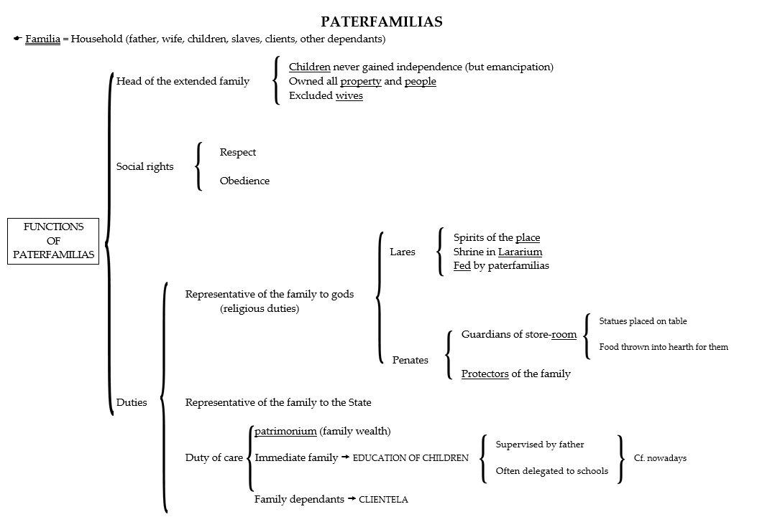

Above is a visual image of the function of the *paterfamilias* answer the following questions:

1. What gave the paterfamilias the power to kill his children?

2. Can you think of a reason why he would want to kill one of his children?

3. Find two examples of powers a Roman father had which a modern British father would not have.

4. Can you think of a reason why the power of the paterfamilias eventually weakened

**Patrons and Clients**

In the table above you will have seen the term clientela, these would have been the people the *paterfamilias* would have been responsible for looking after their financial needs.

In Roman society, the poorer Romans needed money so they would attach themselves as **clients** to wealthy Roman men, the **patrons**. The clients would be expected to appear at dawn every morning, and then possibly accompany their patron on their business later in the day. They would act as supporters of the patron and be expected to vote for him if he ran for official office. In return, the clients would hope for a small gift, money, or opportunity each day. If they were good clients, they might even dine with the patron. As we can see Martial discuss this below:

The first and second hours wear out clients; the third keeps hoarse lawyers busy; Rome continues in her various labours to the end of the fifth hour. The sixth will be the siesta for the weary, the seventh will be the end of work. The eighth up to the ninth provides enough time for the glistening exercise grounds. The ninth orders men to rumple cushions piled high on couches. The tenth, Euphemus, is the hour for my little books when you take care of organising the ambrosial feasts and the Emperor Domitian is relaxed by heavenly nectar and he holds a small cup in his mighty hand. Then bring in witty poems: my Muse of comedy is scared to approach Jupiter. **Martial, Epigram, IV.8**

Almost everyone had a patron or client, and the system worked like a well-oiled machine as wealthy men would seek patronage of wealthier men, and the money would be distributed to the less wealthy. Even though the system worked well, this does not mean that everyone appreciated it. If we look at two more of Martial’s epigrams we will see that he isn’t best pleased!

How much longer have I got to turn up to these early-morning buttering-up sessions, mingling with the mob of followers and little men all done up in their posh togas? And for what? A handful of brass for a full day’s work. **Martial, Epigrams, X.74**

What type of impression does this Epigram give you about how Martial feels to visit his patron?

You order me to perform for you the duties of a new and recent friend, Fabianus; that at first light, shivering, I should greet you and that your litter should drag me through the middle of the mud; that when I am worn out, I should follow you at the tenth hour or later to the baths of Agrippa ... Is this what I have deserved, Fabianus, that, when my toga is threadbare, you think I have not yet earned my discharge? **Martial, Epigrams III.36**

Again we can see that Martial conveys a particular tone about how he feels about visiting his patron Fabianus. What does this tell you about the cycle of patrons and clients?

Martial was a Roman poet and he fondly satirised Roman culture, if we consider these three *Epigrams*, what impression do they give you about his views on patronage?

________________________________________________________________________________________________________________________________________________________________________________________________________________________________________________________________________________________________________________________________________________________________________________________________

**Prescribed Source: Inscription F14 (Cooley and Cooley, *Pompeii: a Sourcebook)***

**Location:** Pompeii, Vicolo di Balbo

**Significance:** An inscription which shows a client supporting his patron in an annual election campaign.

One example of a client publicly supporting his patron can be seen in an election notice carefully painted on the wall of a street in Pompeii, where a man, Thalamus, identiﬁes himself as the client of Publius Paquius Proculus and thereby encourages others to vote for his patron as duumvir, the highest political ofﬁce in the town.

Thalamus, his client, elects Publius Paquius Proculus duumvir with judicial power. CIL IV 933

Is there anything similar to the patron system in our society? If you think so, what is it, how is it similar, and what does it do for the wider context of society?

________________________________________________________________________________________________________________________________________________________________________________________________________________________________________________________________________________________________________________________________________________________________________________________________

Why do you think the patron system was not sustainable?

________________________________________________________________________________________________________________________________________________________________________________________________________________________________________________________________

What do you think would happen if the patron system returned, would it benefit society?

________________________________________________________________________________________________________________________________________________________________________________________________________________________________________________________________

**Education of Boys**

The Romans did not have an education system in the way that we understand it, children would learn from their parents, fathers would teach their sons their own trade as well as some basic literacy and numeracy skills. The mothers would teach daughters how to manage the household.

As the Roman civilisation became more powerful, it is clear that they wanted to model their systems on the Greeks. The Greeks gave precedence to literature, history, mathematics and philosophy.

Schools began to develop in as much as parents began paying teachers who would hire small areas or even meeting in public places such as the forum or palaestra, though they would need to compete with the noises of the street.

**Prescribed source: Inscription 45 (Cooley and Cooley, *Pompeii: a Sourcebook*)**

**Location: Pompeii, Large Palaestra**

**Description: An inscription by a teacher referring to being paid.**

**Significance: Evidence for the presence of a school at the side of an exercise ground.**

Whoever has paid me the fee for teaching, let him have what he seeks from the gods**. CIL IV 8562**

The above inscription was found on a column on one side of the palaestra in Pompeii. This gives us some understanding that the teacher is thanking the pupils who have paid and of course implies that some people have not!

We can see another example from Martial where he complains that he is being woken up by a teacher who is working outside of his apartment.

What do you have against us, spiteful school teacher? We know you are hated by all the boys and girls you teach. Before the crested cockerel has even crowed, you shatter the silence with your harsh voice and the lashes of your whip . . . Would you be willing, you old windbag, to accept the same pay for being silent as you now receive for shouting out lessons? **Martial, Epigrams , IX.68**

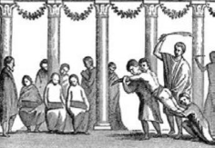This fresco was found in the estate of Julia Felix, an estate in Pompeii, the house is covered with frescoes depicting everyday life of Pompeii. The image to the left clearly highlights that a boy is being caned, as we can see he is being held down by two other pupils and is seemingly bare.

Martial makes the point of stating the lessons were before dawn which implies that they used this time to prevent too much public noise. The other thing is the nod to corporal punishment, which appears commons as Horace mentions Orbilius the Flogger. The quality of teaching varied, as there were no formal qualifications in teaching, it was usual for people of the lower class of society to take up the mantle. We cannot assess how they made progress as there were no formal means of assessment that we have evidence of.

**The Roman School System**

* Three stages:
* Stage 1 – Between 7-11 with a primary school style teacher known as the **Litterator**
* Stage 2 – 11-15 the pupils had a secondary education with the **Grammaticus**
* Stage 3 – 16+ the pupils learned rhetoric with a **Rhetor,** and continued the study of public speaking.

It is hard to know exactly what proportion of children went to school, and it is likely that it was mainly the preserve of the wealthy; interestingly, it is clear that **some girls** did attend lessons with the litterator as well as boys. By the age of fourteen, girls were preparing to get married and boys from poorer families had started working. Evidence suggests that the literacy levels amongst the population were very low, although there may have been a higher level of ‘functional literacy’, whereby people had a limited ability to read and write where they needed to.

**Litterator**

The ﬁrst stage of a Roman education was at the school of the litterator. Boys and girls would attend his lessons from the age of seven and learnt reading, writing and some basic arithmetic. The education was very repetitive at this stage – pupils had to practise writing letters endlessly and, once they had mastered the alphabet, they were forced to copy out useful phrases such as ‘Seek advice from a wise man’. We even have a diary extract from a Roman school boy that tells us about learning at this age:

My slave who carries my books handed me my waxed tablets, my writing box, and my writing instruments. Sitting in my place, I smoothed over the tablets. I printed the assigned sentence. When I had ﬁnished it, I showed it to the teacher. He corrected it, wrote over my errors, and told me to read it aloud. So instructed, I recited it to another student. **CGL III , pp. 645–647**

The boy’s words tell us a lot about the equipment used by Roman pupils. They ﬁrst used wax tablets (**cera)** – thin sheets of wood covered with wax, on which pupils could write with a **stilus**, an implement with a sharp end for marking the wax and a ﬂat end to rub the wax out and smooth it over again. When pupils were competent writers, they would be allowed to move on to write with a pen and ink on a papyrus, thick reed paper invented in ancient Egypt.

Another feature of this passage is that it explains that a pupil would have a slave who accompanied him called a pedagogue. The slave would be there to accompany him to school, hold his supplies, and even punish him if he does not behave.

What problems might a slave have who is responsible for punishing the son of a Roman household? Consider the role of *paterfamilias* and what could happen in the future.

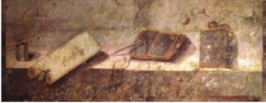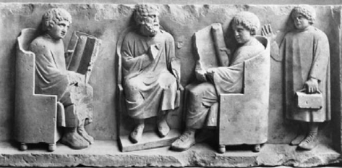

**Grammaticus**

If parents could afford it, then their sons moved onto the grammaticus at the age of about twelve. The basis of the studies was Greek and Roman literature. The ﬁrst century BC saw the emergence of some of Rome’s greatest writers, such as Cicero, Virgil, Horace and Ovid.

The standard text for a Roman child might have been Virgil’s Aeneid. The pupils would have studied this in a similar respect to how we study Shakespeare. The children would be expected now to learn passages by heart. The strong working memory was given primacy at this stage in the education.

At this point the pupil would also learn Greek. The Romans would learn Greek as it was a status symbol and the language of the educated. Moreover, it was also important to learn Greek because the eastern half of the Roman empire was predominantly Greek-speaking; Greek was the language of government and law there, and a Roman provincial official would have needed to know Greek ﬂuently. They might also study music, astronomy, philosophy and natural sciences.

**Rhetor**

At the age of 16, privileged Romans would go on to study with a rhetor. They would teach them the art of public speaking, and this was crucial for a successful public figure.

Pupils learnt to compose and deliver speeches and a common exercise would be to debate historical events. Another exercise would be for them to analyse specific legal cases and argue for either side. These were called **declamations**. Most of the successful public figures began their careers in the lawcourts, and a particularly famous lawyer and public speaker, Cicero, states the following:

The student must develop his style by careful attention not only to word choice but also to sentence construction. He must be thoroughly acquainted with all the emotions which nature has given to the human race because he must use all his power and ability at speaking to calm or, alternatively, to stir up those that listen to him . . . Delivery of speech must be reinforced by bodily movement, gesture, facial expression, and by modulation and variation of the voice. **Cicero, About the Orator , 1.17–18**

Complete the Venn diagram showing similarities and difference in education.

Rome Modern

Both

Why do you think teachings were undervalued in Roman society when they shaped the leading political figures?

________________________________________________________________________________________________________________________________________________________________________________________________________________________________________________________________________________________

Are there any aspects from the Roman education system that you think we should bring back or teach in modern schools?

________________________________________________________________________________________________________________________________________________________________________________________________________________________________________________________________________________________

Think about how you learn best, do you think that a Roman education would be for everyone?

________________________________________________________________________________________________________________________________________________________________________________________________________________________________________________________________________________________

What would you say are the key strengths and weaknesses of a Roman education?

________________________________________________________________________________________________________________________________________________________________________

Designing a Roman School

Consider that you have been asked to produce a pamphlet for a Roman school in the modern world. Everything needs to be the same other than the public teaching, you have your own property, your own outside space and colonnade, but you need to recruit teachers and pupils.

**Task 1** – Write the job description for an advert for teachers in your school. Think about what each of the teachers needs as a minimum requirement to take part, then also consider what support staff you might need.

**Task 2** -Now that you have your teachers, you must attract pupils. Produce a pamphlet showing your school in the best light. Think about what you can offer, when will it take place, what type of learning is offered and what type of behavioural management you might have.

**Roman Dinner Parties**

Videos – Horrible Histories Dinner Party - <https://www.youtube.com/watch?v=jZT7b79VbMc>

Blue Peter – A Roman Banquet – (Very dated!)

<https://www.youtube.com/watch?v=9CqDKkcguDk>

The Roman dinner party was known as the **cena**. This was an excellent opportunity for the *paterfamilias* to show off his estate or domus, and then promote his own social status. As a patron he would also be expected to invite his clients to dinner.

The dinner party was quite a ritual event, as you will see in the Martial passage on page 7, that the host would usually attend the baths and then they would return to their home for the party in the late afternoon, around the 8th/9th hour (3/4pm). When the guests, formally dressed, entered the home they would have had time to admire the artwork before the slave would lead them to the triclinium. The **triclinium** was the dining room and literally meant three couches. Guests would recline on the couch as they ate and they could fit up to three people on each couch. They would eat while reclined and there would be a number of slaves offering wine, water for washing their hands, and replenishing the food.

You’ll have a nice meal, Julius, at my house; do come if you’ve nothing better to do. Keep the eighth hour (two o’clock) free; we’ll go to Stephanus’ baths beforehand, just next door. For starters you’ll get lettuce, fresh young leeks, then salted tunny-fish a little bigger than a mackerel and garnished with eggs done up with rue; then more eggs, this time baked to a turn in a moderate oven with cheese and olives. For the main course, you can have fish and oysters, sow-belly, chicken and duck. I promise I won’t recite anything, but you can read me your poem ‘The Giants’ again, or recite some of the ones about the countryside. **Martial, Epigrams XI.52**.

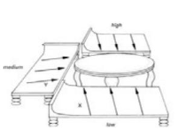The seating plan at the dinner party was of great significance. There were the high, medium, and low couches, with the same division from right to left as you looked at the couch. Seat Y would be for the guest of honour and x reserved for the host.

A dinner party typically had three courses. The ﬁrst might be made up of light appetisers, such as eggs, olives or salads; these were followed by **mulsum** , a type of wine sweetened by honey. The second, the main course, was typic ally a selection of meats or ﬁsh accompanied by vegetables and a variety of sauces. The ﬁnal course was dessert, which might consist of fruit, nuts or simple sweet-cakes. The host would want to show off throughout by serving a variety of foods and recipes, as well as good quality wine, both red and white.

What do you mean by accepting my invitation to dinner and then not turning up? It was all set out, a lettuce each, three snails, two eggs, barley-water, wine with honey, chilled with snow (an expensive item, please note, since it disappears in the dish!), some olives, beetroots, gherkins, onions and plenty of other delicacies as well. You could have had a comic play, a poetry reading, or a singer. But no, instead you preferred to go where you could have oysters, sow’s innards, sea-urchins and Spanish dancing girls! **Pliny, Letters I.15**

A number of sources suggest that some hosts served different quality food and wine at the same meal: what you received depended on your social status. Some evidence of this comes from the satirist Juvenal, who writes in a poem (Satire 5)[1] of dining with his patron. The dinner party had three categories of guest: the host Virro and his friends; Virro’s clients; and the freedmen. Like Pliny, some wealthy Romans clearly disapproved of this practice.

A good host would also put on entertainment during or after the meal. One possibility was an extended session of drinking wine. This was not simply a short- cut to getting drunk, since the Romans always watered down their wine, perhaps by adding as much as four-ﬁfths of water to one-ﬁfth of wine. Other entertainment might include dancers, acrobats and clowns, while we also hear of guests playing games similar to dice and back gammon. Some hosts might organise more intellectual activities, such as a discussion about literature or philosophy, as we can see with Pliny above. Whatever the case, a host would have hoped that his guests would mix well and behave appropriately.

**Prescribed Source: Inscription D80 (Cooley and Cooley, *Pompeii: a Sourcebook*)**

**Location: Pompeii, House of Sallust**

**Description: Three inscriptions on the wall of the summer dining room.**

**Significance: Instructions for guests about how to behave at a dinner party.**

Let water wash your feet clean and a slave wipe them dry; Let a cloth cover the couch, take care of our linens. Remove lustful expressions and ﬂirtatious tender eyes. From another man’s wife; may there be modesty in your expression.[. . .] postpone your tiresome quarrels. If you can, or leave, and take them home with you. CIL IV 7698a–c

The first inscription refers to the preparations at the start of the dinner party: guests should have their feet washed by slaves and take care not to dirty the furniture. The second inscription warns male diners not to ﬂirt with another man’s wife, while the third one tells diners to go home if they are likely to start an argument.

Create your own menu, what would you serve at a dinner party?

________________________________________________________________________________________________________________________________________________________________________________________________________________________________________________

Consider a modern dinner party, how similar would they be?

________________________________________________________________________________________________________________________________________________________________________________________________________________________________________________

What do you think the benefits would be for hosting a good party?

________________________________________________________________________________________________________________________________________________________________________________________________________________________________________________

What do you think would have been the most enjoyable part of a dinner party?

________________________________________________________________________________________________________________________________________________________________________________________________________________________________________________

What would be the worst part of a dinner party?

________________________________________________________________________________________________________________________________________________________________________________________________________________________________________________

How would you feel if you were given the seat of honour?

________________________________________________________________________________________________________________________________________________________________________________________________________________________________________________

1. <https://www.tertullian.org/fathers/juvenal_satires_05.htm> if you would like to see.