**OCR Classical Civilisation GCSE**

**Myth and Religion Unit 1.1**

Greek & Roman Gods

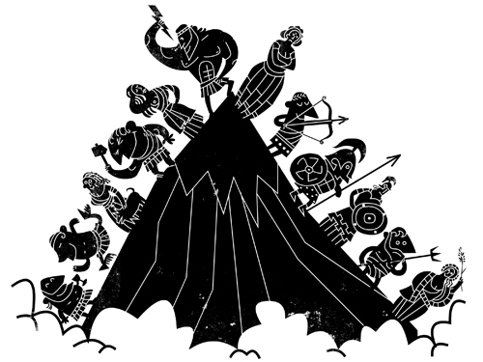

**HOMEWORK SCHEDULE:**

|  |  |
| --- | --- |
| Week | Pages |
| 1 | 1-4 |
| 2 | 5-6 |
| 3 | 7 |
| 4 | 8 |
| 5 | 9 |
| 6 | 11-12 |

Name & form: ________________________________

|  |
| --- |
| **Topic Overview** |
| Greek and Roman gods, their responsibilities and symbols and how they are typically represented in ancient Greek and Roman art |
| **Greece:** Zeus, Hera, Demeter, Poseidon, Hephaistos, Apollo, Artemis, Athena, Aphrodite, Ares, Dionysos, Hestia,Hermes, Hades |
| **Rome:** Jupiter, Neptune, Vulcan, Mercury, Mars, Pluto, Apollo, Juno, Venus, Minerva, Diana, Bacchus, Vesta and Ceres |
| The prescribed source for this topic is: *Homeric Hymn to Demeter* (in sources booklet) |

**Ancient Religion: Introduction**

Ancient religion was very different from modern Christianity because its followers worshipped not just one God (**monotheism**) but several different gods (**polytheism**).

The ancient Greeks and Romans were a **polytheistic** culture.

The collective term used when referring to all of the gods together is the **pantheon** (we will also meet a temple with the same name later in the course – so don’t get confused!)

They believed that each of their many gods was responsible for a different area of life (e.g. music, farming, archery, the sea…) and they would choose which god/s to worship depending on what was important to them at the time.

Another important difference from Christianity is that the Greeks and Romans did not worship their gods because they loved them, or because they felt that it was the right thing to do. They presented gifts (animal sacrifices, war spoils, offerings of food, oil and wine) only in order to get something in return.

Worshipping a god was more like making a deal or a transaction – you were “paying” for a favour that you hoped to receive.

On the whole, gods were worshipped **communally** rather than privately. Sacrifices and offerings were made at temples and shrines, and festivals which involved the whole city took the place of individual prayer.

Although they believed that their gods had supernatural powers, these gods were also very human (they were **anthropomorphic**) – i.e. they had human forms and many human characteristics and vices.

The Greeks and Romans believed that the gods could easily become angry or jealous, that they had human favourites, and that they often misbehaved! According to the myths and stories, gods could appear to humans, interact with humans, and sometimes even have children with them.

In addition to their individual responsibilities, each Greek god or goddess had its own specific way of being represented in art (mostly on vases or in sculpture). Usually these were linked to their responsibilities – for example, Zeus often has a crown and an eagle because he is king of the gods, and he carries a thunderbolt because he is in charge of the weather. This is known as **iconography.**

The Greeks and Romans did not actually have a word for religion! Instead they used the words **hiera** (holy affairs) and **religio** (the correct worship of the state gods).

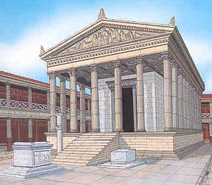This is important as we should not think of Greek and Roman religion as purely based on faith. It was not enough to just believe in the gods; Greek and Roman religion was all about action (physically worshipping the gods through performing sacrifices and making offerings).



*N.B. When talking about Greek and Roman religion, “gods” is written with a lower-case “g” – only use a capital when talking about the Christian “God” (His name)!*

Answer in your books:

1. What are the advantages of a religion with lots of gods?
2. What are the disadvantages?
3. Which areas of ancient life do you think the 12 most important gods would need to be in charge of?

*Check that you know the key terms by matching them with the definition*s *– there is one new word which is matched up for you!*

**pantheon** giving human form or characteristics to something non-human

**iconography** the belief in many gods

**polytheism** the symbols attached to a character when shown in a picture

**hiera** correct worship of state gods

**religio** collective term given to all gods

**anthropomorphism** holy affairs

**epithets** word or phrase applied to a god to describe a quality they had

**GREECE VS. ROME**

There are three sections in your final exam – the first is on Greece, the second is on Rome, and in the third section you have to compare and contrast both cultures.

Therefore it is very important that you know the names of and key facts about the Greek **and** Roman gods, as well as the key differences between the two.

[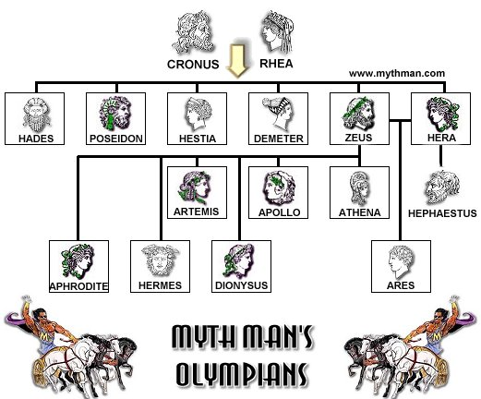](https://www.google.co.uk/url?sa=i&rct=j&q=&esrc=s&source=images&cd=&cad=rja&uact=8&ved=0ahUKEwjq5PCMiMXVAhVDaVAKHYgRAZsQjRwIBw&url=https://www.emaze.com/@AFZZZRZF/zeus&psig=AFQjCNH90fawncZgNNrh65lzTCam0cLxmw&ust=1502193222075713)

The 14 **Greek** gods you need to know are pictured here.

Why are they known as **Olympians**?

Which god is **not** an Olympian and why?

Before Rome was founded in 753 BC, Italy was divided into lots of different tribes. One of the biggest of these were the **Etruscans**. When the Roman empire began they took on lots of Etruscan customs and ideas.

Both the Romans and Etruscans were also very influenced by the **Hellenes** (another word for the Greeks). This is because lots of Greeks had migrated and taken over areas in Sicily and the south of Italy. These areas became known as **Magna Graecia** (Great Greece) because so many of them lived there.

As you might know, the Romans copied the Greeks and adapted many parts of their culture – religion was no exception.

**Use the info above and p13 to write down the following definitions in the glossary at the end of this booklet: a) Etruscans b) Hellenes c) Magna Graecia?**

|  |  |  |  |
| --- | --- | --- | --- |
| **Greek and Roman names** | **Responsibilities** | **Iconography** | **Extra Info.** |
| Zeus/Jupiter |  |  |  |
| Poseidon/Neptune |  |  |  |
| Hades/Pluto |  |  |  |
| Hera/Juno |  |  |  |

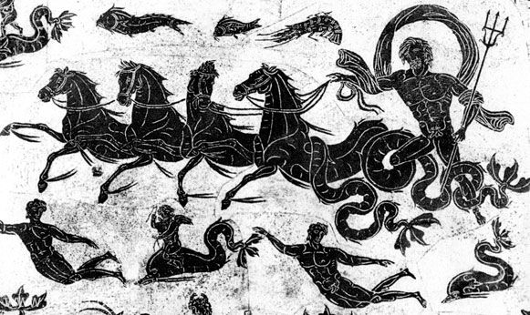

**Answer in your books using the pages mentioned in the textbook:**

Who were the Titans and Cronos? P7 yellow box

Why did Poseidon hate Odysseus in the Odyssey? P7

Why did Hera hate the Trojans? P8

Where was the temple of Jupiter Optimus Maximus in Rome? Why was this place important? P14

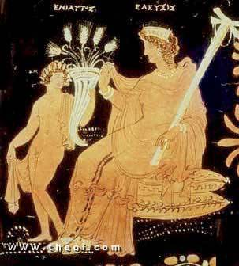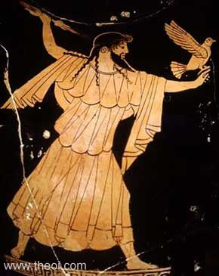

Label the iconography you recognise in the sources

|  |  |  |  |
| --- | --- | --- | --- |
| **Greek and Roman names** | **Responsibilities** | **Iconography** | **Extra Info.** |
| Athene/Minerva |  |  |  |
| Demeter/Ceres |  |  |  |
| Hestia/Vesta |  |  |  |
| Hephaistos/Vulcan |  |  |  |

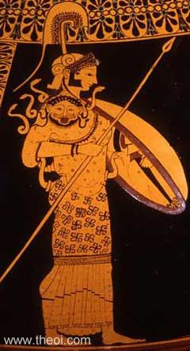

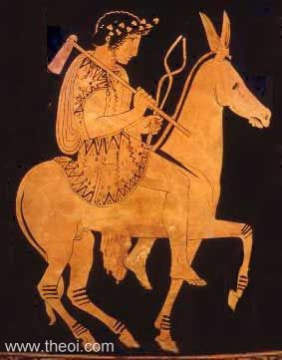

Label the symbols you recognise in the sources

**Answer in your books referring to the pages in the textbook:**

What was weird about Athene’s birth? Who was her mother? P9

What has the **Parthenon** got to do with Athene? P9

What were the **Eleusinian Mysteries** and the **Cerealia**? P9-10

Why did Hephaistos/Vulcan have a limp? P10

|  |  |  |  |
| --- | --- | --- | --- |
| **Greek and Roman names** | **Responsibilities** | **Iconography** | **Extra Info.** |
| Aphrodite/Venus |  |  |  |
| Artemis/Diana |  |  |  |
| Apollo/Apollo |  |  |  |
| Hermes/Mercury |  |  |  |

**Answer in your books referring to the pages in the textbook:**

Which god was Aphrodite married to and which one did she have an affair with? P10

Which god has the epithet **Phoebus** and why? P11

Who was Servius Tullius and how was he linked to the goddess Diana? P16

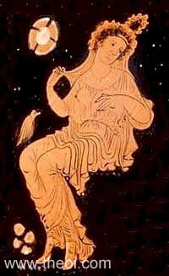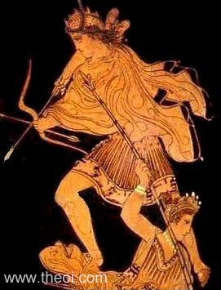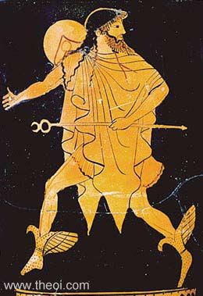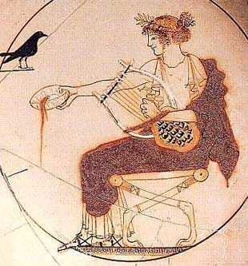

Label the symbols you recognise in the sources

Winged boots

Spear

Dove

Traveller’s cape

Thyrsus

Armour

Herald’s wand

Mirror

Leopard

Drinking cup

Apple

Vine/grapes

Scallop shell

wide-brimmed hat

|  |  |  |  |
| --- | --- | --- | --- |
| **Greek and Roman names** | **Responsibilities** | **Iconography** | **Extra Info.** |
| Ares/Mars |  |  |  |
| Dionysos/Bacchus |  |  |  |

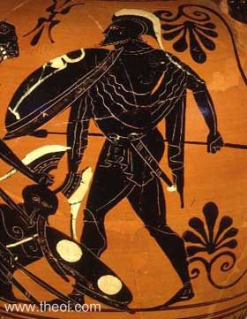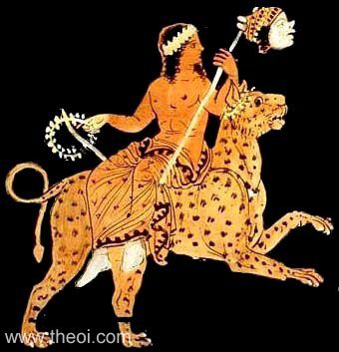

Label the iconography you recognise in the sources

**Answer in your books referring to the pages in the textbook:**

What was strange about the birth of Dionysos/Bacchus? P11 and 18

Who were the maenads and satyrs? P12 (look at definitions)

What was the Campus Martius or Field of Mars in Rome? P17

What was the Bacchanalia and why did some Roman officials disapprove of it? P18

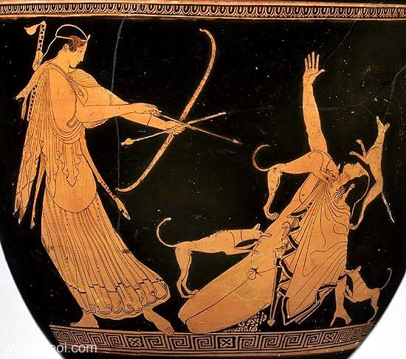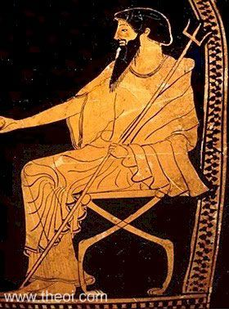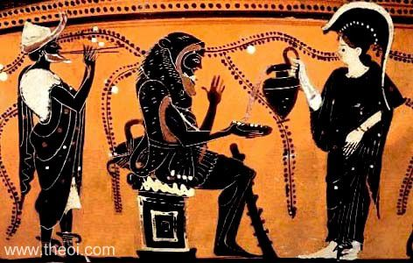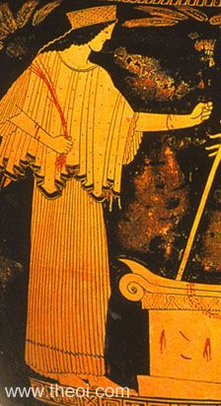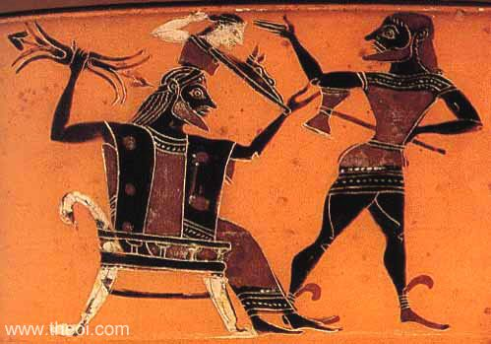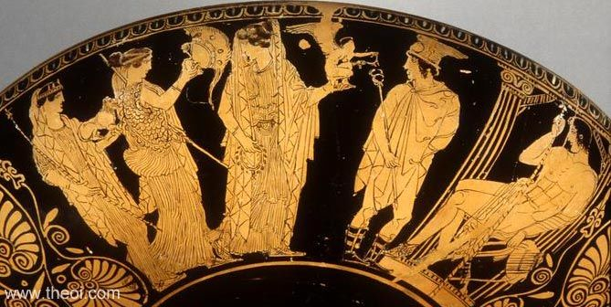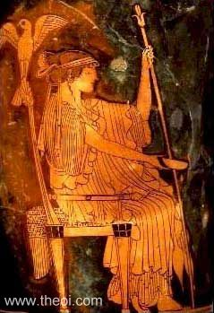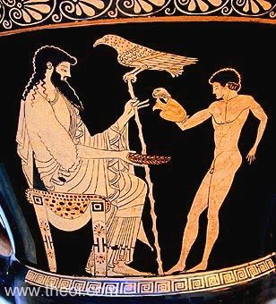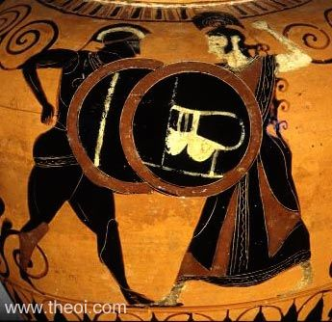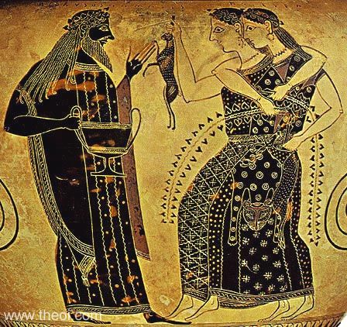

**Test Yourself… Who’s Who?**

**Test yourself… Who’s who?**

|  |
| --- |
| **Topic Review: You should be able to** |
| **Describe:**   * The key responsibilities of each of the Olympian Gods * The symbols used to identify the Olympians, as well as Hades/Pluto * Any differences between the Greek and Roman versions of the gods * The storyline of the *Homeric Hymn to Demeter* |
| **Explain**   * The character of Greek and Roman religion, including polytheism and anthropomorphism * The importance of epithets to describe the gods * What the relationship between men and gods was like * The importance of the *Homeric Hymn to Demeter* for the Greek understanding of the cycle of the seasons |

**Greek and Roman gods: Review Questions**

**Prepare for the end of topic test with these questions!**

1. What was the name of the founder of Athens?

2. Who were the brothers of Zeus?

3. What is the Greek name for the Roman god Vulcan?

4. Why was Ceres so important to Roman worshippers?

5. Why might Mars be more important to Romans than Ares was to Greeks?

6. Give **five** responsibilities of the god Apollo.

7. Explain what **oracles** and **prophecies** were.

8. Explain what is meant by polytheism and anthropomorphism.

9. Describe what was weird about the birth of either Aphrodite or Dionysus.

10. Who were **maenads** and **satyrs**?

11. Which do you think would be the most important Roman god for a) a merchant or b) a slave?

12. Explain what either a lyre or a caduceus is.

13. Which gods are **not** Olympians and why?

14. Explain what happened to Persephone/Proserpina as told in the *Homeric Hymn* *to Demeter*

15. What is an epithet and why is it important?

16. Give one example of a god behaving in an **anthropomorphic** way.

17. Why do you think Persephone’s story is a popular one for decorating **sarcophagi?**

18. Explain why the Romans were so influenced by Greek religion.

**Glossary**

**Use these definitions, and add your own:**

|  |  |
| --- | --- |
| Acropolis | large rocky outcrop overlooking Athens; full of temples |
| anthropomorphism | giving human attributes to something that is not human |
| communal | shared by all the members of a community |
| Iliad | ancient "epic" (adventure) poem about war, written down by Homer |
| immortal | able to live forever |
| invocation | calling upon a god in prayer |
| lyre | ancient stringed instrument |
| maenad | female follower of Dionysus |
| Olympians | The 12 Greek gods thought to live on Mount Olympus |
| Parthenon | major temple on the Acropolis, dedicated to Athene |
| polytheism | belief in many gods |
| prophecy | a prediction of what will happen in the future |
| sceptre | staff carried by kings and other rulers (like Zeus) |
| trident | three-pronged instrument, as carried by Poseidon |
| wreath | leaves or flowers arranged into a circular crown |
| pantheon |  |
| iconography |  |
| hiera |  |
| religio |  |
| epithet |  |
| chthonic |  |
| cornucopia |  |
| diadem |  |
| aegis |  |
| oracle |  |
| caduceus |  |
| Thebes | An ancient city in Greece where many myths are set |
| thyrsus |  |
| maenads |  |
| satyrs |  |
| Etruscans |  |
| Hellenes |  |
| Magna Graecia |  |
| sarcophagus |  |
| plebs |  |
| Cerealia |  |
| Vulcanalia |  |
| votive |  |
| lararium |  |
| Bacchanalia |  |
|  |  |
|  |  |
|  |  |
|  |  |
|  |  |
|  |  |
|  |  |
|  |  |
|  |  |
|  |  |
|  |  |
|  |  |