Independent learning task - Graph Theory

Rationale
Students of mathematics need to be good at reading a maths textbook and using it as a source for learning and revision. To help you develop these skills we would like you to complete this task before we look at the topic of Graph Theory. Don’t worry if you can’t do some of the questions as we will be covering the topic at the maths school at a future date, but you will learn much more if you are able to try and understand some of the concepts yourself before then. To successfully complete the task, you will need to be resourceful and resilient. If you get stuck on a question don’t let that put you off answering later questions, the question aren’t in order of difficulty and what you find easy or difficult will probably differ from others.

What you need to do
Work your way through each of the questions on the reverse of this sheet. This worksheet provides some definitions and examples of different graphs and asks you to get to grips with the basic ideas that underpin graph theory. Some of the questions will also guide you through some basic proofs.

Graph Theory is a very different type of mathematics to what you’ve seen so far at GCSE. Although it’s a very abstract part of mathematics, it has lots of real-world applications particularly when it comes to algorithms in computer science. At A level you’ll have the opportunity to study more graph theory in the Decision module of the course. Some of the ideas and proofs on this worksheet are outside the A level curriculum.

Graph Theory
A graph is defined as a set of vertices $(V)$ and a set of edges ($E$). Vertices are points, and edges are lines (not necessarily straight) that connect two vertices together.
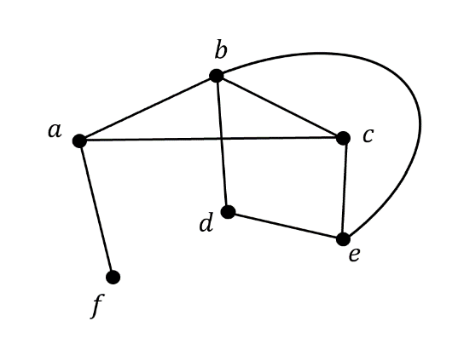
For example, the graph $G$ pictured below has:
- a vertex set: $V=\{a,b,c,d,e,f$}. This is simply a list of all the vertices in the graph.

- an edge set: $E=\{ab,ac,af,bc,bd,be,ce, de\}$. This is a list of all the edges, where $ab$ represents the line connecting $a$ and $b$ together. Note that we don’t include $ba$ in the set as it’s the same edge as $ab.$


Graphs must also obey the following rules:

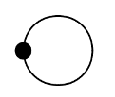
- No loops
(A loop is when an edge begins and finishes on the same vertex.)

- No multiple edges

Q1. a) Write down $V$ and $E$ for the graph shown.
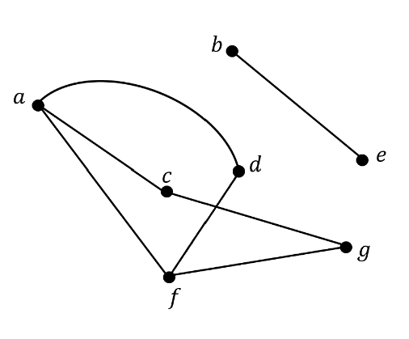

b) Draw the graph $G$ described by the following vertex and edge sets.

$$V=\{a,b,c,d,e,f,g,h\}$$
$$E=\{ab,af,ag,bd,bg,ce,df, fg\}$$

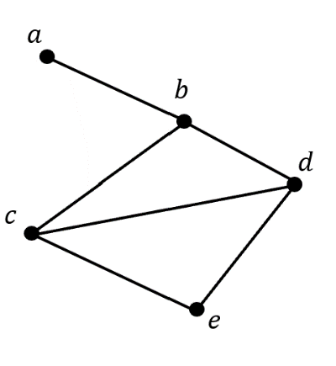
Definition 1: The degree, or order, of a vertex is the number of edges incident to it. (A vertex and edge are incident if the vertex lies at either end of the edge).
$a$ has degree 1 as only one edge meets here.

$c$ has degree 3 as three edges meets here.

Definition 2: Isomorphic graphs are graphs with the same number of vertices connected in the same way with the same number of edges, but may be drawn differently.
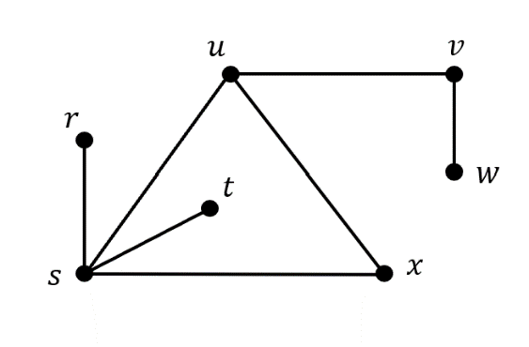
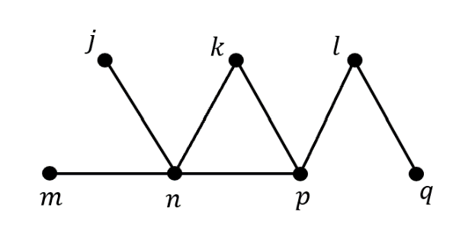
Q2. The two graphs, $G_{1}$and $G_{2}$, below are isomorphic.
$$G_{2}:$$
$G_{1}$:

a) Copy and complete the table below. One row is already completed for you.
Vertex on $G_{1}$ | Corresponding Vertex on $G_{2}$ | Degree of vertex
$$j$$
$$k$$
$$l$$
$$m$$
$$n$$ | $$s$$ | $$4$$
$$p$$
$$q$$

b) Was there only one correct way to fill out the table above?

Definition 3: A subgraph of a graph $G$, is a graph each of whose vertices and edges both belongs to $G$. In other words, it is simply a part of $G$.
Definition 4: A finite graph is a graph with a finite number of vertices.
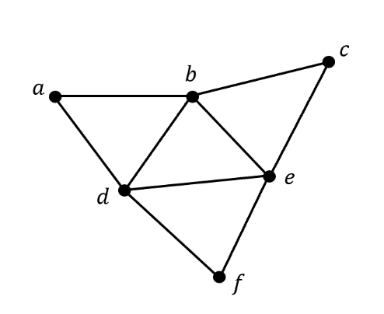
Why do we define it as a finite number of vertices rather than a finite number of edges?

Q3. The graph $G$ is drawn below.

$$G:$$

- Draw three non-isomorphic subgraphs of $G,$ each with four vertices.
- Identify which of graphs $A, B$ and $C$ are isomorphic to graph $G.$
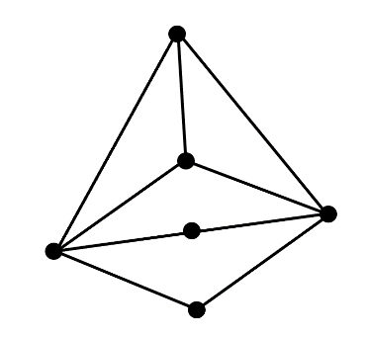
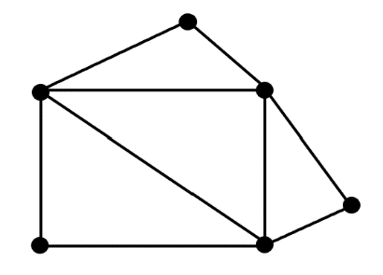
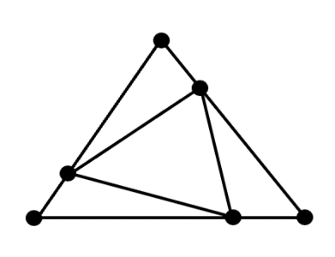
$$C:$$
$$A:$$
$$B:$$

Q4. a) Prove that the sum of the degrees of the vertices of any finite graph is even.
(Hint: Start with a graph containing $n$ vertices and no edges. What happens each time you add an edge to the graph?)
b) Does this still hold if you allow graphs to have loops?

Definition 5: A walk is a route through a graph along edges, from one vertex to the next.
Definition 6: A path is a walk where no vertex is visited more than once.
Definition 7: A trail is a walk in which no edge is visited more than once.
We can use the notation $P_{n}$ to represent the path with $n$ vertices.
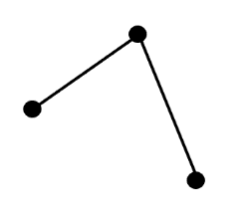
For example:

$$P_{3}:$$
$$P_{5}:$$

$$G:$$
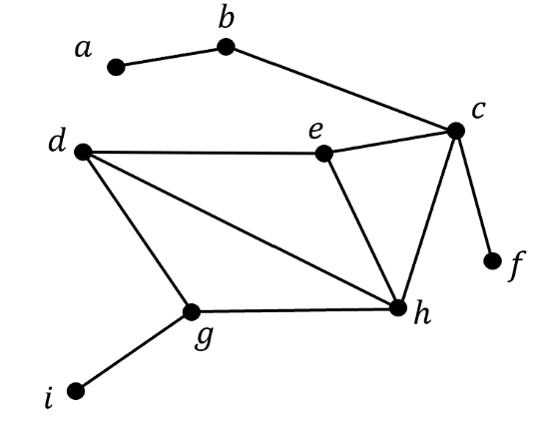
Q5. a) Draw the graph $P_{6}$.
b) How many edges does the graph $P_{n}$ have?
c) What is the longest path, $P_{n}$, you can find in the graph $G$? List the vertices in the order you visit them.
d) What is the longest trail you can find in the graph $G$? List the vertices in the order you visit them.

Definition 8: A cycle is a walk in which the end vertex is the same as the start vertex, but no other vertex is repeated more than once.
We can use the notation $C_{n}$ to represent the cycle with $n$ vertices, for $n≥3.$Why do we only define $C_{n}$ for $n≥3?$
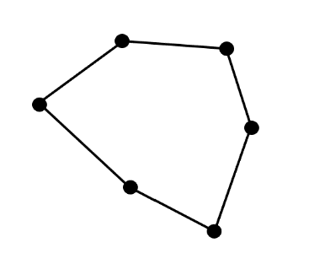
For example:
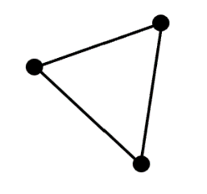
$$C_{6}:$$
$$C_{3}:$$

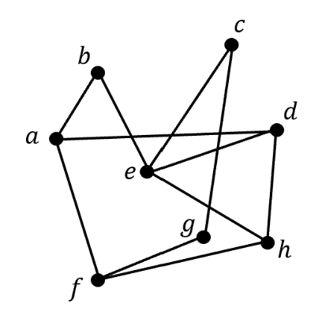
Q6. a) Draw the graph $C_{4}$.
$$G:$$
b) How many edges does the graph $C_{n}$ have?
c) How many non-isomorphic cycles are subgraphs of the graph $G$ below?
List the vertices in the order you visit them for each possible cycle.

Definition 9: A Hamiltonian cycle is a cycle that include every vertex in a graph.
Definition 10: Two vertices are connected if a path lies between them. A graph is connected if all its vertices are connected.

Example: In the graph $G$below, an example of:
It is ok to include a vertex or an edge more than once on a walk.
- a walk is $rsuwvu$
- a path is $rsuvw$
- a trail is $rusvuw$
It in not necessary to include every vertex in a cycle.
- a cycle is $rsur$
- a Hamiltonian cycle is $rsuvwtr$
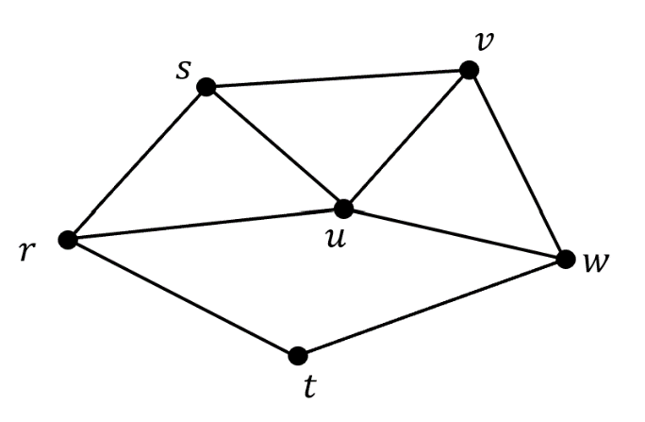
$$G:$$

Q7. a) Draw a disconnected graph with 7 vertices.
- Draw a graph with the minimum number of edges that contains both $C_{4}$ and $P_{7}$ as subgraphs.
- Draw a connected graph which doesn’t contain a cycle.
- Is it possible for a graph to contain a Hamiltonian cycle and a vertex of degree 1?
- Is it ever possible to find a walk through a graph that is also a path, a trail, and a cycle?

Definition 11: A complete graph is a graph in which every vertex is directly connected to every other vertex with a single edge.
We can use the notation $K_{n}$ to represent the completed graph with $n$ vertices.
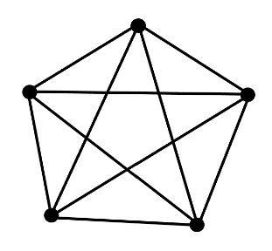
Below are the graphs of $K_{4}$ and $K_{5}$.
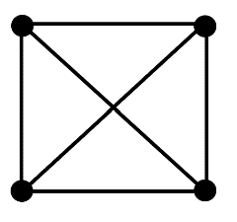
$$K_{5}:$$
$$K_{4}:$$

Q8. a) Draw the graphs $K_{1}, K_{2}, K_{3}$ and $K_{6}$.
- How many edges does the graph of $K_{n}$ have?
- Draw all the possible subgraphs of $K_{4}$, ignoring isomorphisms.
Definition 12: A planar graph is a graph that can be drawn in a plane without any edges meeting except at a vertex.
$K_{4}$ is a planar graph as shown by the two isomorphism below.
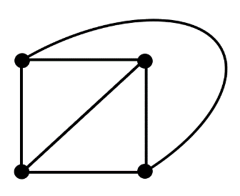
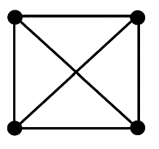
We can redraw $K_{4}$ where no edges cross over each other

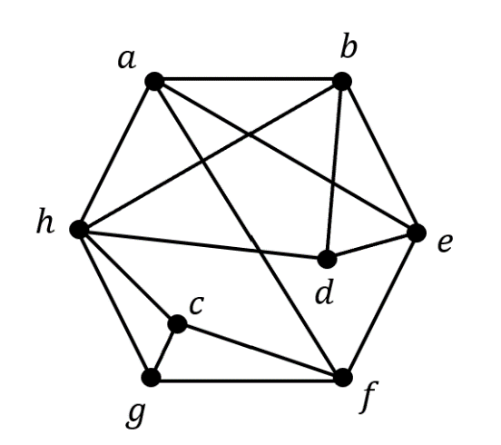
Q9. a) Draw an isomorphism of the graph $G$ below to show that it is planar.
$$G:$$

$K_{5}$ isn’t planar.
- Hence prove that $K_{n}$ also isn’t planar for $n≥6$.

The pigeonhole principle states that if you have $n+1$ pigeons and only $n$ pigeonholes then there must be at least one pigeonhole containing two or more pigeons.
More generally we can say if you have $a$ objects and $b$ containers, with $a>b$, then at least one container must contain more than one item.
This seems pretty obvious, but it’s extremely useful in a lot of different mathematical proofs.

Q10. By considering a graph with $n$vertices, make use of the pigeonhole principle to answer the following questions:
- Show that every connected graph has two vertices of the same degree.

- Show that this also holds for graphs which aren’t connected.

Definition 13: A tree is a connected graph which contains no cycles.
For example, the graph $G_{1}$ is a tree but the graph $G_{2}$ isn’t as it contains a $C_{4}$.
$$G_{2}:$$
$$G_{1}:$$
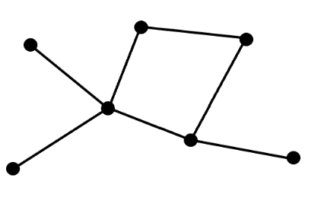
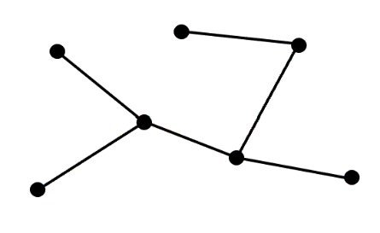

Definition 14: A spanning tree of a graph $G$, is a subgraph which contains all the vertices in $G$ and is also a tree.
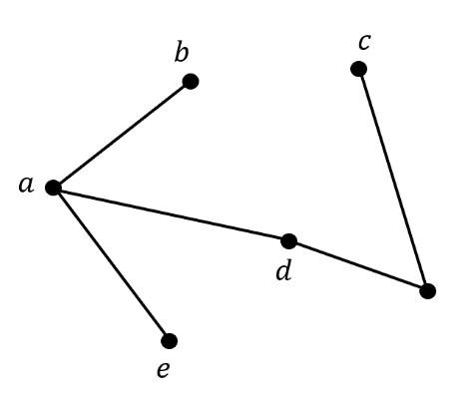
For example, in the graph $G$ below a possible spanning tree $T$ is:
$$T:$$
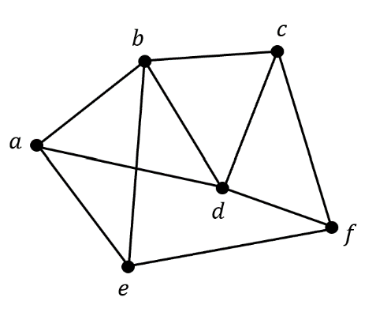
$$G:$$

Q11. a) Find all possible trees containing 5 vertices, ignoring isomorphisms.
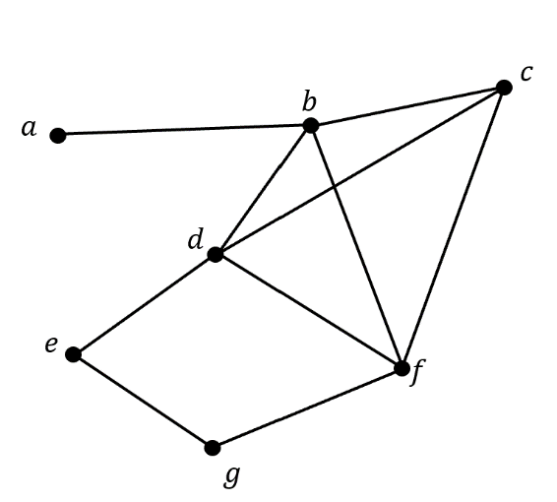
- For the graph $G$ below, show that there isn’t a unique spanning tree.
$$G:$$

- How many edges will any spanning tree of graph with $n$ vertices have?

Q12. a) For any tree, explain why connecting any two vertices with a single edge will always create a cycle.
- For any tree, explain why removing a single edge will always result in a disconnected graph.
- A graph $G$contains two vertices $a$ and $b$. Prove that if there are two different paths connecting vertices $a$ and $b$, then $G$can’t be a tree.

Q13. (Research Question)
Find the definitions for each of the following graphs theory terms and explain them using your own words.
Draw an example to illustrate each term.
- A leaf
- A forest
- A Eulerian circuit
- A bipartite graph

