**Year 12 combined science transition work: chemistry practice booklet**

This document has been designed for students who have studied combined science at GCSE. It reviews the content that is unique to the Chemistry GCSE to help you prepare for starting the A Level Chemistry course.

**To do:**

1. Read through each section and make your own study notes
2. Attempt the practice questions at the end of each section
3. When you have worked through all sections of this practice booklet, attempt the exam booklet under exam conditions

**Practice booklet contents:**

|  |  |  |
| --- | --- | --- |
| **Section** | **Page number** | **Topic** |
| One | 2 | Transition metals |
| Two | 3 | Nanoparticles |
| Three | 4 | Atom economy and yield |
| Four | 5 | Concentrations and volumes |
| Five | 6 | Titrations |
| Six | 7 | Cells and batteries |
| Seven | 8 | Organic functional groups |
| Eight | 10 | Polymerisation |
| Nine | 11 | Qualitative tests for ions |
| Ten | 12 | Materials |
| Eleven | 13 | Haber process and fertilisers |

**Student name: ___________________________________________________**

**Section one**

**AQA GCSE Chemistry topic:** C1

**Triple-only content:** transition metals

Transition metals are found in the central part of the periodic table (‘D block’). While they share many physical properties with other metals, typically they have:

* Higher melting points
* Higher densities
* Greater strength
* Greater hardness

Unlike Group 1 and Group 2 metals, transition metals react slowly (or not at all) with oxygen and water. However, many still react with halogens.

Transition metals may form ions of different charges. For example, iron commonly forms Fe2+ and Fe3+ ions. Due to this chemical property, they can often act as good catalysts (as they can both accept and donate electrons).

Transition metals often form colourful compounds and ions. For example, this video shows the colours of different vanadium ions: <https://www.youtube.com/watch?v=sFAGQLokym4>

**Practice questions:**

1. Compare the properties of potassium and copper.
2. Suggest whether manganese or magnesium oxide would be a better catalyst for the decomposition of hydrogen peroxide. Justify your answer.
3. Write a balanced symbol equation (include state symbols) for the reaction of iron and chlorine, forming iron (iii) chloride.

**Exam practice link:** Question one

**Section two**

**AQA GCSE Chemistry topic:** C2

**Triple-only content:** nanoparticles

Nanoparticles are structures made of only few hundred atoms, between 1 and 100 nm in size. They also have a much greater surface area to volume ratio than bulk materials.

For the difference in particle size and SA:V ratio, nanoparticulate materials have different properties to their bulk materials. For example, silver nanoparticles display antibacterial properties and have a number of medical uses.

Nanoparticles are often excellent catalysts due to their increased SA:V ratio, and may even different reactions to their bulk material.

Read about why some people are concerned about the use of nanoparticles here: <https://www.bbc.co.uk/bitesize/guides/z8m8pbk/revision/2#:~:text=Possible%20risks%20of,determine%20their%20risks>.

**Practice questions:**

1. A circular nanoparticle has a radius of 6 nm. Calculate its surface area to volume ratio using the equations SA = 4πr2 and V = 4/3 πr3 .
2. State a potential risk of using nanoparticles in aerosol sprays.

**Exam practice link:** Question two

**Section three**

**AQA GCSE Chemistry topic:** C3

**Triple-only content:** atom economy and yield

Atom economy is a measure of the amount of starting materials that end up as useful products in a chemical reaction.

To equation for atom economy is: $atom economy= \frac{Mr of desired product}{Total Mr of reactants} x 100$

Theoretical yield is the maximum possible mass of product that can be made in a reaction. You can calculate this if you know the mass of the limiting reactant, and the molar ratio between this reactant and the product from a balanced chemical equation.

However, the theoretical yield is impossible to obtain in practice. Alternative reactions may occur. The reaction may not go to completion. Some product may be lost during transfer or filtering.

The percentage yield shows what percentage of the theoretical yield was actually obtained in a reaction.

The equation for percentage yield is: $percentage yield= \frac{mass of product}{theoretical yield} x 100$

Read about how both atom economy and percentage yield are important factors to consider when designing a synthetic pathway here: <https://www.bbc.co.uk/bitesize/guides/z8wkh39/revision/3>

**Practice questions:**

1. Calculate the atom economy of the production of magnesium chloride from magnesium and hydrochloric acid.
2. 46 g of sodium was reacted with excess fluorine gas. 64 g of sodium fluoride was obtained from this reaction. Calculate the percentage yield.

**Exam practice link:** Question three

**Section four**

**AQA GCSE Chemistry topic:** C3

**Triple-only content:** concentration and volume

Concentration can be measured in both gdm-3 and moldm-3. You can convert between these quantities using these equations:

$$moles= \frac{mass}{Mr}$$

$$moles=concentration x volume$$

Avogadro’s law states that equal volumes of different gases contain the same number of molecules at the same temperature and pressure. You can use this information along with the molar ratios from balanced chemical equations to calculate the volume of gas involved in a reaction.

The molar volume is the volume of one mole of any gas at room temperature and pressure (RTP): 24 dm3 (24,000 cm3). If you know the moles of gas present, multiplying this by the molar volume will give the volume occupied by this gas.

**Practice questions:**

1. 5 g of calcium sulfate was dissolved completely in 200 cm3 of water. Calculate the concentration of the solution in moldm3.
2. 20 cm3 of 0.1 moldm-3 sulfuric acid reacted completely with 30 cm3 of sodium hydroxide solution: 2NaOH(aq) + H2SO4(aq) 🡪 Na2SO4(aq) + 2H2O(l)  
   Calculate the concentration of the sodium hydroxide solution.
3. 250 cm3 of hydrogen gas reacted completely with fluorine gas. What volume of hydrogen fluoride gas was produced?
4. What is the volume occupied by 0.2 mol of neon at RTP?
5. What mass of carbon dioxide occupies 22 dm3 at RTP?

**Exam practice link:** Question four

**Section five**

**AQA GCSE Chemistry topic:** C4

**Triple-only content:** titrations

A titration is a reaction between a known ratio of two solutions. This allows the concentration of one of the solutions to be determined, if the concentration of the other solution and the volumes of both solutions are known.

Read about how to conduct a titration experiment here: <https://www.bbc.co.uk/bitesize/guides/zx98pbk/revision/1#:~:text=Carrying%20out%20a%20titration%20to%20find%20out%20volumes%20of%20acid%20and%20alkali%20solutions%20that%20react>

**Practice questions:**

1. Which piece of equipment should be used to accurately measure a fixed volume of solution?
2. Which piece of equipment should be used to accurately measure variable volumes of solution?
3. Why would universal indicator be unsuitable to use for a titration?
4. What is meant by the phrase ‘concordant titre’?
5. Describe how the mean titre should be calculated.
6. 0.5 moldm-3 hydrochloric acid was reacted with 20 cm3 of nitric acid in a titration. Three titres of hydrochloric acid were obtained: 24.80 cm3, 24.85 cm3, and 24.60 cm3.
   1. Calculate the mean titre of hydrochloric acid.
   2. Write a balanced symbol equation for the reaction.
   3. Use your answers to 6a) and 6b) to calculate the concentration of the nitric acid.

**Exam practice link:** Question five

**Section six**

**AQA GCSE Chemistry topic:** C5

**Triple-only content:** cells and batteries

A simple cell can be made by connecting two different metals with an electrolyte. A voltage will be produced until one reactant is used up. The greater the difference in reactivity between the two metals, the greater the voltage produced.

Fuel cells produce a voltage continuously, as long as they are supplied with fuel and oxygen. In contrast to combustion, in fuel cells the fuel is oxidised electrochemically (not burned), and electrical energy is released (not thermal energy).

In hydrogen fuel cells, liquid water is the only product.

At the cathode, the following reaction occurs: 2H2 + 4HO­- 🡪 4H2O + 4e-

At the anode, the following reaction occurs: O2 + 2H2O + 4e­-­ 🡪 4HO-

Read more about how hydrogen fuel cells work here: <https://www.savemyexams.co.uk/gcse/chemistry/aqa/18/revision-notes/5-energy-changes/5-2-chemical-cells--fuel-cells/5-2-2-fuel-cells/>

**Practice questions:**

1. Suggest which combination of the following metals would produce the highest cell voltage: magnesium, iron, potassium, copper, zinc
2. Which species is reduced or oxidised at each electrode in hydrogen fuel cells?
3. Suggest a suitable material for the electrodes in a hydrogen fuel cell.
4. Write the overall equation for the reaction that occurs in hydrogen fuel cells.

**Exam practice link:** Question five

**Section seven**

**AQA GCSE Chemistry topic:** C7

**Triple-only content:** organic functional groups

Functional groups are groups of atoms that determine the main chemical properties of a compound.

The functional group of alkenes is the c=c double bond.

Alkenes typically undergo incomplete combustion in oxygen.

They undergo addition reactions with diatomic halogen molecules to form halogenoalkanes.

An example of this type of reaction is shown here:

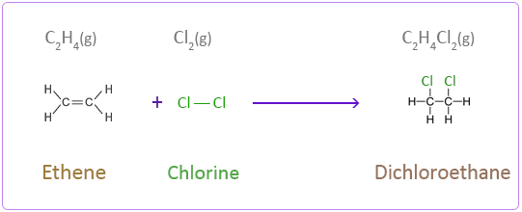

This reaction shown with aqueous bromine can be used to test for the presence of alkenes. Bromine water remains orange-brown when mixed with alkanes, but becomes colourless when mixed with alkenes as the above reaction occurs.

Alkenes undergo addition reactions with diatomic hydrogen (called hydrogenation) to form alkanes. This reaction requires a catalyst.

Alkenes undergo addition reactions with steam (called hydration) to form alcohols. This reaction requires a high temperature (~300°C) and a catalyst.

An example of a hydration reaction is shown here:

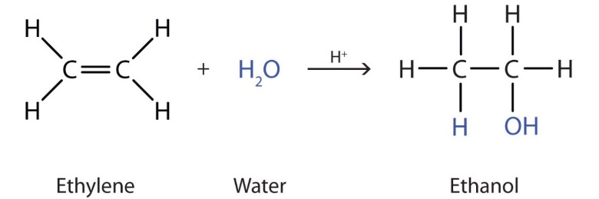

Alcohols are compounds with the functional group –OH (hydroxyl).

Alcohols are named in a similar way to alkanes and alkenes, depending on the number of carbons in their main chain. All alcohols have names ending in ‘ol’. For example, an alcohol with three carbons would be called propanol, and an alcohol with four carbons would be called butanol.

All alcohols undergo complete combustion. Many alcohols also undergo reactions with sodium. Read more about the details of this reaction and its uses here: <https://www.chemguide.co.uk/organicprops/alcohols/sodium.html>

Carboxylic acids contain the carboxyl functional group –COOH:

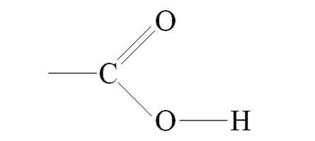

These display the typical properties of weak acids (eg reactions with metals and bases).

Carboxylic acids are named based on the number of carbons in their main chain, and their names end in ‘anoic acid’. For example, ethanoic acid contains two carbons.

Carboxylic acids and alcohols can react together to for esters. This reaction, called esterification, requires a catalyst and also produces water.

Esters contain the functional group -COO- :

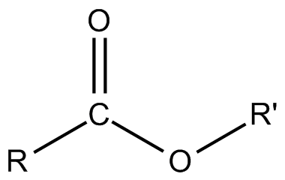

An example of an esterification reaction is shown here:

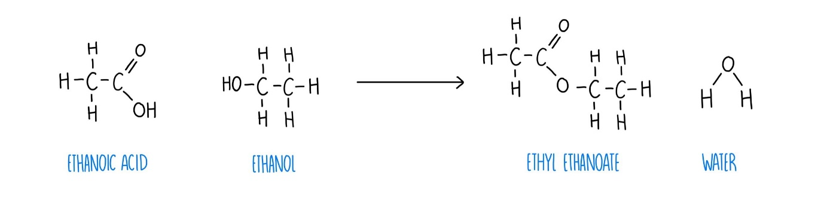

**Practice questions:**

1. Draw the displayed formulae of ethene and butane.
2. Ethene reacts with fluorine gas. Draw the displayed formula of the product.
3. Name the alkane that would be formed from the hydrogenation of propene.
4. Draw the displayed formula of the alcohol that would be formed from the hydration of butene.
5. Write a balanced symbol equation for the complete combustion of butanol.
6. Draw the structural formula of propanoic acid.
7. Draw the products of the esterification reaction between ethanol and butanoic acid.

**Exam practice link:** Question six

**Section eight**

**AQA GCSE Chemistry topic:** C7

**Triple-only content:** polymers

Polymers are made of many small repeating units called monomers. For example, many ethene molecules (monomers) can form a long chain called poly(ethene), which is a polymer.

Read about how to draw the repeating units of addition polymers here (four examples): <http://www.passmyexams.co.uk/GCSE/chemistry/addition-polymerisation.html>

DNA, carbohydrates (eg starch), and proteins are all examples of polymers found in living organisms. The monomers of proteins are amino acids. Amino acids contain the functional groups –NH2 (amino group) and –COOH (carboxyl group).

The general structure of an amino acid is shown below:

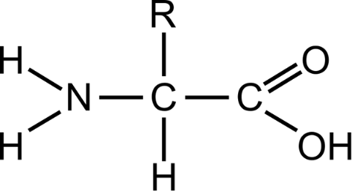

In this structure, R is not the symbol of an element! It means that this part of the molecule, called a side chain, can vary in structure. In some amino acids, the R group is small (eg in glycine it is a hydrogen atom). In others it is much larger (eg in tryptophan it is C9H8N).

Amino acids can undergo condensation polymerisation. Read about how this reaction works here: <https://www.bbc.co.uk/bitesize/guides/z3v4xfr/revision/8>

You may notice that the peptide bond formed between amino acids looks similar to an ester link. In fact, alcohols and carboxylic acids can form condensation polymers too!

**Practice questions:**

1. Draw the repeating unit of poly(ethene)
2. Draw the repeating unit of poly(difluroethene): CH2F2
3. Draw the general structure of an amino acid, and label the amino and carboxyl fundtional groups.
4. Draw the repeating unit of poly(glycine)

**Exam practice link:** Question seven

**Section nine**

**AQA GCSE Chemistry topic:** C8

**Triple-only content:** qualitative tests for ions

Some metal ions can be identified by the colour of the flame when they are burned. Read about the flame test colours for some common metal ions here: <https://www.bbc.co.uk/bitesize/guides/zxtvw6f/revision/1#:~:text=The%20table%20shows,Green>

Metal ions that form insoluble hydroxides can be tested for by reaction with dilute sodium hydroxide solution. Read about the precipitate colours for some common metals here, and how to distinguish between metals that produce white precipitates, here: <https://www.bbc.co.uk/bitesize/guides/zxtvw6f/revision/2#:~:text=The%20table%20shows%20the,calcium%20and%20magnesium%20ions>.

A test for carbonate ions is reaction with dilute acid. Carbon dioxide bubbles are given off. The identity of this gas can be confirmed with limewater.

A test for sulfate ions is reaction with aqueous barium chloride. The positive result of this test is the formation of white barium sulfate precipitate. The solution should first be acidified with dilute acid, to remove any carbonate ions that would give a false positive result. This acid should not be sulfuric acid, as this would also give a false positive result!

The test for halide ions is reaction with aqueous silver nitrate. Chloride ions form a white precipitate, bromide ions form a cream precipitate, and iodide anions form a yellow precipitate. The solution should first be acidified with dilute nitric acid to remove any carbonate or hydroxide ions that would also form insoluble silver salts and obscure the results. As with the sulfate test, hydrochloric acid should not be used for this purpose, as it would give a false positive result.

Instrumental methods have a number of benefits over traditional qualitative tests. Read about these here: <https://www.bbc.co.uk/bitesize/guides/zxtvw6f/revision/5>

**Practice questions:**

1. A salt solution burns with a green flame. Predict the colour of its hydroxide precipitate.
2. A salt solution forms a green precipitate upon reaction with sodium hydroxide, and a cream precipitate upon reaction with silver nitrate. What is its molecular formula?

**Exam practice link:** Question eight

**Section ten**

**AQA GCSE Chemistry topic:** C10

**Triple-only content:** materials

Alloys are mixtures containing at least one metal element. Read about the uses of a number of alloys here: <https://www.bbc.co.uk/bitesize/guides/ztrwng8/revision/3>

Composite materials are combinations of materials with different properties. Most composites contain a substance that forms the bulk of the material, called the reinforcement, and a substance that binds it together, called the matrix. For example fibreglass is a composite material made of glass fibre reinforcement and a polymer resin matrix. Most composites have improved strength.

Ceramics are materials that are neither metallic nor organic. Both clay and glass ceramics have a range of uses – read about these here: <https://www.bbc.co.uk/bitesize/guides/ztrwng8/revision/4>

**Practice questions:**

1. Explain why gold alloys are often used instead of pure gold in jewellery.
2. Explain why the properties of high carbon steel make it suitable for use as a building material.
3. Compare the properties of soda-lime and borosilicate glass.

**Exam practice link:** Question nine

**Section eleven**

**AQA GCSE Chemistry topic:** C10

**Triple-only content:** the Haber process and fertilisers

Ammonia can be manufactured in a reversible reaction between hydrogen and nitrogen called the Haber process. This requires an iron catalyst, and is typically performed at 200 atmospheres of pressure and between 350-450°C. The reaction mixture can be periodically cooled to remove ammonia, and the unreacted gases can be recycled for future reactions.

Ammonia can be used in the synthesis of ammonium and nitrate salts, which are a vital component of fertilisers as they provide a soluble source of nitrogen for plants. Phosphate and potassium ions are also vital components of most fertilisers, providing soluble sources of phosphorous and potassium respectively. Fertilisers containing all of these three elements are known as NPK fertilisers.

A key component of many NPK fertilisers is the salt ammonium sulfate. This can be produced by reacting aqueous ammonia and sulfuric acid. Sulfuric acid can be produced by reacting sulfur with oxygen in multiple stages, then reacting sulfur trioxide with water.

**Practice questions:**

1. Write a balanced symbol equation for the Haber process.
2. Explain, with reference to Le Chatelier’s principle, why the reaction conditions of the Haber process are a compromise between rate and yield.
3. Write a balanced symbol equation for the production of ammonium sulfate.

**Exam practice link:** Question ten