  Combined science biology transition
  work: exam booklet
  Name: | ________________________
  Class: | ________________________
  Date: | ________________________



Time: | 120 minutes
Marks: | 99 marks

Q1.
A student investigated the effectiveness of three different antibiotics.
Figure 1 shows how the student set up an agar plate.
Figure 1
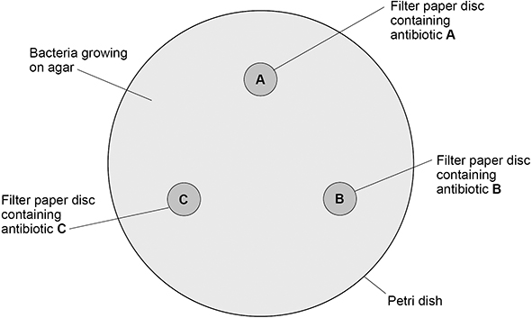
The student used aseptic techniques to make sure that only one type of bacterium was growing on the agar.
(a) Describe two aseptic techniques the student should have used.
1 ________________________________________________________________
___________________________________________________________________
___________________________________________________________________
2 ________________________________________________________________
___________________________________________________________________
___________________________________________________________________
(2)

The student placed the agar plate in an incubator at 25 °C for 48 hours.
The image on the next page shows the agar plate after 48 hours.

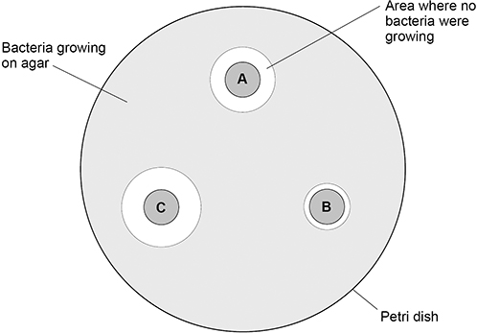

(b) Which antibiotic is the least effective?
Give a reason for your answer.
Least effective antibiotic _______________
Reason ____________________________________________________________
___________________________________________________________________
___________________________________________________________________
(1)
(c) Calculate the area where no bacteria were growing for antibiotic C.
Use π = 3.14
Give the unit.
___________________________________________________________________
___________________________________________________________________
___________________________________________________________________
___________________________________________________________________
___________________________________________________________________
Area = ____________________ Unit __________
(5)
(d) Suggest one way the student could improve the investigation.
___________________________________________________________________
___________________________________________________________________
(1)
(Total 9 marks)
Q2.
A virus called RSV causes severe respiratory disease.
(a) Suggest two precautions that a person with RSV could take to reduce the spread of the virus to other people.
1. _________________________________________________________________
___________________________________________________________________
2. _________________________________________________________________
___________________________________________________________________
(2)
(b) One treatment for RSV uses monoclonal antibodies which can be injected into the patient.
Scientists can produce monoclonal antibodies using mice.
The first step is to inject the virus into a mouse.
Describe the remaining steps in the procedure to produce monoclonal antibodies.
___________________________________________________________________
___________________________________________________________________
___________________________________________________________________
___________________________________________________________________
___________________________________________________________________
___________________________________________________________________
___________________________________________________________________
___________________________________________________________________
(3)
(c) Describe how injecting a monoclonal antibody for RSV helps to treat a patient suffering with the disease.
___________________________________________________________________
___________________________________________________________________
___________________________________________________________________
___________________________________________________________________
(2)

A trial was carried out to assess the effectiveness of using monoclonal antibodies to treat patients with RSV.
Some patients were given a placebo.
(d) Why were some patients given a placebo?
___________________________________________________________________
___________________________________________________________________
(1)
A number of patients had to be admitted to hospital as they became so ill with RSV.
The results are shown in the table below.

Treatment received by patient | % of patients within each group admitted to hospital with RSV
Group A: Monoclonal antibody for RSV | 4.8
Group B: Placebo | 10.4
The trial involved 1 500 patients.
• Half of the patients (group A) were given the monoclonal antibodies.
• Half of the patients (group B) were given the placebo.
(e) Calculate the total number of patients admitted to hospital with RSV during the trial.
___________________________________________________________________
___________________________________________________________________
___________________________________________________________________
___________________________________________________________________
Total number of patients admitted to hospital = ____________________
(2)
(f) Evaluate how well the data in the table above supports the conclusion:
‘monoclonal antibodies are more effective at treating RSV than a placebo’.
___________________________________________________________________
___________________________________________________________________
___________________________________________________________________
___________________________________________________________________
(2)
(Total 12 marks)

Q3.
Many plants have evolved defence mechanisms.
The image below shows part of a gorse plant and part of a deadly nightshade plant.
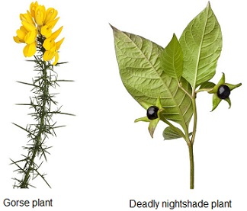
(a) The gorse plant has evolved to have sharp thorns.
What type of defence response are thorns?
___________________________________________________________________
(1)
(b) How do thorns defend the gorse plant?
___________________________________________________________________
(1)
(c) The deadly nightshade plant has poisonous berries.
What type of defence response are poisonous berries?
___________________________________________________________________
(1)

(d) A scientist noticed that in one area the gorse plants had yellow leaves and stunted growth.
One reason for yellow leaves and stunted growth is a deficiency of nitrate ions in the soil.
Explain two other possible reasons for the yellow leaves and stunted growth.
Do not refer to nitrate ions in your answer.
Reason 1
___________________________________________________________________
___________________________________________________________________
Explanation
___________________________________________________________________
___________________________________________________________________
___________________________________________________________________
___________________________________________________________________
Reason 2
___________________________________________________________________
___________________________________________________________________
Explanation
___________________________________________________________________
___________________________________________________________________
___________________________________________________________________
___________________________________________________________________
(5)

(Total 8 marks)

Q4.
The diagram below shows the brain.
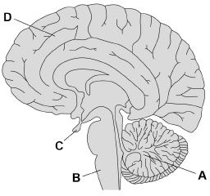
(a) Which part of the brain becomes more active if a person balances on one leg instead of standing on two legs?
Tick (✓) one box.

A |  |  | B |  |  | C |  |  | D
(1)
(b) Name the part of the brain that is responsible for making a decision.
___________________________________________________________________
(1)
(c) In most MRI scanners the person being scanned needs to stay completely still.
A functional MRI (fMRI) scanner allows a person to move while the scanner makes images of the person’s brain activity.
Suggest how the fMRI scanner could help to find out more about the brain damage a person has.
___________________________________________________________________
___________________________________________________________________
__________________________________________________________________
___________________________________________________________________
__________________________________________________________________
___________________________________________________________________
(3)

(d) Describe how the brain receives information about light entering the eye.
You should include the names of structures in your answer.
___________________________________________________________________
___________________________________________________________________
___________________________________________________________________
___________________________________________________________________
___________________________________________________________________
___________________________________________________________________
(3)
(e) The eyes of some birds contain cells that detect ultraviolet (UV) light.
UV light is reflected by some fruits and the urine of small mammals.
Explain how birds that detect UV light have evolved from birds that could not detect UV light.
___________________________________________________________________
___________________________________________________________________
___________________________________________________________________
___________________________________________________________________
___________________________________________________________________
___________________________________________________________________
___________________________________________________________________
___________________________________________________________________
___________________________________________________________________
___________________________________________________________________
___________________________________________________________________
___________________________________________________________________
(6)
(Total 14 marks)

Q5.
Humans keep their internal conditions almost constant.
Body temperature is kept within a narrow range.
When the core body temperature is too low, this is detected by the thermoregulatory centre in the brain.
Describe how the body responds when a decrease in core body temperature is detected.
_______________________________________________________________________
_______________________________________________________________________
_______________________________________________________________________
_______________________________________________________________________
_______________________________________________________________________
_______________________________________________________________________
_______________________________________________________________________
_______________________________________________________________________
_______________________________________________________________________
_______________________________________________________________________
_______________________________________________________________________
_______________________________________________________________________
(Total 6 marks)
Q6.
Water conservation is important to the human body.
(a) Which gland releases the hormone that controls water loss from the body?
Tick (✓) one box.

Adrenal | 
Pancreas
Pituitary
Thyroid
(1)
(b) Which hormone helps the kidneys to control water loss from the body?
___________________________________________________________________
(1)
(c) A man is walking across a desert.
The man has used up his supply of drinking water.
Explain how the gland you named in part (a) and the kidneys reduce water loss.
___________________________________________________________________
___________________________________________________________________
___________________________________________________________________
___________________________________________________________________
___________________________________________________________________
___________________________________________________________________
___________________________________________________________________
___________________________________________________________________
___________________________________________________________________
___________________________________________________________________
(3)
(d) Some people have kidney failure.
Doctors may treat patients with kidney failure by either dialysis or a kidney transplant.
Explain two biological reasons why most doctors think that a kidney transplant is a better method of treatment than dialysis.
Reason 1 __________________________________________________________
___________________________________________________________________
___________________________________________________________________
Reason 2 __________________________________________________________
___________________________________________________________________
___________________________________________________________________
___________________________________________________________________
(4)
(Total 9 marks)

Q7.
Plant hormones are used in horticulture.
(a) Name one plant hormone.
___________________________________________________________________
(1)
(b) The diagram shows how new plants are produced using tissue culture.
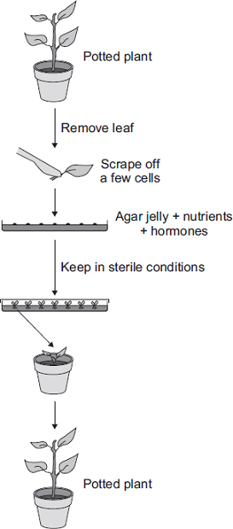
Tissue culture is a type of asexual reproduction.
Give the main features of asexual reproduction .
______________________________________________________________
______________________________________________________________
______________________________________________________________
______________________________________________________________
______________________________________________________________
______________________________________________________________
(3)
(Total 4 marks)
Q8.
DNA is a polymer of nucleotides.
(a) Why is DNA described as a polymer?
___________________________________________________________________
___________________________________________________________________
(1)
The diagram below shows part of a DNA molecule.
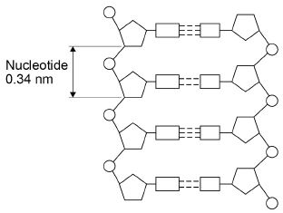
(b) Describe the structure of a nucleotide.
___________________________________________________________________
___________________________________________________________________
___________________________________________________________________
___________________________________________________________________
___________________________________________________________________
___________________________________________________________________
___________________________________________________________________
___________________________________________________________________
___________________________________________________________________
___________________________________________________________________
(4)

(c) The length of a DNA double helix increases by 0.34 nm for every pair of nucleotides.
The total number of nucleotides in a human body cell is 1.2 × 10¹⁰.
Calculate the total length of double helix in a human body cell.
Give your answer in metres. Use information from the diagram.
___________________________________________________________________
___________________________________________________________________
___________________________________________________________________
___________________________________________________________________
___________________________________________________________________
___________________________________________________________________
___________________________________________________________________
___________________________________________________________________
___________________________________________________________________
___________________________________________________________________
Total length = ______________________ m
(5)
(d) Some parts of DNA do not code for proteins.
Describe how non-coding parts of DNA can affect the expression of genes.
___________________________________________________________________
___________________________________________________________________
(1)
(Total 11 marks)

Q9.
Darwin’s theory of evolution states that all species of living things have evolved from simple life forms.
Darwin’s theory was published in 1859.
(a) Give two reasons why Darwin’s theory was only slowly accepted.
___________________________________________________________________
___________________________________________________________________
___________________________________________________________________
___________________________________________________________________
(2)
(b) Darwin observed birds called finches on the Galapagos Islands, 1000 km from the coast of South America.
He saw that the birds were similar to, but not the same as, birds he had seen on the mainland of South America.
Recent evidence suggests that 13 different species of finch on the islands evolved from 1 species of finch that arrived from the mainland about 1 million years ago.
Describe how a new finch species may have evolved from the original species of finch that arrived from the mainland.
___________________________________________________________________
___________________________________________________________________
___________________________________________________________________
___________________________________________________________________
___________________________________________________________________
___________________________________________________________________
___________________________________________________________________
___________________________________________________________________
___________________________________________________________________
___________________________________________________________________
___________________________________________________________________
(4)

(c) The diagram below shows the evolutionary tree for some Galapagos finches.
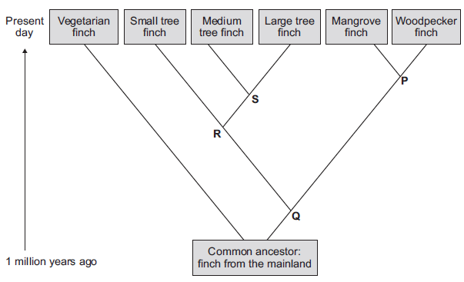
(i) Which type of present-day finch is least closely related to all the others?
______________________________________________________________
(1)
(ii) Which branching point, P, Q, R or S, on the diagram above shows the most recent common ancestor of all the tree finches?
Write the correct answer in the box. 
(1)
(iii) Which two finches have the most recent common ancestor?
1. ____________________________________________________________
2. ____________________________________________________________
(1)
(Total 9 marks)

Q10.
A food web contains several food chains. Figure 1 shows a food web.
Figure 1
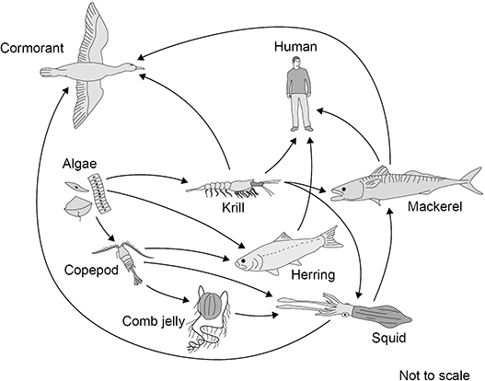
(a) The animals in Figure 1 get their energy by eating other organisms.
Describe how the algae get energy.
___________________________________________________________________
___________________________________________________________________
___________________________________________________________________
___________________________________________________________________
(2)
(b) Name one primary consumer in Figure 1.
___________________________________________________________________
(1)
(c) Name one producer in Figure 1.
___________________________________________________________________
(1)
(d) The different food chains in Figure 1 have different numbers of organisms.
Complete Figure 2 to show a food chain in Figure 1 with five organisms, including the human.
Figure 2
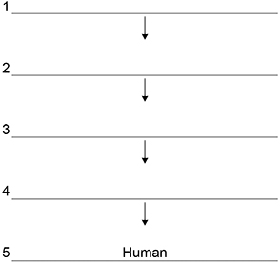
(1)
(e) Figure 1 shows that mackerel eat krill and squid.
The biomass of mackerel is much less than the combined biomass of krill and squid.
One reason for this is that the mackerel cannot digest all parts of the krill and squid.
Give two other reasons.
1 ________________________________________________________________
___________________________________________________________________
2 ________________________________________________________________
___________________________________________________________________
(2)

Figure 3 shows how the biomass of adult herring in the North Sea has changed between 1950 and 2010.
Figure 3
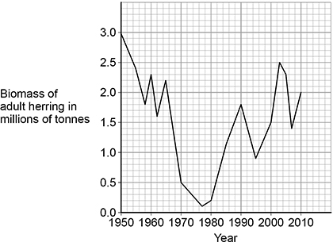
(f) Calculate the percentage decrease in the biomass of herring between 1960 and 1977.
Give your answer to the nearest whole number.
___________________________________________________________________
___________________________________________________________________
___________________________________________________________________
___________________________________________________________________
___________________________________________________________________
___________________________________________________________________
___________________________________________________________________
___________________________________________________________________
Percentage decrease = _______________ %
(4)

(g) Too many herring were caught by fishermen between 1960 and 1977.
Herring can live for up to 12 years and begin to reproduce when 3 to 4 years old.
Laws have been introduced to help conserve herring:
• 1977 to 1981 – herring fishing was banned in the North Sea
• 1984 to present day – control of mesh size of fishing nets
• 1997 to present day – fishing quotas were introduced
• 1998 to present day – herring fishing was banned in breeding grounds during the breeding season.
Figure 4 shows how a minimum mesh size helps to conserve herring.
Figure 4
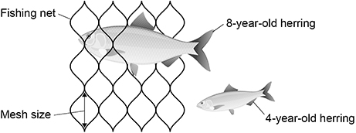
Figure 3 is repeated below.
Figure 3

Evaluate the effect of these laws on the conservation of herring stocks.
Use data from Figure 3 and information from Figure 4 in your answer.
___________________________________________________________________
___________________________________________________________________
___________________________________________________________________
___________________________________________________________________
___________________________________________________________________
___________________________________________________________________
___________________________________________________________________
___________________________________________________________________
___________________________________________________________________
___________________________________________________________________
___________________________________________________________________
___________________________________________________________________
(6)
(Total 17 marks)

