Athena Sixth Form College Criminology Transition Pack
QUALIFICATION | Applied Certificate/Diploma in Criminology
Teacher Name(s) | Mr Dobson
Contact email(s) | c.dobson@downhammarketacademy.co.uk
Exam board and link | WJEC wjec.co.uk
Specification details | 601/6248/X Applied Diploma Level 3
Recommended online learning | https://revisesociology.com/tag/criminology/  https://criminology.uk.net/  https://www.wjec.co.uk/en/qualifications/criminology-level-3/#tab_overview
Textbooks that are used  We currently use these in year 12.  They can be purchased from Amazon. We have some copies in the Library. | 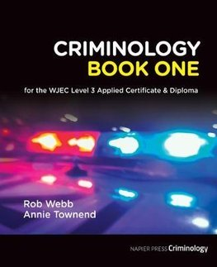  by Rob Webb  published by Napier Press  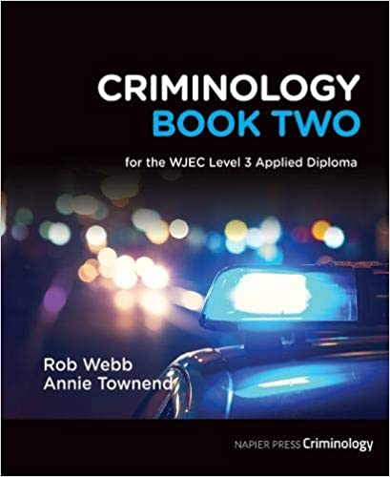  by Rob Webb  published by Napier Press  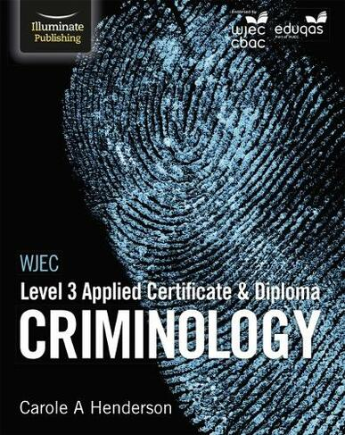  by Carole Henderson  Published by Illuminate  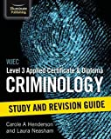  by Carole Henderson  Published by Illuminate

Welcome to WJEC Applied Criminology Level 3 Diploma

You have chosen a subject that combines elements of psychology, law and sociology and that complements studies in humanities. Each unit has an applied purpose which demands that learning is related to authentic case studies – this is the interesting bit! It will certainly ‘keep you on your toes’ and make you think in ways you couldn’t imagine. You will certainly have a very different outlook on society by the end of your course.

Overview of the course:

This is a two-year course. Units 1 and 2 completed in the first year comprise an 8-hour Controlled Assessment plus a formal examination. This is replicated in Year 2 with Units 3 and 4. You must complete and pass ALL units to gain the Diploma. The overall grades will be recorded on a scale A*-E.

Unit 1: Changing Awareness of Crime (Controlled Assessment)
Unit 2: Criminological Theories (Exam)
Unit 3: Crime Scene to Courtroom (Controlled Assessment)
Unit 4: Crime and Punishment (Exam)

Look at the specification for more detail about these topics. You can find this at: WJEC ENTRY LEVEL FRAMEWORK SPECIFICATION

Reading List - Criminology
- 1984 – George Orwell
- Folk Devils and Moral Panics – Stanley Cohen
- A Glasgow Gang Observed – Patrick James
- Gang Leader For A Day – Sudhir Venkatesh
- Fake Law – The Secret Barrister
- Traces: Memoir of a Forensic Scientist and Criminal Investigator – Patricia Wiltshire
- My Life With Murderers – David Wilson
- A wide range of newspapers including The Guardian and Independent
- To catch a killer Emma kavanagh
- Helter Skelter – Vincent Bugliosi
- The couple next door –Hari Lapena
- The Stranger beside me – Anne Rule
- The Red Parts – Maggie Nelson
- The Dark side of the mind – Kerry Danes
- In cold Blood -Truman Capote
- A bit of a stretch – Chris Atkins

Watching List - Criminology
- Black Mirror series (Netflix)
- Goodfellas
- The Godfather (part 2 is the best)
- Legend
- McMafia (previously BBC i-player)
- Freedom Writer’s Diary
- Dangerous Minds
- Chernobyl (drama)
- When They See Us (Netflix)
- Criminal Minds
- The Lincoln Lawyer
- True Story
- The Society (Netflix)
- Blood Diamond
- Orange is the New Black (Netflix)
- The Innocence Files (Netflix)
- Cold Case Files (Netflix)
- I Am A Killer (Netflix)
- Catching Killers - netflix
- When They See Us Now – Oprah Winfrey (Netflix)
- The Push – Derren Brown (Netflix)
- MacIntyre Undercover: The Chelsea Headhunters (Youtube)
- The Shawshank Redemption
- The Green Mile
Youtube documentaries to watch:
Louis Theroux – Prison docs
Colin Stagg
The Stanford Prison Experiment
Damilola Taylor
Sally Clark
Angela Cannings
Barry George
Amanda Knox
OJ Simpson
Stephen Lawrence
Alice Ruggles
Joanna Yeates
24 hours in Police Custody
BBC Real CSI

Task 1
Choose something from the Reading and Watching List or something else that’s related to crime that you are going to briefly report on in your first Criminology lesson.

Task 2 - Sneak peak into Unit 2
Nature vs Nurture
There are many ways of explaining why certain people do things in certain ways. For example, biologists think that people behave as they do because they are controlled by nature. This is known as Nature theory. Humans are compared to animals and seen to act on instinct.
Sociologists believe that people behave as they do because they are taught how to behave. For example, the sociologist Michael Haralambos states, ‘Human beings learn their behaviour and use their intelligence whereas animals simply act on instinct.’ This is known as Nurture theory. Nurture means the way you are brought up. It is also a reference to socialization, the lifelong process by which we learn our culture, values, norms and how to behave.

Task 3

Research 3 notorious serial murderers such as Fred West or Harold Shipman or Jeffrey Dahmer for example.
The focus should be on early life history and subsequent crimes. Give an overview of interesting facts and modus operandi.
Thinking about what you have read about Nature and Nurture, which criminological explanations could best account for their criminal behaviour?

Submit your work to cdobson@dma.tela.org.uk in preparation for September Criminology lessons to start.

