Athena Sixth Form College Criminology Transition Pack
QUALIFICATION | Applied Certificate/Diploma in Criminology
Teacher Name(s) | Mr Dobson
Contact email(s) | c.dobson@downhammarketacademy.co.uk
Exam board and link | WJEC wjec.co.uk
Specification details | 601/6248/X Applied Diploma Level 3
Recommended online learning | https://revisesociology.com/tag/criminology/  https://criminology.uk.net/  https://www.wjec.co.uk/en/qualifications/criminology-level-3/#tab_overview
Textbooks that are used  We currently use these in year 12.  They can be purchased from Amazon. We have some copies in the Library. | 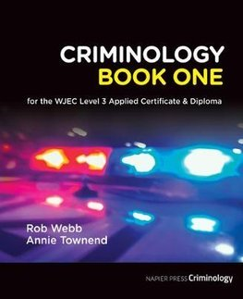  by Rob Webb  published by Napier Press  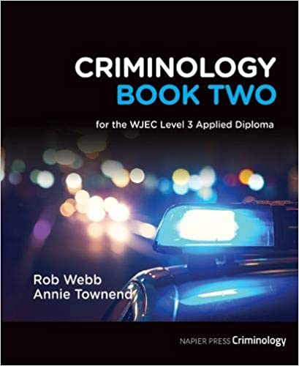  by Rob Webb  published by Napier Press  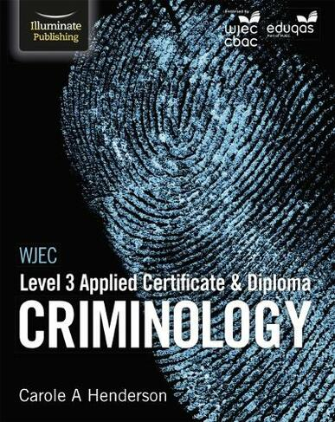  by Carole Henderson  Published by Illuminate  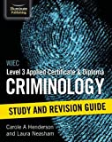  by Carole Henderson  Published by Illuminate

Welcome to Applied Criminology!

You have chosen a subject that combines elements of psychology, law and sociology and that complements studies in humanities. Each unit has an applied purpose which demands that learning is related to authentic case studies – this is the interesting bit! It will certainly ‘keep you on your toes’ and make you think in ways you couldn’t imagine. You will certainly have a very different outlook on society by the end of your course.

Overview of the course:

This is a two-year course. Units 1 and 2 completed in the first year comprise an 8-hour Controlled Assessment plus a formal examination. This is replicated in Year 2 with Units 3 and 4. You must complete and pass ALL units to gain the Diploma. The overall grades will be recorded on a scale A*-E.

Unit 1: Changing Awareness of Crime (Controlled Assessment)
Unit 2: Criminological Theories (Exam)
Unit 3: Crime Scene to Courtroom (Controlled Assessment)
Unit 4: Crime and Punishment (Exam)

Look at the specification for more detail about these topics. You can find this at: WJEC ENTRY LEVEL FRAMEWORK SPECIFICATION

You will be expected to know and understand the information covered, to be able to apply that knowledge and understanding and to be able to analyse and evaluate that knowledge and understanding.

Task 1

Read the specification carefully and make a note below of the sections there are to each Unit:

Changing Awareness of Crime…………………………………………………………..
.………………………………………………………………………………….………………
………………………………………………………………….............................................
Criminological Theories…………………………..………………………………………...
…………………………………………………………………………………………………..
…………………………………………………………………...……………………………..
Crime Scene to Courtroom………………………………………………………………..
…………………………………………………………………………………………………..
…………………………………………………………………………………………………..
Crime and Punishment in Society………………………………………………………..
………………………………………………………………………………………………….
…………………………………………………………………..………………………………

Expectations of the course:

- Lessons consist of taking notes, group discussions, watching relevant documentaries, group work and PowerPoint presentations. All of my resources are available on our Criminology TEAM following the lesson.
- Homework/NoN contact tasks consists of note making, wider reading, research, past exam questions, paired presentations and essay questions. It is expected that about 300 minutes a week will be spent on Criminology homework. Period 7’s are also available to support you.
- The Reading and Watching List on the following page will help you to gain wider knowledge and a broader framework in which to apply your knowledge. You will be expected to choose something to watch/read every half term and to feed back to the rest of the class. You may do this individually, in pairs or groups.
- Your progress will be reviewed on a regular basis. The review process will provide feedback at specific times throughout the year. You will also be expected to be within two grades of your target grade on each piece of work.
- You are expected to use the resources available to you in the library , your textbook and wider reading as well as the internet.
- Use teams to chat Criminology for questions and help from others and myself.
- Your folders of notes will be checked on a regular basis to see if you are organised and up to date with your work.
- USE YOUR STUDY TIME wisely and be proactive and always ask questions in class.

Reading List - Criminology
- 1984 – George Orwell
- Folk Devils and Moral Panics – Stanley Cohen
- A Glasgow Gang Observed – Patrick James
- Gang Leader For A Day – Sudhir Venkatesh
- Fake Law – The Secret Barrister
- Traces: Memoir of a Forensic Scientist and Criminal Investigator – Patricia Wiltshire
- My Life With Murderers – David Wilson
- A wide range of newspapers including The Guardian and Independent
- To catch a killer Emma kavanagh
- Helter Skelter – Vincent Bugliosi
- The couple next door –Hari Lapena
- The Stranger beside me – Anne Rule
- The Red Parts – Maggie Nelson
- The Dark side of the mind – Kerry Danes
- In cold Blood -Truman Capote
- A bit of a stretch – Chris Atkins

Watching List - Criminology
- Black Mirror series (Netflix)
- Goodfellas
- The Godfather (part 2 is the best)
- Legend
- McMafia (previously BBC i-player)
- Freedom Writer’s Diary
- Dangerous Minds
- Chernobyl (drama)
- When They See Us (Netflix)
- Criminal Minds
- The Lincoln Lawyer
- True Story
- The Society (Netflix)
- Blood Diamond
- Orange is the New Black (Netflix)
- The Innocence Files (Netflix)
- Cold Case Files (Netflix)
- I Am A Killer (Netflix)
- Catching Killers - netflix
- When They See Us Now – Oprah Winfrey (Netflix)
- The Push – Derren Brown (Netflix)
- MacIntyre Undercover: The Chelsea Headhunters (Youtube)
- The Shawshank Redemption
- The Green Mile
Youtube documentaries to watch:
Louis Theroux – Prison docs
Colin Stagg
The Stanford Prison Experiment
Damilola Taylor
Sally Clark
Angela Cannings
Barry George
Amanda Knox
OJ Simpson
Stephen Lawrence
Alice Ruggles
Joanna Yeates
24 hours in Police Custody
BBC Real CSI

Task 2
Choose something from the Reading and Watching List that you are going to briefly report on in your first Criminology lesson.
Task 3
Watch the following clip and jot down 5 things that tell you what Criminology is.

https://www.youtube.com/watch?v=tdaqqlFQdTE
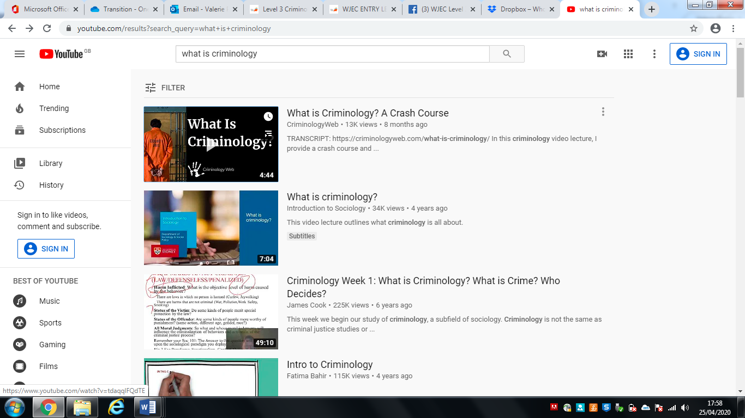

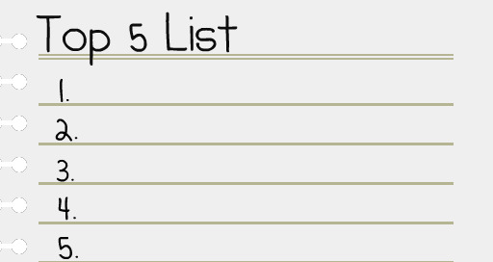

Task 4

What’s the difference between a crime and deviance?

A crime can be defined as ……………………………………………………………….

…………………………………………………………………………………………………..

Deviance is …………………………………………………………………………………..

…………………………………………………………………………………………………..

Examples of crimes are: …………………………………………………………………...

…………………………………………………………………………………………………..

Examples of deviance are: ……………………………………………………………….

…………………………………………………………………………………………………..

Task 5

Famous Faces and their crimes? Or deviance? Match the famous face to the act of crime or deviance.

- Trespassing and damage of property leading to loss of owner’s income
- Arrested for possession and being under the influence of drugs, possession of an unloaded gun and trespassing
- Arrested for protesting outside the South African embassy against unfair treatment of Black people in South Africa
- Arrested for assault, driving under the influence of drugs, driving whilst license was suspended
- Avoiding paying £20 million in tax that would help to pay for the NHS, Welfare and Schools in this country
- Driving under the influence of alcohol and causing a collision injuring two other people

Task 6
Research the following types of crime. You need to understand the definition of the type of crime, the typical offender and the typical victim.

- State Crime

Definition……………………………...............................................................................

.......................................................................................................................................

Typical Offender …………………………………………………………………………….

Typical Victim …………………………………………………………………………......

Example: ……………………………………………………………………………………

…………………………………………………………………………………………………

…………………………………………………………………………………………………

…………………………………………………………………………………………………

…………………………………………………………………………………………………

- White Collar Crime

Definition……………………………...............................................................................

.......................................................................................................................................

Typical Offender …………………………………………………………………………….

Typical Victim ………………………………………………………………………….........

Example: ……………………………………………………………………………………...

…………………………………………………………………………………………………

…………………………………………………………………………………………………

…………………………………………………………………………………………………

…………………………………………………………………………………………………

- Moral Crimes

Definition……………………………...............................................................................

.......................................................................................................................................

Typical Offender …………………………………………………………………………….

Typical Victim ………………………………………………………………………….........

Example: ……………………………………………………………………………………...

…………………………………………………………………………………………………..

…………………………………………………………………………………………………..

…………………………………………………………………………………………………

…………………………………………………………………………………………………

- Technological Crimes

Definition……………………………...............................................................................

.......................................................................................................................................

Typical Offender …………………………………………………………………………….

Typical Victim ………………………………………………………………………………

Example: ……………………………………………………………………………………...

…………………………………………………………………………………………………

…………………………………………………………………………………………………

…………………………………………………………………………………………………

…………………………………………………………………………………………………

- Hate Crime

Definition……………………………...............................................................................

.......................................................................................................................................

Typical Offender …………………………………………………………………………….

Typical Victim …………………………………………………………………………......

Example: ……………………………………………………………………………………...

…………………………………………………………………………………………………..

…………………………………………………………………………………………………

…………………………………………………………………………………………………

…………………………………………………………………………………………………

Task 7

As part of your course you will have to look at campaigns that have caused a change in the law. You will also have to plan your own campaign.
Conduct research on the following campaigns. Find out what the original crime was that sparked the campaign; what the aim of the campaign was; what methods were used (eg. TV interviews, advertising, wristbands, petitions, T-shirts etc) and whether the campaign was successful.
Sarah’s Law
The Double Jeopardy Law
Dignity in Dying
Snowdrop Campaign
Bobby Turnbulls campaign
Lillians Law
Clare’s Law
Task 8 - Sneak peak into Unit 2
Nature vs Nurture
There are many ways of explaining why certain people do things in certain ways. For example, biologists think that people behave as they do because they are controlled by nature. This is known as Nature theory. Humans are compared to animals and seen to act on instinct.
Sociologists believe that people behave as they do because they are taught how to behave. For example, the sociologist Michael Haralambos states, ‘Human beings learn their behavior and use their intelligence whereas animals simply act on instinct.’ This is known as Nurture theory. Nurture means the way you are brought up. It is also a reference to socialization, the lifelong process by which we learn our culture, values, norms and how to behave.

Task 9

Research the childhood backgrounds of 3 notorious serial murderers such as Fred West or Harold Shipman or Jeffrey Dahmer for example.
The focus should be on early life history and not subsequent crimes. Thinking about what you have read about Nature and Nurture, which criminological explanations could best account for their criminal behaviour?

Submit your work to cdobson@dma.tela.org.uk in preparation for September Criminology lessons to start.

