**Subject: Physics**

**Year 12 Prep Task**

|  |  |  |
| --- | --- | --- |
| **Key Info**   * **Deepen your knowledge of motion and how this idea is interpreted dependent on the observer.** * **Explore and understand a scientific article and answer questions on the most famous physics equation E=mc2.** * **Extend your knowledge of free-body diagrams from GCSE.** | | |
| **Week beginning:**  **22.07.24** | **Expected completion time:**  **Due Sept 2024 – first lesson.** | |
| **Activities to be completed** | **Location of resources** | **Additional resources/support** |
| 1.) Watch the documentary and produce a summary on the video, you should include;   * What does it mean to move relative to something else? * Are you moving right now? Linking back to question 1. * If you are in orbit around the earth on the ISS and go on a space walk, how fast are you moving? Be clear about linking the idea of relative motion in ti your answer.   2.) Read the article and answer the questions on the document.  3.) Draw a free body diagram for and describe the motion of the following scenarios:   1. An object falling through the air under gravity and affected by air resistance. 2. An object on an inclined plane with friction opposing motion down the plane. 3. An object in an eccentric orbit about the earth.   Please define all terms you are unfamiliar with referencing your sources (website URL), NOT WIKIPEDIA. | TedTalk  <https://www.ted.com/talks/tucker_hiatt_how_fast_are_you_moving_right_now?language=en>  Separate document  <https://www.youtube.com/watch?v=wBrJ30plBhw>  GCSE notes | Video transcript available with button to the bottom right of the video. |
| **Work to be submitted:**   1. As above. | | |

**Mass-Energy Extended Reading Task**

Instructions:

* Read the text
* Answer the questions at the end (you will need to do some research!)

Does the inertia of a body depend on its energy content?

A. Einstein

September 27, 1905

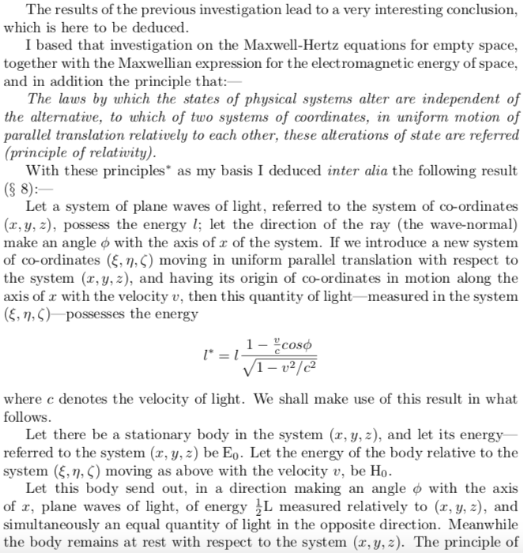

5

10

15

20

25



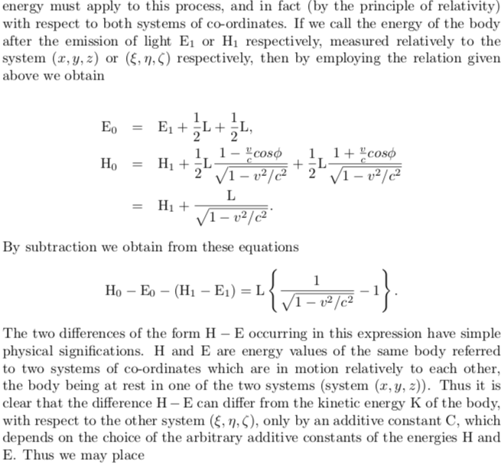 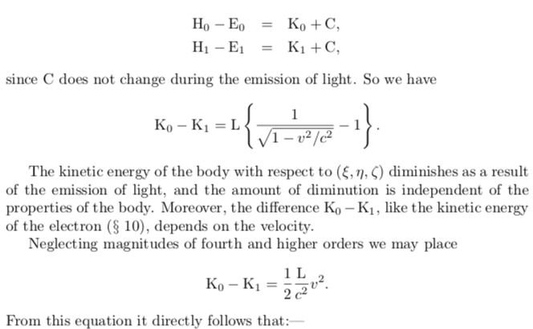 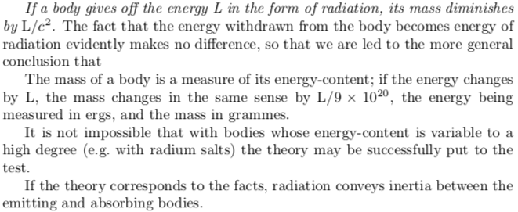

30

35

40

45

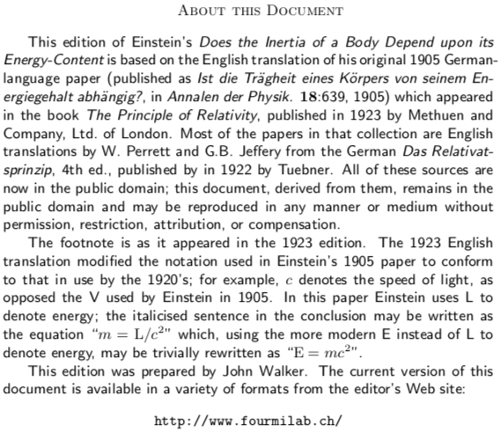

50

55

60

**Questions**

1. Who do you think the intended audience for this text is?
2. Lines 6-9: the principal of relativity is referred to here. Re-write this paragraph in more accessible language.
3. Lines 14-17: a second set of coordinates  is introduced and explained here. Draw a diagram explaining how the two coordinate systems are related.
4. Lines 27-28: ‘the principle of energy must apply to this process’. To what is this line referring?
5. Lines 35-41: what does this mean about the energy of a system if measured in two different reference frames?
6. Lines 49-55: Which now well known equation is this section referring to?
7. Lines 53-55: ‘where energy is measured in ergs’. Use the equation from question 6 and the statement about mass to determine what an erg of energy is in joules.
8. Lines 59-60: it is stated that ‘radiation conveys inertia between the emitting and absorbing bodies’. What property must light have in order to do this?