**Athena Sixth Form College Criminology Transition Pack**

|  |  |
| --- | --- |
| **QUALIFICATION** | **Applied Certificate/Diploma in Criminology** |
| Teacher Name(s) | Mr Dobson |
| Contact email(s) | CDobson@dma.tela.org.uk |
| Exam board and link | WJEC wjec.co.uk |
| Specification details | 601/6248/X Applied Diploma Level 3 |
| Recommended online learning | <https://revisesociology.com/tag/criminology/>  <https://criminology.uk.net/>  <https://www.wjec.co.uk/en/qualifications/criminology-level-3/#tab_overview> |
| Textbooks that are used.  They can be purchased from Amazon.  You should buy the first one ready for September.  We have some copies of these textbooks in the Library. They are ideal for recapping work missed and or consolidating taught information following a lesson. | Criminology Book One for the WJEC Level 3 Applied Certificate & Diploma by Rob Webb and Annie Townend  by Rob Webb  published by Napier Press  Year 12      https://images-na.ssl-images-amazon.com/images/I/41F%2BsECf3VL._SX407_BO1,204,203,200_.jpg  by Rob Webb  published by Napier Press  Year 13  WJEC Level 3 Applied Certificate & Diploma Criminology  by Carole Henderson  Published by Illuminate  WJEC Level 3 Applied Certificate and Diploma Criminology: Study and Revision Guide  by Carole Henderson  Published by Illuminate |

**Welcome to Applied Criminology!**

You have chosen a subject that combines elements of psychology, law and sociology and that complements studies in humanities. Each unit has an applied purpose which demands that learning is related to authentic case studies – this is the interesting bit! It will certainly ‘keep you on your toes’ and make you think in ways you couldn’t imagine. You will certainly have a very different outlook on society by the end of your course.

**Overview of the course:**

This is a two-year course. Units 1 and 2 completed in the first year comprise an 8-hour Controlled Assessment plus a formal examination. This is replicated in Year 2 with Units 3 and 4. You must **complete and pass ALL units** to gain the Diploma. The overall grades will be recorded on a scale A*-E.

Unit 1: Changing Awareness of Crime (Controlled Assessment)

Unit 2: Criminological Theories (Exam)

Unit 3: Crime Scene to Courtroom (Controlled Assessment)

Unit 4: Crime and Punishment (Exam)

Look at the specification for more detail about these topics. You can find this at: <https://www.wjec.co.uk/media/21xjkr24/applied-diploma-in-criminology-specification-from-2015.pdf>

**Expectations of the course:**

* Lessons consist of taking notes, group discussions, watching relevant documentaries, group work and PowerPoint presentations. All of my resources are available on our Criminology TEAM following the lesson.
* Homework/NON contact tasks consists of note making, wider reading, research, past exam questions, paired presentations and essay questions. It is expected that about **300 minutes** a week will be spent on Criminology homework. Period 7’s are also available to support you.
* The ***Watch List*** on the following page will help you to gain wider knowledge and a broader framework in which to apply your knowledge. You will be expected to choose something to watch/read every half term and to feed back to the rest of the class. You may do this individually, in pairs or groups. There will also be a real crime documentary club to join or even help run.
* Your progress will be reviewed on a regular basis. The review process will provide feedback at specific times throughout the year. You will also be expected to be within two grades of your target grade on each piece of work.
* You are expected to use the resources available to you in the library , your textbook and wider reading as well as the internet.
* Use teams to chat Criminology for questions and help from others and myself.
* Your folders of notes will be checked on a regular basis to see if you are organised and up to date with your work.
* USE YOUR STUDY TIME wisely and be proactive and always ask questions in class.

*Watching List recommendations – Criminology (Over 2 years)*

* Black Mirror series (Netflix)
* Goodfellas
* The Godfather (part 2 is the best)
* Legend
* McMafia (previously BBC i-player)
* Escape from Pretoria
* Dangerous Minds
* Chernobyl (drama)
* When They See Us (Netflix)
* Criminal Minds
* The Lincoln Lawyer
* True Story
* The Society (Netflix)
* Blood Diamond
* Orange is the New Black (Netflix)
* The Innocence Files (Netflix)
* Cold Case Files (Netflix)
* I Am A Killer (Netflix)
* Catching Killers - netflix
* When They See Us Now – Oprah Winfrey (Netflix)
* The Push – Derren Brown (Netflix)
* MacIntyre Undercover: The Chelsea Headhunters (Youtube)
* The Shawshank Redemption
* The Green Mile

**Youtube documentaries to watch:**

Louis Theroux – Prison docs

Colin Stagg

The Stanford Prison Experiment

Damilola Taylor

Sally Clark

Angela Cannings

Barry George

Amanda Knox

OJ Simpson

Stephen Lawrence

Alice Ruggles

Joanna Yeates

24 hours in Police Custody

BBC Real CSI

***Task 1***

Choose **anything** from the **Watch List** above that you are going to briefly report back on. You can watch more than one if you wish.

***Task 2***

Watch the following clip and jot down 5 things that tell you what Criminology is.

<https://www.youtube.com/watch?v=tdaqqlFQdTE>

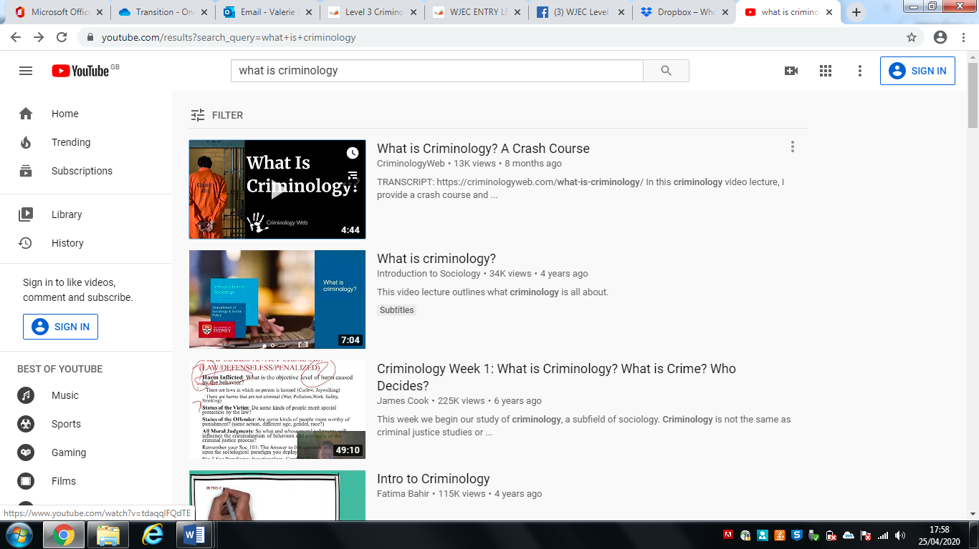

[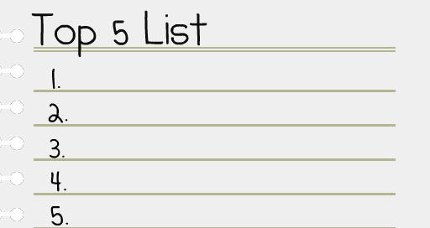](https://www.google.com/url?sa=i&rct=j&q=&esrc=s&source=images&cd=&cad=rja&uact=8&ved=2ahUKEwjqrrnnmvHbAhXiJsAKHVe2D3UQjRx6BAgBEAU&url=https://melissafoster.com/time-management-tips-following-through-commitments-limited-time/&psig=AOvVaw2_2_YFqRQyGw9LEUIgtpZI&ust=1530098356438301)

***Task 3***

Famous Faces and their crimes? Or deviance? Match the famous face to the act of crime or deviance.



1. Trespassing and damage of property leading to loss of owner’s income
2. Arrested for possession and being under the influence of drugs, possession of an unloaded gun and trespassing
3. Arrested for protesting outside the South African embassy against unfair treatment of Black people in South Africa
4. Arrested for assault, driving under the influence of drugs, driving whilst license was suspended
5. Avoiding paying £20 million in tax that would help to pay for the NHS, Welfare and Schools in this country
6. Driving under the influence of alcohol and causing a collision injuring two other people

**Answers at the end!**

***Task 4***

Research the following types of crime. You need to understand the definition of the type of crime, the typical offender and the typical victim.

1. State Crime

Definition……………………………...............................................................................

.......................................................................................................................................

Typical Offender …………………………………………………………………………….

Typical Victim …………………………………………………………………………......

Example: ……………………………………………………………………………………

…………………………………………………………………………………………………

…………………………………………………………………………………………………

…………………………………………………………………………………………………

…………………………………………………………………………………………………

1. White Collar Crime

Definition……………………………...............................................................................

.......................................................................................................................................

Typical Offender …………………………………………………………………………….

Typical Victim ………………………………………………………………………….........

Example: ……………………………………………………………………………………...

…………………………………………………………………………………………………

…………………………………………………………………………………………………

…………………………………………………………………………………………………

…………………………………………………………………………………………………

1. Moral Crimes

Definition……………………………...............................................................................

.......................................................................................................................................

Typical Offender …………………………………………………………………………….

Typical Victim ………………………………………………………………………….........

Example: ……………………………………………………………………………………...

…………………………………………………………………………………………………..

…………………………………………………………………………………………………..

…………………………………………………………………………………………………

…………………………………………………………………………………………………

1. Technological Crimes

Definition……………………………...............................................................................

.......................................................................................................................................

Typical Offender …………………………………………………………………………….

Typical Victim ………………………………………………………………………………

Example: ……………………………………………………………………………………...

…………………………………………………………………………………………………

…………………………………………………………………………………………………

…………………………………………………………………………………………………

…………………………………………………………………………………………………

1. Hate Crime

Definition……………………………...............................................................................

.......................................................................................................................................

Typical Offender …………………………………………………………………………….

Typical Victim …………………………………………………………………………......

Example: ……………………………………………………………………………………...

…………………………………………………………………………………………………..

…………………………………………………………………………………………………

…………………………………………………………………………………………………

…………………………………………………………………………………………………

***Task 5***

As part of your course you will have to look at campaigns that have caused a change in the law. You will also have to plan your own campaign.

Conduct research on **3** of the following campaigns. Find out what the **original crime** **was** that sparked the campaign; what the **aim** of the campaign was; what **methods** were used (eg. TV interviews, advertising, wristbands, petitions, T-shirts etc) and whether the campaign was **successful**.

Sarah’s Law

The Double Jeopardy Law

Harper’s Law

Snowdrop Campaign

Bobby Turnbulls campaign

Lillians Law

Clare’s Law

***Task 6 - Sneak peak into Unit 2***

***Nature vs Nurture***



There are many ways of explaining why certain people do things in certain ways. For example, biologists think that people behave as they do because they are controlled by nature. This is known as **Nature theory**. Humans are compared to animals and seen to act on **instinct**.

Sociologists believe that people behave as they do because they are taught how to behave. For example, the sociologist Michael Haralambos states, ‘Human beings learn their behavior and use their intelligence whereas animals simply act on instinct.’ This is known as **Nurture theory**. Nurture means the way you are brought up. It is also a reference to **socialization**, the lifelong process by which we learn our culture, values, norms and how to behave.

Briefly research the childhood backgrounds of **3 notorious serial murderers such as Fred West, Harold Shipman or Jeffrey Dahmer for example**.

The focus should be on **early** **life history** and not subsequent crimes. Thinking about what you have read about Nature and Nurture, **which explanation could account for their criminal behaviour?**

**Answers to Task 3**

1. Trespassing and damage of property leading to loss of owner’s income
2. Arrested for possession and being under the influence of drugs, possession of an unloaded gun and trespassing
3. Arrested for protesting outside the South African embassy against unfair treatment of Black people in South Africa
4. Arrested for assault, driving under the influence of drugs, driving whilst license was suspended
5. Avoiding paying £20 million in tax that would help to pay for the NHS, Welfare and Schools in this country
6. Driving under the influence of alcohol and causing a collision injuring two other people
7. Ant McPartlin – F
8. Lindsay Lohan – D
9. Robert Downey Jr – B
10. Gary Barlow – E
11. Jeremy Corbyn – C
12. Theresa May - A